**UNIT-1**

***Introduction***

The word “*energy*” itself is derived from the **Greek** word *en-ergon*, which means ‘*in-work’* or *work content*. The work output depends on the energy input. Energy is the most basic infra-structure input required for economic growth & development of a country. Thus, with an increase in the living standard of human beings, the energy consumption also accelerated.

A systematic study of various forms of energy & energy transformations is called energy science. While fossil fuels will be the main fuel for thermal power, there is a fear that they will get exhausted eventually in the next century. Therefore other systems based on non-conventional & renewable sources are being tried by many countries. These are solid, wind, sea, geothermal & bio-mass.

**The need for alternatives:**

1. The average rate of increase of oil production in the world is declining & a peak in production may be reached around 2015. There after the production will decline gradually & most of the oil reserves of the world are likely to be consumed by the end of the present century.
2. The serious nature of this observation is apparent when one notes that oil provides about 30% of the world‘s need for energy from commercial sources & that oil is the fuel used in most of the world‘s transportation systems.
3. The production of natural gas is continuing to increase at a rate of about 4% every year. Unlike oil, there has been no significant slowdown in the rate of increase of production. Present indications are that a peak in gas production will come around 2025, about 10 years after the peak in oil production.
4. As oil & natural gas becomes scarcer, a great burden will fall on coal. It is likely that the production of coal will touch a maximum somewhere around 2050.
5. Finally, it should be noted that in addition to supplying energy, fossil fuels are used extensively as feed stock material for the manufacture of organic chemicals. As resources deplete, the need for using fossil fuels exclusively for such purposes may become greater.

**India’s production & reserves of commercial sources:**

***Coal*:** Coal is the end product of a natural process of decomposition of vegetable matter buried in swamps & out of contact with oxygen for



thousands of years. The word ‘coal‘ denotes a wide variety of solid fuels. The varieties in approximate order of their formation are peat, lignite, bituminous & anthracite coal.

The rate of production of coal in India over the last 50 years is shown in fig (a). It can be seen that there has been an eleven-fold increase in production from 1951 to 2004 & that the average annual growth rate has been about 4.5%. In 2000, India‘s production was 300mt, which was about 6.7% of the world‘s production. India has fairly large reserves of coal.

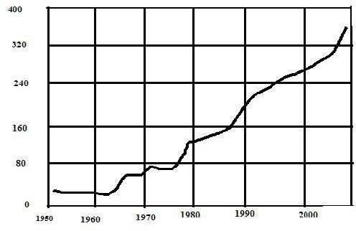

**Fig.1. Annual production of coal in India [production rate (Mt/Year] v/s Year**

**Table 1: Coal reserves in India (in Mt)**

|  |  |  |  |
| --- | --- | --- | --- |
| Year | Proved  reserves | Indicated & inferred  reserves | Total reserves (  Resources) |
| 1972 | 21360 | 59590 | 80950 |
| 1981 | 27912 | 87490 | 115402 |
| 1985 | 35030 | 120870 | 155900 |
| 1992 | 64800 | 129000 | 193800 |
| 2006 | 95866 | 157435 | 253301 |

***Oil*:** The below fig.2. Represents presents data on the annual consumption of petroleum products in India (curve 3) from 1951



onwards. It also shows the variation in the domestic production of crude oil (curve 1) & the import of crude (curve 2) over the years.

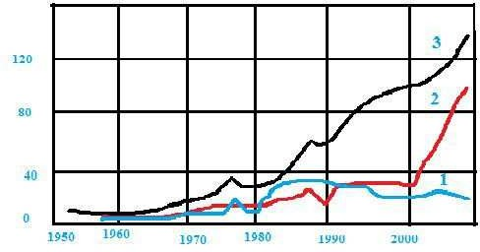

**Fig.2. Annual production, import & consumption of oil in India [Production Rate (Mt/Year) v/s Year]**

*Curve 1*.Domestic production of crude, *Curve 2*.Import of crude, *Curve 3*. Consumption of products

**Natural gas:** presents data on the annual useful production of natural gas in India from 1969 onwards. In 1969, the production was only 0.516 billion m3. It did not change much till 1973. However, subsequently the production increased rapidly. It was 8.913 billion m3 in 1989, 13.5% from 1989 to 1997 & 3.1% from 1997 to 2005.

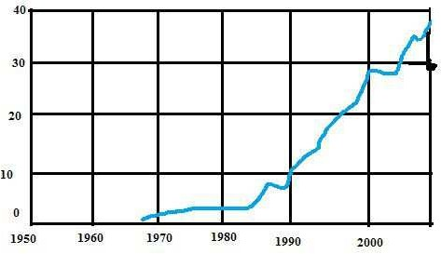

**Fig.3. Annual production of natural gas in India [Production rate (109 m3/Year) v/s Year]**

**Water –power:**

It is one of the indirect ways in which solar energy is being used. Water-power is developed by allowing water to fall under the force of gravity. It is used almost exclusively for electric power generation. Data on the installed capacity of hydro power in India & the electricity produced from it from 1947 onwards is presented in below fig. 4.

(103

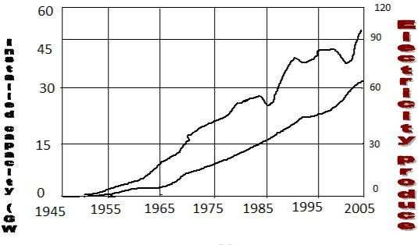

GWh

**Fig.4. installed capacity & electricity generation from water-power**

**in India.**

**Nuclear power:**

Data on the electricity production from nuclear power is plotted in below fig .5. It is seen that the electricity produced has been generally increasing over the years, as more units are getting commissioned. The higher amount, viz 19242 GWh was produced in 2002. The fall in certain years is because of some units being down for maintenance.

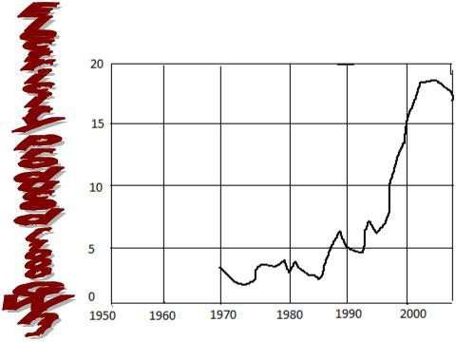

YEARS

**Fig.5. Electricity produced from nuclear power in India Miscellaneous Sources:**

In India, the miscellaneous sources are renewable source like wind energy, biomass, small hydro-power. As was the case for the world, in India also, wind energy is the main contributor. The growth in installed capacity for wind energy & along with data on the electricity produced from the wind is as shown in below fig. 6.

The growth of installed capacity for wind energy in India has been very impressive. At the end of 1990, the capacity was only 37 MW. 15 years later, at the end of 2005, it was 5342 MW & India now ranks 4th in the world in terms of wind power installed capacity.

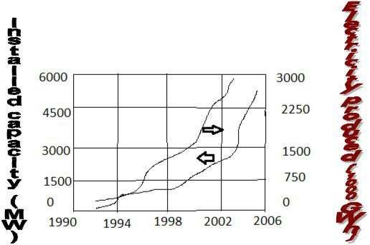

**Fig.6. Installed capacity & electricity generation from wind power in India**

The contribution of small hydro-power & biomass are also significant. Table 2 presents data on the growth of small hydro power & biomass power capacity in the country.

**Table 2: Installed capacity of small hydro-power units & biomass power in India**

|  |  |  |
| --- | --- | --- |
| Year | Capacity | |
|  | Small hydro-power | Biomass power |
| Up to 2001 | 1438.89 | 379.50 |
| 2002 | 80.39 | 103.00 |
| 2003 | 84.04 | 129.50 |
| 2004 | 102.27 | 137.60 |



|  |  |  |
| --- | --- | --- |
| 2005 | 120.84 | 117.93 |
| Total ( up to 2005) | 1826.43 | 867.53 |

**Electricity production in India:**

The below fig .7. data shows that the installed capacity has increased from 1362 MW in 1947 at the time of independence to 16664 MW in 1973 & to 124287 MW in 2005. These correspond to an impressive average annual growth rate of 10.1 % from 1947 to 1973 & to a rate of 6.5% from 1973 to 2005

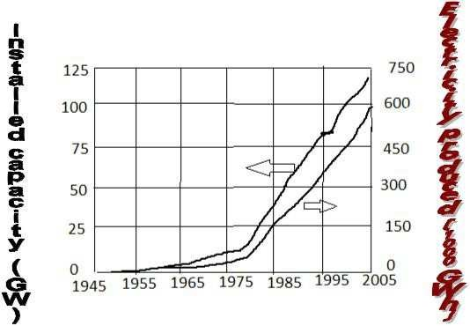

.

**Fig.7. The total installed capacity & electricity generation in India**

**from all commercial sources**

***Annual production of energy:***

**Table 3: Energy production from commercial energy sources in India-Year 2000**

|  |  |  |  |
| --- | --- | --- | --- |
| Energy source | Production/consumption | Energy equivalent( in  1015 J) | Percent contribution |
| Coal | 310 Mt | 8177 | 56.16 |
| Oil | 103.44 Mt | 4331 | 29.75 |
| Natural  gas | 27.860×109 m3 | 1087 | 7.47 |
| Water-  power | 74362 GWh | 765 | 5.25 |

|  |  |  |  |
| --- | --- | --- | --- |
| Nuclear  power | 16621GWh | 199 | 1.37 |
| Total |  | 14559 | 100.00 |

The calculations are performed for the year 2000 & are presented in table 3. It is seen that the total energy production is 14559×1015 J. Once again the dominant role played by fossil fuels in the energy sector is apparent. 93% of India‘s requirement of commercial energy is being met by fossil fuels, with coal contributing 56%, & oil & natural gas contributing 37%. Water power & nuclear power contribute only about 7% to the total energy production. Comparing the total energy production in India from commercial sources with that of the world. We see that it is only 3.5% of the total world production.

**India’s reserves & production relative to world data:**

|  |  |  |  |  |  |  |
| --- | --- | --- | --- | --- | --- | --- |
| Energy source | Proved reserves | | | Production (2004) | | |
| World | India | % of  world | World | India | % of  world |
| Coal (Mt) | 980000 | 95866 | 9.8 | 5516 | 377 | 6.8 |
| Oil(billion  barrels) | 1300 | 5.75 | 0.4 | 26.36 | 0.25 | 0.9 |
| Natural gas(billion  m3) | 175000 | 1101 | 0.6 | 2792.6 | 30.775 | 1.1 |
| Nuclear  power | 3.62 | 0.061 | 1.7 | 2619180 | 16709 | 0.6 |
| Water  power | 3×106 | 148700 | 5.0 | 2746880 | 84495 | 3.1 |

**Classification of energy resources:**

1. **Based on usability of energy:**
   1. Primary resources: Resources available in nature in raw form is

called primary energy resources. Ex: Fossil fuels (coal, oil & gas), uranium, hydro energy. These are also known as raw energy resources.

* 1. Intermediate resources: This is obtained from primary energy resources by one or more steps of transformation & is used as a vehicle of energy.



* 1. Secondary resources: The form of energy, which is finally

supplied to consume for utilization. Ex: electrical energy, thermal energy (in the form of steam or hot water), chemical energy (in the form of hydrogen or fossil fuels).

Some form of energies may be classified as both intermediate as well as secondary sources. Ex: electricity, hydrogen.

1. **Based on traditional use:**
   1. Conventional: energy resources which have been traditionally used for many decades. Ex: fossil fuels, nuclear & hydro resources
   2. Non-conventional: energy resources which are considered for large scale & renewable. Ex : solar, wind & bio-mass
2. **Based on term availability:**
   1. Non-renewable resources: resources which are finited, & do not get replenished after their consumption. Ex : fossil fuels, uranium
   2. Renewable resources: resources which are renewed by nature again & again & their supply are not affected by the rate of their consumption. Ex : solar, wind, bio-mass, ocean ( thermal, tidal & wave), geothermal, hydro
3. **Based on commercial application:**
   1. Commercial energy resources: the secondary useable energy forms such as electricity, petrol, and diesel are essential for commercial activities. The economy of a country depends on its ability to convert natural raw energy into commercial energy. Ex : coal, oil, gas, uranium, & hydro
   2. Non-commercial energy resources: the energy derived from nature & used – directly without passing through commercial outlet. Ex: wood, animal dung cake, crop residue.
4. **Based on origin :**
   1. Fossil fuels energy f) bio-mass energy
   2. Nuclear energy g) geothermal energy
   3. Hydro energy h) tidal energy
   4. Solar energy i) ocean thermal energy
   5. Wind energy j) ocean wave energy

**Consumption trend of primary energy resources**



renewable (mainly hydro & wind) 7%

38% oil

28% coal

21%

gas

6% nuclear

**Fig.8. percentage consumption of various primary energy resources**

The average % consumption trend of various primary energy resources of the world is indicated in the above fig, though the trend

differs from country to country. Looking at figure the heavy dependence

on fossil fuels stands out clearly. About 87% of the world‘s energy supply comes mainly from fossil fuels. The share of fossil fuels is more than 90% in case of India.

**Importance of Non-commercial energy resources:**

The concern for environmental due to the ever increasing use of fossil fuels & rapid depletion of these resources has lead to the

development of alternative sources of energy, which are renewable & environmental friendly. Following points may be mentioned in this connection.

1. The demand of energy is increasing by leaps & bounds due to rapid industrialization & population growth, the conventional sources of energy will not be sufficient to meet the growing demand.
2. Conventional sources (fossil fuels, nuclear) also cause pollution; there by their use degrade the environment.
3. Conventional sources (except hydro) are non-renewable & bound to finish one day.
4. Large hydro-resources affect wild-life, cause deforestation & pose various social problems, due to construction of big dams.
5. Fossil fuels are also used as raw materials in the chemical industry (for chemicals, medicines, etc) & need to be conserved for future generations.

Due to these reasons it has become important to explore & develop non- conventional energy resources to reduce too much

dependence on conventional resources. However, the present trend development of nces indicates that these will serve as supplements rather than substitute for conventional sources for some more time to time.

**SALIENT FEATURES OF NON-CONVENTIONAL ENERGY RESOURCES**

**Merits:**

* 1. NCES are available in nature, free of cost.
  2. They cause no or very little pollution. Thus, by and large, they are environmental friendly.
  3. They are inexhaustible.
  4. They have low gestation period.

**Demerits:**

1. Though available freely in nature, the cost of harnessing energy from NCES is high, as in general, these are available in dilute forms of energy.
2. Uncertainty of availability: the energy flow depends on various natural phenomena beyond human control.
3. Difficulty in transporting this form of energy.

**ADVANTAGES & DISADVANTAGES OF CONVENTIONAL ENERGY RESOURCES:**

**ADVANTAGES:**

1. Coal: as present is cheap.
2. Security: by storing certain quantity, the energy availability can be ensured for a certain period.
3. Convenience: it is very convenient to use.

**DISADVANTAGES:**

* 1. Fossil fuels generate pollutants: CO, CO2, NOX, SOX. Particulate matter & heat. The pollutants degrade the environment, pose health hazards & cause various other problems.
  2. Coal: it is also valuable petro-chemical & used as source of raw material for chemical, pharmaceuticals & paints, industries, etc. From long term point of view, it is desirable to conserve coal for future needs.
  3. Safety of nuclear plants: it is a controversial subject.
  4. Hydro electrical plants are cleanest but large hydro reservoirs cause the following problems
     1. As large land area submerges into water, which leads to deforestation
     2. Causes ecological disturbances such as earthquakes
     3. Causes dislocation of large population & consequently their rehabilitation problems.

**SOLAR ENERGY:**

 Solar energy is a very large, inexhaustible source of energy. The power from the Sun intercepted by the earth is approximately **1.8×1011** MW which is many thousands of time larger than the present consumption rate on the earth of all

commercial energy sources. Thus, in principle solar energy could supply all the present & future energy needs of the world on a continuing basis. This makes it one of the most promising of the unconventional energy sources.

 Solar energy is received in the form of radiation, can be converted directly or indirectly into other forms of energy, such as heat & electricity. This energy is radiated by the Sun as electromagnetic waves of which 99% have wave lengths in the range of 0.2 to 4 micro meters.

 Solar energy reaching the top of the Earth‘s atmosphere consists about 8% U.V radiation, 46% of visible light, 46% Infrared radiation.

**Classification of methods for solar energy utilisation:**

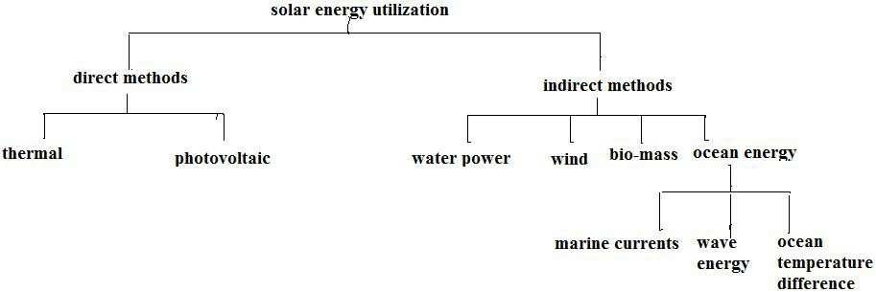

**Merits of solar energy:**

* It is an environmental clean source of energy
* It is free & available in adequate quantities in all most all parts of world where people live.
* It is a dilute source of energy because even in hottest region the radiation flux is available only 1 KW/m2 & total radiation over a day is 7 KW/m2. These are low values from the point of view of

technological utilization.

* It is required large collecting areas are required in many applications & these results increase of cost.
* Solar energy availability varies widely with time, it occurs because of the day- night cycle & also seasonally because of the Earth‘s orbit around the Sun [even local weather condition].

**Solar applications:**

 Solar heating

 Solar cooling  Solar pumping  Solar furnace

 Solar production of hydrogen  Solar green houses

 Solar distillation

 Solar energy  Solar cooking

**Thermal Energy:**

Thermal energy refers to the internal energy present in a system in a state of thermodynamic equilibrium by virtue of its temperature. The average transitional kinetic energy possessed by free particles in a system of free particles in thermodynamic equilibrium. This energy comes from the temperature of matter.

Thermal energy is the total energy of all the molecules in an object.

The thermal energy of an object depends on the 3 things:

1. The number of the molecules in the object
2. The temperature of the object ( average molecular motion)
3. The arrangement of the object molecules (states of matter)

There are 3 modes of thermal energy 1.

Conduction, 2.convection, 3.radiation

* 1. **Conduction:** Heat is transferred from one molecule to another without the movement of matter.
  2. **Convection:** Fluids (liquids & gases) transfer heat by convection, a process that causes mixing of the warmer regions with the cooler regions of liquid or gas.

The main difference between convection & conduction is that convection involves the movement of matter & conduction does not.

* 1. **Radiation:** it is the transfer of energy by electromagnetic waves.

**ADVANTAGES:**

 It is eco friendly

 Renewable sources

 No/less pollution

 By using this produce electricity

 Its help full for oil refining in Industry & home heating

**DISADVANTAGES:**

 Producing green house gas

 Collecting of energy is a big problem, it requires sophisticated technology hence cost is more.

 Steam engine

 Gasoline engine

**Photovoltaic (PV) or Solar Cell:**

It is a device that converts solar energy into electric current using the photoelectric effect. The first PV was introduced by Charles Frilt in the 1880‘s. In 1931 a German engg Dr.Bruno Lange developed PV by using Silver Solenoid in place of Copper oxide.

Photovoltaic power generation employs solar panels, composed of number of solar cells containing photovoltaic material. Photovoltaics are made up of semiconductors & it converts solar radiation into direct current electricity.

Photovoltaic system consists of

a) Solar cell array, b) load leveler, c) storage system, d) tracking system( where necessary)

**Working Principle**:

PV‘s are made up of semiconductors that generate electricity when they absorb light. As photons are received, free electrical charges are generated that can be collected on contacts applied to the surface of the semiconductors. Because of solar cells are not heat engines, & therefore, do not need to operate at higher temperature, they are adapted to the weak energy flux of solar radiation, operating at room temperature.

**Advantages:**

* Compare to fossil fuels nuclear energy sources, very little research money has been invested in the development of solar cells.
* It gives long duration period( operation)
* Operating costs are extremely low compared to existing power technologies.  Space craft ( silicon solar cell)

 It can be applicable to either small or large power plants

 These solar cells are used to operate irrigation pumps, navigational signals, highway emergency call systems, rail road crossing warnings & automatic metrological station.

**WATER POWER (HYDRO POWER):**

Power derived from the energy of falling water & running water, which may be harnessed for useful purposes. In ancient years hydro-power has been used for irrigation & the operation of various mechanical devices such as water mills, saw mills, textile mills, domestic lifts, power house & paint making.

**How the generator works:** A hydraulic turbine converts the energy of flowing water into mechanical energy. A hydro-electric generator converts this mechanical energy into electricity. The operation of generator is based on the principle discovered by Faraday. He found that when a magnet is moved past a conductor it causes electricity to flow.

In a large generator electro magnets are made by circulating d.c through loops of wire wound around stacks of magnetic steel laminations. These are called field poles & are mounted on the perimeter of the rotor.

The rotor is attached to the turbine shaft & rotates at a fixed speed. When rotor turns, it causes the field poles (electromagnetic) to move past the conductors mounted in the stator. This is turn causes electricity to flow & a voltage to develop at the generation output terminals.

**Classification of hydro power:**

 Conventional hydro electric, referring hydroelectric dams

 Run of the river hydroelectricity, which captures the kinetic energy in rivers or streams without use of dams.

 Small hydro projects are 10 MW or less & often have no artificial reservoirs.

 Micro hydro projects a few KW to a few hundred KW isolated homes, villages or small industries.

The power available from falling water can be calculated from the flow rate & density of water, the height of fall & the local acceleration due to gravity.

**P=□pQgh**

Where, P – Power in Watts

□- dimension less efficiency of the turbine

ρ –density of water in Kg/m3 Q-

Flow in m3/sec

1. Acceleration due to gravity
2. Height difference between inlet & outlet

**WIND ENERGY:**

Energy of wind can be economically used for the generation of electricity.

Winds are caused from 2 main factors:

1. Heating & cooling of the atmosphere which generates convection currents. Heating is caused by the absorption of solar energy on the Earth‘s surface & in the atmosphere.
2. The rotation of the Earth with respect to atmosphere & its motion around the sun

 The energy available in the wind over the Earth‘s surface is estimated to be

1.6×107 MW



In India, high wind speeds are obtainable in coastal areas of Saurashtra, Western  Rajasthan & some parts of Central India. Wind energy which is an indirect source

of solar energy conversion can be utilized to run wind mill, which in turn drives a generator to produce electricity.

 The combination of wind turbine & generator is sometimes referred as an *AERO- * *GENERATOR*.

A step up transmission is usually required to match the relatively slow speed of the wind rotor to the higher speed of an electric generator.

 Data quoted by some scientists that for India wind speed value lies between 5 Km/hr to 15-20 Km/hr

 Wind forms are operating successfully & have already fed over 150 lakh units of electricity to the respective state grids.

 Wind speed increases with height.

**The power in wind:**

Wind possesses energy by virtue of its motion. There are 3 factors determine the output from a wind energy converter, 1] the wind speed, 2] The cross section of wind swept by rotor & 3] The overall conversion efficiency of the rotor, transmission system & generator or pump.

 Only 1/3rd amount of air is decelerating by the rotors & 60% of the available energy in wind into mechanical energy.

 Well designed blades will typically extract 70% of the theoretical max, but losses incurred in the gear box, transmission system & generator or pump could decrease overall wind turbine efficiency to 35% or loss.

 The power in the wind can be computed by using the concept of kinetics. The wind mill works on the principle of converting kinetic energy of the wind to mechanical energy.

Kinetic energy = k.E= ½ mv2 But m = **p**Av

Available wind Power =**Pa = 1/8 pπD2V3** Watts

Major factors that have lead to accelerated development of the wind power are as follows:

 Availability of high strength fiber composites for constructing large low-cost rotor blades.

 Falling prices of power electronics

 Variable speed operation of electrical generators to capture maximum energy

 Improved plant operation, pushing the availability up to 95%

 Economy of scale, as the turbines & plants are getting larger in size.

 Accumulated field experience (the learning curve effect) improving the capacity factor.

 Short energy payback ( or energy recovery) period of about year,

**Power coefficient:**

The fraction of the free flow wind power that can be extracted by a rotor is called the power coefficient.

Power coefficient =

The max theoretical power coefficient is equal to 16/27or 0.593.

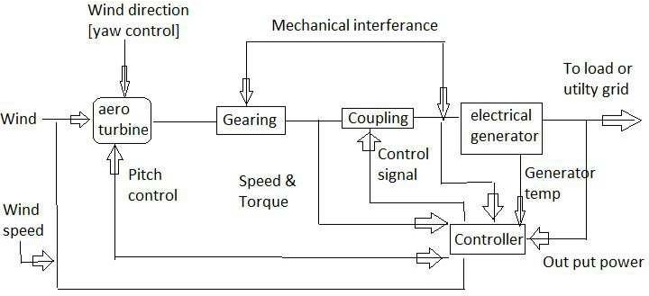

**Fig.9.Basic components of wind electric system**

Applications:

A] Applications require mechanical power

i] Wind power, ii] Heating, iii] Sea transport B] As of grid electrical power source

Types of wind turbines:

1] Horizontal axis wind turbines 2] Vertical axis wind turbines

**BIO MASS:**

 Bio-mass means organic matter.

 *The energy obtained from organic matter, derived from biological organisms (plants & animals)* is known as bio-mass energy.

 The average efficiency of photosynthesis conversion of solar energy into bio mass energy is estimated to be 0.5% - 1.0%.

 To use biomass energy, the initial biomass maybe transformed by chemical or biological processes to produce intermediate bio-fuels such as methane, producer gas, ethanol & charcoal etc.

 It is estimated that the biomass, which is 90% n tress, is equivalent to the proven current extractable fossil fuel reserves in

the world. The dry matter mass of biological material cycling in biosphere is about 250 × 109 tons/Y.

 Animals feed on plants, & plants grow through the photosynthesis process using solar energy. Thus, photosynthesis process is primarily responsible for the generation of bio mass energy.

 In simplest form the reaction is the process of photosynthesis in the presence of solar radiation, can be represented as follows

H2O + CO2 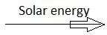 CH2O + O2

 In the reaction, water & carbon dioxide are converted into organic material i.e., CH2O, which is the basic molecule of forming carbohydrate stable at low temperature, it breaks at high temperature, releasing an amount of heat equal to 112,000 Kcal/mole (469 KJ/mole).

 CH2O + O2 CO2 + H2O + 112 Kcal/mole

 The biomass energy is used directly by burning or is further processed to produce more convenient liquid & gaseous fuels.

Bio-mass resources fall into three categories:

1. bio-mass in its traditional sold mass (wood & agricultural residue), & 2] bio-mass in non-traditional form (converted into liquid fuels)
   * The first category is to burn the bio-mass directly & get the energy.
   * In the second category, the bio-mass is converted into ethanol & methanol to be used as liquid fuels in engines.

3] The 3rd category is to ferment the biomass an aerobically to

obtain a gaseous fuel called bio- gas (bio-gas contains 55to 65% Methane, 30-40% CO2 & rest impurities i.e., H2, H2S, & some N2).

**Bio-mass resources include the following:**

1. Concentrated waste- - municipal solids, sewage wood products, industrial waste, and manure of large lots.
2. Dispersed waste residue—crop residue, legging residue, disposed manure. 3] Harvested bio-mass, standby bio-mass, bio-mass energy plantation.

**ADVANTAGES:**

1. It is renewable source.
2. The energy storage is an in-built feature of it.
3. It is an indigenous source requiring little or no foreign exchange.
4. The forestry & agricultural industries that supply feed stocks also provide substantial economic development opportunities in rural areas.
5. The pollutant emissions from combustion of biomass are usually lower than fossil fuels.

**DISADVANTAGES:**

1. It is dispersed & land intensive source. 2] Low energy density

3] Labour intensive & the cost of collecting large quantities for commercial applications are significant.

Bio-mass conversion technologies:

1. Incineration,
2. Thermo-chemical,
3. Bio-chemical

i] Ethanol fermentation, ii] Anaerobic fermentation.

**TIDAL ENERGY:**

The tides in the sea are the result of the universal gravitational effect of heavenly bodies like SUN & MOON on the Earth.

 *Periodic rise & fall of the water level of sea* is called TIDE.

 These tides can be used to produce electrical power which is known as tidal power.

 When the water is above the mean sea level called ***flood tide***.

 When the water is below the mean sea level called ***ebb tide***

**Basic principal of tidal power:**

Tides are produced mainly by the gravitational attraction to the moon & the sun on the water of solid earth & the oceans. About 70% of the tide producing force due to the moon & 30% to the sun. The moon is thus the major factor in the tide formation.

Surface water is pulled away from the earth on the side facing the moon & at the same time the solid earth is pulled away from the water on the opposite side. Thus high tides occur in these two areas with low tides at intermediate points.

As the earth rotates, the position of a given area relative to the moon changes, & so also do the tides.

 The difference between high & low water level is called the range of

the tide.

**Limitations of tidal energy:**

1. Economic recovery of energy from tides is feasible only at those sites where energy is concentrated in the form of tidal range of about 5m or more, & geography provide a favorable site for economic construction of tidal plant, thus it is site specific.
2. Due to mis-match of lunar driven period of 12 hrs 25 min & human (solar) period of 24 hrs, the optimum tidal power generation is not in phase with demand,
3. Changing tidal range in 2 weeks period produces changing power,



1. The turbines are required to operate at variable head.
2. Requirement of large water volume flow at low head necessitates parallel operation of many times &
3. Tidal plant disrupts marine life at the location & can cause potential harm to ecology.

 To hardness the tides, a dam would be built, across the mouth of the bay. It will have large gates in it & also low head hydraulic reversible turbines are installed in it.

The constructed basin is filled during high tide & emptied during low tide passing thorough sluices turbine respectively.

 By using reversible water turbine, turbine can run continuously, both during high & low tide.

 The turbine is coupled to generator, potential energy of the water stored in the basin as well as energy during high tide, is used to drive the turbine, which is couple d to generator, generate electricity.

 Above arrangement of harnessing tidal energy called *single basin plant*. The plant continues generate power till the tide reaches, its lower level.

 By using bypass valve to drain the remaining basin water to sea.  Single basin plant cannot generate power continuously.

 The potential in ocean tides resource is estimated as 550 billion KWh/year [120,000 MW power.]

**WAVES ENERGY:**

* *Waves are caused by the transfer of energy from surface winds to sea*. The rate of energy transfer depends upon the wind speed & the distance over which interacts with water.
* The energy flux in waves is more than that available from solar, wind & other renewable sources. The power in the waves is proportional to the square if its amplitude & to the period of its motion. The energy stored is dissipated through friction at shore & turbulence at rates depending on characteristics of wave & water

depth.

* Wave energy in open oceans is likely to be inaccessible. The resource potential near coastlines is estimated as in excess of 20, 00,000 MW. Wave power is usually expressed in KW/m, repressing the rate at which energy is transferred across a line of 1 m length parallel to the wave front.

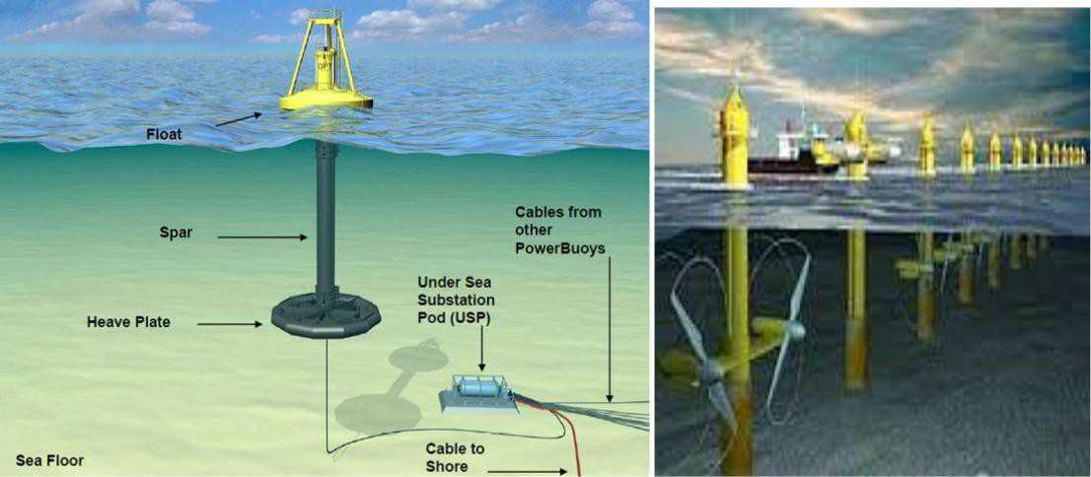

ADVANTAGES:

 The availability of large energy fluxes

 Productivity of wave conditions over periods of days,

DIFFICULTIES:

 Irregularity of wave patterns in amplitude, phase & direction, which makes it difficult to extract power efficiently

 The power extraction system is exposed to occasional extreme stormy conditions.

 Peak power of deep water waves is available in open sea, where is difficult to construct, operate & maintain a system & transmit power to the store,

 The slow & irregular motion of wave is required to be coupled to be electrical generator requiring high & constant speed motion.

**GEOTHERMAL ENERGY:**

 Geothermal energy is energy coming out of the molten interior (in the form of heat) of the earth towards the surface. Volcanoes, Geysers, Hot springs & boiling mud pots are visible evidence of the great reservoirs of heat that lies within the earth.

 Most Geothermal energy produces low grade heat at about 50-70˚c which can be used directly for thermal applications.

 Occasionally, geothermal heat is available at temperature about

90˚c & so electrical power production from turbines can be contemplated.

 Because of non-homogeneous in the earth crust, there are numerous local hot spots just below the surface where the temperature is in fact much higher than the average value expected. Ground water comes into contact with the hot rocks in some of those locations & as a result, dry steam wet & hot water or hot water alone is formed. A well drilled to these locations causes the steam/water to emerge at the surface where its energy can be utilised either for generating electricity or for space heating.



Two ways of electrical power production from geothermal:

* 1. Heat energy is transformed to a working fluid which operates the power cycle. This may be particularly useful at a place of fresh volcanic activity. Where the molten interior mass of earth vents to the surface through fissures & substantially at high temperature, such as between 450 to 550 ˚c can be found. By embedding coil of pipes & sending water through them can be raised.
  2. Hot geothermal water & or steam is used to operate the turbines directly. From the well head of the steam is transmitted by pipe lines up to 1 m in dia over distance up to about 3 Km to the power station. Water separators are usually required to separate the moisture & solid particles from steam.

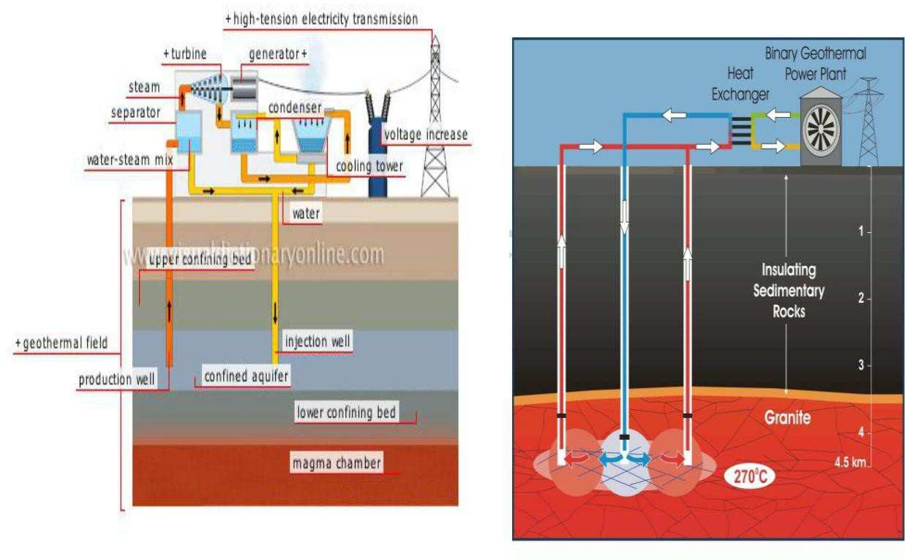

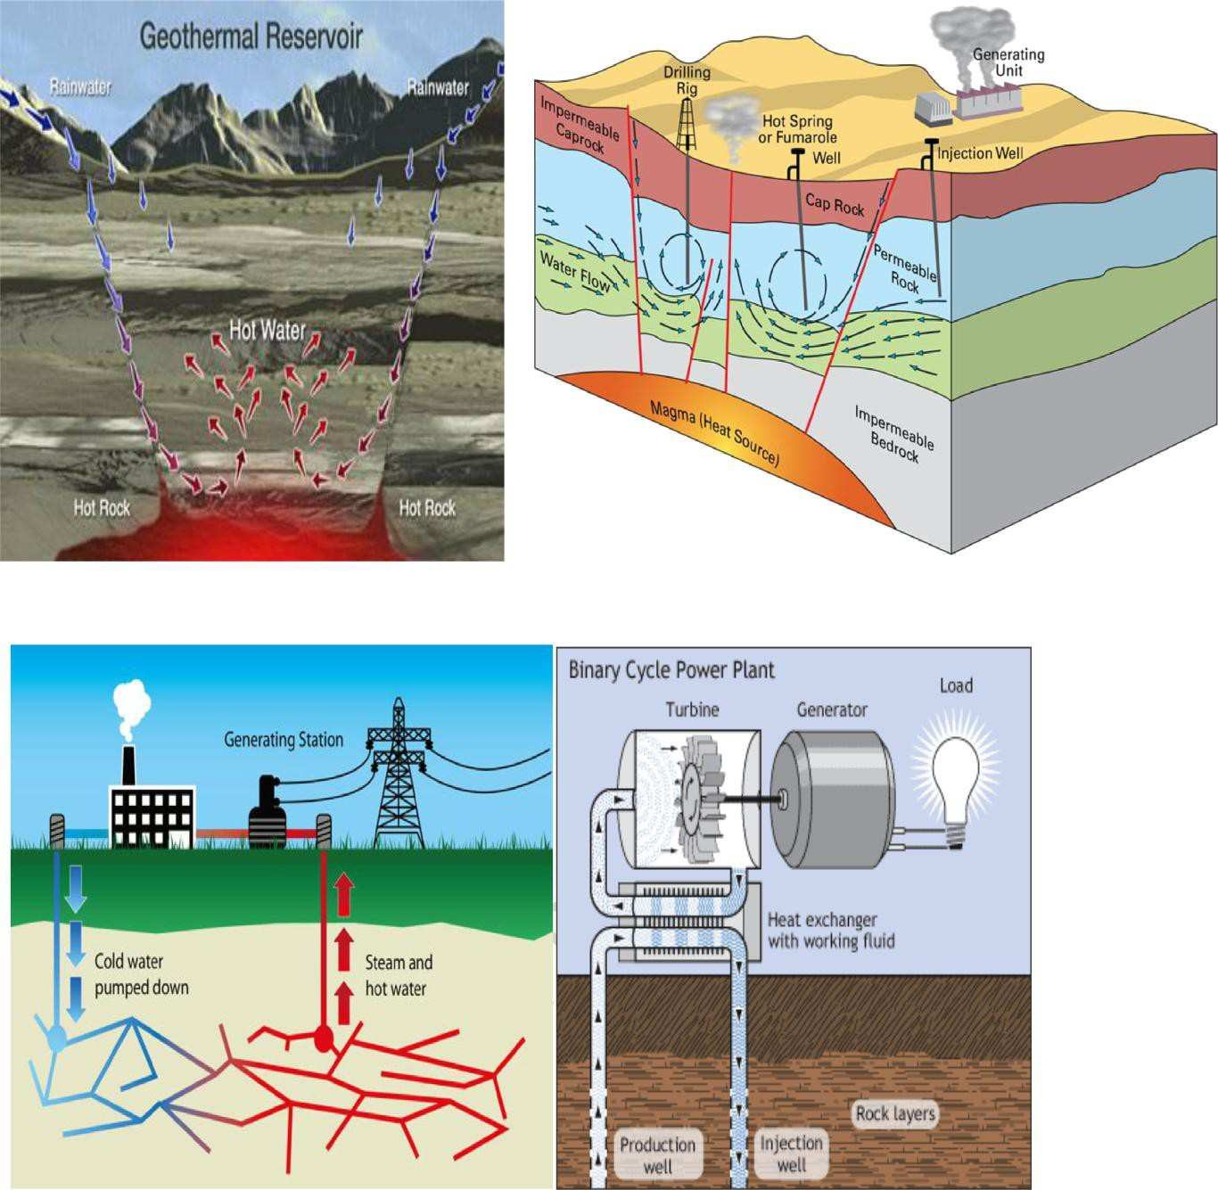

 The earth‘s heat content is about 1031 J. This heat naturally flows to the surface by conduction at a rate of 44.2 Tetra watts.

 The heat inside the earth is intense enough to melt rocks. Those molten rocks are called Magma. Because magma is less dense than the rocks so it rises to the surface. Sometimes magma escapes through cracks in the earth‘s crust, empting out of volcanoes as part of lava.

 But most of the time magma stays beneath the surface, heating surrounding rocks & the water that has become trapped within these rocks. Sometimes that water escapes through cracks in the earth to form pools of hot water [hot springs] or burst of hot water & steam [geysers].

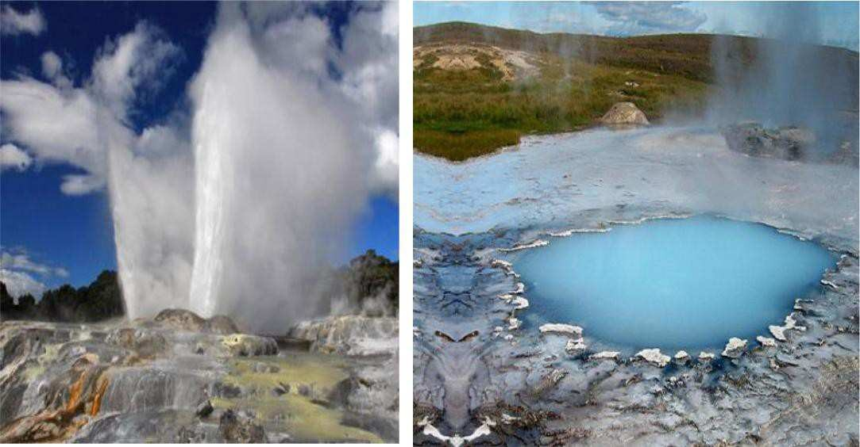

The rest of the heated water remains in pools under the earth‘s surface is called geothermal reservoirs.

**Types of geothermal reservoirs:**

a] Dry steam power plant, b] Flash steam power plant, c] Binary

cycle power plant. ADVANTAGES:

 It is reliable source of energy

 It is available 24 hours/day

 It is available is independent of weather

 It has an inherent storage future, so no extra storage facility is required

 Geo thermal plants require little land area.

DISADVANTAGES:

 Generally, energy is available as low grade heat

 Continuous extraction of heated ground water may leads to subsidence[setting or slumping of land]

 Geo thermal fluid also brings with it the dissolved gases & solute [as high as 25 Kg/m3] which leads to air & land pollution.

 Drilling operation leads to noise pollution

 Thermal energy cannot be distributed easily over long distances [longer than ~30 Km]

 Corrosive & abrasive geo thermal fluid reduces the life of plants.

Applications:

1] Direct heat use, 2] Electric power generation.

**TAR SANDS:**

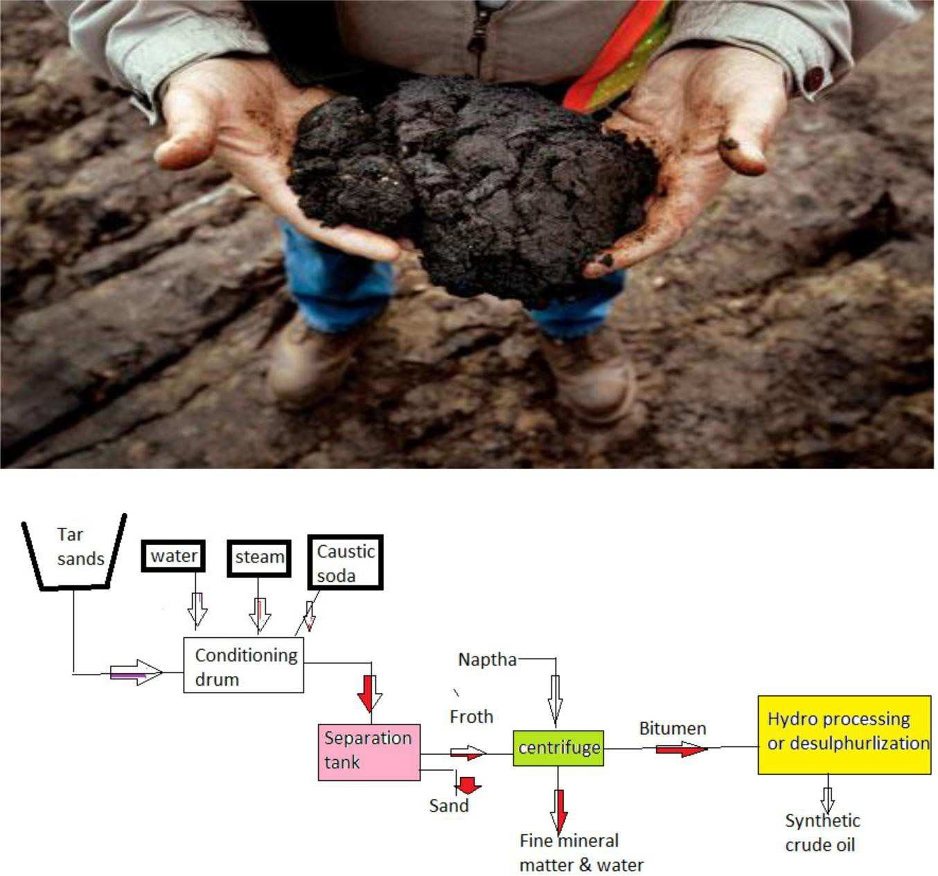

**Fig.10.production of synthetic crude oil from tar sands**

 Tar sand or oil sands is an expression used to describe porous sandstone deposits impregnated with heavy viscous oils called *bitumen or simply deposits of heavy oils*.

 The above schematic diagram indicating the processes involved in producing synthetic crude oil from tar sands made up of sand stone deposits containing bitumen.

 The sands obtained from surface mining are first passed through a conditioning drum where water, steam & *caustic soda* are added & *slurry* is formed. The slurry passes into a separation tank where the coarse sand settles at the bottom & a froth of bitumen, water & fine mineral matter forms on the top.

 The froth is diluted with *naptha* & subjected to *centrifugal action*. As a result, fine mineral matter & water is removed. After this, the naptha is recovered & recycled, & the bitumen obtained is

subjected to hydro processing & desulphurization to produce synthetic crude oil.

**OIL SHALE:**

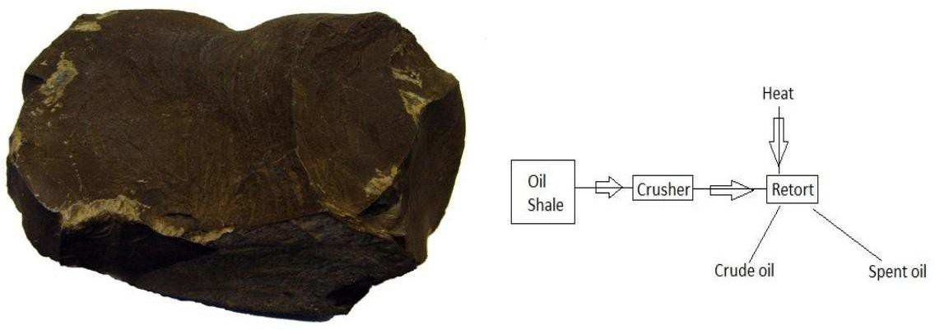

**Fig.11.a. Oil shale Fig.11.b. Production of crude oil from oil shale**

Oil shale [a sedimentary rock] refers to a finely textured rock mixed with a *solid organic material* called *kerogen*. When crushed, it can be burnt directly [like coal] & has a heating value ranging from 2000 to 17,000 KJ/Kg. It is used in this manner for generating electricity & supplying heat.

Alternatively, the oil shale can be converted to oil. This is done by heating crushed oil shale to about 500 ˚c in the absence of air. Under the conditions*, pyrolysis* occurs & the kerogen is converted to oil.

Demerits:

1. The use of oil shale is the environmental degradation associated with surface mining & with the disposal of large amounts of sand & spent shale rock which remains after the crude oil is obtained.
2. A large amount of energy is consumed in producing oil from these sources.

**NUCLEAR POWER:**

Under the nuclear option, the 2 alternatives under study are, 1] the breeder reactor, 2] nuclear fusion

1. The breeder reactor: In order to understand the working of a breeder reactor, it is necessary to understand the fission reactions. Naturally occurring uranium contains 3 isotopes, U234, U235 & U 238. The relative % of these isotopes is U234 – 0.006%, U235- 0.711% & U 238 -99.283% of these isotopes, only U235 undergoes spontaneous fission when subjected to bombardment by slow neutrons. It is in fact that only naturally occurring fissile material.

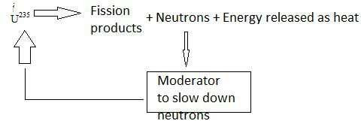

**Fig.12. Fission reaction of U235**

The break-up of U235 when subjected neutrons & the release of a large amount of energy as heat [8.2 ×107 KJ/gm of U235]. The neutrons are slowed down by a moderator, & used to bombard the U235 nucleus again, there by setting up a controlled chain reaction. Although U238 is not a fissile material, it is a fertile material, i.e., it can be converted by neutron bombardment into a fissile material, plutonium-239. Similarly, naturally- occurring thorium-232 is also a fertile material. It can be converted into U233 which is a fissile material.

It will be seen that the neutrons generated by the fission reaction serve two purposes. They help in converting a fertile material to a fissile material & also sustain the fission reaction for the fissile material formed. The above reactions are called *breeder reactions* if they produce more fissile material than they consume & the nuclear reactor in which they are caused to occur is called a *breeder reactor*.

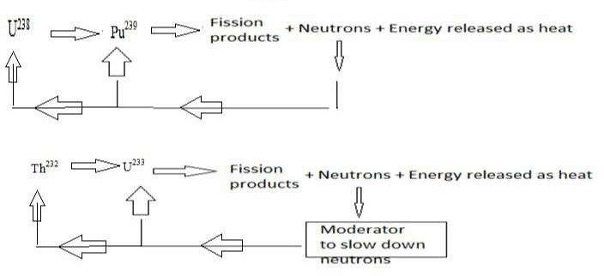Breeding is achieved by having both fissile & fertile materials in the reactor core under conditions which provide enough neutrons to propagate chain reactions in the fissile material as well as to convert more fertile material into fissile material than was originally present.

**Fig.13. Breeder reactor for U238 & Th232**

Reactors working on various breeder cycles have been built. However, the major effort has been on liquid-metal cooled, fast breeder reactors working on the U238 to Pu239 cycle.

**NUCLEAR FUSION:**

In nuclear fusion, energy is released by joining very light atoms. The reactions of interest involve the fusing of the heavy isotopes of hydrogen [deuterium D & tritium T] into the next heavier element, viz, helium. They are as follows.

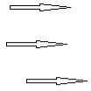D + D T + P + 4.0 MeV [1]

D + D He3 + n + 3.2 MeV [2]

D + T He4 + n + 17.6 MeV [3]

D + He3 He4 + p + 18.3 MeV [4]

6D 2 He4 + 2p + 2n + 43.1 Me



. [5]

Equation [1] & [2] show that 2 nuclei of deuterium can fuse in 2 ways. Both ways are equally probable. In the first, tritium & one proton are formed, while in the second, helium-3& one neutron are formed. The energy released by the fusion reaction is indicated. Tritium is unstable & combines with deuterium to form helium-4& one neutron, Equation [3], while helium-3 combines with deuterium to form helium-4& one proton, Equation [4]. The net result Equation [5], is the addition of all the 4 reactions. It indicates that 6 deuterium nuclei are converted to 2 helium-4 nuclei, 2 protons & 2 neutrons with an energy release of 43.1 MeV.

Deuterium occurs naturally in sea water & it is estimated that the fusion of all the deuterium in just one cubic metre of sea water would yield energy of 12×109 KJ.

The development of nuclear fusion reactor are the attainment of the required high temperature by initially heating the fuel charge & the confinement of the heated fuel for a long enough time for the reaction to become self-sustaining.

The research being conducted to solve these problems is proceeding broadly along 2 conceptual directions- magnetic confinement & laser induced fusion.

In the first concept, the fuel charge [in the form of a charged particle gas composed of positively charged nuclei & free electrons] is contained in a hermetically sealed vacuum chamber & is heated to the required high temperature by passing an electric current through it. At this temperature, the fusion reaction takes place successfully only if the gas is confined within a certain volume for a specified time & not allowed to come into contact with containing chamber‘s walls. This confinement is achieved by the application of a very strong, specially shaped magnetic field.

In the second concept, the fuel charge in the form of very small pellets. These are positioned one by one at a specific location & subjected to intense focused laser beams which heat the pellets to the required temperature & cause fusion to occur. By adopting this method, the confinement time is substantially reduced & the need for a magnetic field is removed.



Department of ME, Page 27



Of the reactions given in equation [1] to [4], the D-T reaction takes place at the lowest temperature; about 107 K. since tritium does not occur naturally, the D-T reaction should be supplemented by one using lithium as follows:

D + T He4 + n + 17.6 MeV [6]



N + Li6 He4 + T + 4.8 MeV [7]

D + Li6 2 He4 + 22.4 MeV [8]

**Solar Radiation Solar Radiation Outside The Earth’s Surface:**

Sun is a large sphere of very hot gases, the heat being generated by various kinds of fusion reactions. It's diameter is 1.39X106km, while that of the

earth is 1.27X104 km. It subtends an angle of 32minutes at the earth's surface. This is because it is also at large distance. Thus the beam radiation received from the sun on the earth is almost parallel. The brightness of the sun varies from it's center to it's edge. However for engineering calculations. It is customary to assume that the brightness all over the solar disc uniform.

**Solar Constant(Isc):**

It is the rate at which energy is received from the sun on a unit area perpendicular to the ray's of the sun , at the mean distance of the earth from the sun. Based on the measurements made up to 1970 a standard value of

1353 W/m2 was adopted in 1971. However based on subsequent measurements, a revised value of 1367 W/m2 has been recommended.

The earth revolves around the sun in an elliptical orbit having a very small eccentricity and the sun at the foci. Consequently, the distance between earth and sun varies a little through the year. Because of this variation, the extra terrestrial flux also varies. The value on any day can be calculated from the equation.

’ = ’ + 0.033 cos 360

**Solar Radiation Received at the Earth’s surface:**

365

Solar radiation received at the earth's surface is in the attenuated form because it is subjected to the mechanisms of absorption and scattering as it passes through the earth's atmosphere (Figure below).

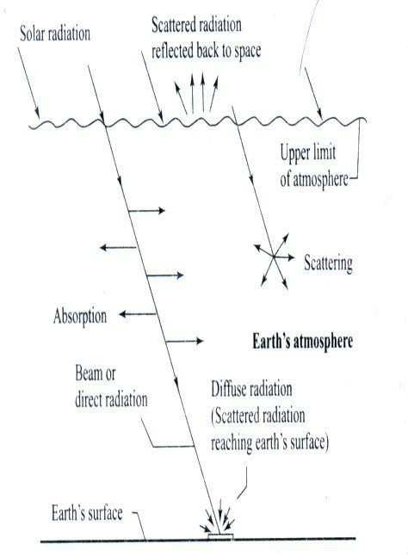

Absorption occurs primarily because of the presence of ozone and water vapour in the atmosphere and lesser extent due to other gases( like CO2,

NO2, CO,O2 and CH4) and particulate matter. It results in an increase in the internal energy of the atmosphere. On the other hand, scattering occurs due to all gaseous molecules as well as particulate matter in the atmosphere. The scattered radiation is redistributed in all directions, some going back to the space and some reaching the earth's surface.

Solar radiation received at the earth's surface without change of direction i.e, in line with the sun is called *direct radiation* or *beam radiation*. The radiation received at the earth's surface from all parts of sky's hemisphere (after being subjected to scattering in the atmosphere) is called *diffuse radiation*. The sum of beam radiation and diffuse radiation is called as *total* or *global radiation*.

**Instruments used for measuring solar radiation: Pyranometer:**

A pyranometer is an instrument which measure's either global or diffuse radiation falling on a horizontal surface over a hemispherical field of view.A sketch of one type of pyranometer as installed for measuring global radiation is shown in the following figure.

bolts,

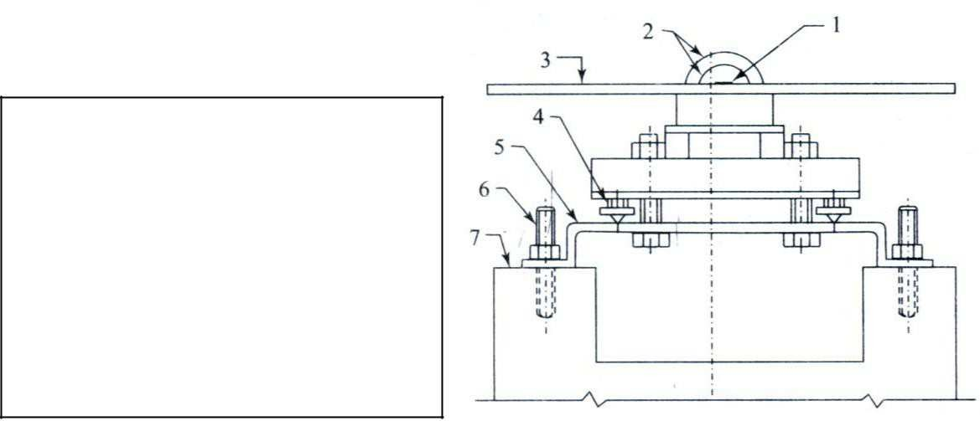

1.Black surface, 2. Glass domes,

3. Guard plate, 4. Levelling screws,

5. mounting plate, 6. Grouted

7. platform.

Pyranometer consists of a black surface which heats up when exposed to solar radiation. It's temperature increases until the rate of heat gain by solar radiation equals the rate of heat loss by convection, conduction and radiation. The hot junctions of thermopile are attached to the black surface, while the cold junctions are located under a guard plate so that they do not receive the radiation directly. As a result an emf is generated. This emf which is usually in the range of 0 to 10mv can be read, recorded or integrated over a period of time and is a measure of global radiation.

The pyranometer can also be used for measurement of diffuse radiation. This is done by mounting it at the center of a semi circular shading ring. The shading ring is fixed in such a way that it's plane is parallel to the plane of path of sun's daily movement across the sky and it shades the thermopile element and two galss domes of pyranometer at all the times from direct sun shine. Consequently the pyranometer measures only the diffuse radiation received from the sky.

**Pyrheliometer:**

This is an instrument which measures beam radiation falling on a surface normal to the sun's rays. In contrast to a pyranometer, the black absorber plate (with hot junctions of a thermopile attached to it) is located at the base of a collimating tube. The tube is aligned with the direction of the sun's rays with the help of a two-axis tracking mechanism and alignment indicator. Thus the black plate receives only beam radiation and a small amount of diffuse radiation falling within the acceptance angle of the instrument.

The Following figure shows a pyrheliometer.



Department of ME, Page 31

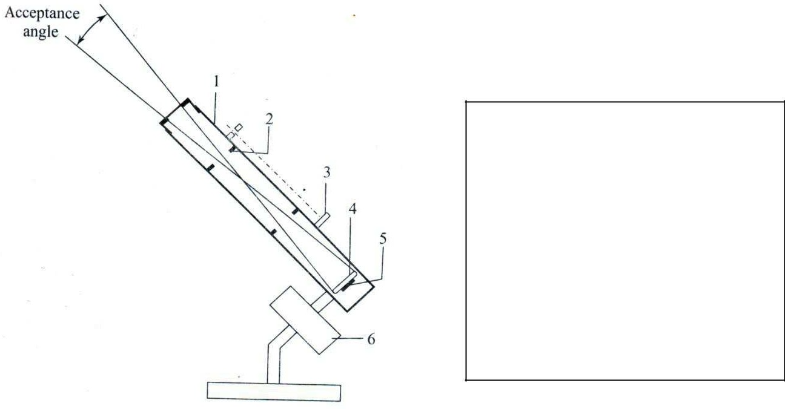

1. tube blackened on inside surface,
2. baffle, 3.Alignment indicator,

4. Black absorber plate 5.thermopile junctions

6.two-axis tracking mechanism

**Solar Radiation Geometry Definations:**

* 1. **Solar altitude angle(a):**

Altitude Angle is the angle between the Sun‘s rays and projection of th*e Sun’s rays* on the horizontal plane

* 1. **Zenith angle(θz):**

It is Complementary angle of Sun‘s Altitude angle

It is a vertical angle between Sun‘s rays and line perpendicular to the horizontal plane through the point i.e. angle between the beam and the vertical Θz=π/2-a

* 1. **Solar Azimuth Angle(γs):**

It is the solar angle in degrees along the horizon east or west of north

or

It is the horizontal angle measured from north to the horizontal projection of sun‘s rays.

* 1. **Declination(δ):**

It is the angle between a line extending from the centre of the Sun and center of the earth and projection of this on earth‘s equatorial plane.

 Declination is the direct consequence of earth‘s tilt and It would vary between

23.5o on June 22 to – 23.5o on December 22. On equinoxes of March21 & Sept22 declination is zero.

The declination is given by the formula



Department of ME, Page 32



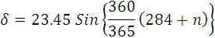

Where n is the day of the year

* 1. **Meridian:**

Meridian is the immaginery line passing through a point or place on earth and north and south poles of the earth‘.

* 1. **hour angle(ω):**

Hour angle is the angle through which the earth must turn to bring meridian of the point directly in line with the sun‘s rays.

Hour angle is equal to 15o per hour.

* 1. **slope(β):**

Angle between the collector surface with the horizantal plane is called slope(β).

* 1. **surface azimuth angle(γ):**

Angle between the normal to the collector and south direction is called surface azimuth angle(γ)

* 1. **Solar Incident angle(θ):**

It is the angle between an incident beam radiation falling on the collector and normal to the plane surface

Figures:

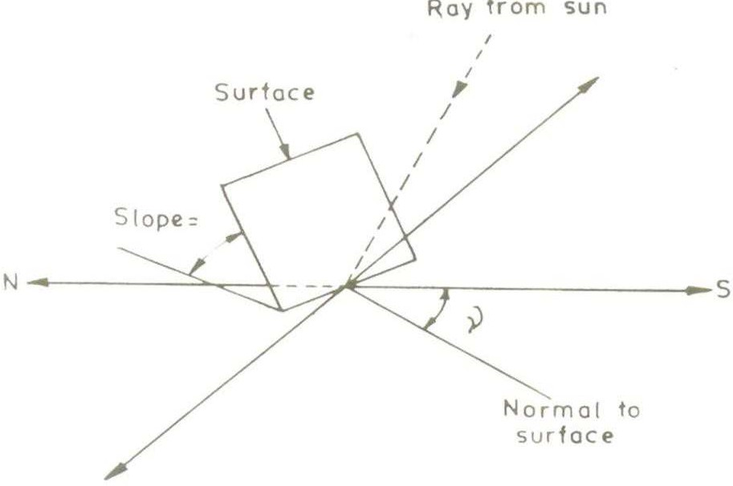



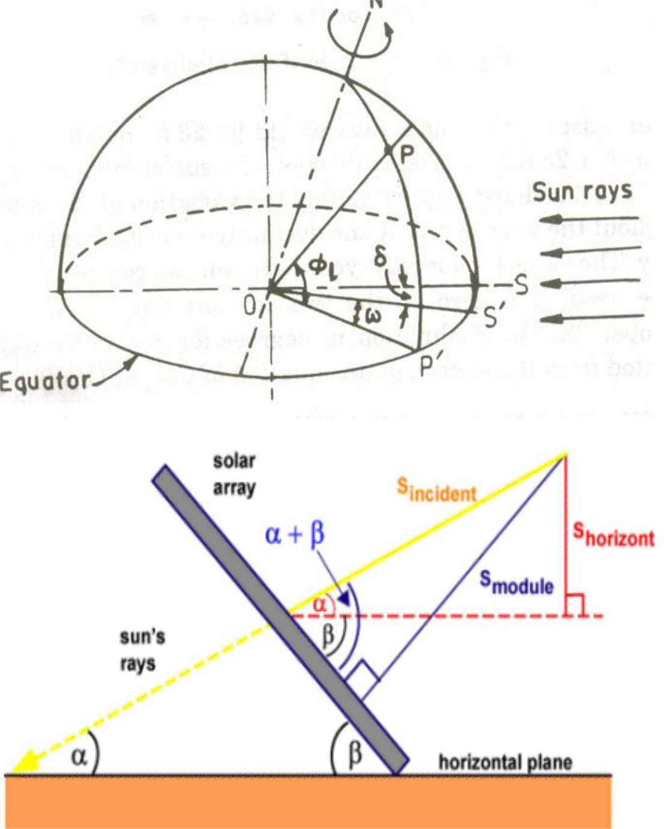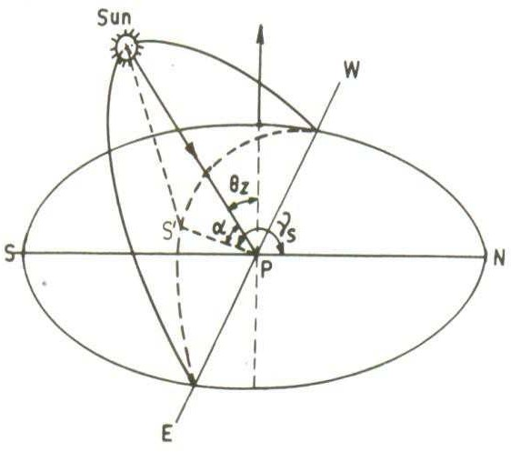he plane surface.

Relation between θ and other angles is as follows

Cosθ=Sin фl(sinδ cosβ+Cosδ cosγ cos ω sin β)+ Cosфl (Cosδ cosω cos β- sinδ cosγ sin β)+ Cosδ sinγ sinωsin β----- Eqn(1)

фl=Latitude( north positive) δ=declination(north positive)

ω=solar hour angle(Positive between midnight and solar noon)

➢

Case1

Vertical Surface:

β=90o Eqn (1) becomes

Cosθ=Sin ф cosδ cosγ cos ω- Cos фsinδ cosγ+ Cosδ sinγ Sinω Eqn(2)

➢

Case2

Horizantal surfaces β=0o Eqn(1) becomes

Cosθ=Sin ф sinδ+cosδ cos ф cosω=sina=cos θz----- Eqn(3)



➢

Case3

Surface facing south γ =0

cos θT=Sin ф (sinδcosβ+ Cosδ cosω sinβ)

=Cos ф(cosδ cosω cosβ-sinδ sinβ)

=Sinδ Sin(ф-β)+Cosδ cosω Cos(ф-β)------ Eqn(4)

➢

Case4

Vertical surfaces facing south(β=90o , γ=0)

cos θz=Sin ф cosδ cos ω- Cos ф Sinδ-------- Eqn(5)

**Day Length:**

At the time of sunset or sunrise the zenith angle θz=90o , we obtain sunrise hour angle as

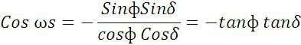

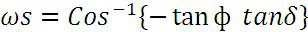

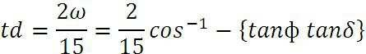Since 150 of the hour angle are equivalent to 1 hour The day length(hrs) is given by

**Local Solar Time(Local Apparent Time (LAT):**

Local Solar Time can be calculated from standard time by applying two corrections. The first correction arises due to the difference in longitude of the location and meridian on which standard time is based. The correction has a magnitude of 4minutes for every degree difference in longitude. Second correction called the equation of time correction is due to the fact that earth‘s orbit and the rate of rotation are subject to small perturbations. This is based on the experimental observations.

Thus,

Local Solar Time=Standard time± 4(Standard time Longitude-Longitude of the location)

+(Equation of time correction)

***Example 1:***

Determine the local solar time and declination at a location latitude 23015‘N, longitude 77030‘E at 12.30 IST on june 19. Equation of Time correction is =

-(1‘01□).

***Solution:***

The Local solar time=IST-(standard time longitude-longitude of location)+ Equation of

time correction.

=12h30‘-4(82030‘-77030‘)-1‘01□

=12h8‘59‘‘

Declination δ can be calculated Cooper‘s Equation i.e,



= 23.45 sin

***Example 2:***

360

365

(284 + 170)

= 23.45 sin 860 = 23.430

Calculate an angle made by beam radiation with normal to a flat plate collector on December 1 at 9.00 A.M, Solar time for a location at 28035‘N. The collector is tilted at an angle of latitude plus 100, with the horizontal and is pointing due south.

***Solution:***

Here γ=0 since collector is pointing due south. For this case we have equation.

cos = Sinδ Sin(ф-β)+Cosδ cosω Cos(ф-β)

Declination δ can be calculated Cooper‘s Equation on December 1st i.e, n=335



= 23.45 sin

360

365

(284 + 335) = –22011‘‘

Hour angle ω corresponding to 9.00hr=450 Hence,

cos = cos 28.580 – 38.580 cos –22.110 cos 450 +

sin –22.110 sin 28.580 – 38.580 =0.7104

= 44.720



**UNIT-2**

**Beam Radiation**

***TILTFACTOR(rb):*** The ratio of beam radiation flux falling on the tilted surface to that of horizontal surface is called the *TILT FACTOR* for beam radiation.

**For case of tilted surface facing due south γ=0**

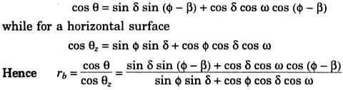

**Diffuse Radiation:**

***TILT FACTOR (rd):***The ratio of diffuse radiation flux falling on the tilted surface to that of horizontal surface is called the *TILT FACTOR* for diffuse radiation.

Its value depends on the distribution of diffuse radiation over the sky and the portion of the sky dome seen by the tilted surface.

Assuming that the sky is an isotropic source of diffuse radiation, for a tilted surface with slope β, we have

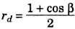

(1+ cosβ)/2 is the shape factor for a tilted surface w.r.t. sky

For Total radiation, let Hb=Hourly beam radiation and Hd=Hourly diffuse radiation. Thus the total beam radiation incident on a tilted surface is given as,

**HT=HbRb+** ( + ) **+** ( + ) ( – ) **p**

ρ = diffuse reflectance which is used to account for the reradiated

**Solar collectors:**

Solar collectors are the devices used to collect solar radiation. Generally there are two types of solar collectors. They are 1) Non-conventional type or Flat plate collector and 2) Concentrating or Focusing collector.

In a non-concentrating type the area of the absorber is equals the area of the collector and since the radiation is not focused, the maximum temp achieved in this type is about 100° C. on the other hand in a concentrating type the area of the absorber is very small (50-100 times) as compared to the collector area. This results in less loss of heat and also since the radiation is focused to a point or a line the maximum temp achieved is about 350°C.

**Principle of solar energy conversion to heat:**

The principle on which the solar energy is converted into heat is the —greenhouse effect□. The name is derived from the first application of green houses in which it is possible to grow vegetation in cold climate through the better utilization of the available sunlight. The solar radiation incident on the earth‘s surface at a particular wavelength increases the surface temp of

the earth. As a result of difference in temp between the earth‘s surface and the surroundings, the absorbed radiation is reradiated back to the atmosphere with its wavelength increased. The Co2 gas in the atmosphere is transparent to the incoming shorter wavelength solar radiation, while it is opaque to the long wavelength reradiated radiation. As a result of this the

long wavelength radiation gets reflected repeatedly between the earth‘s atmosphere and the earth‘s surface resulting in the increase in temp of the earth‘s surface. This is known as the —Green House Effect□. This is the

principle by which solar energy is converted to thermal energy using collector.

In a flat plate collector the absorber plate which is a black metal plate absorbs the radiation incident through the glass covers. The temp of the absorber plate increases and it begins to emit radiation of longer wavelength (IR). This long wavelength radiation is blocked from the glass covers which act like the Co2 layer in the atmosphere. This repeated reflection of radiation between the covers and the absorber plate results in the rise of the temp of the absorber plate.

**Flat plate collector (FPC):**

The schematic diagram of a FPC is as shown in fig. it consists of a casing either made up of wood or plastic having an area of about 2m*1m*15cm. in the casing insulator is provided at the bottom to check conductive heat transfer. Mineral wool, glass wool, fibre glass, asbestos thermocol etc. are used as insulator. Above the insulator the absorber plate is fixed. The absorber plate is made of good conducting material like aluminum or copper. It is coated black to increase its absorption property. Usually the

black coating is done by chemical treatment. Selective coatings which allow for maximum absorption of radiation and minimum amount of emission are applied on to the absorber plate. The underside of the plate consists of absorber tubes which run along the length of the plate. These plates are also made of the same material as that of the absorber plate. Sometimes the plate itself is bent into the form of tubes. Through these tubes the heat absorbing medium (water) is circulated. This medium will absorb the heat from the plates and the tubes and its temp increases. This medium will absorb the heat from the plates and the tubes and its tempincreases. This way solar energy is collected as heat energy. Above the absorber plate glass covers are provided.

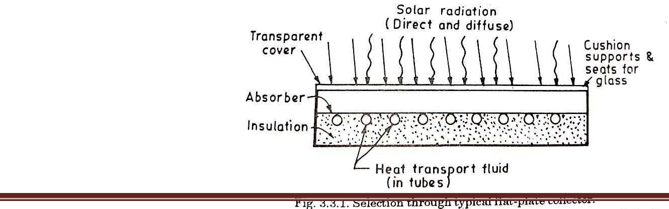

These glass covers help to bring out the greenhouse effect, thus increasing the η of the collector. More than

one cover is used to

Department of ME,

Page 40

prevent the loss of radiation by refraction.

**Energy balance equation and collector efficiency:** The performance of solar collector is described by an energy balance equation that indicates the distribution of incident solar radiation into the useful energy gain and various losses.

The energy balance equation is given as Qu=Ac [HR (τ, a) – UL (tp-ta)]

Where Qu is the useful energy gained by the collector in watts, Ac is the collector area in m2, HR is the solar energy received on the upper surface of the inclined collector, τ is the fraction of incoming radiation that is transmitted through the cover system and is known as transmissivity, a is the fraction of solar energy reaching the surface that is absorbed and is known as absorptivity. (τ,a) is the effective transmittance and absorptance product of cover system for beam and diffuse radiation. UL is the overall

heat transfer coefficient. It is the rate of heat transfer to the surroundings per sq.meter of exposed collector surface per deg C Difference between average collector surface temp and the surrounding air temp in w/m2 C.

tp is the absorber plate temp in °C, ta is the atmospheric temp in °C. Thus the total incident radiation on the collector is QT= AcHR[(τ,a)] The total losses from the collector is AcUL[(tp-ta)]

In order to increase the η of the collector Qu has to be increased. This is done by decreasing the losses as it is not possible to vary the incident radiation.

The losses that occur are

1. **Conduction loss:** This loss is prevented by introducing an insulating material between the absorber plate and the casing where there is contact between the two and also by using a low conducting material like wood or plastic for the casing. Thus the conduction loss is reduced.
2. **Convection loss:** It takes place both from the top and the bottom of the absorber plate. The bottom loss is reduced by providing insulation between the absorber tubes and the base of the casing. The top side loss is prevented by providing glass covers and maintaining the distance between the covers by about 1.25 to 2.5 cm. Also convection loss is prevented by evacuating the top and the bottom side of the absorber plate.
3. **Radiation losses:** It is prevented by applying a selective coating on to the top side of the absorber plate. This coating allows 90% of the radiation to be incident on to the absorber plate while transmissivity of the plate is reduced to only 10%. The usual material used for the coating is —black chromel□. The radiation loss also prevented by treating the underside of the glass covers by coating which are opaque to the reradiated infrared radiations but are transparent to the incident visible radiation. The materials used for this coating are tin oxide or indium oxide.
4. **Reflection and refraction losses:** These losses are prevented by providing more than one glass covers so that the reflected and refracted radiation is incident back on the absorber plate.

Thus the collector efficiency is given as,

η=  =

**Parameters affecting the performance of the FPC:**

1. Selective coating
2. No. of covers
3. Spacing between the covers
4. Tilt of the collector
5. Incident radiation
6. Inlet fluid temperature
7. Dust collection on the cover plate
   1. **Selective coating:** The η of the collector can be maximized by coating the absorber plate by materials which will absorb maximum amount of radiation but emit minimum amount of radiation. Such a coating is known as selective coating. By applying the selective coating on the absorber plate,

input to the collector is maximized while the loss is minimized by this the η

of the collector will improve. The selective coating

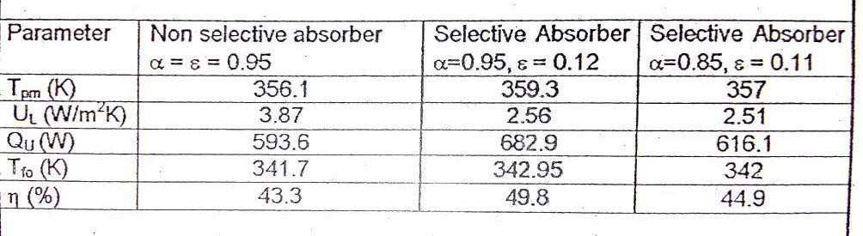

Should have maximum absorptivity for a wavelength of less than 4µm, because the incident radiation will be having a wavelength less than 4µm. Similarly the coating should have minimum transmissivity for λ greater than 4µm, because the radiation emitted from the absorber plate will be having a λ of greater than 4µm.

The effect of selective coating on the performance of the collector is studied with the help of following data.

From the above data it is seen that the η of the collector having a non-

selective absorber is minimum because of the maximum loss. As the loss increases, the useful heat gain decreases resulting in decreased η. A collector having a selective absorber coating will have less loss and more useful heat gain because of its improved absorptivity and reduced emissivity. As result of this the useful heat gain will increase resulting in the increased η of the collector.

The commercially used selective coating are copper oxide on copper (a=0.89, ε=0.17) nickel black on galvanized iron (a=0.868, ε=0.088).

*Desirable properties of selective coatings:* The selective coatings should withstand the continuous exposed to high temperature without losing the absorbing and emitting characteristics. These should be less expensive. These coatings should not get corroded or eroded by the atmosphere.

* 1. **Effect of no. of covers:** The effect of no. of covers is well understood by studying the foll. data

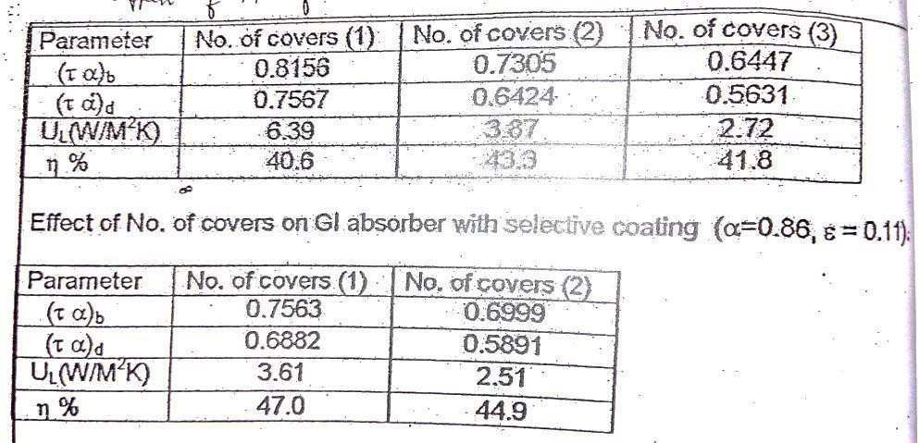

In a FPC normally one or two glass covers are used to prevent convective, reflective and refractive losses. The effect of no. of covers on the performance is studied with the help of above data.

From the above data it is seen that for two covers the η will increase while it decreases when a third cover is added. The increase in η is due to the decrease in the overall heat loss coefficient.

The decrease in η when the third cover is added is due to decrease in (τ a) product which decreases the available incident radiation. This decrease in

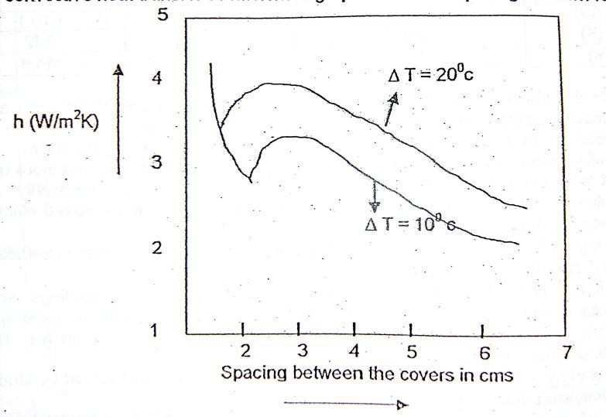input affects decrease in loss coefficient resulting in the decreased η. When the selective coating is used with only one cover, the η achieved is maximum. When a second cover is added the (τ a) product decreases resulting in the decrease in input energy thus reducing the η.

* 1. **Spac****ing between the covers:**Since convective heat transfer is proportional to the convective heat transfer

coefficient, a graph of Oh‘ versus the spacing is drawn for two temperature difference of 10 and 20°C as shown in the fig. (The temp difference is between the absorber plate and the ambient air). The objective here is to decrease the heat loss or to decrease the Oh‘-loss.

From the graph it is seen that Oh‘ decreases continuously upto about 2cm spacing and then increases with the spacing, reaches a maximum continuously decreases their after. From the above graph it is observed that minimum value of Oh‘ is achieved with spacing 0-2cm and 5- 7cm. When the spacing 5-7cm is provided it results in shadowing of the absorber plate which in turn reduces the input, hence reducing the η of the collector. Thus the best spacing for minimum heat loss is about 2cm.

* 1. **Tilt of the collector:** The collector is tilted in order to improve its η. The η is improved by increase in the amount of solar radiation that is absorbed by the collector. A graph of insolation versus latitude for different tilt angles [S] is as shown in the fig. from the

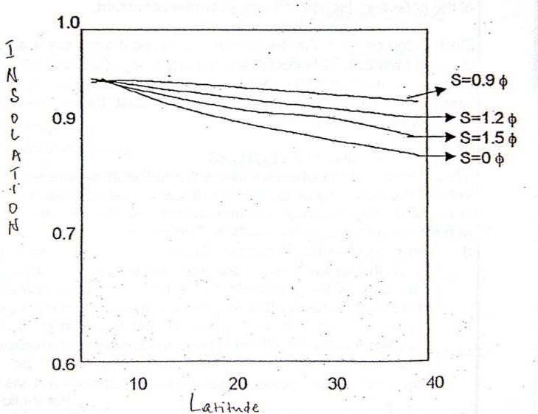graph it is observed when Os‘ is

0.9 times the latitude, the solar insolation absorbed is maximum. Hence the best tilt for maximum

η of the collector is equal to the latitude of the place.

* 1. **Fluid inlet temperature:** The foll. Graph suggests the variation of η wrt inlet fluid temp. From

the graph it is observed that the η will decrease with the increase in inlet temp. This is because, as the inlet temp of the fluid increases the loss from the collector increases due to increase in the temp diff between the collector and the atmosphere. This increase in loss decreases the output resulting in reduced η.

* 1. Incident solar flux: As seen from the graph, the η of the collector increases with the incident flux to certain extent after which the η ceases to increase.

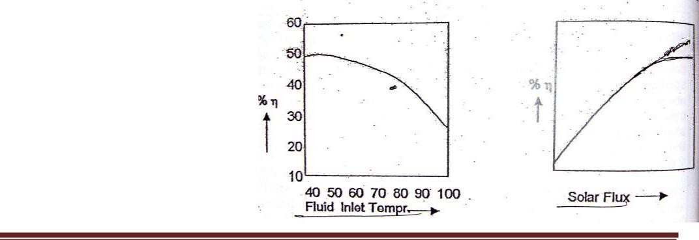

This is because at this instant the loss from the collector equals the gain of the collector. Hence η remains constant.

Department of ME, Page 45

* 1. Dust on top cover: The dust accumulation on the top cover acts as an insulator for incident radiation. This decreases the η of the collector. In order to take care of this correction factor ranging from 0.92 to 0.99 is used. The selection of which depends on the location, the density of the dust, the collector orientation, cleaning frequency, and the season.

**Concentrating collectors:** These are the solar collectors where the radiation is focused either to a point (focal point of the collector) or along a line (focal axis of the collector). Since the radiation is focused, the η of

concentrating collector is always greater than that of non-focusing or FPC. This is because of the following reasons,

1. In case of focusing collector the area of the absorber is many times smaller than that of the area of the collector. Where as in a non-concentrating type the area of the absorber equals area of the collector. Hence here the loss of absorbed radiation is more compared to the concentrating type.
2. In a concentrating collector since the radiation is focused, its intensity is always greater than that in the non-focusing type. Because of these reasons
3. the concentrating collectors are always used for high temp applications like power generation and industrial process heating.

**Classification of concentrating collectors:**

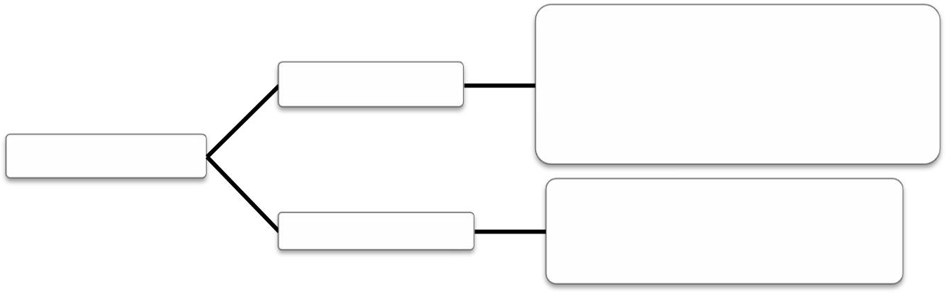

1. Parabolic trough collector
2. cylindrical parabolic

Line focusing

3) Mirror strip collector

Focusing type

4) Fresnal lense collector

1) Parabolidal collector

Point focusing

2)central tower concept

Non-focusing type

Mirror boosting collector

Compound parabolic concentrator



Department of ME, Page 46

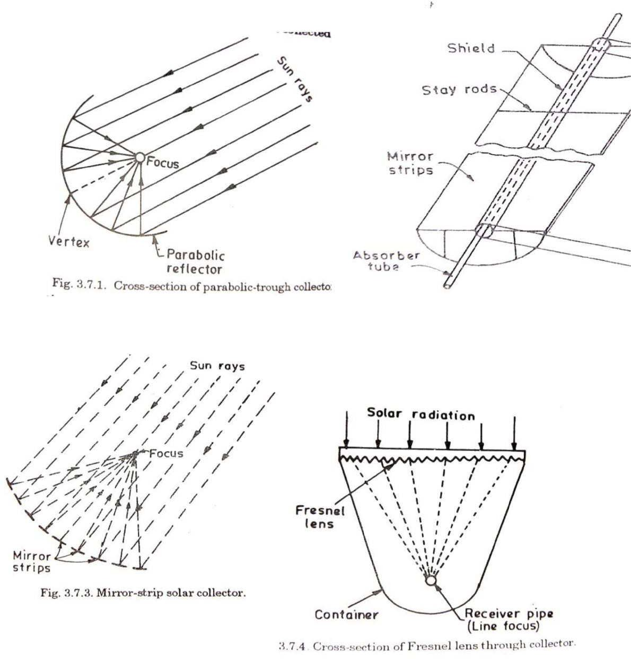

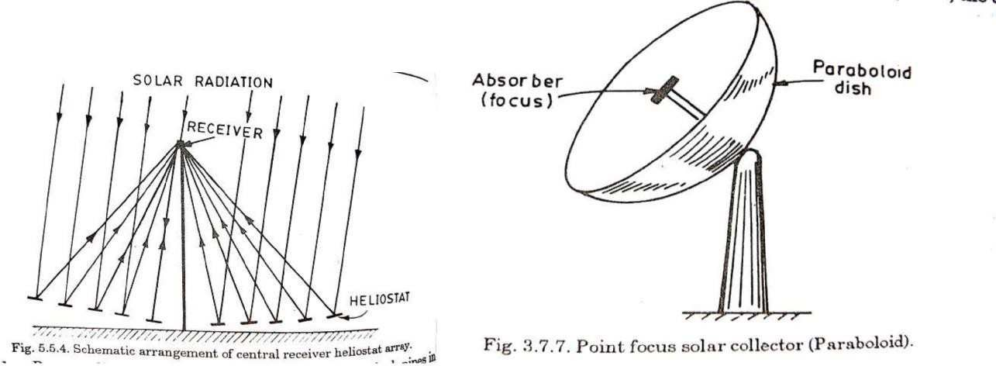



Department of ME, Page 47

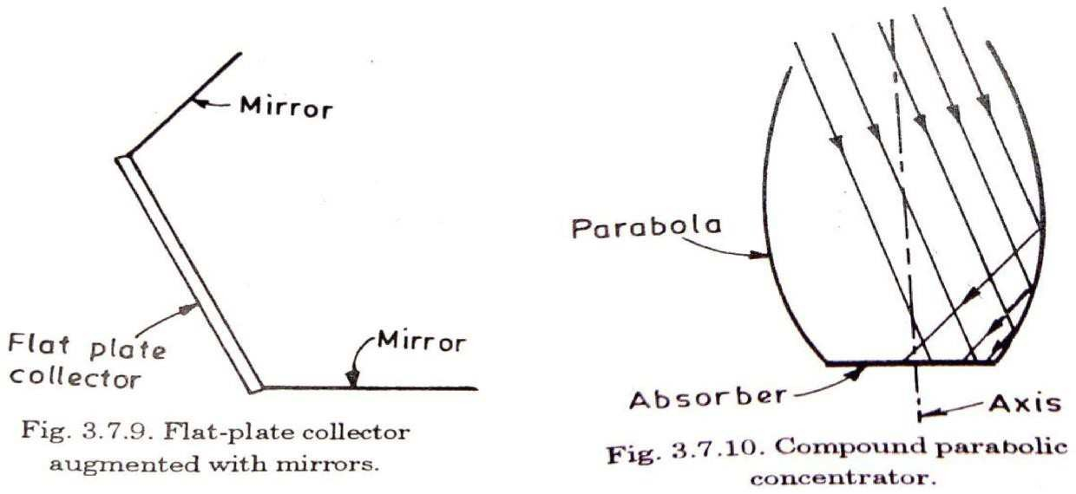

**Compound Parabolic Concentrator (CPC):**

Compound Parabolic Concentrator consists of two parabolic mirror segments, attached to a flat receiver. The segments are oriented such that the focus of one is located at the bottom end point of the other in contact with the receiver. It has a large acceptance angle and needs to be adjusted intermittently. Rays in the central region of the aperture reach the absorber directly whereas, those near the edges undergo one or more reflections before reaching the absorber. The concentration ratio achieved from this collector is in the range of 3-7.

**Cylindrical Parabolic Concentrator:**

It consists of a cylindrical parabolic through reflector and a metal tube receiver at its focal line as shown in figure above. The receiver tube is blackened at the outside surface to increase absorption. It is rotated about one axis to track the sun. The heat transfer fluid flows through the receiver tube, carrying the thermal energy to the next stage of the system. This type of collector may be oriented in any one of the three directions: East-West, North-South or polar. The polar configuration intercepts more solar radiation per unit area as compared to other modes and thus gives best performance. The concentration ratio in the range of 5-30 may be achieved from these collectors.

**Fixed Mirror Solar Concentrator:**

Due to practical difficulty in manufacturing a large mirror in a single piece in cylindrical parabolic shape, long narrow mirror strips are used in this

concentrator. The concentrator consists of fixed mirror strips arranged on a circular reference cylinder with a tracking receiver tube as shown in Figure above. The receiver tube is made to rotate about the center of curvature of reflector module to track the sun. The image width at the absorber is ideally the same as the projected width of a mirror element; the concentration ratio is approximately the same as the number of mirror strips.

**Linear Fresnel Lens Collector:**

In this collector a Fresnel lens, which consists of fine, linear grooves on the surface of refracting material (generally optical quality plastic) on one side and flat on the other side, is used. The angle of each groove is designed to make the optical behavior similar to a spherical lens. The beam radiation, which is incident normally, converges on focal line, where a receiver tube is provided to absorb the radiation. A concentration ratio of 10-30 may be realized which yields temperatures between 150-3000C.

**Paraboloidal Dish Collector:**

When a parabola is rotated about its optical axis a paraboloidal surface is

produced. Above figure shows the details of this type of collector. Beam radiation is focused at a point in the paraboloid. This requires two axis tracking. It can have concentration ratio ranging from 10 to few thousands and can yield temperature up to 3000oC. Paraboloidal dish collectors of 6-7m in diameter are commercially manufactured.

**Hemispherical Bowl Mirror Concentrator:**

It consists of hemispherical fixed mirror, a tracking absorber and supporting structure, as shown in Figure. All rays entering the hemisphere after reflection cross the paraxial line at some point between the focus and the mirror surface. Therefore, a linear absorber pivoted about the center of curvature of the hemisphere intercepts all reflected rays. The absorber is to be moved so that its axis is always aligned with solar rays passing through the center of the sphere. This requires two-axis tracking. The absorber is either driven around a polar axis at a constant angular speed of 15 degrees/hour or adjusted periodically during the day. This type of concentrator gives lesser concentration, owing to spherical aberration, than that obtained in paraboloidal concentrator.

**Central Tower Receiver:**

In central tower receiver collector, the receiver is located at the top of a tower. Beam radiation is reflected on it from a large number of independently controlled; almost flat mirrors, known as heliostats, spread over a large area on the ground, surrounding the tower. Thousands of such heliostats track the sun to direct the beam radiation on the receiver from all sides. The heliostats, together act like a dilute paraboloid of very big size. Concentration ratio of as high value as 3,000 can be obtained. The absorbed energy can be extracted from the receiver and delivered at a temperature and pressure suitable for driving turbines for power generation. The schematic view of central tower receiver is shown in figure above.

**Applications of solar Energy:**

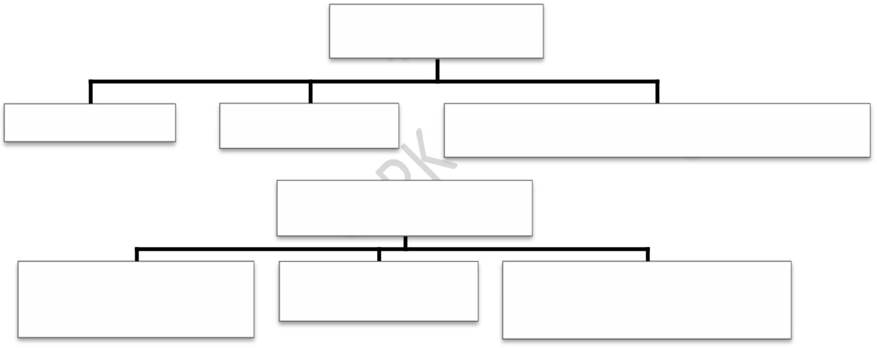

Direct thermal application

Water heating

Space heating

Agriculture and Industrial process heating

Electrical Power generation

Generation with hot

working fluid

Generation with

Photovoltaics

Wind, OTEC, Tidal,

Geothermal, Hydel etc

Biomass and Biogas generation (Fossil fuels)

**Thermal applications:**

1. Water heating
2. Space heating or cooling
3. Process heating
4. Refrigeration
5. Distillation
6. Furnace heating
7. Electric power generation
8. Cooking
9. Pumping

***WATER HEATING SOLAR SYSTEM***

**NATURAL CIRCULATION SOLAR WATER HEATER (PRESSURIZED):**

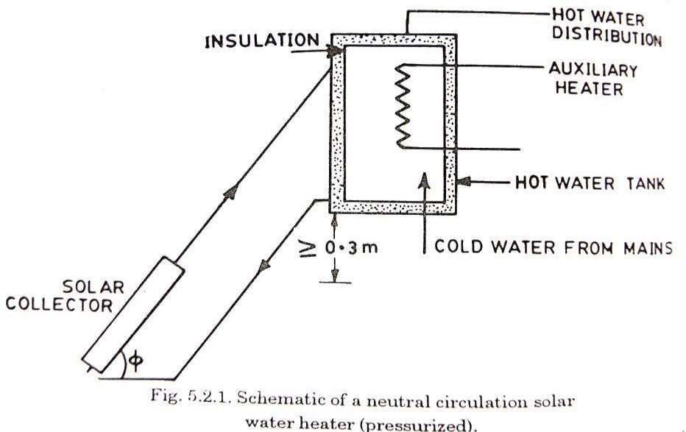

A natural circulation system is shown in Fig. 5.2.1. It consists of a titled collector with transparent cover glasses, a separate highly insulated water storage tank, and well insulated pipes connecting the two. The bottom of the

tank is at least 1ft the top of the collector, and no auxiliary energy is required to circulate water through it. The density difference between the hot and cold water thus provides the driving force for the circulation of water through the collector and the storage tank. Hot water is drawn off from the top of the tank as required and is replaced by cold water from the service system. As long as the sun shines the water will quietly circulate, getting warmer. After sunset, a thermosiphon system can reverse its flow direction and loss heat to the environment during the night. The thermosiphon system is one of the least expensive solar hot-water systems and should be used whenever possible.

Thermosiphon solar water heaters are passive systems and do not require a mechanical pump to circulate the water. Such heaters can be used extensively in rural areas, where electricity is expensive and there is little danger of freezing.

**NATURAL CIRCULATION SOLAR WATER HEATER (NON-PRESSURIZED):**

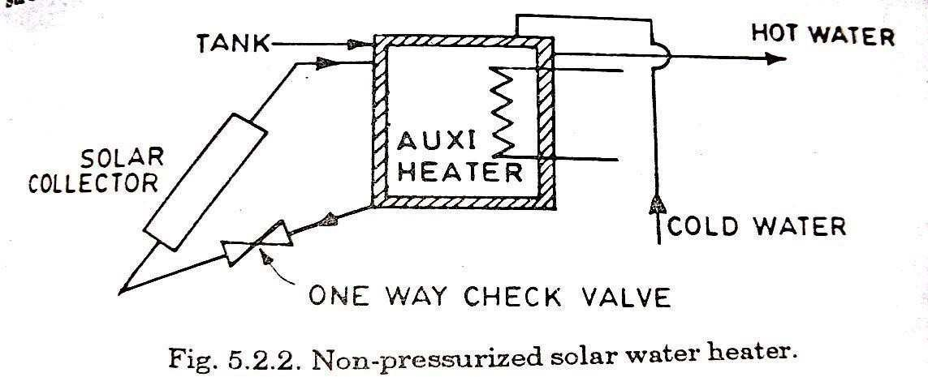

The pressurized system is able to supply hot water at locations of the storage tank. This creates considerable stress on the water channels in the collector which must be designed accordingly. The non-pressurized systems supply hot water by gravity flow only to users lower than tank. If pressurized hot water is required (for showers, or appliances) the difference in height will have to be large enough to meet the requirements. If the height

of difference cannot be accommodated, the only solution is to install a separate pump and pressure tank. The stresses within non-pressurized system are lower which allows cheaper and easier construction. In this type also mechanical pump is not required as shown in Fig.5.2.2, however, a oneway check valve may be desirable to prevent reverse circulation and thus loss of heat at night. A typical system for domestic water heating is shown in Fig.5.2.3.

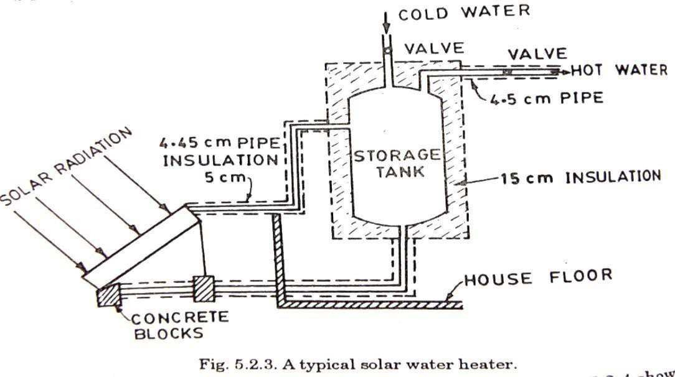



**FORCED CIRCULATION SOLAR WATER HEATER (WITHOUT**

**ANTIFREEZE):**

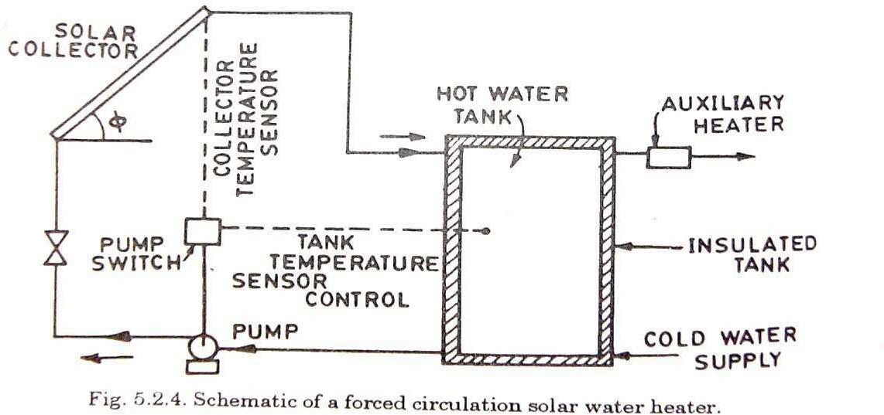

Fig.5.2.4 shows schematically an example of forced circulation system. By including an electric pump in the return circuit between the bottom of the storage tank and the lower header of the collector, the tank can be placed at a more convenient level (e.g. in the house basement). This is now an active system. A control unit permits the pump to operate only when the temperature of the water at the bottom of the tank is below that of the water in the upper header.

A check valve is needed to prevent reverse circulation and resultant night time thermal losses from the collector. In this example, auxiliary heater is shown as provided to the water leaving the tank and going to the load.

When there is a danger of freezing, the water may be drained from the collector; alternately, a slow reverse flow of the warmer water may be permitted through the collector on cold nights. The freezing danger can be overcome, although at some increase in cost, by using an antifreeze solution as the heat-transport medium, as described earlier. The heat is then transferred to water in the storage tank by way of a heat exchanger coil.

**FORCED CIRCULATION SOLAR WATER HEATER (WITH ANTIFREEZE):**

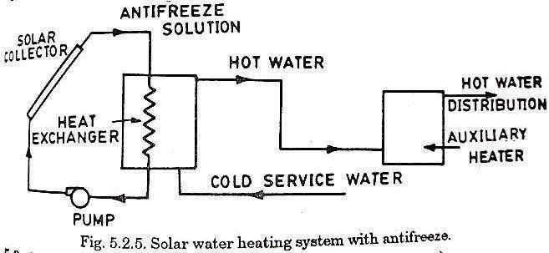

**SPACE-HEATING:**

**SOLAR HEATING OF BUILDING:**

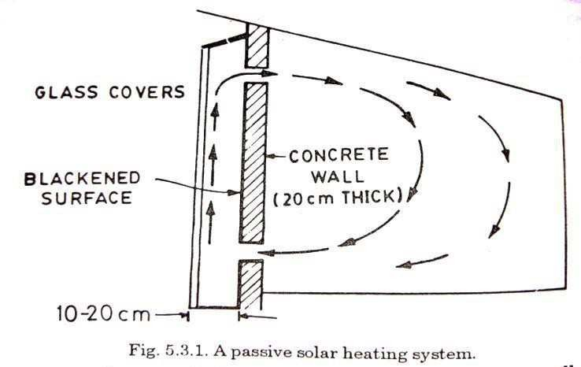

A sunspace is any enclosed space, such as a green house or sun porch, with a glass wall on the south side. A sunspace may be attached (or built on) to a thick south wall of the building to be heated by the sun. Vents near the top and bottom of the wall, as in Fig. 5.3.1, permit circulation through the main building of the heated in the sunspace. Heat storage is provided by the thick wall, a concrete or masonry floor, water containers, and other materials in the sunspace. Thus, an attached sunspace system combines features of direct gain and storage wall concepts.



**ROOF STORAGE OF SOLAR HEAT:**

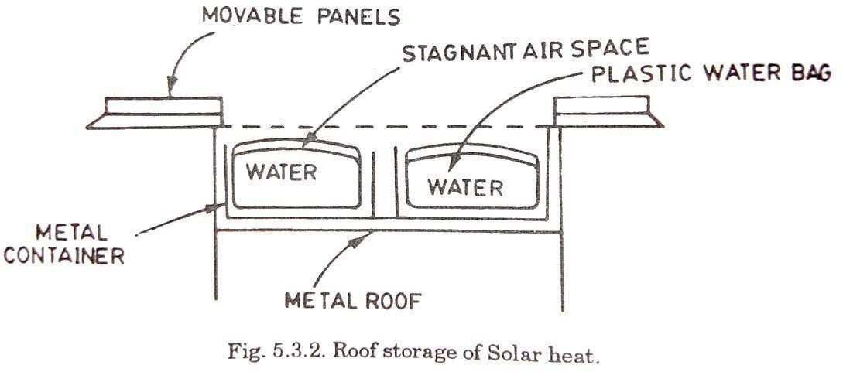

A passive solar system, trade named sky therm, was designed for house having a flat roof located in a mild climate. The heat is absorbed and stored in water about 0.25 m deep contained in plastic bags held in blackened steel boxes on the house roof. In a later design, a layer of clear plastic sealed to the top of the bag provides a stagnant airspace to reduce heat losses to the atmosphere.

Heat is transferred from the heated water to the rooms below by conduction through

a metal ceiling. Air circulation may be aided by means of electric fans, but this is not essential. To prevent loss of heat during the night, thermal insulator panels are moved, either manually or by a time controlled electric motor, to cover the water bags. In the day time, the panels, which are in sections, are removed and stacked one above the other.

**CONVECTIVE LOOP PASSIVE SOLAR HEATING:**

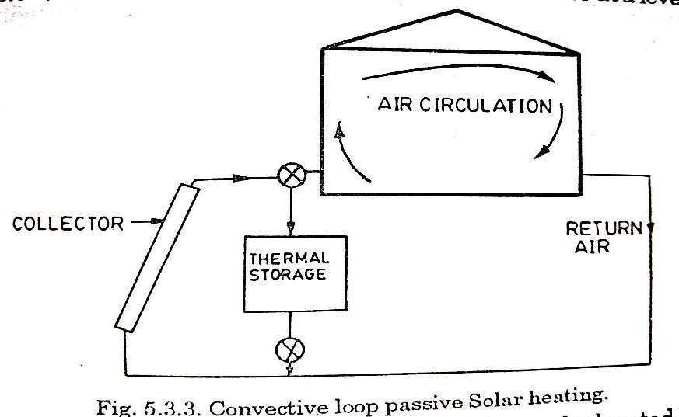

In most passive solar space heating systems, the heated air is circulated by convection, but the term convective loop is applied to systems that resemble the thermosiphon hot-water scheme described earlier. Such a convective loop heating system is outlined in Fig.5.3.3. It includes a convectional flat-plate collector at a level below that of the main structure. A bed of rock, which may be located beneath a sunspace, provides thermal storage. In normal operation, air passing upward through the collector is heated and enters the building through floor vents. The cool, denser air leaving the building returns to the bottom of the collector and is reheated. If more solar heat is available than is required for space heating, the floor vents may be partly closed. The heated air then flows through and deposits heat in the storage bed. Heat stored in this way may be used later, as needed, by transfer to the cooler air leaving the building.

**BASIC HOT WATER ACTIVE SYSTEM:**

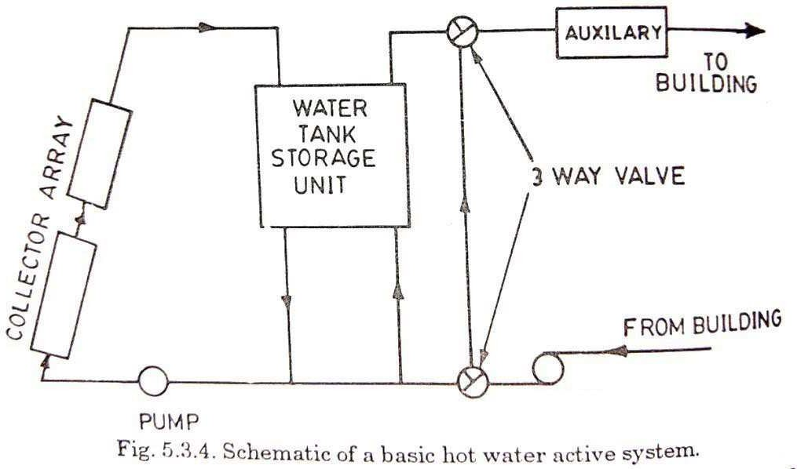

BLOWER

An outline of an active heating system with a sloping flat plate collected located on the roof of the building is given in Fig.5.3.4. This is a basic hot water heating system, with water tank storage and auxiliary energy source. Heat is transferred to the water in the storage tank, commonly located in the basement of the building. The solar heated water from the tank passes through an auxiliary heater, which comes on automatically when the water temperature falls below a prescribed level. For space heating, the water may

be pumped through radiators or it may be used to heat air in a water to air heat exchanger. During normal operation, the three way valves are set to permit solar heated water to flow from the storage tank and auxiliary heater to the distribution system and back to the tank. If after several cloudy days, the heat in storage is depleted, the valves will adjust automatically to bypass the storage tank. In this way, auxiliary heating of the large volume of water in the tank is prevented. If the temperature in the heater at the top of the collector should fall below that at the bottom of the tank, the pump would be switched off automatically.

If in this system, the heat transport medium is an antifreeze solution, then there is a closed circuit of it, with the heat exchanger coil in the storage tank. This type of solar space heating system with hot water system is shown in Fig.5.3.5.

**BASIC HOT WATER ACTIVE SYSTEM (WITH ANTIFREEZE):**

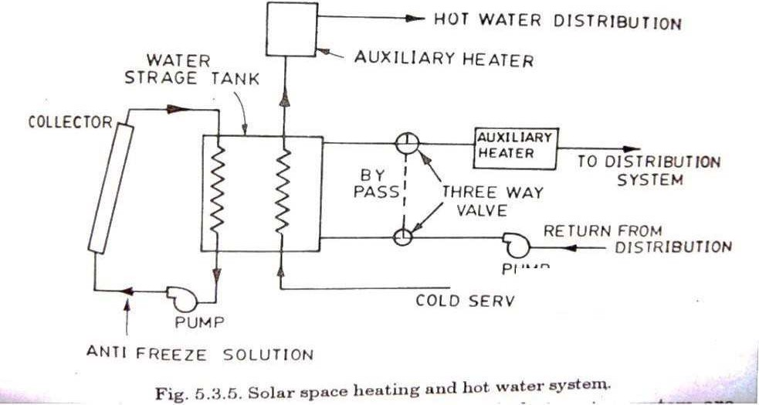

BLOWER

Advantages and disadvantages of basic hot water system are listed below:

**Advantages:**

* 1. In case of water heating, a common heat transfer and storage medium, water is used, this avoids temperature drop during transfer of energy into and out of the storage.
  2. It requires relatively smaller storage volume.
  3. It can be easily adopted to supply of energy to absorption air conditioners, and
  4. Relatively low energy requirements for pumping of the heat transfer fluid.

**Disadvantages:**

1. Solar water heating system will probably operate at lower water temperature than conventional water systems and thus require additional heat transfer area or equivalent means to transfer heat into building.
2. Water heaters may also operate at excessively high temperature (particularly in spring and fall) and means must be provided to remove energy and avoid boiling and pressure build up.
3. Collector storage has to be designed for overheating during the period of no energy level.
4. Care has to be taken to avoid corrosion problems.

**BASIC HOT AIR SYSTEM:**

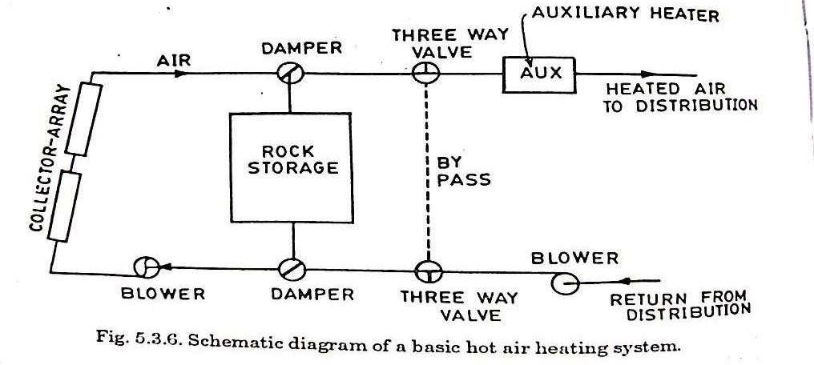

Schematic diagram of a basic hot air heating system is shown in Fig.5.3.6. In this system the storage medium is held in the storage unit, while air is the fluid used to transport energy from collector to the storage and to the building. By adjusting the dampers, the heated air from the collector can be divided between rock storage and the distribution system, as might be required by the conditions. For example, when the sun shines after several cloudy days it would be desirable to utilize the available heat directly in the distribution system rather than placing it in storage. Two three way valves

can be used to bypass the storage tank, as explained above. An auxiliary source of heating is also provided. Auxiliary heating can be used to augment the energy supply to the building from the collector or storage if the supply of heat from it is inadequate.

The position of the blower in figure is shown at the upstream of the collector and the storage, and it forces the air through these for heating. In this case slight leakage of heated air will take place. Blower can also be placed on the downstream side of the collector and storage, so that the pressure in the collector is not above ambient pressure, which might be advantageous in controlling leakage.

**SOLAR SPACE COOLING OF BUILDINGS:VAPOUR ABSORPTION AIR COOLING (LiBr-H2O SYSTEM85 to 95°C with FPC /NH3-H2O COOLER 120 to**

**130°C with concentrating collectors):**

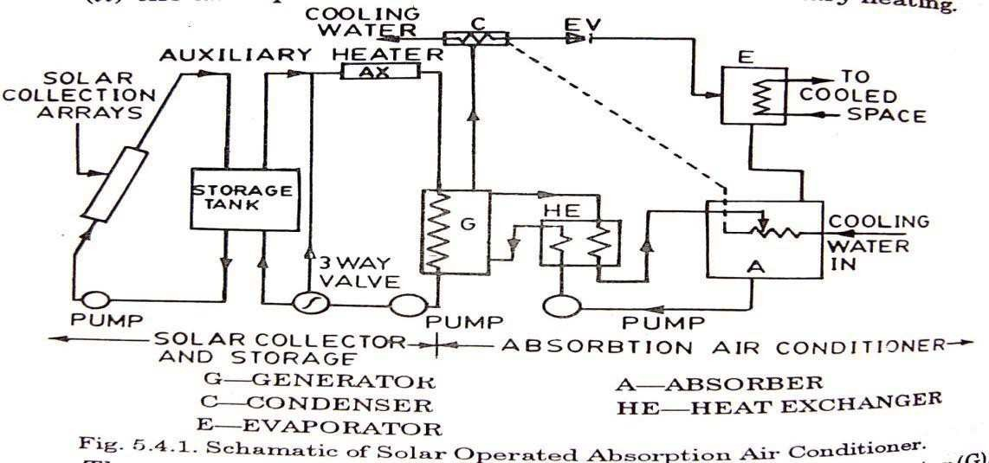

The absorption air conditioning system is shown schematically in Fig.5.4.1. The system consists of two parts

1. The solar collector and storage, and
2. The absorption air conditioner and the auxiliary heating.

The essential components of the cooler are (i) generator (G), (ii) condenser (C), (iii) evaporator (E), (iv) absorber (A), (v) heat-exchanger (HE).

The operation of air conditioners with energy from flat-plate collector and storage systems is the most common approach to the solar cooling today. In



Department of ME, Page 59

essence cooling is accomplished as the generator of the absorption cooler is supplied with heat by a fluid pumped from the collector storage system or from auxiliary. Heat is supplied to a solution of refrigerant in absorbent in the generator, where refrigerant is distilled out of the absorbent fluid. The refrigerant is condensed and goes through a pressure reducing valve to the evaporator where it operates and cools air or water for the cooling space. The refrigerant vapor goes to the absorber where it comes in contact with the solution which is weak in refrigerant and which flows from the generator. The vapor is absorbed in the solution, which is then returned to the generator. A heat exchanger is used for sensible heat recovery and greatly improves cooler C.O.P.

From the point of view of use of a conventional energy source, there is a single index of performance for rating cooling processes, that is the COP, the ratio of the amount of cooling to the energy required. For solar operation there are two additional factors, the temperature required in the solar collector to drive the process and the ratio of cooling produced to solar energy incident on the collector. As solar processes are inevitably transient in their operation, the energy ratios and temperatures will vary with time and COP based on long term integrated performance provides an appropriate index of performance. Pumping to more absorbent solution may be by mechanical means or by vapor-lift pumping in the generator for low pressure systems like LiBr-H2O system require water cooling of absorber and condenser. Systems of this type shown in the figure have been the basis of most of the experience to date with solar air conditioning.

The coolers used in most experiments todate are LiBr-H2O machines water-cooled absorber and condenser. The pressure in the condenser and generator is fixed largely by temperature drops across heat transfer surfaces in the generator and condenser. The pressure in the evaporator and absorber is fixed by the temperature of the cooling fluid to the absorber and by the temperature drop across the heat transfer surfaces in the evaporator and the absorber. Thus, to keep the generator temperatures within the limits imposed by the characteristics of flat-plate collector, the critical



Department of ME, Page 60

design factors and operational parameters include effectiveness of the heat exchangers and coolant temperature. Common practice in solar experiments has been to use water cooled absorbers and condensers, which in turn requires a cooling tower.

**INTERMITTENT ABSORPTION COOLING:**

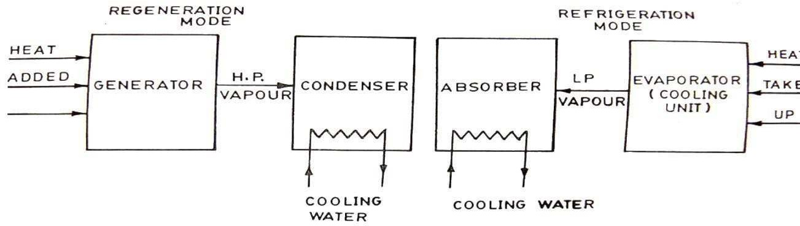

A modified method for absorption cooling which operates intermittently rather than continuously is based on the following principle. In it, the system consists of two vessels which function in two alternative modes. In one mode, one of the vessels is the generator and the other is the condenser

of an absorption system. During this phase, heat is supplied to the generator by oil, gas, steam or solar energy. In the alternative mode, the first vessel becomes the absorber and the other the evaporator. During this phase refrigeration occurs. The system operates in the regeneration mode for a few hours and is then changed to the refrigeration mode, and so on. This technique can also be used for food preservation in rural areas, where electric power is not readily available.

In the refrigeration mode, heat is supplied to a dilute solution of lithium bromide in water contained in the generator unit. Water vapor at a moderately high pressure passes to the condenser unit and is condensed by cooling water. When sufficient liquid water has collected in the condenser, the heat supply and cooling water are shut off and the refrigeration mode becomes operative. The lithium bromide solution in the absorber unit is cooled so that its vapour pressure is lowered. This causes the water in the evaporator to vaporize, and as a result cooling occurs. The relatively low pressure water vapour is then absorbed by the solution in the absorber



Department of ME, Page 61

unit. After some time, the initial conditions are restored, and the system reverts to the regeneration mode.

The other refrigerant absorbent combinations used in this system are ammonia water (NH3- H2O) and ammonia-sodium thiocynanate (NH3-NasCN).

**SOLAR THERMAL ELECTRIC CONVERSION:**

**SOLAR POND:**

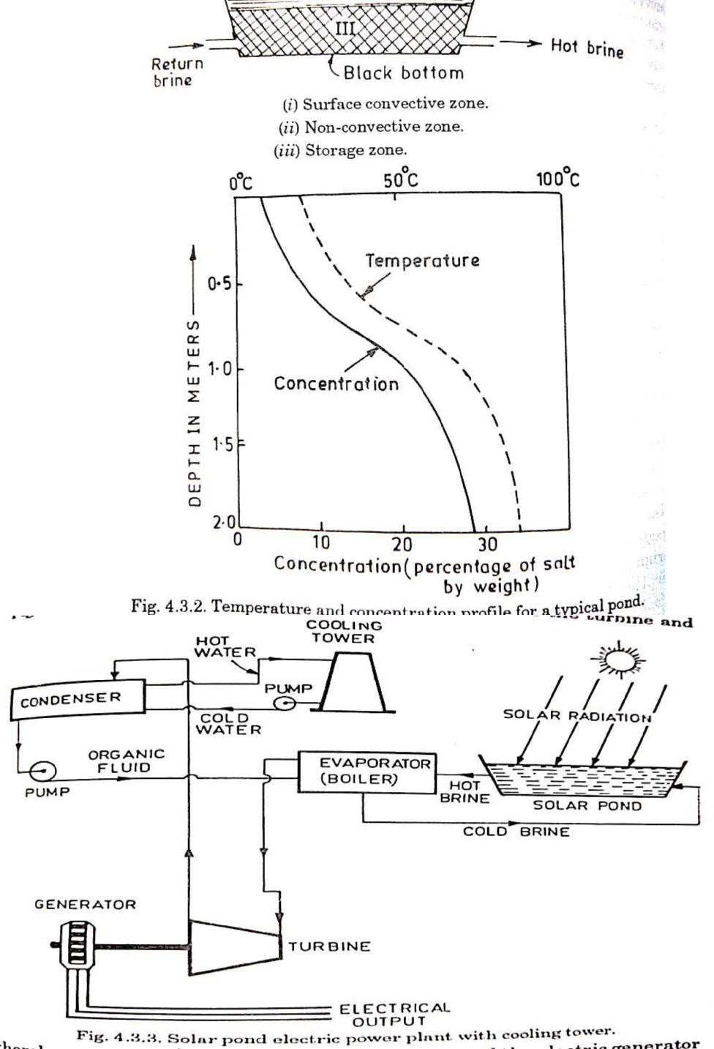



Department of ME, Page 62

A solar pond is a mass of shallow water about 1 or 2 metres deep with a large collection area, which acts as a heat trap. It contains dissolved salts to generate a stable density gradient. Part of the incident solar radiation entering the pond surface is absorbed throughout the depth and the remainder which penetrates the pond is absorbed at the black bottom. If the pond were initially filled with fresh water, the lower layers would heat up, expand and rise to the surface. Because of the convective mixing and heat loss at the surface, only a small temperature rise in the pond could be realized. On the other hand, convection can be eliminated by initially creating a sufficiently strong salt concentration gradient. In this case, thermal expansion in the hotter lower layers is insufficient to destabilize the pond. With convection suppressed, the heat is lost from the lower layers only by conduction. Because of the relatively low conductivity, the water acts as an insulator and permits high temperature (over 90oC) to develop in the bottom layers. At the bottom of the pond, a thick durable plastic liner is laid. Materials used for the liner include butyl rubber, black polyethylene and hypalon reinforced with nylon mesh. Salts like magnesium chloride, sodium chloride or sodium nitrate are dissolved in the water, the concentration varying from 20 to 30 percent at the bottom to almost zero at the top.

**Solar Chimney Power Plant:**

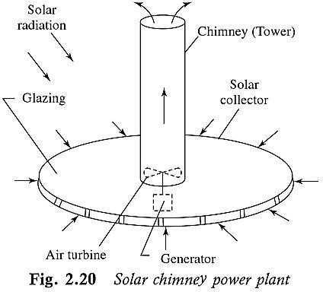

Solar chimney is much simpler but works with much lower efficiency as compared to central tower receiver power plant. The circular field of heliostats is replaced by a circular area of land covered with glazing. The



Department of ME, Page 63

central receiver tower is replaced by a tall chimney that houses a wind turbine. The air under the glazing is heated by solar energy and drawn up through the chimney driving the turbine coupled with a generator.

**LOW-TEMPERATURE SOLAR POWER PLANT (Max 100°C by FPC and solar**

**pond)):**

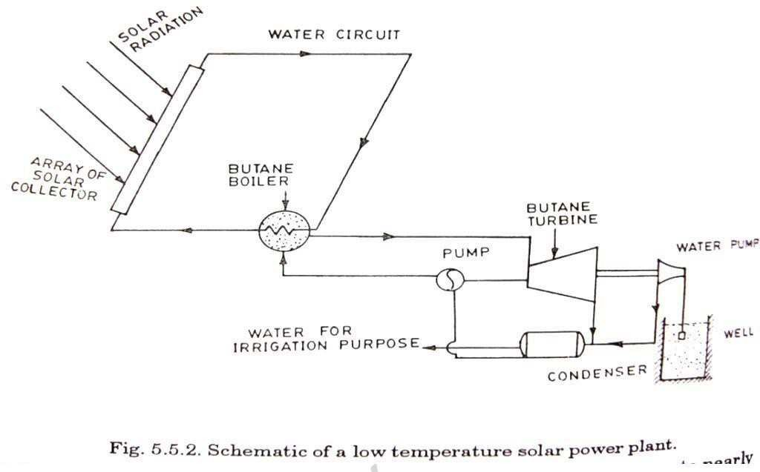

The system has a array of flat-plate collectors to heat water upto nearly 70oC and in the heat exchanger, the heat of water is used for boiling butane. The high pressure butane vapour runs a butane turbine which operates a hydraulic pump which pumps the water from well and used for irrigation. The exhaust butane vapour from butane turbine is condensed with the help of water which is pumped by the pump. This condensate is fed to the heat exchanger or butane boiler.

**MEDIUM TEMPERATURE SYSTEMS WITH CONCENTRATING COLLECTORS**

**(100 - 300°C by Concentrating collectors):**

These systems generally employ an array of parabolic trough concentrating collectors, which give temperature above 1000C. General range of temperature is of the order of 250 to 5000C. As described earlier, a simple parabolic cylindrical concentrator for medium temperature system is shown in Figure. It consists of a parabolic cylindrical reflector to concentrate sunlight on to a collecting pipe within a pyrex or glass envelop. A selective coating of suitable material is applied to pipe to minimize infrared emission.





Proper suntracking arrangement is made so that maximum sunlight is focused on the absorber.

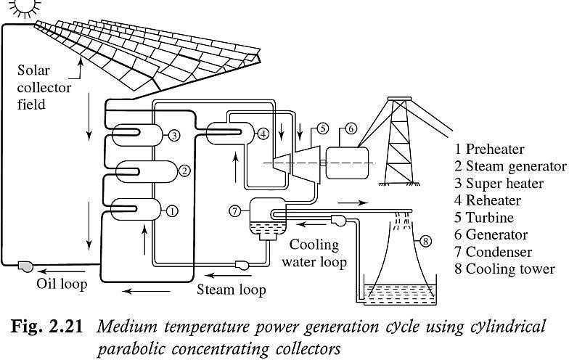

1. Preheater, 2. Steam generator, 3. Super heater, 4. Re-heater, 5.

Turbine, 6. Generator, 7. Condenser, 8. Cooling tower.

**HIGH TEMPERATURE SYSTEMS (above 300°C) [CENTRAL RECIEVER SYSTEM**

**/ TOWER POWER PLANT]:**

This power plant uses central tower receiver to collect solar radiation from a large area on the ground. The receiver mounted at the top of the tower, converts water into high-pressure steam at around 500oC. This high-pressure steam is expanded in a turbine coupled with an alternator. The electric power produced is fed to a grid. Thermal buffer storage is provided to continue operating the plant for some time during cloud cover and a bypass is used for starting and shutdown operations. The schematic diagram is shown in figure below.

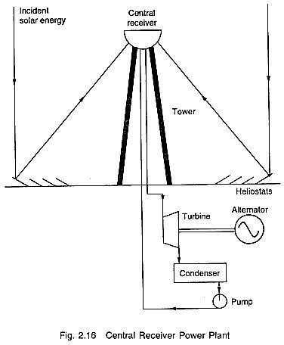

**SOLAR POWER GENERATION BY THERMAL STORAGE:**

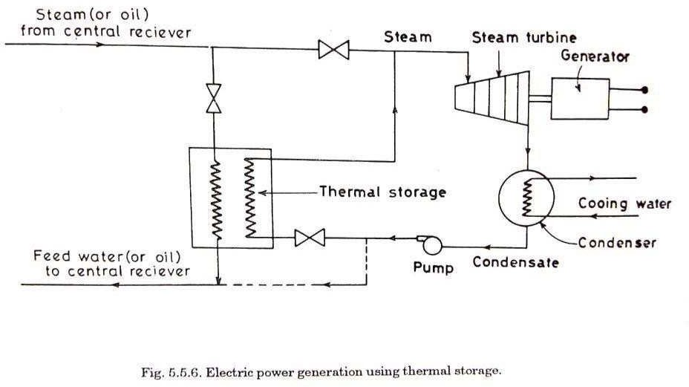

**SOLAR ELECTRIC POWER GENERATION BY SOLAR PHOTOVOLTAIC**

**CELLS:** A PVC is one which converts photons into voltage or light energy to electricity. The materials used for this is silicon which has 4 free valence e-Os in its outermost cell. When the silicon is doped with phosphorous or arsenic having 5 valence e-Os in the outer most cell it forms an On-junction‘ 4 e-Os of phosphorous with 4 e-Os of silicon and one negative charged electron is left out in the On-junction‘. Similarly the Op-junction‘ is formed by doping silicon with boron having 3 valance e-Os in its outermost cell to create positively charged hole which attracts negatively charged electron from n to p junction through external load of cell.



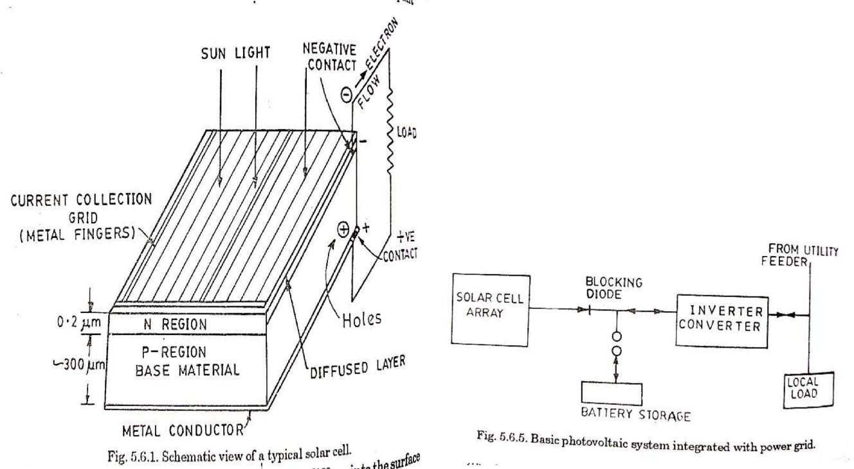

**AGRICULTURAL AND INDUSTRIAL APPLICATIONS:**

In this application there are 3 categories namely

1. Low Temp (below 100°C)
2. Intermediate Temp (100-175°C)
3. High Temp (above 175°C)

In low temp applications FPC‘s are used and the working fluid used is either water or air. The applications are heating and cooling of commercial green houses, space heating, dairy facilities and poultry houses, curing of bricks, drying of grains and distillation of water.

Intermediate temp applications are food processing, laundry, pickling etc

In high temp applications solar energy is used for thermal electric conversion their by generating electric power.

**SOLAR DISTILLATION:**

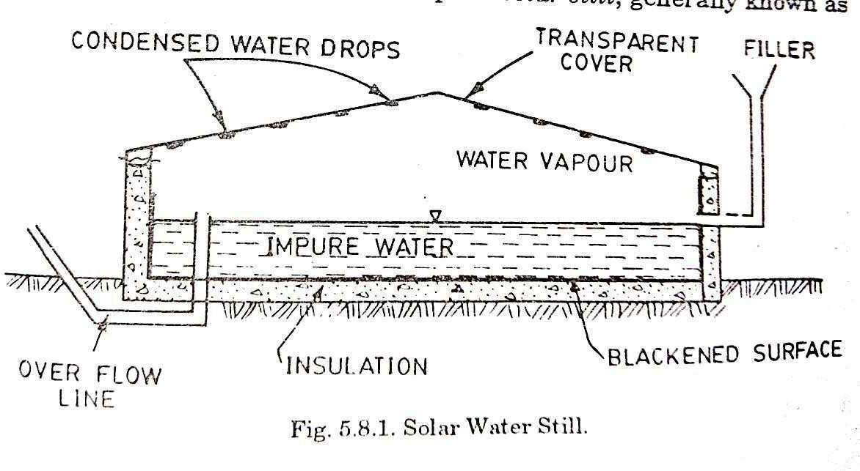

Potable or fresh water is one of the fundamental necessities of life for a man. Industries and agriculture also require fresh water without which they cannot thrive. Man has been dependent on rivers, lakes and underground water reservoir to fulfill his need of fresh water.

The use of solar energy for desalting seawater and brackish well water has been demonstrated in several moderate sized pilot plants in the Unites States, Greece, Australia and several other countries. The idea was first applied in 1982.

A simple basin type solar still consists of a shallow blackened basin filled with saline or brackish water tobe distilled. The depth of water is kept about 5-10 cm. It is covered with sloppy transparent roof. Solar radiation, after passing through the roof is absorbed by the blackened surface of the basin and thus increases the temperature of the water. The evaporated water increases the moisture content, which gets condensed on the cooler underside of the glass. The condensed water slips down the slope and is collected through the condensate channel attached to the glass. The construction is shown in figure above.

**SOLAR PUMPING:** working non-freezing organic fluids- Toulene, Monochlorobenzene, Trifluoro ethanol, Hexafluoro bnzene, Pyridine, Freon-11,113, Thiopene etc.

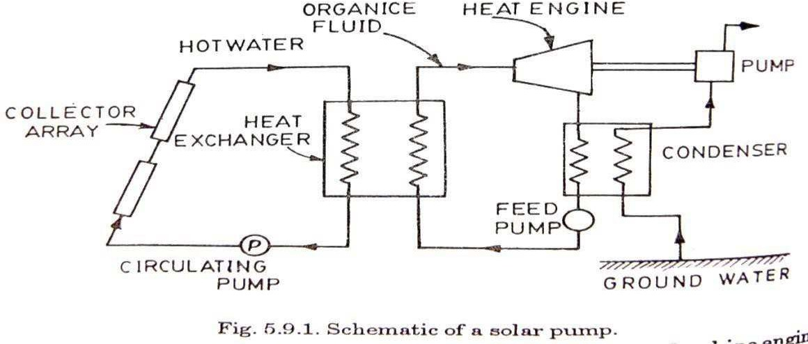

The solar pump is not much different from a solar heat engine working in a low temperature cycle. The sources of heat is the solar collector, and sink is the water to be pumped. A typical solar powered water pumping system is shown in above Fig.5.9.1. The primary components of the system are an array of flat-plate collectors and an Rankine engine with an organic fluid as

the working substance. During operation a heat transfer fluid flows through the collector arrays. Depending upon the collector configuration, solar flux and the operating conditions of the engine, the fluid will be heated in the collector to a higher temperature, the solar energy which is thus converted to the thermal energy. The fluid flows into a heat exchanger, due to temperature gradient, and comes back to the collector. This water yields its heat to an intermediate fluid in the boiler. This fluid evaporates and expands in the engine before reaching the condenser, where it condenses at low pressure. The condenser is cooled by the water to be pumped. The fluid is then reinjected in the boiler to close the cycle. The expansion engine or rankine engine is coupled to the pump and it could of course be coupled to an electric generation.

**TURBINE-DRIVEN PUMP USING SOLAR ENERGY:**

A simplified outline of a turbine –driven pump system utilizing solar energy is shown in Figure below. In a particular system in New Mexico, the heat

transport fluid (HT - 43) is heated to 216oC in parabolic through collectors with a total operature area of 624 m2. Part of the heated liquid is stored for use when the sun is not shining. The turbine working fluid (Freon type R-

113) leaves the boiler and enters the turbine as vapour at a temperature of 1600C and 15 atm pressure. After expansion in the turbine, the vapor leaves at 930C and 0.7 atm; it is converted back to liquid in the condenser and returns to the boiler.

The irrigation pump operates at a rated power of 19 kw and delivers water at 500 to 600 gal/min (32 to 38 litres/sec) from a well roughly 30m deep.

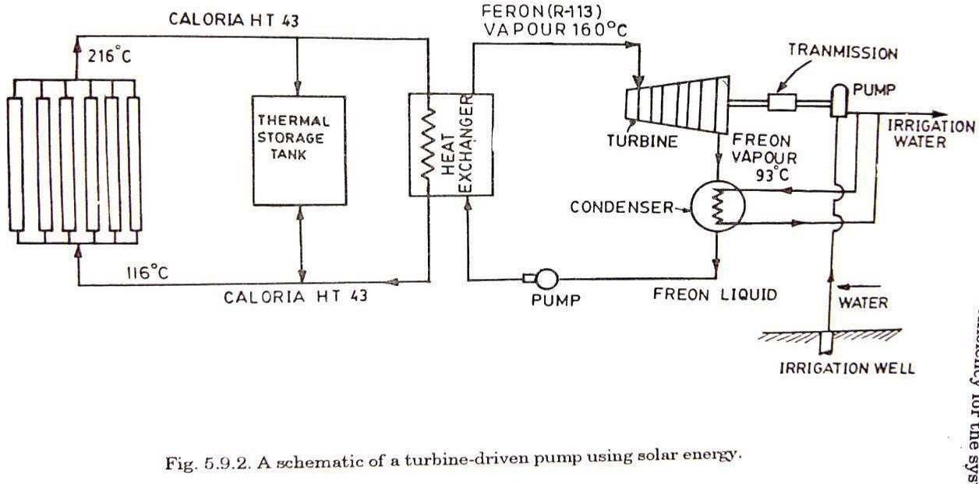

**SOLAR FURNACE (3800°C):**

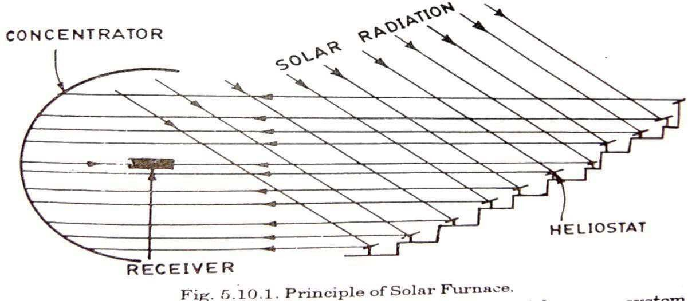



Department of ME, Page 70

Principle of Working:

The principle of the solar furnace is outlined in Fig.5.10.1. A number of heliostates are arranged in terraces on a slopping surface so that, regardless of the sun‘s position, they always reflect solar radiation in the same direction onto a large paraboloid reflecting collector made up of many fixed mirrors attached to the face of a structure. The collector then brings the radiation to a focus within a small volume. In figure a heliostat type furnace with horizontal optical axis is shown which is comparatively convenient and widely used in large furnaces. The most desirable mirror is that obtained by grinding and polishing a glass plate into an optical flat, aluminizing or silvering by vacuum evaporation, and cooling with a suitable film. The change of elevation and that of azimuth can be obtained by the rotation of frame about a horizontal axis and about a vertical axis respectively. In order to rotate the frame, hydraulic or electric driving is used which is coupled with a servo system or a time system for sun following. The other method is to use many heliostats to convey the solar radiation into a concentrator.

**SOLAR COOKING:**

Thermal energy requirements for cooking purpose forms a major share of the total energy consumed, especially in rural areas. Variety of fuels like coal, kerosene, cooking gas, firewood, dung cakes and agricultural wastes are being used to meet the requirement. Fossil fuel is a fast depleting resource and need to be conserved, firewood for cooking causes ddeforestation and cow dung, agricultural waste etc. may be better used as a good fertilizer. Harnessing solar energy for cooking purpose is an attractive and relevant option. A variety of solar cookers have been developed, which can be clubbed in four types of basic designs: (i) box type solar cooker, (ii) dish type solar cooker (iii) community solar cooker, and (iv) advance solar cooker.



Department of ME, Page 71

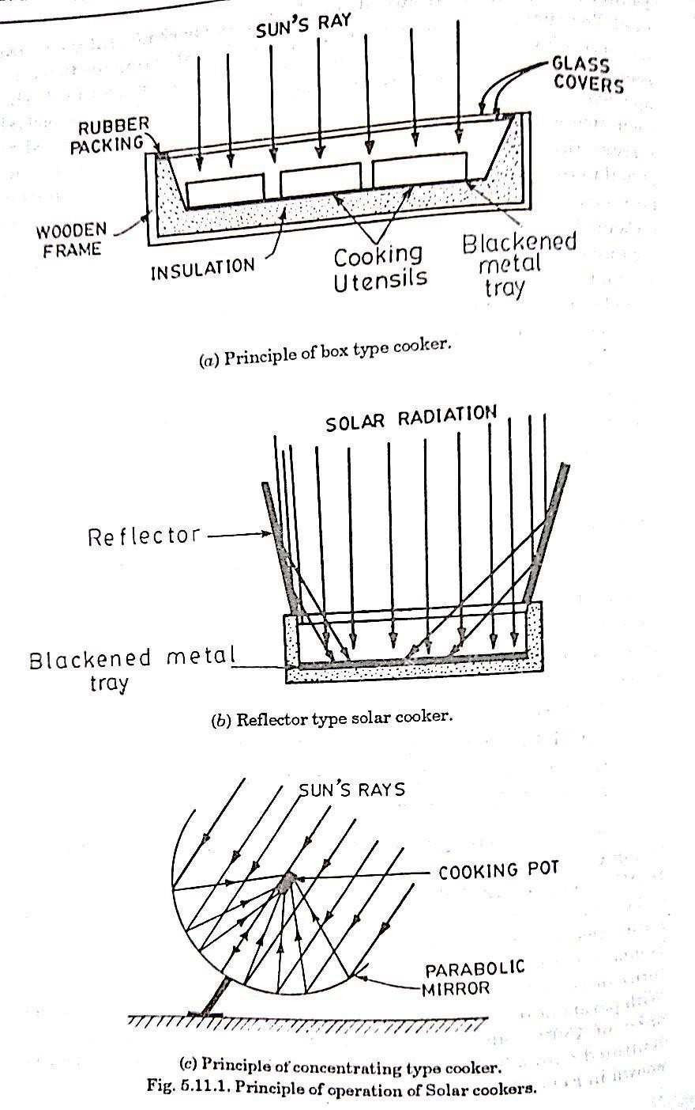

**BOX TYPE SOLAR COOKER: (160°C) & Reflector type (240°C):**

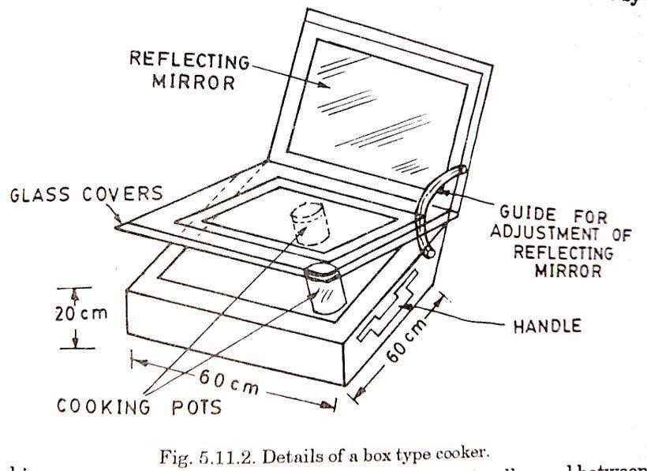



Department of ME, Page 72

The construction of a most common, box type solar cooker is schematically shown in figure above. The external dimensions of a typical family size box type cooker are 60x60x20 cm. This cooker is simple in construction and operation. An insulated box of blackened aluminium contains the utensils with food material. The box receives direct radiation and also reflected radiation from a reflector mirror fixed on inner side of the box cover hinged to one side of the box. The angle of reflector can be adjusted as required. A glass cover consisting of two layers of clear window glass sheets serves as the box door. The glass cover traps heat due to the greenhouse effect. Maximum air temperature obtained inside the box is around 140-1600C. This is enough for cooking the boiling type food slowly in about 2-3 hours.

**SOLAR ENERGY STORAGE SYSTEMS:**

The thermal energy of sun can be stored in a well-insulated fluids or solids. It is either stored as i) sensible heat – by virtue of the heat capacity of the storage medium, or as ii) Latent heat – by virtue of the latent heat of change of phase of the medium or both.

In the first type of storage the temp of the medium changes during charging or discharging of the storage whereas in the second type the temp of the medium remains more or less constant since it undergoes a phase transformation.

An overview of the major techniques of storage of solar energy is as shown in the fig. A wide range of technical options are available for storing low temp thermal energy as shown. Some of the desired characteristics of the thermal energy as shown below. Some of the different storage techniques and their main features are compared in the next table. Desired properties of phase change heat storage materials are also listed in subsequent table.



Department of ME, Page 73



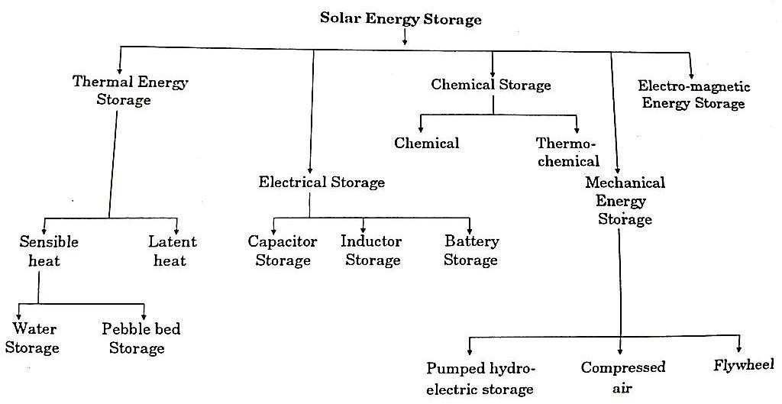

There are four main factors affecting the cost affecting the cost of solar thermal energy storage systems. They are,

1. Thermal heat storage materials,
2. Insulating material,
3. Space occupied by the storage device,
4. Heat exchange for charging and discharging the storage.

The following chart shows the different storage systems used as per the required capacity. Depending on the available energy one can select the particular storage system thus optimizing the cost and the efficiency of the storage system.

**Low Temperature solar thermal energy storage technology classification:**

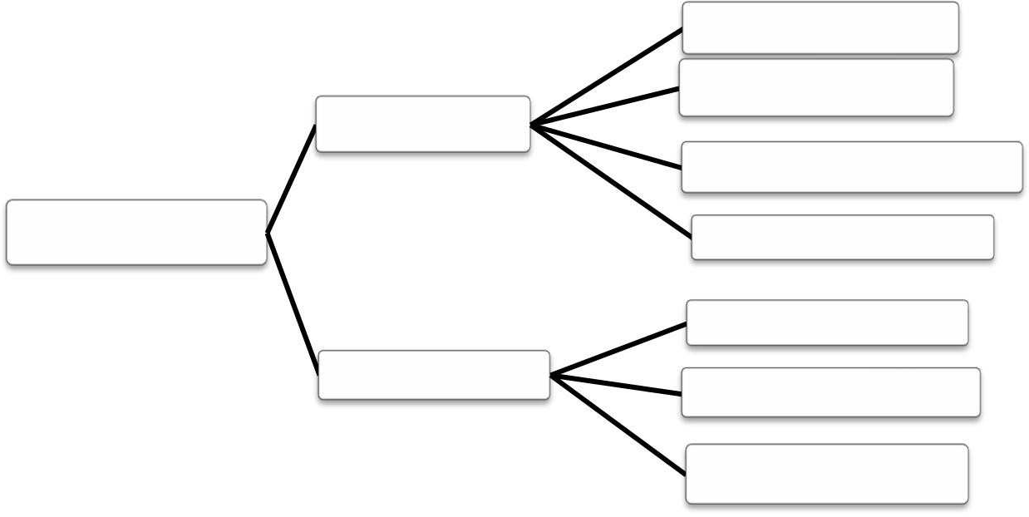

Aquifier

Solar ponds

Annual

Sensible heat (Bulk)

Large tanks or ponds

Earth or Rock beds

Rock bins

Short term

Earth beds

Water tanks

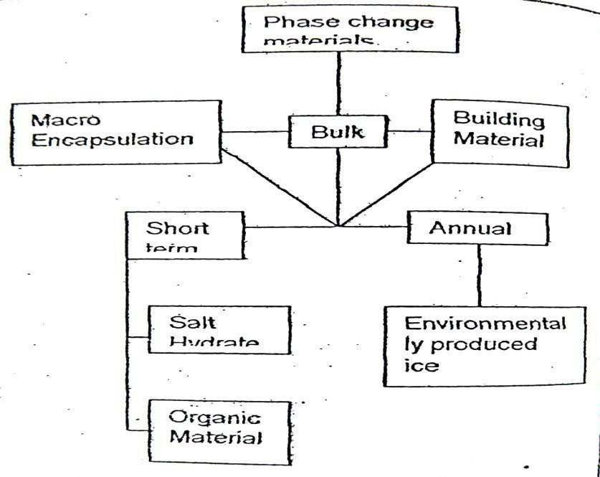

Desired characteristics of a thermal storage system:

1. Compact, large storage capacity per unit mass and volume,
2. High storage efficiency,
3. Heat storage medium with suitable properties in the operating temperature range,
4. Uniform temperature,
5. Capacity to charge and discharge with the largest input/output rates but without temperature gradients,



1. Complete reversibility,
2. Ability to undergo large number of charges and discharge cycles without loss of performance and storage capacity,
3. Small self-discharging rates,
4. Quick charging and discharging,
5. Long life,
6. Inexpensive,
7. Non corrosive,
8. No fire and toxic hazards.

In smaller heat storage, the surface area to volume ratio is large and hence the cost of insulating is an important factor. Phase change storages with higher energy densities are more attractive for small storage. In larger heat storage, on the other hand, the cost of storage material is more important and sensible heat storage like water is very attractive.

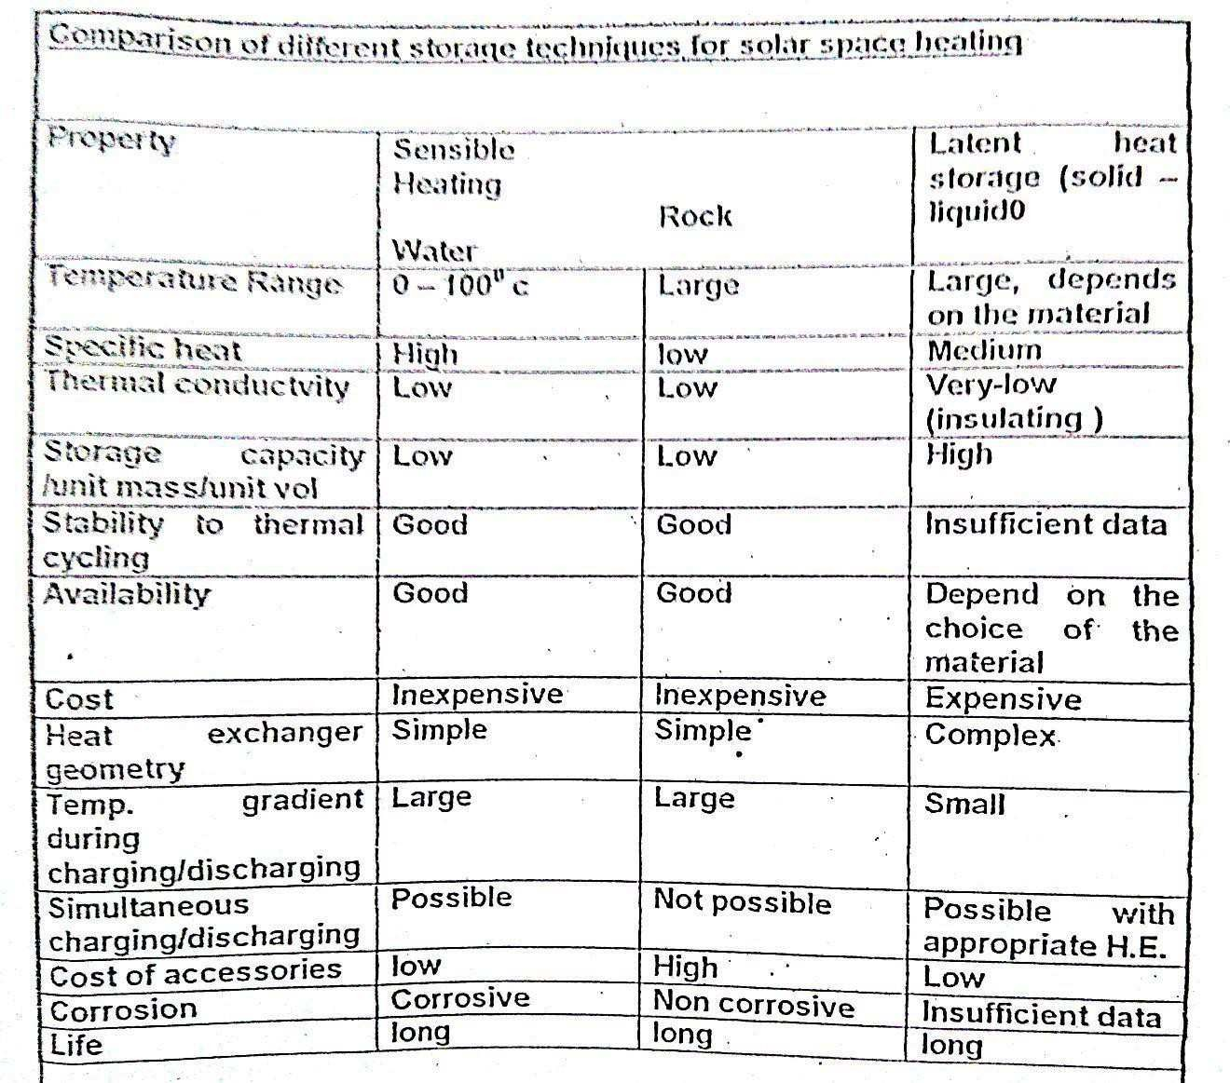

**Photovoltaic Solar Systems**

**What is a solar cell?**

* + Solid state device that converts incident solar energy directly into electrical energy

**Advantages:**

1. Efficiencies from a few percent up to 20-30%
2. No moving parts
3. No noise
4. Lifetimes of 20-30 years or more

**How Does It Work?**

* + The junction of dissimilar materials (n and p type silicon) creates a voltage
  + Energy from sunlight knocks out electrons, creating a electron and a hole in the junction
  + Connecting both sides to an external circuit causes current to flow
  + In essence, sunlight on a solar cell creates a small battery with voltages typically

0.5 v. DC

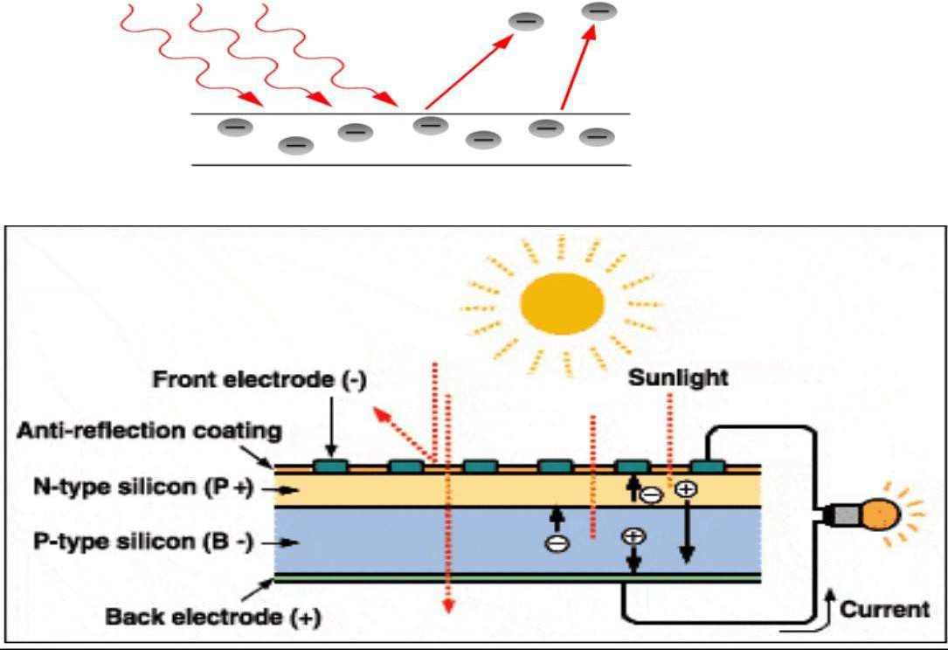



Department of ME, Page 77



**I-V Charecteristics of a solar cell:**

**Theory of I-V Characterization:**

PV cells can be modeled as a current source in parallel with a diode. When there is no light present to generate any current, the PV cell behaves like a diode. As the intensity of incident light increases, current is generated by the PV cell, as illustrated in Figure.

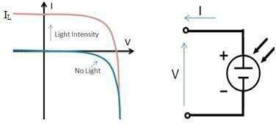

* In an ideal cell, the total current *I* is equal to the current *I4* generated by the photoelectric effect minus the diode current *Id*, according to the equation:

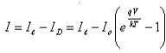

* where *I0* is the saturation current of the diode, q is the elementary charge 1.6x10-19 Coulombs, k is a constant of value 1.38x10-23J/K, T is the cell temperature in Kelvin, and *V* is the measured cell voltage that is either produced (power quadrant) or applied (voltage bias).
* Expanding the equation gives the simplified circuit model shown below and the following associated equation, where *n* is the diode ideality factor (typically between 1 and 2), and *RS* and *RSH* represents the series and shunt resistances that are described in further detail later in this document:

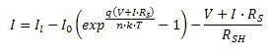

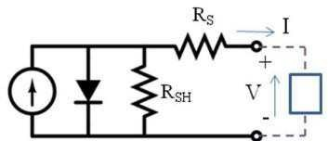

The I-V curve of an illuminated PV cell has the shape shown in the following Figure as the voltage across the measuring load is swept from zero to *Voc*,

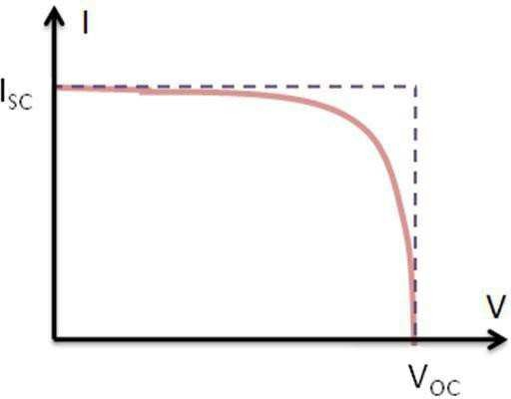

**Short Circuit Current (ISC):**

The short circuit current ISC corresponds to the short circuit condition when the impedance is low and is calculated when the voltage equals 0.

I (at V=0) = ISC

ISC occurs at the beginning of the forward-bias sweep and is the

maximum current value in the power quadrant. For an ideal cell, this maximum current value is the total current produced in the solar cell by photon excitation.

ISC = IMAX = Iℓ for forward-bias power quadrant

**Open Circuit Voltage (VOC):**

The open circuit voltage (VOC) occurs when there is no current passing through the cell. V (at I=0) = VOC

VOC is also the maximum voltage difference across the cell for a forward-bias sweep in the power quadrant.VOC= VMAX for forward-bias power quadrant

**Maximum Power (PMAX), Current at PMAX (IMP), Voltage at PMAX (VMP):**

The power produced by the cell in Watts can be easily calculated along the I-V sweep by the equation *P=IV*. At the *Isc* and *Voc* points, the power will be zero and the maximum value for power will occur between the two. The voltage and current at this maximum power point are denoted as *Vmp* and *Imp* respectively.

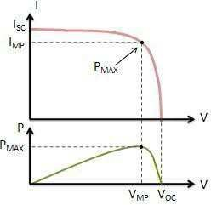

**Fill Factor:**

The Fill Factor (FF) is essentially a measure of quality of the solar cell. It is calculated by comparing the maximum power to the theoretical power

(*Pt*) that would be output at both the open circuit voltage and short circuit current together. FF can also be interpreted graphically as the ratio of the rectangular areas depicted in Figure

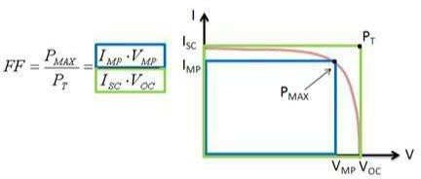

A larger fill factor is desirable, and corresponds to an I-V sweep that is more square-like. Typical fill factors range from 0.5 to 0.82. Fill factor is also often represented as a percentage.

**Efficiency (η):**

Efficiency is the ratio of the electrical power output *Pout*, compared to the solar power input, *Pin*, into the PV cell. *Pout* can be taken to be *PMAX* since



Department of ME, Page 80

the solar cell can be operated up to its maximum power output to get the maximum efficiency.

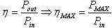

**Shunt Resistance (RSH) and Series Resistance (RS):**

During operation, the efficiency of solar cells is reduced by the dissipation of power across internal resistances. These parasitic resistances can be modeled as a parallel shunt resistance (RSH) and series resistance (RS), as depicted in Figure previously.

For an ideal cell, RSH would be infinite and would not provide an alternate path for current to flow, while RS would be zero, resulting in no further voltage drop before the load.

Decreasing RSH and increasing Rs will decrease the fill factor (FF) and PMAX as shown in Figure 6. If RSH is decreased too much, VOC will drop, while increasing RS excessively can cause ISC to drop instead.

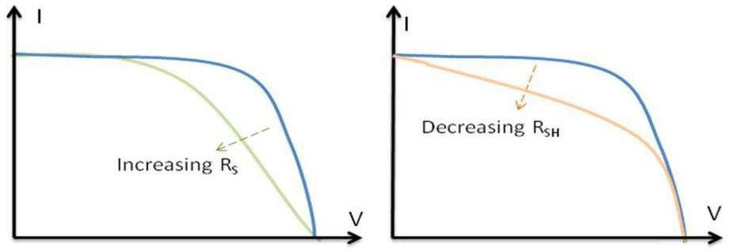

If incident light is prevented from exciting the solar cell, the I-V curve shown in following Figure can be obtained. This I-V curve is simply a reflection of the —No Light□ curve from Figure 1 about the V-axis. The slope of the linear region of the curve in the third quadrant (reverse-bias) is a continuation of the linear region in the first quadrant, which is the same linear region used to calculate RSH in Figure. It follows that RSH can be derived from the I-V plot obtained with or without providing light excitation, even when power is sourced to the cell. It is important to note, however, that for real cells, these resistances are often a function of the light level, and can differ in value between the light and dark tests.



Department of ME, Page

**Unit-3**

**Wind Energy**

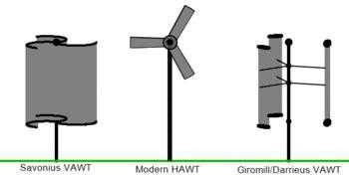

**Generation of the Wind:**

**Planetory winds:**

**wind is generated by**

 Differential solar heating of locations at the equator and poles

 Coriolis force due to earth‘s rotation

 Friction between earth‘s surface and the wind

o Planetory winds are caused because of the above

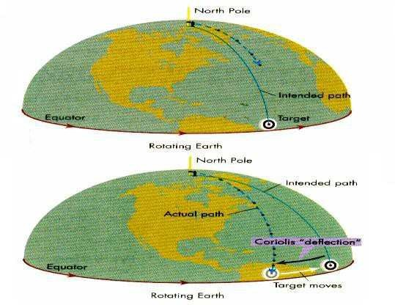



Department of ME, Page

82

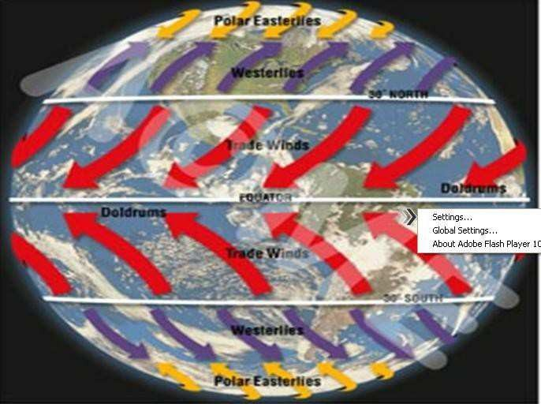

**Local winds:**

 differential heating of the land mass and nearby sea surface water creates local winds

 During day land heats up faster rapidly compared with nearby sea water. Hence there tends to be surface wind flow from the water to the land

 During night wind reverses because land surface cools faster than the water

 Second mechanism of local winds is caused by hills and mountain sides. The air above the slopes heats up during the day and cools down at night, more rapidly than the air above the low lands. This causes heated air in the day to raise along the slopes and relatively heavy air to flow down at night.

Note: It has been estimated that 2% of solar radiation falling on the earth‘s face is converted into kinetic energy in the atmosphere. About 30% of this is available in the lowest 1000m from the earth‘s surface. This is sufficient many times than the need of a country. Direct solar radiation is predictable and dependable whereas wind is erratic, unsteady and not reliable except in some areas.

**Wind turbine:**

A **wind turbine** is a device that converts [kinetic energy](http://en.wikipedia.org/wiki/Kinetic_energy) from the wind into [mechanical energy](http://en.wikipedia.org/wiki/Mechanical_energy). If the mechanical energy is used to produce electricity, the device may be called a **wind generator** or **wind charger**. If the mechanical energy is used to drive machinery, such as for grinding grain or pumping water, the device is called a [windmill](http://en.wikipedia.org/wiki/Windmill) or [wind pump](http://en.wikipedia.org/wiki/Wind_pump). Developed for over a millennium, today's wind turbines are manufactured in a range of vertical and horizontal axis types. The smallest turbines are used for applications such as battery charging



or auxiliary power on sailing boats; while large grid-connected arrays of turbines are becoming an increasingly large source of commercial electric power.

**Types of Wind turbines:**

**Horizontal axis**

 Horizontal-axis wind turbines (HAWT) have the main [rotor](http://en.wikipedia.org/wiki/Rotor) shaft and [electrical](http://en.wikipedia.org/wiki/Electrical_generator) [generator](http://en.wikipedia.org/wiki/Electrical_generator) at the top of a tower, and must be pointed into the wind.

**Vertical axis**

(or VAWTs) have the main rotor shaft arranged vertically. Key advantages of this arrangement are that the turbine does not need to be pointed into the wind to be effective. This is an advantage on sites where the wind direction is highly variable, for example when integrated into buildings.

**Subtypes of VAWM:**

 Darrieu‘s wind turbine

Eggbeater" turbines, or Darrieus turbines, were named after the French inventor, Georges Darrieus. They have good efficiency, but produce large torque ripple and cyclical stress on the tower, which contributes to poor reliability. They also generally require some external power source, or an additional Savonius rotor to start turning, because the starting torque is very low. The torque ripple is reduced by using three or more blades which results in greater solidity of the rotor. Solidity is measured by blade area divided by the rotor area. Newer Darrieus type turbines are not held up by [guy-wires](http://en.wikipedia.org/wiki/Guy-wire) but have an external superstructure connected to the top bearing

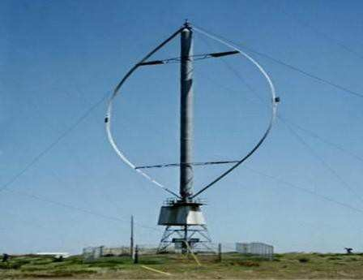

 Savonius Wind Turbine

These are drag-type devices with two (or more) Scoops. They are always self-starting if there are at least three scoops.

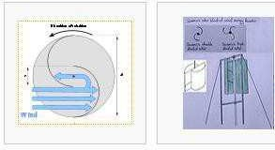

 Twisted Savonius

Twisted Savonius is a modified savonius, with long helical scoops to give a smooth torque, this is mostly used as roof wind turbine or on some boats.

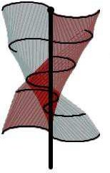

**Subtypes of Horizantal axis wind mills:**

Single blade rotor

* Rotor must move more rapidly to capture same amount of wind
* Gearbox ratio reduced
* Added weight of counterbalance negates some benefits of lighter design
* Higher speed means more noise, visual, and wildlife impacts
* Blades easier to install because entire rotor can be assembled on ground
* Captures 10% less energy than two blade design
* Ultimately provide no cost savings



Two bladed rotor:

* Advantages & disadvantages similar to one blade
* Need teetering hub and or shock absorbers because of gyroscopic imbalances
* Capture 5% less energy than three blade designs



Three bladed rotor:



* Balance of gyroscopic forces
* Slower rotation
  + increases gearbox & transmission costs
  + More aesthetic, less noise, fewer bird strikes

**Calculation of Wind Power:**

**Power in the Wind = ½pAV3**

* Effective swept area, A
* Effective wind speed, V
* Effective air density, 

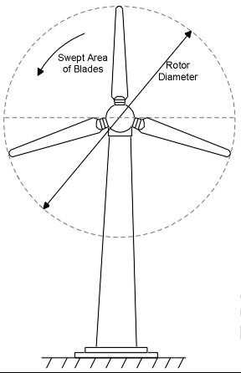

* Swept Area: A = πR2 Area of the circle swept by the rotor (m2).

**Lift/Drag Forces Experienced by Turbine Blades**

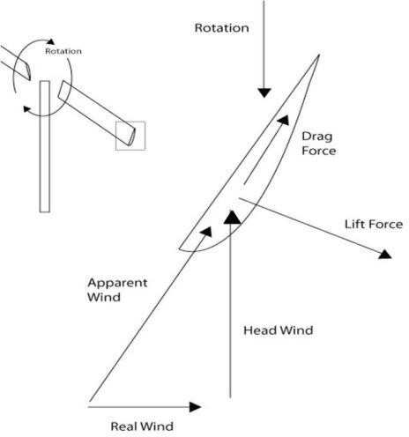

**TIP-SPEED RATIO (TSR):**

Tip-speed ratio is the ratio of the speed of the rotating blade tip to the speed of the free stream wind. There is an optimum angle of attack which creates the highest lift to drag ratio. Because angle of attack is dependent on wind speed, there is an optimum tip-speed ratio

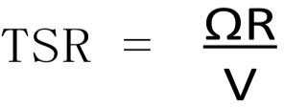

Where,

Ω = rotational speed in radians /sec

R = Rotor Radius

V = Wind —Free Stream□ Velocity

**Performance Over Range of Tip Speed Ratios**:

* Power Coefficient Varies with Tip Speed Ratio ,Characterized by Cp vs Tip Speed Ratio Curve

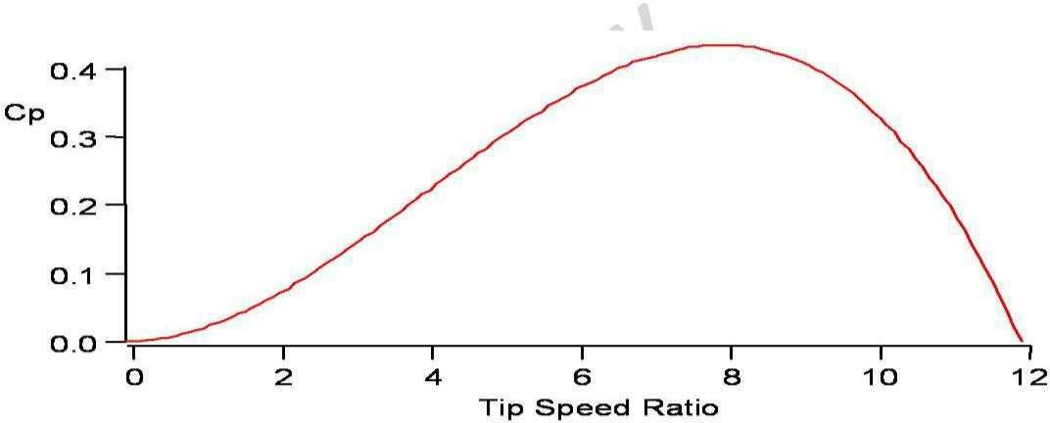

**Betz Limit:**

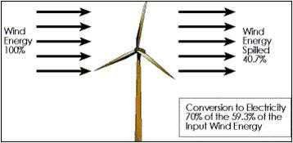

All wind power cannot be captured by rotor or air would be completely still behind rotor and not allow more wind to pass through.Theoretical limit of rotor efficiency is 59%.Most moderntit wind turbines are in the 35 – 45% range.

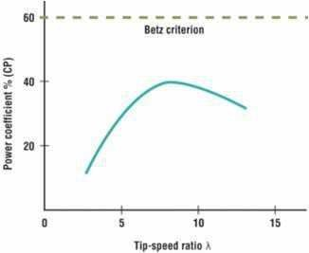

Proof:

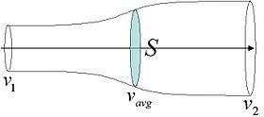

It shows the maximum possible energy — known as the **Betz limit** — that may be derived by means of an infinitely thin rotor from a fluid flowing at a certain speed.

In order to calculate the maximum theoretical efficiency of a thin rotor (of, for example, a [windmill)](http://en.wikipedia.org/wiki/Windmill) one imagines it to be replaced by a disc that withdraws energy from the fluid passing through it. At a certain distance behind this disc the fluid that has passed through flows with a reduced velocity.



**Assumptions:**

The rotor does not possess a hub, this is an ideal rotor, with an infinite number of blades which have no drag. Any resulting drag would only lower this idealized value.

1. The flow into and out of the rotor is axial. This is a control volume analysis, and to construct a solution the control volume must contain all flow going in and out, failure to account for that flow would violate the conservation equations.
2. This is incompressible flow. The density remains constant, and there is no heat transfer from the rotor to the flow or vice versa.
3. The rotor is also massless. No account is taken of angular momentum imparted to either the rotor or the air flow behind the rotor, i.e., no account is taken of any wake effect.



**Application of conservation of mass (continuity equation):**

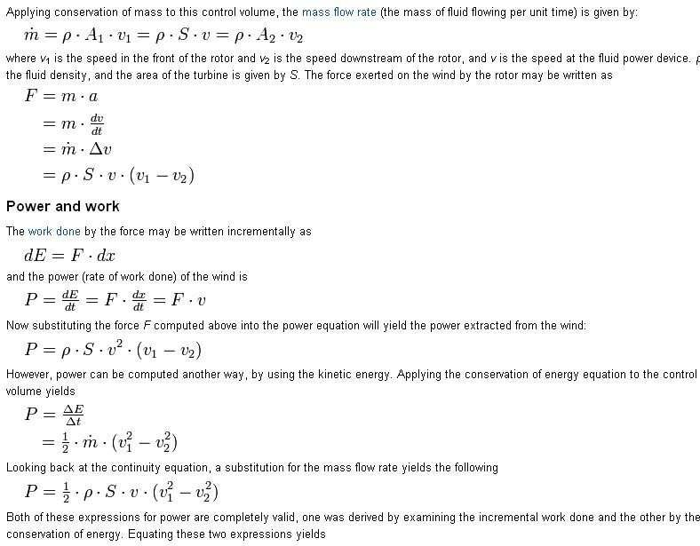

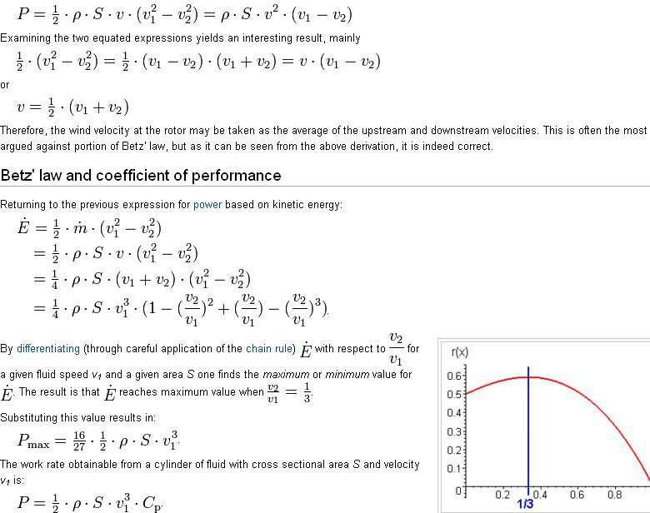

The *"power coefficient" C*p (= *P*/*P*wind) has a maximum value of: *C*p.max = 16/27 = 0.593 (or 59.3%; however, coefficients of performance are usually expressed as a decimal, not a percentage).

**Wind power curve:**

The Power curve of a wind turbine is an important parameter, describing the relation between the wind speed on site and the respective electrical energy output. Power curves and ct-values (a parameter for the calculation of the wake effect) of the turbines under consideration are applied for the energy calculation. Power curves which had been measured by independent institutions are of higher quality than calculated ones. Due to the fluctuations of both the characteristics of the wind turbine components, and the measuring conditions power curves of different measurements differing slightly between each other.

Several manufacturers are thus providing power curves which are calculated from the results of several measured ones; the performance of these calculated power curves might be contractually guaranteed by the manufacturers.

During the calculation of the energy yield, the power curves, given for the standard conditions of air density = 1.225 kg/m3 are adapted to the air density of each individual turbine location at hub height, with the transformed power curves for the average air density. The air density can be calculated for each individual wind turbine according to the site conditions, height above sea level plus the hub height of the turbines (e.g. 57 m / 60 m) and an annual average temperature level. As verification, the calculated adaptations for air density at the turbine sites should be compared to information provided by nearby meteorological stations. Figure next shows the power curves of several wind turbines at an air density of p = 1,225*kg* / *m*3.

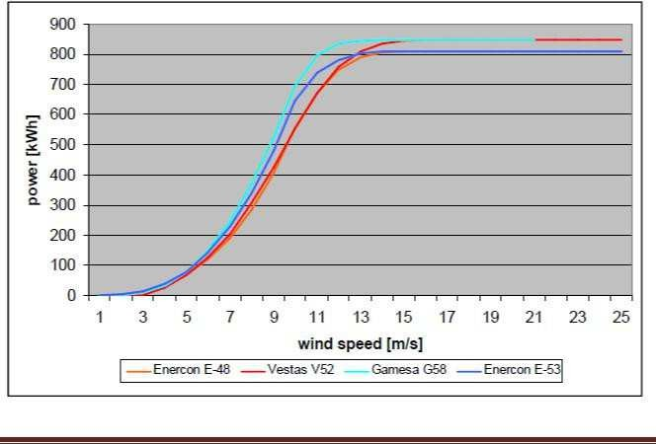

Department of ME, Page 93

**Forces on blades and thrust on turbines:**

There are two types of forces that acting on the blades

1. Circumferential force acting in the direction of wheel rotation that provide torque.
2. Axial force acting in the wind stream that provides axial thrust that must be counteracted by the proper mechanical design

The circumferential force, or torque T can be obtained from,

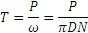

Where

T=Torque in Newton ω=angular velocity in m/s

D=diameter of the turbine wheel

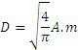

N= wheel revolution per unit time

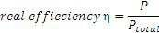

For a turbine operating at power P, the expression for torque becomes

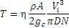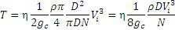

At maximum effciency i.e,59.3%, Torque has maximum value given by,

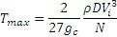

Axial Thrust given by,



Department of ME, Page 94

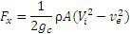

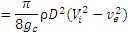

On substituting ve=1/3 vi

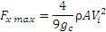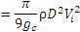

 It can be seen that axial forces are proportional to the square of the diameter of turbine wheel, this limits the turbine wheel diameter of large size.

Wind Energy – India

In the early 1980s, the Indian government established the Ministry of Non-Conventional Energy Sources (MNES) to encourage diversification of the country's energy supply, and satisfy the increasing energy demand of a rapidly growing economy. In 2006, this ministry was renamed the Ministry of New and Renewable Energy (MNRE).

Renewable energy is growing rapidly in India. With an installed capacity of 13.2 GW, renewable energy sources (excluding large hydro) currently account for 9% of India's overall power generation capacity. By 2012, the Indian government is planning to add an extra 14 GW of renewable sources.

In its 10th Five Year Plan, the Indian government had set itself a target of adding 3.5 GW of renewable energy sources to the generation mix. In reality, however, nearly double that figure was achieved. In this period, more than 5.4 GW of wind energy was added to the generation mix, as well as 1.3 GW from other RE ssurces The total power in2008-2012 was increased to 14 GW, 10.5 GW of which to be new wind generation capacity.

The Indian Ministry of New and Renewable Energy (MNRE) estimates that there is a potential of around 90,000 MW for the country, including 48,561 MW of wind power, 14,294 MW of small hydro power and 26,367 MW of biomass In addition, the potential for solar energy is estimated for



Department of ME, Page 95

most parts of the country at around 20 MW per square kilometer of open, shadow free area covered with 657 GW of installed capacity.

The total potential for wind power in India was first estimated by the Centre for Wind Energy Technology (C-WET) at around 45 GW, and was recently increased to 48.5 GW.

This figure was also adopted by the

government as the official estimate.

The C-WET study was based on a comprehensive wind mapping exercise initiated by MNRE, which established a country-wide network of 105O wind monitoring and wind mapping stations in 25 Indian States. This effort made it possible to assess the national wind potential and identify suitable areas for harnessing wind power for commercial use, and 216

suitable sites have been identified.

However, the wind measurements were carried out at lower hub heights and did not take into account technological innovation and improvements and repowering of old turbines to replace them with bigger ones At heights of 55-65 meters, the Indian Wind Turbine Manufacturers Association (IWTMA) estimates that the potential for wind development in India is around 65-70 GW. The World Institute for Sustainable Energy, India (WISE) considers that with larger turbines, greater land availability and expanded resource exploration, the potential could be as big as 100 GW.



Department of ME, Page 96

**Introduction:**

**Biomass and Biogas**

The energy obtained from organic matter, derived from biological organisms (Plants and animals) is known as biomass energy. Animals feed on plants, and plants grow through the photosynthesis process using solar energy. Thus, photosynthesis process is primarily responsible for the generation of biomass energy. A small portion of the solar radiation is captured and stored in the plants during photosynthesis process. Therefore, it is an indirect form of solar into biomass energy is estimated to be 0.5 – 1.0%. To use biomass energy, the initial biomass may be transformed by chemical or biological processes to produce intermediate bio-fuels such as methane, producer gas, ethanol and charcoal etc. On combustion it reacts with oxygen to release heat, but the elements of the material remain available for recycling in natural ecological or agricultural processes. Thus, the use of industrial bio-fuels, when linked carefully to natural ecological cycle, may be non- polluting and sustainable. It is estimated that the biomass, which is 90% in trees, is equivalent to the proven current extractable fossil fuels reserves in the world. The dry matter mass of biological material cycling in biosphere is

about 250 x 109 tons/y. The associated energy bound in photosynthesis is 2 x 1021 J/y (0.7 x 1014 W of power).

Biomass mainly in the form of wood, is mankind‘s oldest form of energy. It has traditionally been used both in domestic as well as industrial activities, basically by direct combustion. As industrial activities increased, the growing demand for energy depleted the biomass natural reserves. The development of new, more concentrated and more convenient sources of energy has led to its replacement to a large extent by other sources. Though biomass energy share in primary energy supply for the industrialized countries is not more than 3%, a number of developing countries still use a substantial amount of it, mostly in the form of non-commercial energy.

Main advantages of biomass energy are:

* 1. It is a renewable source.
  2. The energy storage is an in-built feature of it.
  3. It is an indigenous source requiring little or no foreign exchange.
  4. The pollutant emissions from combustion of biomass are usually lower than those from fossil fuels.



Department of ME, Page 97

* 1. Commercial use of biomass may avoid or reduce the problems of waste disposal in other industries, particularly municipal solid waste in urban centers.
  2. The nitrogen rich bio-digested slurry and sludge from biogas plant serves as a very good soil conditioner and improves the fertility of the soil.

1. It is a dispersed and land intensive source.
2. It is often of low energy density.
3. It is also labour intensive, and the cost of collecting large quantities for commercial application is significant.

Most current commercial applications of biomass energy use material that has been collected for other reasons, such as timber and food processing residues and urban waste.

**Biomass:** It is the organic matter consisting of plant animal matter. Any

matter which is biodegradable is known as biomass or organic matter.

Generation of energy from biomass is referred to as OPhoto chemical‘ harnessing of solar radiation since to generate biomass; solar radiation is a

must as seen from the following equation

Solar radiation  Photosynthesis Biomass Energy

Energy from the biomass is generated in three different forms namely) Direct burning, ii) Liquefaction, iii) Gas generation.

**Direct burning:** When biomass is directly burnt, energy is generated as given by the following expression,

CO2 +O2 sun‘s radiation (photosynthesis) CH2O+O2 CH2O+O2 CO2+H2O + Energy

Thus when photosynthesis reaction is reversed energy is liberated. **Liquefaction:** Biomass is liquefied either by thermo-chemical method or

biochemical method to generate alcohols like methyl and ethyl alcohol.

These are mixed with petrol and used in IC Engines as fuels.

**Bio gas:** Biomass is converted to biogas by the process of digestion or

fermentation in the presence of micro-organisms. This biogas mainly contains methane which is a good combustible gas.

Biogas consists of 50-55% of methane, 30-35% of CO2 and remaining waste gases like H2, N2, H2S etc. since it contains a hydrocarbon gas it is a very good fuel and hence can be used in IC engines. It is a slow burning gas with



Department of ME, Page 98

calorific value of 5000-5500 Kcal/kg. the raw material used to generate this are algae, crop residue, garbage, kitchen waste, paper waste, waste from sugar cane refinery, water hyacinth etc. apart from the above mentioned raw materials excreta of cattle, piggery waste and poultry droppings are also used as raw materials.

Biogas is generated by fermentation or digestion of organic matter in the presence of aerobic and anaerobic micro-organisms. Fermentation is the process of breaking down the complex organic structure of the biomass to simple structures by the action of micro-organisms either in the presence of O2 or in the absence of O2. The container in which the digestion takes place is known as the digester.

**Advantages**

The initial investment is low for the construction of biogas plant. The technology is very suitable for rural areas.

Biogas is locally generated and can be easily distributed for domestic use.

Biogas reduces the rural poor from dependence on traditional fuel sources, which lead to deforestation.

The use of biogas in village helps in improving the sanitary condition and checks environmental pollution.

The by-products like nitrogen rich manure can be used with advantage.

Biogas reduces the drudgery of women and lowers incidence of eye and lung diseases.

The digestion takes place in the following steps

i)Enzymatic hydrolysis ii) Acid formation iii) Methane formation.

1. **Enzymatic hydrolysis:** In this step the complex organic matter like starch, protein, fat, carbohydrates etc are broken down to simple structures using anaerobic micro-organisms.
2. **Acid formation:** In this step the simple structures formed in the enzymatic hydrolysis step are further reacted by anaerobic and facultative micro-organisms (which thrive in both the presence and absence of oxygen) to generate acids.
3. **Methane formation:** In this step the organic acids formed are further converted to methane and CO2 by anaerobic micro-organisms (anaerobes).



Department of ME, Page 99

**Factors affecting Biogas generation:**

* 1. PH value
  2. Temperature
  3. Total solid content
  4. Load rating
  5. Seeding
  6. Uniform feeding
  7. Dia to depth ratio
  8. Carbon to nitrogen ratio
  9. Nutrient
  10. Mixing
  11. Retention time
  12. Type of feedstock
  13. Toxicity
  14. Pressure

1) **PH value:** It is an index of hydrogen ion concentration in the mixture which also predicts acidity or alkalinity of the mixture. For effective gas generation the required PH value is 6.5 to 7.6. If this value decreases to 4-6, the mixture becomes acidic and if the value becomes 9- 10 then it becomes alkaline. Both for acidic and alkaline conditions the methane forming bacteria becomes inactive and the gas generation is reduced. Thus for effective gas

2)

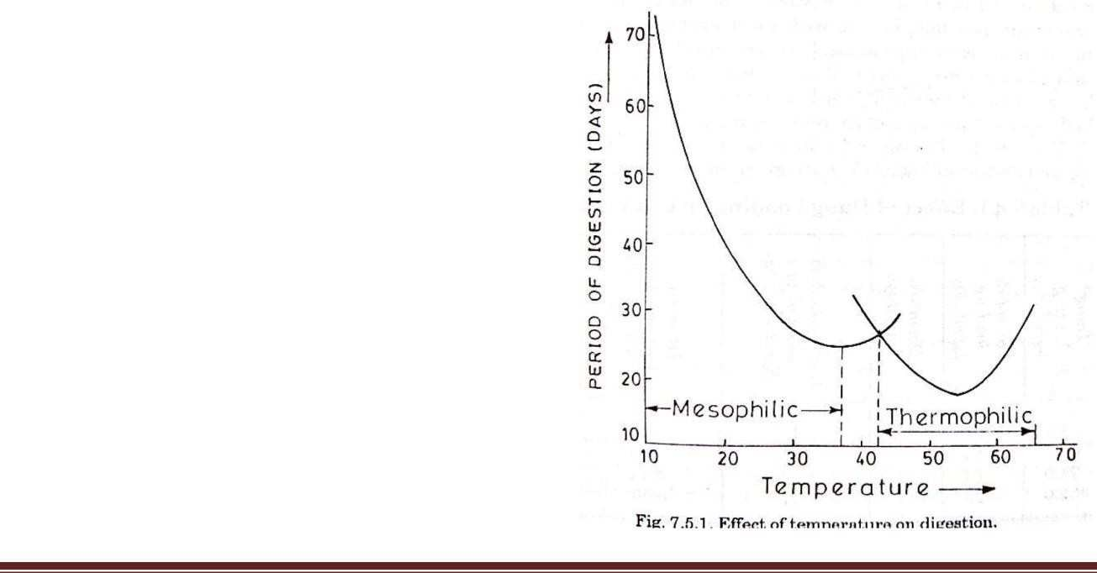

generation the required PH value is 6.5-7.5. **Temperature:** The effect of temp on gas generation is as shown in graph. The two curves represent two types of bacteria which are sensitive to two different temp levels. Mesophilic type of bacteria will effectively generate gas at a temp of about 35º C. Thermophilic type of bacteria will generate gas effectively at a temp of about 55º C. As the temperature

Department of ME, Page 100

decreases or increases from the above values the period of gas generation will be increased. Since it is easy to maintain a temp of 35º C, it is advisable to select mesophilic type of bacteria for digestion.

1. **Total solid content:** The raw material added to the digester contains both solid and liquid in the ratio of 20:80 by weight. From the experience it is found that the gas generation is improved by maintaining the solid content of the mixture at about 8 to 10% by weight. This is done by adding water to the mixture.
2. **Loading rate:** It is the addition of the raw material to the digester/day/unit volume. The effective load rating is found to be 0.5 to 1.6 kg of solid material/day/m3.
3. **Seeding:** During digestion the methane forming bacteria are consumed rapidly and their number will decrease affecting the gas generation. In order to maintain the quantity of methane forming bacteria, digested slurry from the previous batch is added to the digestor. The digested slurry is rich in methane forming bacteria and the process is known as seeding.
4. **Uniform feeding:** this is one of the prerequisites of good digestion. The digester must be fed at the same time every day with a balanced feed of the same quality and quantity.
5. **Dia to depth ratio:** from the experiments it is seen that the gas generation is improved by maintaining a dia to depth ratio of 0.66 to 1. This provides uniform temp distribution throughout the digester resulting in increased gas generation.
6. **Carbon to nitrogen ratio:** The bacteria in the digester utilize carbon for energy generation (as food) while nitrogen is used for cell building. Hence a carbon to nitrogen ratio of 30:1 is maintained for effective gas generation. If the ratio is not maintained the availability of carbon and nitrogen will vary resulting in reduced gas generation.
7. **Nutrients:** The nutrients required by the bacteria for food digestion are hydrogen, nitrogen, oxygen, carbon, phosphorous and sulphur. Of these nitrogen and phosphorous have to be provided externally while the others are contained in the raw material itself. Nitrogen is provided by adding

Oleguminous plants‘ (plants with seeds enclosed in casings, eg: Maize) which



Department of ME, Page 101

are rich in nitrogen content. Phosphorous is provided by adding Onight soil‘ (soil mixed with excreta of animals and humans) to the digester.

1. **Mixing:** Since bacteria in the digester have very limited reach to their food it is necessary that the slurry is properly mixed and the bacteria get their food supply. It is found that the slight mixing improves the digestion and a violent mixing retards the digestion.
2. **Retention time:** It is the time period required for the gas generation. It completely depends on the type of the raw materials used. Eg: Night soil

requires 30 days, pig dump and poultry droppings require 20 days while cow dung and other kitchen waste requires 50 days of retention time.

1. **Type of feed stock:** The usual feed stock used are cow dung, human excreta, poultry dropping, pig dump, kitchen waste etc. To obtain an efficient digestion these feed stocks are in some proportions, Predigested and finally chopping will be helpful for fibrous type of raw materials.
2. **Toxicity:** If the digester is left with the digested slurry it results in toxicity which in turn reduces the gas generation. Hence the digested
3. should be removed after the gas is generated.
4. **Pressure:**It is found that the gas generation is increased with the decrease in the pressure of the digester.

**Photosynthesis Process:**

Solar radiation incident on green plants and other photosynthetic organisms performs two basic functions: (i) temperature control for chemical reactions to proceed, and (ii) Photosynthesis process. The fundamental conversion process in green plants is photosynthesis, which is the process of combining CO2 from the atmosphere with water plus light energy to produce oxygen and carbohydrates (sugars, starches, celluloses and hemicelluloses). They are the ultimate source of most of our foods and other necessities of daily life such as clothes (in the form of cotton), furniture (in the form of wood), etc.

x CO2 + y H2O + light energy x O2 + Cx (H2O)y (i)

The generalized symbol Cx (H2O)y is used to indicate the carbohydrates. The products of this reaction are about 5ev per C atom higher in energy than the initial material. Photosynthesis is a complex process. It involves several successive stages, but the overall basic



Department of ME, Page 102

reaction is the formation of hexose (glucose, fructose, etc.) as represented by:

6CO2 + 6H2O + light energy  6O2 + C6H12O6 (ii)

More complex hydrocarbons (sucrose, starch, cellulose, etc.) are formed by a chain of these simple structures. The reverse of this process is called respiration, in which CO2, H2O and energy are produced using carbohydrate and oxygen. In green plants, both photosynthesis and respiration occur during the day and only respiration at night. This is shown in figure below. There is a net overall gain of energy in the process, as the rate of energy loss in respiration is much less as compared to rate of energy gain during photosynthesis process. The process also results in net gain of oxygen and fixation of carbon in the form of biomass. The net energy absorbed from solar radiation during photosynthesis can be measured from its combustion.

x CO2 + y H2O + ∆Q x O2 + Cx (H2O)y (iii)



∆Q is enthalpy change of the combustion process, equal to the energy absorbed from photons of solar radiation, less the energy of respiration during growth. The value of

∆Q is 4.8eV per carbon atom, 470kJ per mole of carbon or 16 MJ/kg of dry carbohydrate material. It is to be noted that the combustion requires the temperature of approximately 4000C, where as respiration occurs at 200C through catalytic enzyme reactions.

The uptake of CO2 by a plant leaf is a function of many factors, especially temperature, CO2 concentration and the intensity and wavelength distribution of light. Solar radiation incident on a leaf is reflected, transmitted and absorbed. Part of the absorbed radiation (<5%) provides the energy stored in the photosynthesis and produces oxygen and carbohydrate; the remainder is absorbed in the plant as sensible heat raising its temperature, or as latent heat for water evaporation. Absorption is usually most marked in the blue and red regions.

**Biochemical reactions in anaerobic digestion:**

There are four key biological and chemical stages of anaerobic digestion: Hydrolysis

Acido genesis Aceto genesis Methano genesis.

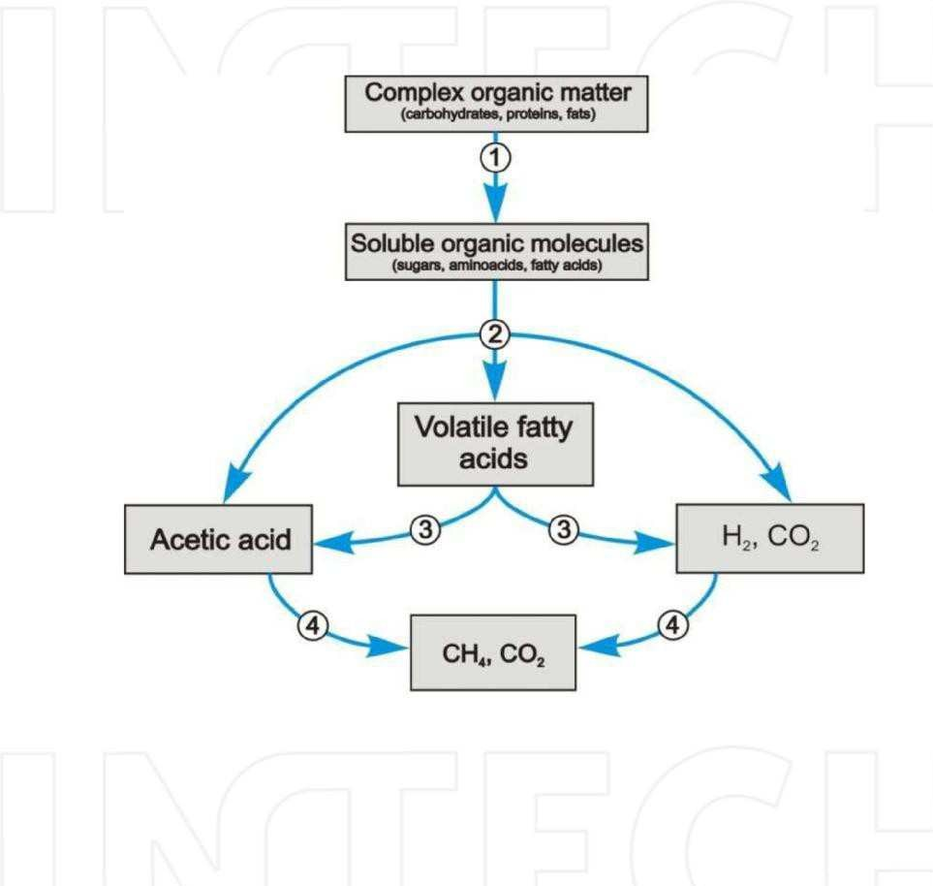Fig.7.2. Anaerobic pathway of complex organic matter degradation

In most cases biomass is made up of large organic compounds. In order for the microorganisms in anaerobic digesters to access the chemical energy potential of the organic material, the organic matter macromolecular chains must first be broken down in to their smaller constituent parts. These constituent parts or monomers such as sugars

are readily available to microorganisms for further processing. The process of breaking these chain sand dissolving the smaller molecules in to solution is called hydrolysis. Therefore hydrolysis of high molecular weight molecules is the necessary first step in an aerobic digestion. It may be enhanced by mechanical, thermal or chemical pretreatment of the waste. Hydrolysis step can be merely biological (using hydrolytic microorganisms) or combined: bio-chemical (using extra cellular enzymes), chemical (using catalytic reactions) as well as physical (using thermal energy and pressure) in nature.

Acetates and hydrogen produced in the first stages can be used directly by methanogens. Other molecules such as volatile fatty acids (VFA‘s) with a chain length that is greater than acetate must first be catabolised into compounds that can be directly utilized by methanogens. The biological process of acidogenesis is where there is further break down of the remaining components by acidogenic (fermentative) bacteria. Here VFA‘s are generated along with ammonia, carbondioxide and hydrogensulphide as well as other by- products.

The third stage anaerobic digestion is acetogenesis. Here simple molecules created through the acidogenesis phase are further digested

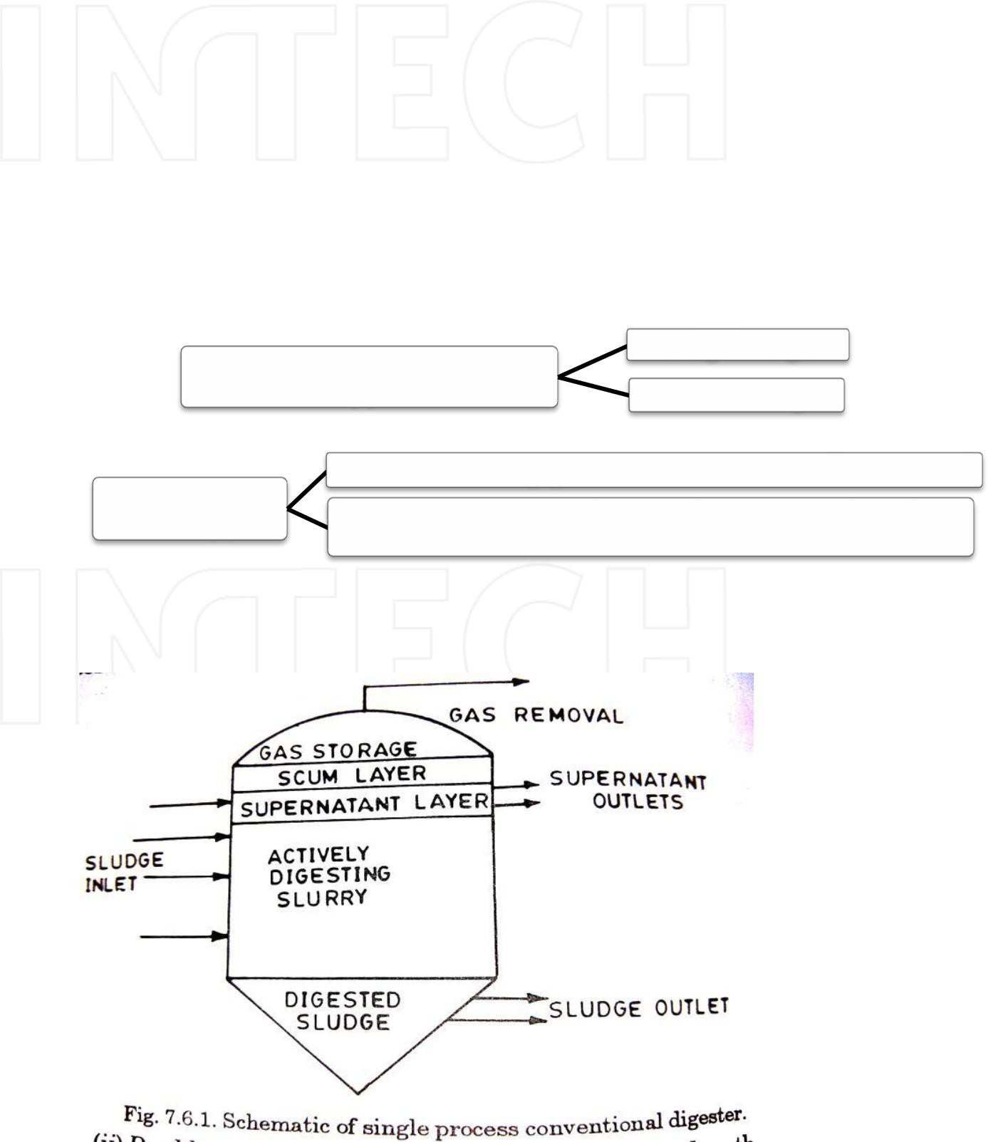by acetogens to produce largely aceticacid (oritssalts) as well as carbondioxide and hydrogen.

The final stage of anaerobic digestion is the biological process of methanogenesis. Here methanogenic archaea utilize the intermediate products of the preceding stages and convert the min to methane, carbondioxide and water. It is these components that makes up the majority of the biogas released from the system. Methanogenesis is– beside other factors-sensitive to both high and low pH values and performs well between pH 6.5 and pH 8. The remaining, non-digestible organic and mineralmaterial, which the microbes cannot feed upon, along with any dead bacterial residues constitutes the solid digestate.

**Classification of the biogas plants:**

1. Continuous and Batch Single stage type Double stage
2. Dome and

Floating gas holder or KVIC model

drum type Fixed dome type or Chainese model or Janatha model

1. **Variation in the above type Single** **stage continuous plant:**

The entire process of conversion of complex organic compounds into biogas in completed in a single chamber. This chamber is regularly fed with the raw materials while the spent residue keeps moving out. Serious problems



are encountered with agricultural residues when fermented in a single stage continuous process.

**Two stage continuous plant: (i)Acid & ii) Methane forming:**

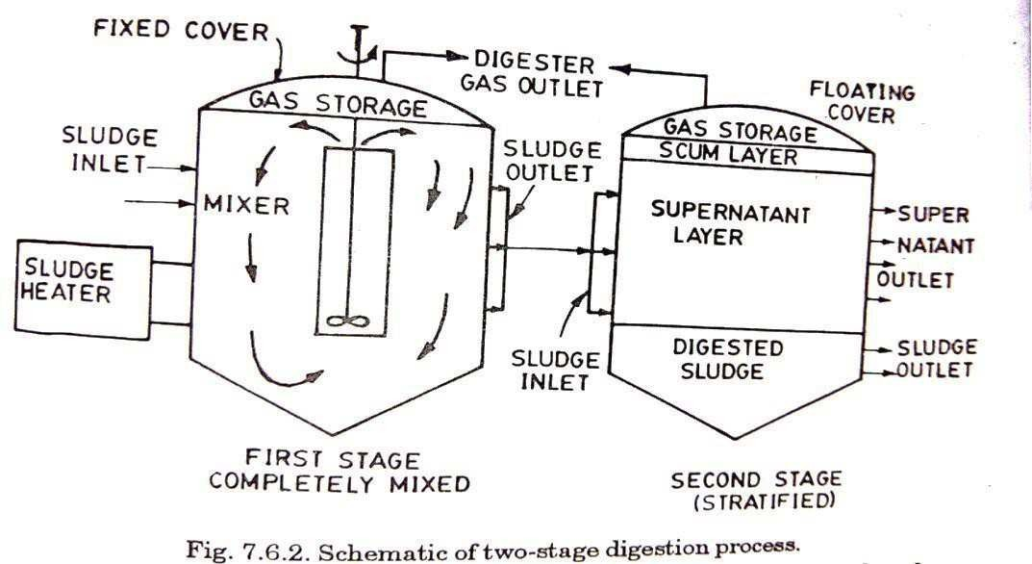

The acidogenic stage and methanogenic stage are physically separated into two chambers.

Thus the first stage of acid production is carried out in a

separate chamber and only the diluted acids are fed into the second chamber where bio- methanation takes place and the biogas can be collected from the second chamber. Considering the problems encountered in fermenting fibrous plant waste materials the two stage process may offer higher potential of success. However, appropriate technology suiting to rural India is needed to be developed based on the bauble stage process.

The main features of continuous plant are that:

* 1. It will produce gas continuously;
  2. It requires small digestion chambers;
  3. It needs lesser period for digestion;
  4. It has fewer problems compared to batch type and it is easier in operation.

1. **Indian Digester (Floating drum type/Khadi Villege Industries Commission Plant (KVIC)):**

This mainly consists of a digester or pit for fermentation and a floating drum for the collection of gas. Digester is 3.5-6.5 m in depth and 1.2 to 1.6 m in diameter. There is a partition wall in the center, which divides the digester vertically and submerges in the slurry when it is full. The digester is connected to the inlet and outlet by two pipes. Through the inlet, the dung is mixed with water (4:5) and loaded into the digester. The fermented material will flow out through outlet pipe. The outlet is generally connected to a compost pit. The gas generation takes place slowly and in two stages. In the first stage, the complex, organic substances contained in the waste are acted upon by a certain kind of

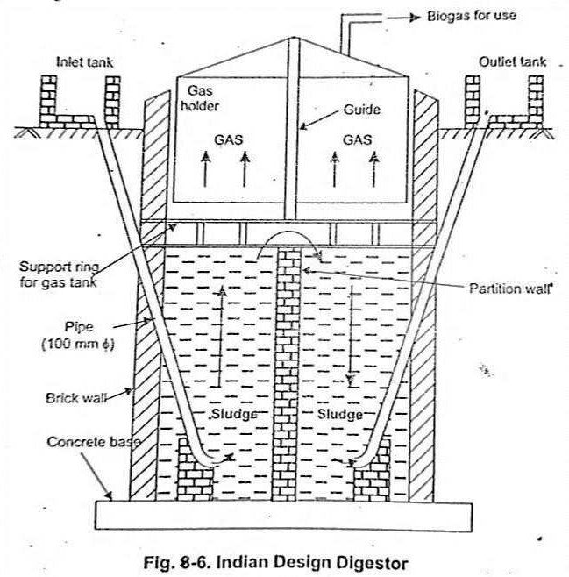bacteria, called acid formers and broken up into small-chain simple acids. In the second stage, these acids are acted upon by another kind of bacteria, called methane formers and produce methane and carbon dioxide.

**Gas holder:**

The gas holder is a drum

constructed of mild steel sheets. This is cylindrical in shape with concave top. The top is supported radially with angular iron stripes. The holder fits into the digester like a stopper. It sinks into the slurry due to its own weight and rests upon the ring constructed for this purpose. When gas is generated the holder rises and floats freely on the surface of slurry. A central guide pipe is provided to prevent the holder from tilting. The holder also acts as a seal for the gas. The gas pressure varies between 7 and 9 cm of water column. Under shallow water table conditions, the adopted diameter of digester is more and depth is reduced. The cost of drum is about 40% of total cost of plant. It requires periodical maintenance. The unit cost of KVIC model with a capacity of 2 m3/day costs approximately Rs.14, 000/.



Department of ME, Page 107



**Janata type biogas plant (Chinese):**

The design of this plant is of Chinese origin but it has been introduced

under the name —Janata biogas plant□ by Gobar Gas Research Station,

Ajitmal in view of its reduced cost. This is a plant where no steel is used, there is no moving part in it and maintenance cost is low. The plant can be constructed by village mason taking some pre-explained precautions and using all the indigenously available building materials. Good quality of bricks and cement should be used to avoid the afterward structural problems like cracking of the dome and leakage of gas. This model have a higher capacity when compared with KVIC model, hence it can be used as a community biogas plant. This design has longer life than KVIC models. Substrates other than cattle dung such as municipal waste and plant residues can also be used in janata type plants. The plant consists of an underground well sort of digester made of bricks and cement having a dome shaped roof which remains below the ground level is shown in figure. At almost middle of the digester, there are two rectangular openings facing

each other and coming up to a little above the ground level, act as an inlet and outlet of the plant. Dome shaped roof is fitted with a pipe at its top which is the gas outlet of the plant.

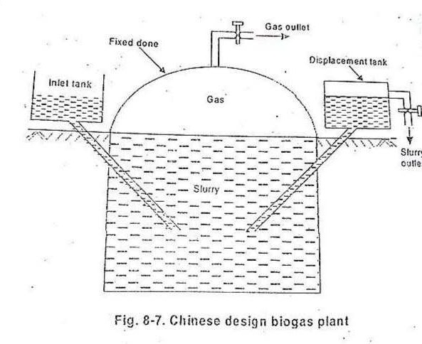The principle of gas production is same as that of KVIC model. The biogas is collected in the restricted space of the fixed dome; hence the pressure of gas is much higher, which is around 90 cm of water column.

**Deenbandhu biogas plant:**

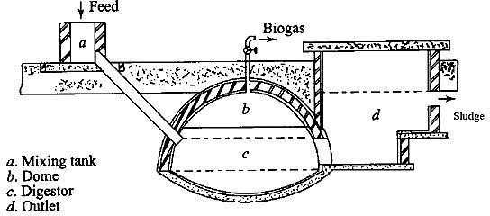

Deenbandhu model was developed in 1984, by Action for Food Production (AFPRO), a voluntary organization based in New Delhi. Schematic diagram of a Deenabandhu biogas plant entire biogas programme of India as it reduced the cost of the plant half of that of KVIC model and brought biogas technology within the reach of even the poorer sections of the population. The cost reduction has been achieved by minimizing the surface area through joining the segments of two spheres of different diameters at their bases. The cost of a Deenbandhu plant having a capacity of 2 m3/day is about Rs.8000/. The Deenbandhu biogas plant has a hemispherical fixed-dome type of gas holder, unlike the floating dome of the KVIC-design is shown. The dome is made from pre-fabricated Ferro cement or reinforced concrete and attached to the digester, which has a curved bottom. The slurry is fed from a mixing tank through an inlet pipe connected to the digester. After fermentation, the biogas collects in the space under the dome. It is taken out for use through a pipe connected to the top of the dome, while the sludge, which is a by-product, comes out through an opening in the side of the digester. About 90% of the biogas plants in India are of the Deenbandhu type. **Problems Related to Bio-gas Plants:**

Some problems are natural and some are created by the persons biogas plants owners but all are controllable.

* 1. Handling of effluent slurry is major problem if the person is not having sufficient open space or compost pits to get the slurry dry. Use of press filters and transportation is expensive and out of reach of poor farmers. For

a domestic plant, 200 litres capacity oil drums can be used to carry this effluent to the fields but this will require some human-animal labour or consumption of diesel if a auto vehicle is used.

* 1. The gas forming-methanogenic bacteria are very sensitive towards the temperature compared to those of non-methanogenic. During winter as the temperature falls, there is decrease in the activity of methanogenic bacteria and subsequently fall in gas production rate. Many methods have been suggested to overcome this temperature problem as described earlier, e.g.,
     1. Use of solar heated hot water to make a slurry of influent but the temperature of water should not exceed 60oC otherwise the mesophilic bacteria will die.
     2. Circulation of hot water obtained either from solar heater or I.C. engine heat exchanger, through pipes inside the digester.
     3. Green house effect also give good results but it is costlier and after few years the polythene sheet used in it becomes opaque.
     4. Addition of various nutrients for bacteria.
     5. Converting the biogas plant by straw bags during night hours.
  2. Due to lack of proper training to the bio-gas plant owners for the operation of plant, a lot of problems arises. It has been noticed that many persons increase the loading rate and some also do not try to mix the cattle dung with water, keeping in mind more gas production. Due to this, the flow of slurry from inlet towards outlet is very slow or even stops. This may cause accumulation of volatile fatty acids and drop in Ph and then failure of digester. Also it is not possible to stir the digester content of high solid concentration.
  3. Some persons add urea-fertilizer in large quantities due to which toxicity of ammonia nitrogen may cause a decrease in gas production.
  4. pH and volatile fatty acids play an important role in anaerobic digestion and should remain under optimum range otherwise this may cause upsetting of digester and even its failure. pH can be checked from time to time by the use of cheep and easily available pH paper but volatile fatty acids can only be determined in a laboratory having its testing facilities. For controlling pH in optimum range, it tends to fall below 7.0, lime has been

suggested, as it is easily available cheap material and does not harm the activity of bacteria.

* 1. Leakage of gas from gas holder especially in case of Janta type biogas plants is a major and very common problem. When there is quite enough gas in a gas holder, the leakage should be checked by using water and the points marked and then get repaired. During repairing there should be no gas inside the gas holder and the stop cock remains open till repaired points get dry. Quality of constructing material such as cement is important. **Advantages of Biogas:**

1. Biogas is an energy carrier which can be used for several energy applications (eg. electricity generation, heat production, combine heat and power production, transport fuel, injection to the natural gas grid).
2. Biogas can contribute to several sectors:
   1. Environment

(eg. Fight against Climate change)

* 1. Energy

(eg. Energy security, local source)

* 1. Agriculture

(eg. Sustainable cultivation and animal breeding)

* 1. Society

(eg. Employment enhancement, rural development)

1. Some Environmental benefits of biogas:
   1. Reduced emissions of greenhouse gases, direct and indirect (eg. CO2, CH4 and nitrous oxide –N2O).
   2. Water and Waste management (Reduced consumption of resources and increased recycling, reduced water environment pollution from leaching of nutrients, environmental friendly solution to the

waste disposal problem).

* 1. Reduced odour and flies nuisances.
  2. Soil and landscape

1. Emissions reduction of greenhouse gases (eg. CO2, CH4 and nitrous oxide –N2O). Direct:

The combustion of biogas also releases CO2. Compared to fossil fuels,

the carbon in biogas was recently up taken from the atmosphere, by photosynthetic activity of the plants (closed carbon cycle) .

* Biogas production by AD reduces also emissions of methane (CH4) and nitrous oxide (N2O) from storage and utilization of animal manure as fertilizer. It is worth mentioning that although biogas is a potential low
* carbon energy source, this depends on the way biogas is produced. In the case that biogas comes from residues, waste or from energy crops grown on abandoned agricultural and this offers sustained GHG advantages.
* Emissions reduction of greenhouse gases (eg. CO2, CH4 and nitrous oxide –N2O). Indirect:
* Utilisation of biogas substitute fossil fuel (such as lignite, hard coal, crude oil and natural gas) and thus reduces emissions (externalities).

1. Water and Waste management

* Compared to other biofuels, biogas needs the lowest amount of process water. This aspect is very important since many regions of the world face huge water problems
* One of the main advantages of biogas production is the ability to transform waste material into a valuable resource, by using it as feedstock for AD.
* Biogas technologies contribute to reduce the volume of wastes and the costs for waste disposal (transportation, disposal).

1. Health issues, odour and flies

Utilisation of digestate as fertilizer improves veterinary safety, when compared to untreated manure and slurries.

AD reduces odours (positive change in the composition of odours as well). Digestate is almost odourless and the remaining disappear shortly after application as fertilizer on the fields (ammonia odours).

1. Employment
2. Rural development
3. Local economy and Energy Market development

**Application of bio-gas in engines:**

**Biogas in Diesel Engine applications:**

Biogas generally has a high self-ignition temperature hence; it cannot be directly used in a CI engine. So it is useful in dual fuel engines. The dual fuel engine is a modified diesel engine in which usually a gaseous fuel called the primary fuel is inducted with air into the engine cylinder. This fuel and air mixture does not auto ignite due to high octane number. A small amount of diesel, usually called pilot fuel is injected for promoting combustion. The primary fuel in dual fuelling system is homogeneously mixed with air that leads to very low level of smoke. Dual fuel engine can use a wide variety of primary and pilot fuels. The pilot fuels are generally of high cetane fuel. Biogas can also be used in dual fuel mode with



vegetable oils as pilot fuels in diesel engines. Introduction of biogas normally leads to deterioration in performance and emission characteristics. The performance of engine depends on the amount of biogas and the pilot fuel used. Measures like addition of hydrogen, LPG, removal of CO2etc. have shown significant improvements in the performance of biogas dual fuel engines. The ignition delay of the pilot fuel generally increases with the introduction of biogas and this will lead to advance theinjection timing. Injectors opening pressure and rate of injection also are found to play important role in the case of biogas fuelled engine, where vegetables oil is used as a pilot fuel. The CO2percentage in biogas acts as diluents to slow down the combustion process in Homogenous charged compression ignition (HCCI) engines. However, it also affects ignition. Thus a fuel with low self-ignition temperature could be used along with biogas to help its ignition. This kind of engine has shown a superior performance as compared to a dual fuel mode of operation.

**Biogas in Dual Fuel Engine applications:**

In this case, the normal diesel fuel injection system still supplies a certain amount of diesel fuel. The engine however sucks and compresses a mixture of air and biogas fuel which has been prepared in external mixing device. The mixture is then ignited by and together with the diesel fuel sprayed in. The amount of diesel fuel needed for sufficient ignition is between 10% and 20% of the amount needed for operation on diesel fuel alone. Operation of the engine at partial load requires reduction of the biogas supply by means of a gas control valve. A simultaneous reduction

of airflow would reduce power and efficiency because of reduction of compression pressure and main effective pressure. So, the air/fuel ratio is changed by different amounts of injected biogas. All other parameters and elements of diesel engine remain unchanged.

**Biogas As Alternate Fuel In Diesel Engines:** A Literature Review Modification of diesel engine into dual fuel engine Advantages-Operation on diesel fuel alone is possible when biogas is not available.-Any contribution of biogas from 0% to 85% can substitute a corresponding part of diesel fuel while performance remains as in 100% diesel fuel operation.-Because of existence of a governor at most diesel engines automatic control of speed/power can be done by changing the amount of diesel fuel injection while the biogas flow remains uncontrolled. Diesel fuel substitutions by biogas are less substantial in this case.

**Limitations:**

-

The dual fuel engine cannot operate without the supply of diesel fuel for ignition.

-

The fuel injection jets may overheat when the diesel fuel flow is reduced to 10% or 15% of itsO normal flow. Larger dual fuel engines circulate extra diesel fuel through the injector for cooling. -



To what extent the fuel injection nozzle can be affected is however a question of itsO specific design, material and the thermal load of the engine, and hence differs from case to case. -

A check of the injector nozzle after 500 hours of operation in dual fuel is recommended.

**Biogas in HCCI Engine applications:**

The Homogeneous Charge Compression Ignition (HCCI) concept is a potential for achieving a high thermal efficiency and low Nitrogen Oxide (NO) emission. The HCCI engine with 50 % biogas as a primary fuel and 50% diesel as pilot fuel gives a maximum NO of 20 ppm is a major advantage over biogas diesel dual fuel mode. In biogas diesel dual fuel mode the presence of CO2 in biogas lowers the thermal efficiency however, in biogas diesel HCCI (BDHCCI) mode CO2 reduces high heat release rate. The break mean effective pressure (BMEP) in BDHCCI mode is in the range of 2.5 bar to 4 bar. The smoke and Hydro Carbon (HC) level were also low when the biogas is used as a primary fuel for BDHCCI mode. For HCCI operation the inducted charge temperature is required to be maintained at 80-135°C, which can be obtained from the exhaust heat. Thus biogas with HCCI engine gives high efficiency and low emission.

**REFER TO G. D. RAI FOR OTHER CHAPTERS.**



Department of ME, Page 113



**UNIT-1**

**TIDAL POWER**

Tides have a wave form, but differ from other waves because they are caused by the interactions between the ocean, Sun and Moon.

* Crest of the wave form is high tide and trough is low tide.
* The vertical difference between high tide and low tide is the tidal range.
* Tidal period is the time between consecutive high or low tides and varies between 12 hrs 25 min to 24 hrs 50 min.
* There are three basic types of daily tides defined by their period and regularity: Diurnal tides, Semidiurnal tides, and Mixed tides.

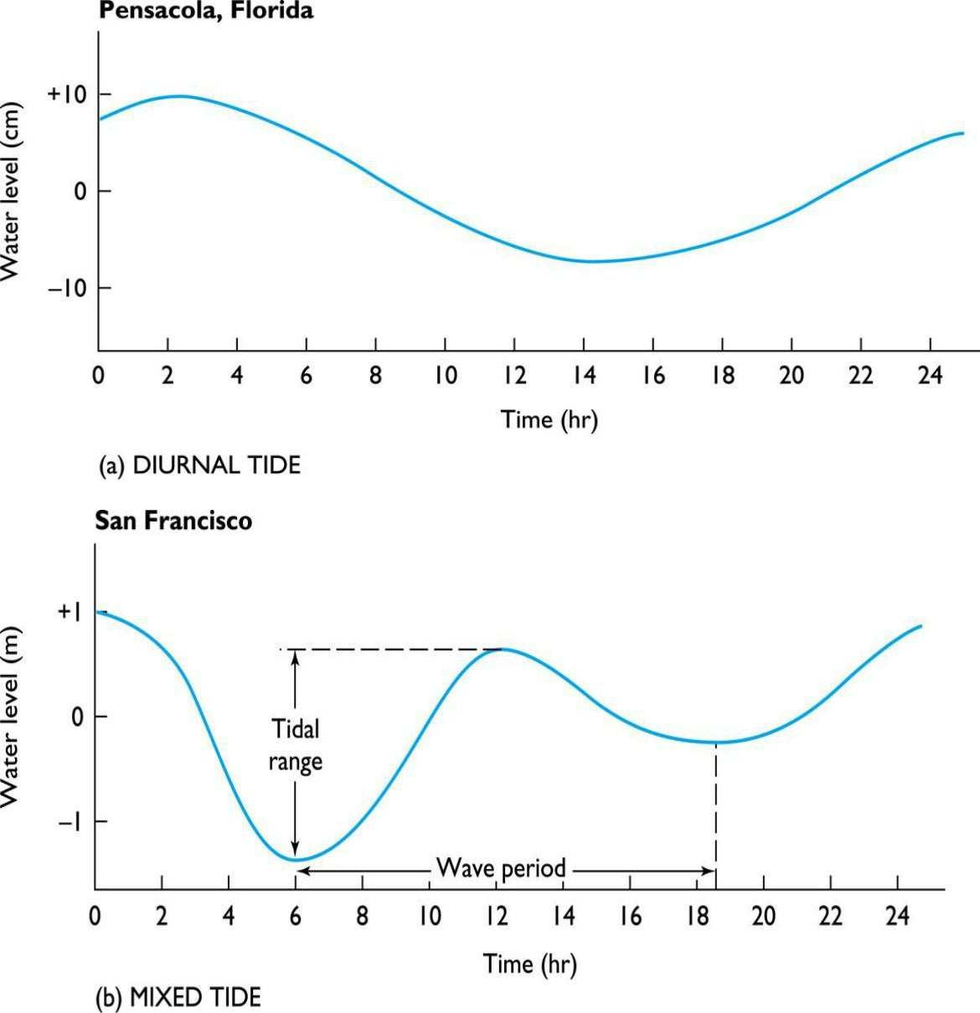

Note:

1. Over a month the daily tidal ranges vary systematically with the cycle of the Moon.
2. 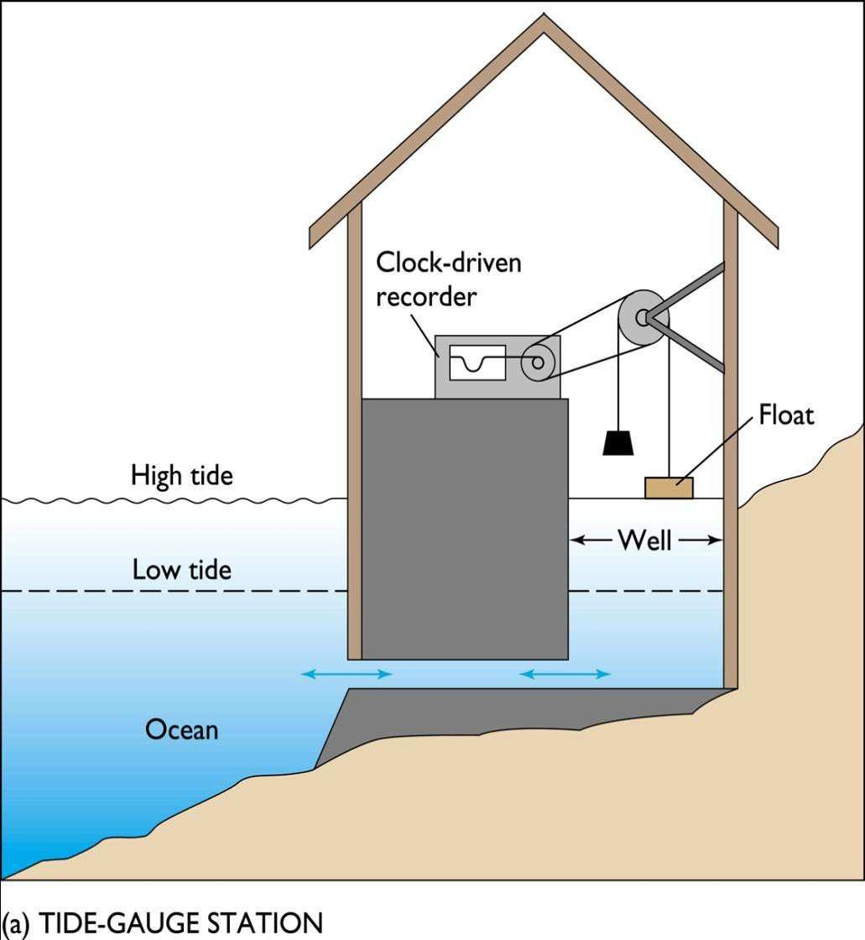Tidal range is also altered by the shape of a basin and sea floor configuration. Following figure shows a tide gauging station

Tides result from gravitational attraction and centrifugal effect.

* + Gravity varies directly with mass, but inversely with distance.
  + Although much smaller, the Moon exerts twice the gravitational attraction and tide-generating force as the Sun because the Moon is closer.
  + Gravitational attraction pulls the ocean towards the Moon and Sun, creating two gravitational tidal bulges in the ocean (high tides).
  + Centrifugal effect is the push outward from the center of rotation.

Following figures show how the gravitational forces and centrifugal forces create tides.

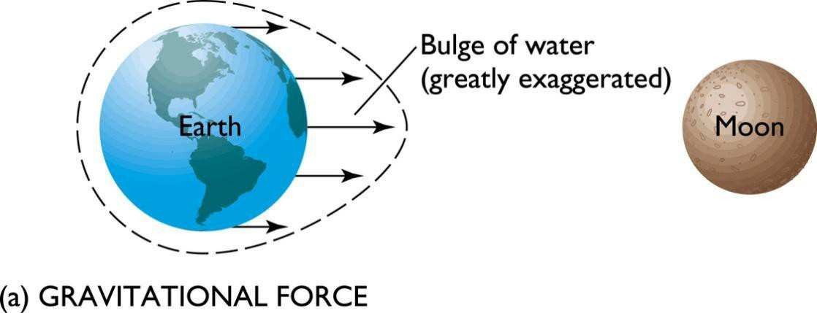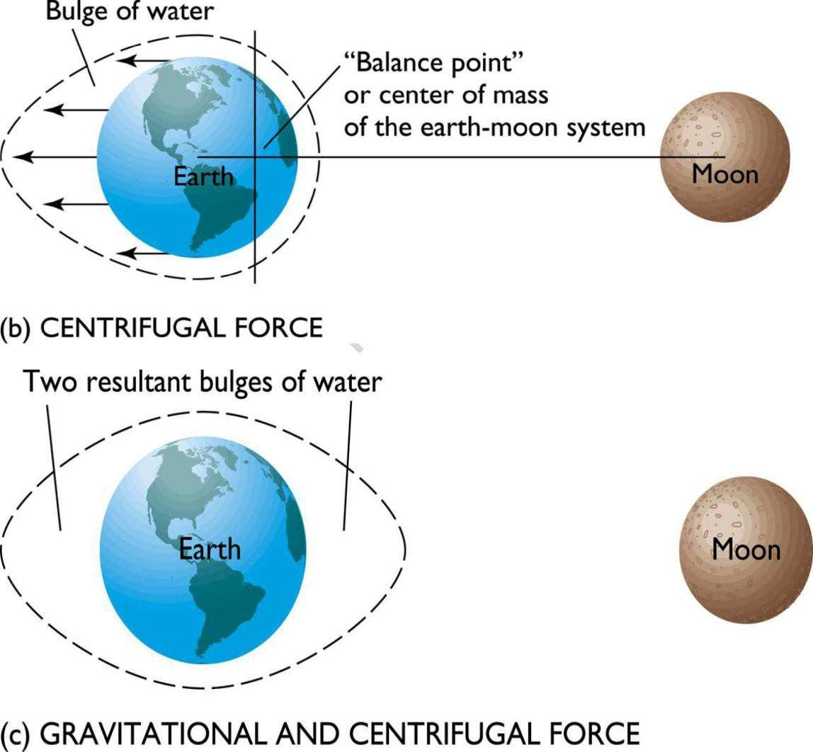

* + ​
  + Latitude of the tidal bulges is determined by the declination, the angle between Earth‘s axis and the lunar and solar orbital plane.
  + Spring tides occur when Earth, Moon and Sun are aligned in a straight line and the tidal bulges display constructive interference, producing very high, high tides and very low, low tides.
  + Spring tides coincide with the new and full moon.



* + Neap tides occur when the Earth, Moon and Sun are aligned forming a right angle and tidal bulges displaying destructive interference, producing low high tides and high low tides.
  + Neap tides coincide with the first and last quarter moon.

Earth on its axis and the Moon in its orbit both revolve eastward and these causes the tides to occur 50 minutes later each day.

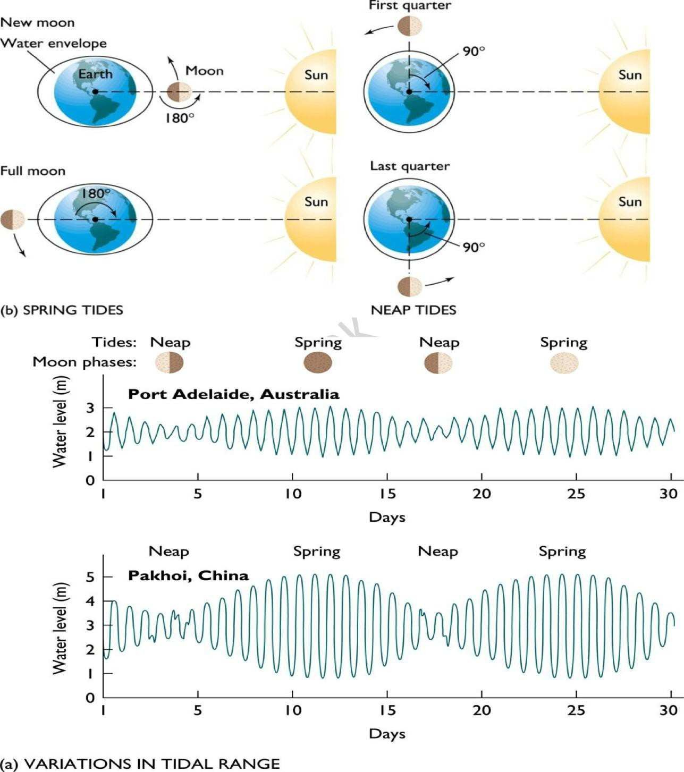

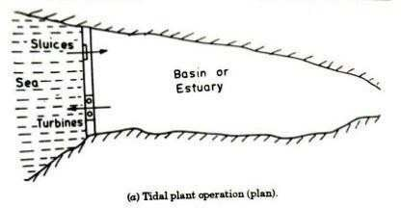

**Tidal Power Stations Single Basin Tidal System:**

* + The simplest generating system for tidal plants, known as an ebb generating system, involves a dam, known as a barrage across an estuary.
  + Sluice gates on the barrage allow the tidal basin to fill on the incoming high tides and to exit through the turbine system on the outgoing tide (known as the ebb tide).

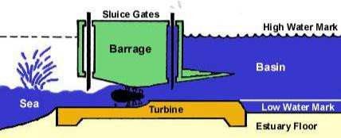

* + Alternatively, flood-generating systems, which generate power from the incoming tide are possible, but are less favored than ebb generating systems**.**

**Double basin Tidal System:** another form of energy barrage configuration is that of the dual basin type. With two basins, one is filled at high tide and the other is emptied at low tide. Turbines are placed between the basins. Two-basin schemes offer advantages over normal schemes in that generation time can be adjusted with high flexibility and it is also possible to generate almost continuously. In normal estuarine



Department of ME, Page

101

situations, however, two-basin schemes are very expensive to construct due to the cost of the extra length of barrage. There are some favorable geographies, however, which are well suited to this type of scheme.

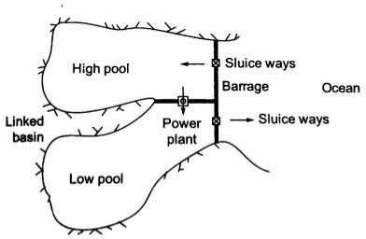

**Components of a tidal power station:**

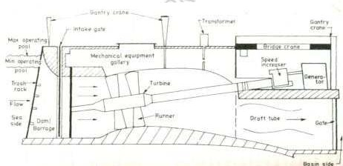

The main components of tidal power plant are

1. Power House
2. The Dam or Barrage
3. Sluice ways from basin to sea and vice versa

**DAM ( Barrage):**

The barrages store water behind them. The barrages should provide channels for the turbines, gates and locks. The tidal power barrages



should be of shorter length. The length should be less than resonant length of tidal waves. The tidal barrages require sites where a sufficiently high tidal range is available. The barrages require flat bottom.

**POWER HOUSE:**

Large size turbines are needed to because of small head available.Hence power house will also be large structure. The types of turbines used are

1. Bulb type:

In systems with a bulb turbine, water flows around the turbine, making access for maintenance difficult, as the water must be prevented from flowing past the turbine.

1. Rim type:

Rim turbines reduce these problems as the generator is mounted in the barrage, at right angles to the turbine blades. Unfortunately, it is difficult to regulate the performance of these turbines and it is unsuitable for use in pumping.

1. Tubular type:

Tubular turbines have been proposed for use some UK projects. In this configuration, the blades are connected to a long shaft and orientated at an angle so that the generator is sitting on top of the barrage.

Following are the figures.

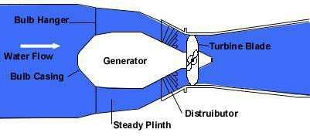

Bulb type turbine



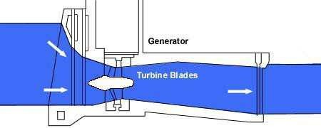

Rim type turbine

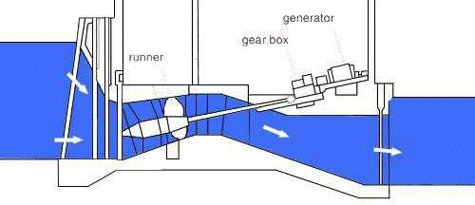

Tubular type turbine

**Estimation of tidal power: Single basin system:**

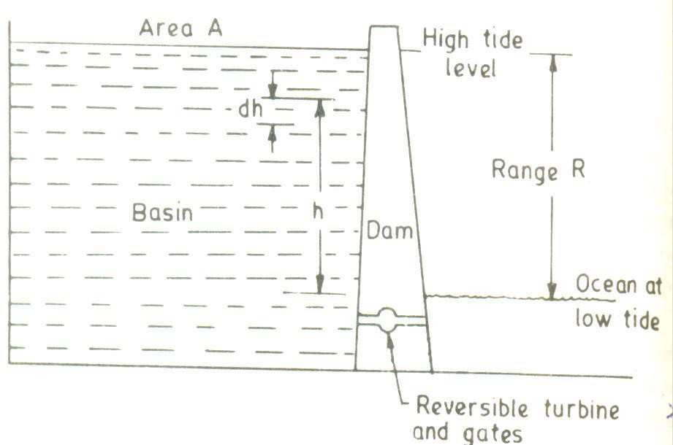

We can write

Where

W=work done by water in joules g=gravitational constant

= . .

= –

= –

m=mass flowing through the turbine, Kg h=head. m

p=water density,Kg/m3 A=basin surface area in m2

The total amount of work during a full emptying or filling is given by

0 0

= = –

1 2

=

2

The power is rate of doing work. The time taken for producing power once is tidal period. Tidal wave has period equal to6h,12.5min i.e,22350seconds.

1

2

= = 2

22350

1

= 44700 2

Assuming an average water density as 1025Kg/m3, The average power per unit basin area is given by,

1

=

44700

× 9.81 × 1025 × 2

= 0.225 2 watts/m2



***Example problem:***

A Tidal power plant of the simple single basin type has a basin area of 30X10 6 m2. The tide has a range of 12m. The turbine however stops operating when the head falls below three meters.Calculate the energy generated in one filling(or emptying) process, in KW hours if the generator efficiency is 0.73.

***Solution***

The total theoretical Work =

Here R=12m

R=the head below turbine stops operating=3m

= – = –

= 12( 2 – 2)

Thus the average power

1

=

1 ( 2 – 2)

= 2

44700

=447001 × 9.81 × 1025 × 30 × 106 × 135

= 44700 × 9.81 × 1025 × 30 × 106 × 122 – 32

=911.25× 106 watts= 911 .25 × 3600 × 106kWh = 3280.5 × 106

1000

Considering turbine generator efficiency, the energy generated

= 3280.5 × 106 × 0.73 = 2395 × 106



**Ocean Power:**

What is OTEC?

 OTEC, or Ocean Thermal Energy Conversion, is an energy technology that converts solar radiation to electric power.

 OTEC systems use the ocean's natural thermal gradient—the fact that the ocean's layers of water have different temperatures—to drive a power-producing cycle.

 As long as the temperature between the warm surface water and the cold deep water differs by about 20°C (36°F), an OTEC system can produce a significant amount of power with a maximum Carnot Efficiency of about 6.7%

**Lambert’s Law**

Solar Energy absorption by the water takes place according to Lambert‘s Law of absorption, which states that each layer of equal thickness absorbs the same fraction of light that passes through it.

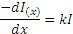

Where Io and I(x) are intensities of radiation at the surface(x=0) and at a distance x below the surface. K is the extinction coefficient and it has the value 0.05m-1 for very clear fresh water, 0.27 for turbid fresh water and 0.5m-1 for very salty water.

**Consequences of Lambert’s Law**

 Intensity decreases exponetially with depth and depending upon K value almost all the absorption takes place very close to the surface water. Maximum temperature occur just below the top surface of water.

 Deep water remains cool

 There will not be thermal convection currents between the warmer, lighter surface water and cool heavier water at the depth

 In the tropics, the ocean surface temperature often exceeds 250 C while 1Km below temperature is not higher than 100C



Department of ME, Page

107



 A heat engine can be made to work between these two temperatures and power can be obtained

**OTEC POWER PLANTS**

***Open-Cycle(Claude Cycle):***

Open-cycle OTEC uses the tropical oceans' warm surface water to make electricity. When warm seawater is placed in a low-pressure container, it boils. The expanding steam drives a low-pressure turbine attached to an electrical generator. The steam, which has left its salt behind in the low-pressure container, is almost pure fresh water. It is condensed back into a liquid by exposure to cold temperatures from deep-ocean water.

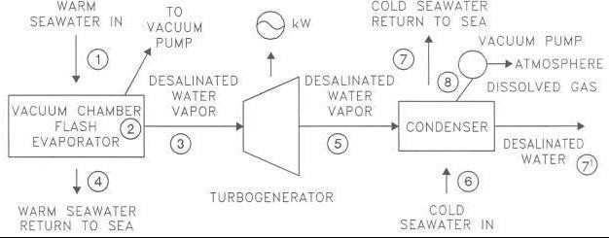

**Open cycle thermodynamic analysis:**

In this scheme, warm surface water at around 27 °C (81 °F) enters an evaporator at pressure slightly below the saturation pressure causing it to vaporize.



Where *Hƒ* is enthalpy of liquid water at the inlet temperature, *T*1.

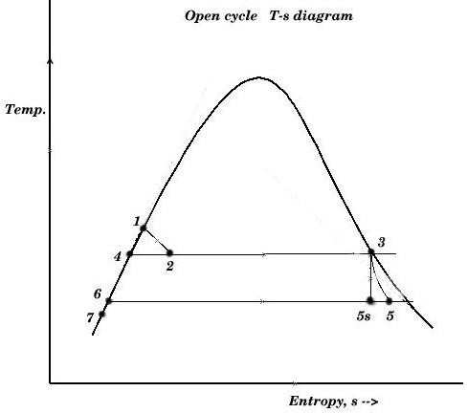

This water undergoes volume boiling as opposed to pool boiling in conventional boilers where the heating surface is in contact. Thus the water partially flashes to steam with two-phase equilibrium prevailing. Suppose that the pressure inside the evaporator is maintained at the saturation pressure, *T*2.



Here, *x*2 is the fraction of water by mass that vaporizes. The warm water mass flow rate per unit [turbine](http://en.wikipedia.org/wiki/Turbine) mass flow rate is 1/*x*2.

The low pressure in the evaporator is maintained by a [vacuum pump](http://en.wikipedia.org/wiki/Vacuum_pump) that also removes the dissolved non-condensable gases from the evaporator. The evaporator now contains a mixture of water and steam of very low [vapor quality](http://en.wikipedia.org/wiki/Vapor_quality) (steam content). The steam is separated from the water as saturated vapor. The remaining water is saturated and is discharged to the ocean in the open cycle. The steam is a low pressure/high [specific volume](http://en.wikipedia.org/wiki/Specific_volume) working fluid. It expands in a special low pressure turbine



Here, *Hg* corresponds to *T*2.

For an ideal [isentropic](http://en.wikipedia.org/wiki/Isentropic_process) [(reversible adiabatic](http://en.wikipedia.org/wiki/Reversible_adiabatic)) turbine,



The above equation corresponds to the temperature at the exhaust of the turbine, *T*5. *x*5,*s* is the mass fraction of vapor at state 5.

The enthalpy at *T*5 is,



This enthalpy is lower. The adiabatic reversible turbine work = *H*3-*H*5,*s* . Actual turbine work *W*T = (*H*3-*H*5,*s*) x *polytropic eƒƒiciency*



The condenser temperature and pressure are lower. Since the turbine exhaust is to be discharged back into the ocean, a direct contact condenser is used to mix the exhaust with cold water, which results in a near-saturated water. That water is now discharged back to the ocean.



*H*6=*Hƒ*, at *T*5. *T*7 is the temperature of the exhaust mixed with cold sea water, as the vapour content now is negligible



The temperature differences between stages include that between warm surface water and working steam, that between exhaust steam and cooling water, and that between cooling water reaching the condenser and deep water. These represent external [irreversibility](http://en.wikipedia.org/wiki/Reversible_process) that reduce the overall temperature difference.

The cold water flow rate *per* unit turbine mass flow rate,

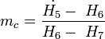

Turbine mass flow rate,

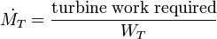

Warm water mass flow rate,



Cold water mass flow rate



*Closed-Cycle* (Rankine)

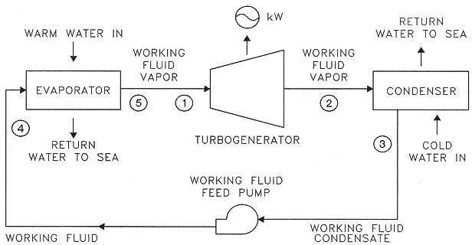

Closed-cycle systems use fluid with a low-boiling point, such as ammonia, to rotate a turbine to generate electricity. Here's how it works. Warm surface seawater is pumped through a heat exchanger where the low-boiling-point fluid is vaporized. The expanding vapor turns the turbo-generator. Then, cold, deep seawater—pumped through a second heat exchanger—condenses the vapor back into a liquid, which is then recycled through the system.

**Thermodynamic analysis**

In this cycle, *Qh* is the heat transferred in the evaporator from the warm sea water to the working fluid. The working fluid exits the evaporator as a gas near its [dew point.](http://en.wikipedia.org/wiki/Dew_point)

The high-pressure, high-temperature gas then is expanded in the turbine to yield turbine work, *Wt*. The working fluid is slightly superheated at the turbine exit and the turbine typically has an efficiency of 90% based on reversible, adiabatic expansion.

From the turbine exit, the working fluid enters the condenser where it rejects heat, *-QC*, to the cold sea water. The condensate is then compressed to the highest pressure in the cycle, requiring condensate pump work, *WC*. Thus, the Anderson closed cycle is a Rankine-type cycle

similar to the conventional power plant steam cycle except that in the Anderson cycle the working fluid is never superheated more than a few [degrees Celsius](http://en.wikipedia.org/wiki/Degrees_Fahrenheit). Owing to viscous effects, working fluid pressure drops in both the evaporator and the condenser. This pressure drop, which depends on the types of heat exchangers used, must be considered in final design calculations but is ignored here to simplify the analysis. Thus, the parasitic condensate pump work, *Wc*, computed here will be lower than if the heat exchanger pressure drop was included. The major additional parasitic energy requirements in the OTEC plant are the cold water pump work, *Wct*, and the warm water pump work, *Wht*. Denoting all other parasitic energy requirements by *Wa*, the net work from the OTEC plant, *Wnp* is



The thermodynamic cycle undergone by the working fluid can be analyzed without detailed consideration of the parasitic energy requirements. From the first law of thermodynamics, the energy balance for the working fluid as the system is

where *Wn* = *Wt* + *Wc* is the net work for the thermodynamic cycle.



Department of ME, Page

111

For the idealized case in which there is no working fluid pressure drop in the heat exchangers, and so that the net thermodynamic cycle work becomes,

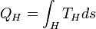

and

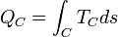

so that the net thermodynamic cycle work becomes

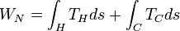

Sub cooled liquid enters the evaporator. Due to the heat exchange with warm sea water, evaporation takes place and usually superheated vapor leaves the evaporator. This vapor drives the turbine and the 2-phase mixture enters the condenser. Usually, the subcooled liquid leaves the condenser and finally, this liquid is pumped to the evaporator completing a cycle

**Hybrid System:**

Hybrid systems combine the features of both the closed-cycle and open-cycle systems. In a hybrid system, warm seawater enters a vacuum chamber where it is flash-evaporated into steam, similar to the open-cycle evaporation process. The steam vaporizes a low- boiling-point fluid (in a closed-cycle loop) that drives a turbine to produces electricity.

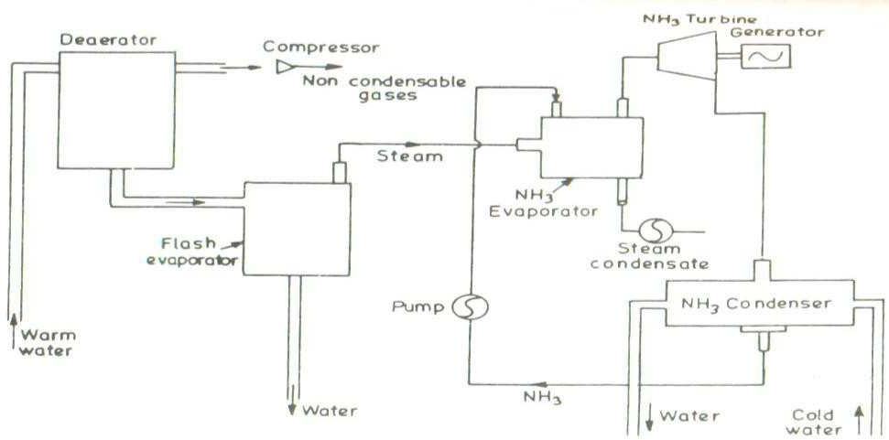



Department of ME, Page

112

**Advantages:**

 **Low Environmental Impact**

The distinctive feature of OTEC energy systems is that the end products include not only energy in the form of electricity, but several other synergistic products.

 **Fresh Water**

The first by-product is fresh water. A small 1 MW OTEC is capable of producing some 4,500 cubic meters of fresh water per day, enough to supply a population of 20,000 with fresh water.

 **Food**

A further by-product is nutrient rich cold water from the deep ocean. The cold "waste" water from the OTEC is utilised in two ways. Primarily the cold water is discharged into large contained ponds, near shore or on land, where the water can be used for multi-species mariculture (shellfish and shrimp) producing harvest yields which far surpass naturally occurring cold water upwelling zones, just like agriculture on land.

* **Minerals**

OTEC may one day provide a means to mine ocean water for 57

trace elements. Most economic analyses have suggested that mining the ocean for dissolved substances would be unprofitable because so much energy is required to pump the large volume of water needed and because of the expense involved in separating the minerals from seawater. But with OTEC plants already pumping the water, the only remaining economic challenge is to reduce the cost of the extraction process.



Department of ME, Page 113

# UNIT-I

## Principles of solar radiation:

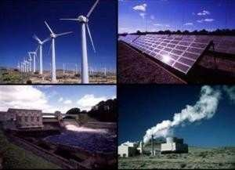

### MAN AND ENERGY:

˜ ENERGY is the ability to do work.

˜ ENERGY is the primary and most universal measure of all kind of work by human beings and nature.

˜ Energy: It is the capability to produce motion, force, work, change in shape, change in form etc.

Energy exists in several forms such as:

˜ Chemical energy

˜ Nuclear energy

˜ Mechanical energy

˜ Electrical energy

˜ Internal energy

˜ Bio-energy in vegetables and animal bodies

˜ Thermal energy etc.

˜ Man has needed and used energy at an increasing rate for his sustenance and well- being ever since he came on the earth a few million years ago.

˜ Primitive man required energy primarily in the form of food. He derived this by eating plants or animals which he hunted. Subsequently he discovered fire and his energy needs increased as he started to make use of wood and other biomass to supply the energy needs for cooking as well as for keeping himself warm.

˜ With the passage of time man started to cultivate land for agriculture. He added a new dimension to the use of energy by domesticating and training animals to work for him. With further demand for energy, man began to harness the wind for sailing ships and for driving windmills, and the force of falling water to turn water wheels.

˜ Till this time, it would not be wrong to say that the sun was supplying all the energy needs of man either directly or indirectly and that man was using only renewable sources of energy.

### CLASSIFICATION OF ENERGY SOURCES:

1. **BASED ON USABILITY**
   1. PRIMARY SOURCES

˜ These sources are obtained from environment.

˜ Example: fossil fuels, solar energy, hydro energy and tidal energy.

* 1. SECONDARY SOURCES

˜ These resources do not occur in nature but are derived from primary energy resources.

* 1. SUPPLY MENTRY SOURCES

˜ It is define as those whose net energy yield is zero and those requiring highest investment in terms of energy insulation (thermal) is an example of this source.

1. **BASED ON TRADITIONAL**
   1. CONVECTION

˜ The sources of energy which have been in use for a long time, e.g., coal, petroleum, natural gas and water power.

* 1. NON CONVECTION

˜ The resources which are yet in the process of development over the past few years. It includes solar, wind, tidal, biogas, and biomass, geothermal.

1. **BASED ON LONG TERM AVAILABILITY**
   1. RENEWABLE

˜ These sources are being continuously produced in nature and are inexhaustible.

˜ Wood, wind energy, biomass, biogas, solar energy etc.

* 1. NON RENEWABLE

˜ These are finite and exhaustible.

˜ Coal, petroleum etc.

1. **BASED ON COMMERCIAL APPLICATION**
   1. COMMERCIAL

˜ The commercial energy has great economic value. This energy pollutes the environment badly. These types of energy are limited in nature. High capital investment is required in the purification. It is used in urban as well as rural areas. Coal, petroleum, natural gas and nuclear energy.

* 1. NON COMMERCIAL

˜ The non-commercial energy is cheaper. This is pure and keeps the environment clean. Abundant in nature. It can be used in raw form. It is dominantly used in rural areas. Cow dung, charcoal, firewood and agricultural waste.

### WORLD’S AND INDIA’S PRODUCTION AND RESERVES OF ENERGY

˜ Today, every country draws its energy needs from a variety of sources.

˜ We can broadly categorize these sources as

* + 1. Commercial/Conventional
    2. Non-commercial/Non-conventional

˜ The commercial source include the fossil fuels, nuclear, Hydro-electric power, while the non-commercial source include wood ,animal waste and agricultural wastes.

**GLOBAL ENERGY CONSUMPTION**

˜ The global primary energy consumption at present was equivalent to 9741 million tons of oil equivalent (Mtoe)

|  |  |  |
| --- | --- | --- |
| Coal | 32.5 |  |
| Oil | 38.3 |
| Gas | 19 | **92%** |
| Uranium | 0.13 |  |
| Hydro | 2 |  |
| Wood | 6.6 |  |
| Dung | 1.2 | **8%** |
| Waste | 0.3 |  |

### CONVECTIONALINON RENEWABLE ENERGY SOURCES

Convectional sources are as follow: FOSSIL FUEL: Coal

Oil Ga s

Uranium/

Nuclear Hydro- electric

**COAL**

˜ It has been estimated that there are over 847 billion tones of proven coal reserve worldwide. This means that there is enough coal to last us around 118 years at current rate of production (2011). In contrast, proven oil and gas reserves are equivalent to around 46 and 59 years at current production levels respectively.

˜ Coal reserves are available in almost every country worldwide, with recoverable reserves in around 70 countries. The biggest reserves are in the USA, Russia, China, and India.

˜ Coal provides 30.3% of global primary energy needs and generates 42% of the world's electricity. In 2011 coal was the fastest growing form of energy outside renewable. Its share in global primary energy consumption increased to 30.3% - the highest since 1969.

˜ Total world coal production reached a record level of7,678 Mt in year 2011, increasing by 6.6% over 2010. The average annual growth rate of coal since 1999 was 4.4%.

**India’s scenario**

˜ The coal reserves in India up to depth of 1200 meters have been estimated by the geological survey of India is 285.86 billion tones as on 1st April, 2011,

˜ Coal deposits are chiefly located in Jharkhand, Odessa, Chhattisgarh, west Bengal, Madhya Pradesh, Andhra Pradesh, and Maharashtra.

˜ The coal production all over India during the year 2011 was 588.5 million tones

˜ = 5.6% of world's production.

˜ The production of coal by country and year is shown in Table 1.1:

*Table 1.1*

|  |  |  |  |  |  |  |  |
| --- | --- | --- | --- | --- | --- | --- | --- |
| Country | Production Year | | % share | | | Reserve life (years) | |
|  | 2010 | | 2011 |  |  |  |
| China | | 3235 | | 3520 | 49.5 | | 35 |
| USA | | 983.7 | | 992.8 | 14.1 | | 239 |
| India | | 573.8 | | 588.5 | 5.6 | | 103 |
| European Union | | 535.7 | | 576.1 | 4.2 | | 97 |
| Australia | | 424 | | 415.5 | 5.8 | | 184 |

**OIL**

˜ World's proven oil reserves in 2012 are estimated to be about 1324 billion barrels; it is equivalent to 210.5 x 109 m3. The most of the world's oil reserves (56%) are in the Middle East.

˜ Oil began to be used in significant quantities around 1900 and that there was an almost steady increase in its production all through and even during the world wars. The production increased at the average rate of over 7% per year from 1945 to 1973 and reached a value of 19.96 billion barrels in 1973. Thereafter with the beginning of the oil crisis, the annual production fluctuated up and down for 12 years from 1973 to 1985 before starting to increase more or less steadily from 1985 onwards.

**India’s scenario**

˜ In 1951, the consumption of petroleum products was only 3.89 Mt, most of which were imported; while in 2011 it was increase to 141.785 Mt.

˜ Crude oil production during 2010-11 at 37.71 Mt. The refining capacity in country was 187.686 Mt per annum as on 1st April 2011.

˜ India has total reserves (proved and indicated) of 757 Mt of crude oil 1 as on 1st April 2011.

**NATURAL GAS**

˜ Natural gas is a mixture of various compounds of hydrocarbons and small quantities of non-hydrocarbons.

˜ The world's proven natural gas reserves are estimated to be 196,163 billion m3 in the year 2011. They were 192,549 billion m3 in the year 2010. Associated gas will last for approximately the same time as crude oil. However, the presence of non- associated gas should help. Thus, the peak in the production of natural gas may occur around 2025, about 10 years after the peak in oil production.

˜ The world's marketed production of natural gas is about 2,636,611 million m3 in the year 2011. It is seen that the production has been increasing more or less continuously at the rate of about 5% per year.

˜ India has total reserves (proved and indicated) of 1241 billion m3 of natural gas as on 1st April 2011.Gross production of natural gas in the country at

52.22 billion m3 during 2010-11

**HYDRO-ELECTRIC POWER**

˜ Hydro-electric power (water power) is developed by allowing water to fall under the force of gravity. Hydroelectricity accounted for 16% of global electricity consumption and 3,644 terawatt hours of electricity production in 2011.

˜ Hydroelectric power is produced in 150 countries with the Asia-Pacific region generated 32% of global hydropower in 2010. China is the largest hydroelectricity producer, with 721 terawatt-hours of production in 2010, representing around 17% of domestic electricity use.

˜ Brazil, Canada, New Zealand, Norway, Paraguay, Australia, Switzerland, and Venezuela have a majority of the internal electric energy production from hydroelectric power. Paraguay produces 100% of its electricity from hydroelectric dams, and exports 90% of its production to Brazil and to Argentina. Norway produces 98-99% of its electricity from hydroelectric sources.

˜ Out of the total power generation installed capacity in India of 1, 76,990 MW (June, 2011), hydro power contributes about 21.5%, i.e. 38,106 MW.

˜ The public sector has a predominant share of 97% in this sector.

˜ National Hydroelectric Power Corporation (NHPC), Northeast Electric Power company (NEEPCO), Satluj Jal Vidyut Nigam ltd.(SJVNL), Tehri Hydro Development Corporation, NTPC-Hydro are a few public sector companies engaged in development of Hydro electric power in India.

**NUCLEAR POWER**

˜ Nuclear power is developed by fission reactions of nuclear fuel in nuclear reactor.

˜ Common nuclear fuel used is uranium. Nuclear power plants provided 12.3% of the world's electricity production in 2011. In total, 13 countries relied on nuclear energy to supply at least one-quarter of their total electricity.

˜ As of August 2012, 30 countries worldwide are operating 435 nuclear reactors for electricity generation and 66 new nuclear plats are under construction in 14 countries.

˜ The world's resources of uranium are estimated to be 8.8 Mt.

˜ As of 2011, India had 4.8 GW of installed electricity generation capacity using nuclear fuels. Nuclear power plants generated 32455 million units or 3.75% of total electricity produced in India.

˜ India's nuclear power plant development began in 1964. India signed an agreement with general electric of the United States for the construction and commissioning of two boiling water reactors at Tarapur. In 1967, this effort was placed under India's Department of atomic energy. In, 1971, India set up its first pressurized heavy water reactors with Canadian collaboration in Rajasthan. In 1987, India created Nuclear Power Corporation of India Limited (NPCIL) to commercialize nuclear power.

˜ India's Kakrapar-I reactor is the world's first reactor which uses thorium rather than Depleted uranium to achieve power flattening across the reactor core. India, which has about 25% of the world's thorium reserves; is developing a

300 MW prototype of a thorium-based Advanced Heavy Water Reactor (AHWR). The prototype is expected to be fully operational by 2013, after which five more reactors will be constructed. India currently envisages meeting 30% of its electricity demand through thorium based reactors by 2050.

˜ India's resources of uranium are not extensive. It is estimated that reserves available are about 61,000 t. It is easy to show that the reserves would only be adequate for providing

˜ The requirements of an installed capacity of 10,000 MW for about 30 years.

**Advantages of convectionalInon renewable energy sources**

˜ The advantage of non renewable energy is it's easy and cheap to use.

˜ There is no better way to store transfer and use energy than gasoline for powering motor vehicles.

˜ It's quick to pump fossil fuel into a car. It's stable in the tank and a gas tank hold quite a bit, and a gasoline powered car is cheap to manufacture.

˜ Coal is a ready-made fuel. It is relatively cheap to mine and to convert into energy. Coal supplies will last longer than oil or gas Oil is a ready-made fuel. Relatively cheap to mine and to convert into energy It is a relatively cheap form of energy.

˜ Natural Gas is a ready-made fuel. It's a slightly cleaner fuel than coal or oil, emitting less carbon dioxide.

˜ Nuclear has a small amount of radioactive material produces a lot of energy. And raw materials are relatively cheap and can last quite a long time. It doesn't give off atmospheric pollutants.

**Disadvantages of convectionalInon renewable energy sources**

˜ Non-renewable energy comes from fossil fuels (coal, oil, natural gas, uranium): they are non-renewable and fast depleting.

˜ They leave behind harmful by-products upon combustion, thereby causing a lot of pollution; mining of such fuels leads to irreversible damage to the adjoining environment.

˜ Fossil fuels pollute the environment. They will eventually run out. Prices for fossil fuels are rising, especially if the real cost of their carbon is included. Burning fossil fuels produces carbon dioxide, a major cause of global warming.

### NON CONVENTIONALI RENEWABLE ENERGY SOURCE PRODUCTION & RESERVE

˜ These sources include wind energy, solar energy, biomass and biofuel, small hydro resources, geothermal energy etc.

˜ The mankinds have started the use of these sources recently, hence they are known as non-conventional energy sources. The share of these sources in world's electricity generation is around 3% in 2011.

˜ The use of wind power is increasing at an annual rate of 20% with a worldwide installed capacity of 238,000 MW at the end of 2011, and is widely used in Europe, Asia, and the United States. Since 2004, photovoltaics passed. Wind as the fastest growing energy source, and since 2007 has more than doubled every two years.

˜ At the end of 2011 the photovoltaic (PV) capacity worldwide was 67,000 MW, and PV power stations are popular in Germany and Italy.

˜ Solar thermal power stations operate in the USA and Spain, and the largest of these is the 354 MW SEGS power plant in the Mojave Desert.

˜ The world's largest geothermal power installation is the Geysers in California; with aerated capacity of 750 MW Brazil has one of the largest renewable energy programs in the world, involving production of ethanol fuel from sugarcane, and ethanol now provide 18% of the country's automotive fuel. Ethanol fuel is also widely available in the USA.

˜ Top ten wind power generating countries are given in table 1.2

*Table 1.2*

|  |  |  |  |
| --- | --- | --- | --- |
| COUNTRY | TOTAL CAPACITY IN 2011(MW) | COUNTRY | TOTAL CAPACITY IN 2011(MW) |
| China | 62,733 | France | 6,800 |
| USA | 46,919 | Italy | 6,747 |
| Germany | 29,060 | U.K. | 6,540 |
| Spain | 21,674 | Canada | 5,265 |
| India | 16,084 | Portugal | 4,083 |

**India’s non-conventional sources**

1. **Grid based:** As of June 2011, the Government of India was successful in deploying a total of 2051.05 MW capacity of grid based renewable energy 14550.68 MW of which was from wind power, 3105.63 MW from small hydro power, 1742.53 MW from bagasse cogeneration, 1045.10 MW from biomass power, 39.66 MW from solar power (SPV), and the rest from waste to power.
2. **Off-grid:** As of June 2011, the total deployment total deployment of off-grid based renewable energy capacity was 601.23 MW Of these, biomass (non- bagasse) cogeneration consisted of 316.76 MW, biomass gasifier was 133.63 MW; waste to energy was 73.72 MW. SPV systems (less than 1 kW) capacity was 69 MW, and the rest from micro-hydro and wind power.

As was the case for the world, in India also, wind energy is the main contributor. India has the fifth largest installed wind power capacity in the world. In 2011, wind power accounted for 6% of India's total installed power capacity, and 1.6% of the country's power output. Suzlon is the leading Indian company, in wind power, with an installed generation capacity of 6.2 GW in India.

### NON-CONVENTIONAL SOURCESIRENEWABLE ENERGY SOURCES

˜ A plenty of energy is needed to sustain industrial growth and agricultural production. The existing sources of energy such as coal, oil, uranium etc. may not be adequate to meet the ever increasing energy demands. These conventional sources of energy are also depleting and may be exhausted at the end of the century or beginning of the next century.

˜ Consequently sincere and untiring efforts shall have to be made by the scientists and engineers in exploring the possibilities of harnessing energy from several non- conventional energy sources.

˜ The various non-conventional energy sources are as follows:

* 1. Solar energy
  2. Wind energy
  3. Energy from biomass and biogas
  4. Ocean thermal energy conversion
  5. Tidal energy
  6. Geothermal energy
  7. Hydrogen energy
  8. Fuel cells
  9. Magneto-hydro-dynamic generator
  10. Thermionic converter
  11. Thermo-electric power.

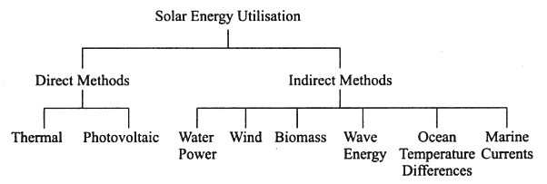

1. **Direct application of solar energy**
   1. Solar Space heating and cooling of residential buildings
   2. Solar water heating
   3. Solar drying of agricultural and animal products
   4. Solar distillation
   5. Salt production by evaporation of seawater or inland brines
   6. Solar cookers
   7. Solar pumping
   8. Food refrigeration
   9. Solar green houses
   10. Solar furnaces
   11. Solar electric Power generation
   12. Solar photovoltaic cells
2. **Indirect application of solar energy**
3. **Wind energy**

˜ A small portion of solar radiation reaches on earth surface causes wind due to:

* 1. Heating up of earth surface due to absorption of solar radiation and cooling at night.
  2. Rotation of earth and its motion around sun.

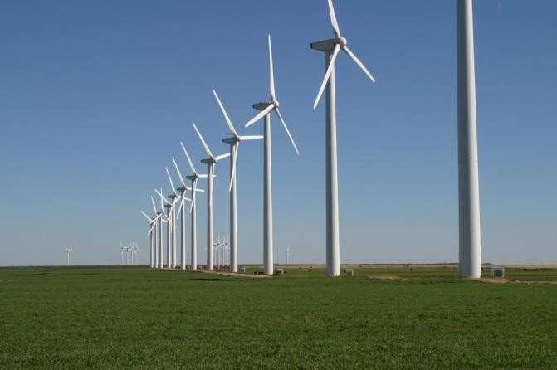

*Fig1.1 Horizontal Axis Wind Turbine*

1. **Tidal energy**

˜ Tides are generated due to gravitational pull between the earth and the moon and sun.

˜ The difference between high tide & low tide could be utilized to operate hydraulic turbine.

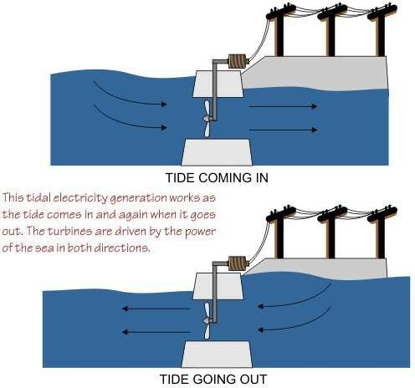

*Fig1.2*

1. **Wave energy**

˜ The wave energy is developed due to wind interacting with the surface of the ocean .wind get 1 to 5% of sun energy and part of this is transfer to wave this can be used for power generating.

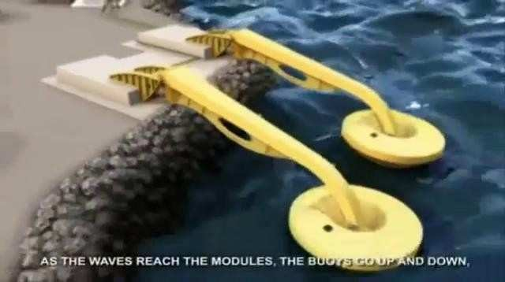

*Fig1.3*

1. **Geo thermal energy**

˜ Geo thermal energy itself on earth's surface in the form of geyster, hot spring, furnarhole& boingMud

˜ By drilling hole 3 km deep in the field the steam and water comes out from surface at temperature Up to 500°c

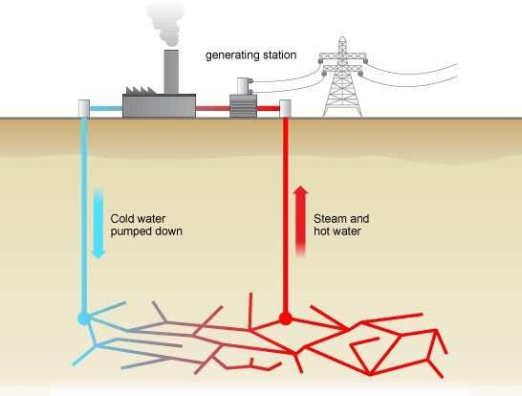˜ It can be used for power generating.

*Fig1.4*

1. **Ocean thermal energy**

˜ Ocean serves a big store house of solar energy

˜ At water surface 23°c-source ,while temperature at depth of 100m is 5°c-sink

˜ Temperature differential can be used to run heat engine & power can be produce using working fluids NH3,R-12, propane gas .

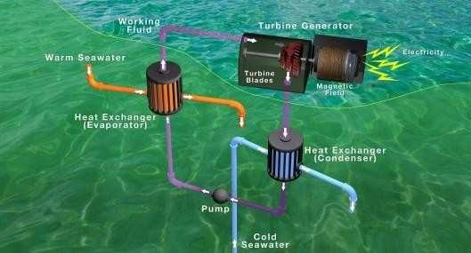

*Fig1.5*

1. **Biomass & biogas**

˜ Bio mass is an organic matter produced by plant both grown on land and in

water and their derivatives and animal manure .

˜ Biomass is in indirect application because it grows by photo synthesis.

˜ Bio-gas is a gaseous fuel which is obtained by fermenting the biomass anderobically in absence of oxygen.

˜ It contains

˜ Methane (55 to 65%)

˜ CO2 (30 to 40%)

˜ Rest impurities N2, H2S, H2 etc.

˜ Used for power generation, cooking etc.

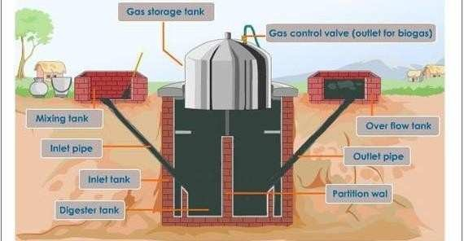

*Fig1.6*

**Advantages of non-conventional sourcesIrenewable energy sources**

˜ The main advantage is the fact that they are renewable.

˜ We will never run out of sources of renewable energy (at least in our lifetimes, as long as humans will exist) solar energy - the sun will always be there, and in abundance.

˜ The amount of solar energy intercepted by the Earth every minute is greater than the amount of energy the world uses in fossil fuels each year.

˜ wind energy - the wind will always exist - The energy in the winds that blow across the United States each year could produce more than 16 billion GJ of electricity - more than one and one-half times the electricity consumed in the United States in 2000.

˜ Tidal energy - the moon which provides the forces that causes the tides will always be there hydroelectric energy - unless there is a drastic change in rain patterns, it will always be there On the other hand, non-renewable resources such as fossil fuels are finite - our resources of them will run out eventually.

˜ A second advantage, renewable resources are seen as being 'green', or environmentally friendly. This is because they do not emit carbon dioxide (the biggest contributor to global warming) into the atmosphere. Non-renewable resources such as petroleum release CO2 into the environment when they are combusted for energy.

˜ Other renewables such as biofuels are carbon neutral - producing them consumes about as much CO2 as using them produces.

**Disadvantages of non-conventional sourcesIrenewable energy sources**

˜ Renewable energy is energy derived from sources that will not run out. Some of the present disadvantages are:

˜ Solar panels are expensive. Governments are not all willing to buy home generated electricity. Not all climates are suitable for solar panels.

˜ Wind -- turbines are expensive. Wind doesn't blow all the time, so they have to be part of a larger plan.

˜ Waves -- different technologies are being tried around the world. Scientists are still waiting for the killer product.

˜ Tides -- barrages (dams) across river mouths are expensive to build and disrupt shipping. Smaller turbines are cheaper and easier to install. rivers -- Dams are expensive to build and disrupt the environment. They have also caused earthquakes. Smaller turbines are cheaper and easier to install.

˜ Geothermal -- Difficult to drill two or three kilometers down into the earth.

˜ Biofuel -- Often uses crop lands and crops (like corn) to produce the bio- alcohol. This means that more land has to be cleared to grow crops, or there is not enough food, or that food becomes more expensive.

**Electrical power generation**

˜ It has been widely recognized that the fossil fuels and other conventional resources, presently used in generation of electrical energy, may not be either sufficient or suitable to keep pace with the ever increasing world demand for electrical energy. The prospects for meeting this demand and avoiding a crisis in supply would be improved if new and alternative energy sources could be developed.

˜ The present total installed capacity of electrical power generation in India is 1,10,000 MW, produced from various resources as given in Table 1.3:

*Table 1.3*

|  |  |
| --- | --- |
| **RESOURCE** | **%** |
| THERMAL | 68.8 |
| HYDRO | 24 |
| NUCLEAR | 2.7 |
| NON  CONVENTIONAL | 4.5 |

#### Need for alternate sources

˜ Due to increasing use of fossil fuels and environmental concern and rapid depletion of natural resources have led to development of alternative source of energy which are renewable and environment friendly. In this connection, the following points may be considered.

˜ Due to rapid industrialization and population growth the demand of energy is increasing very rapidly. Hence the conventional source of energy will not be sufficient to meet the growing demand.

˜ Conventional sources except hydropower are non-renewable and are bound to finish up one day.

˜ Conventional sources also cause pollution; thereby their use degrades the environment.

˜ Large hydro resources affect wildlife, cause deforestation and pose various social problems.

˜ Fossil fuels can also be used extensively as feed stock materials for the manufacture of organic chemicals.

˜ Now, it has become important to explore and develop non-conventional energy resources to reduce too much dependence on conventional resources due to above reasons.

# UNIT-II

## Solar energy collectors & applications:



### SOLAR WATER HEATER:

˜ It is a solar system that uses thermal energy of sun to heat water.

˜ The basic idea behind the solar water heater is piece of black piping filled with water and laid in the sun for the water to heat up. To heat up more water you increase the number of pipes to make a collector and add tank to store the heated water in. The whole system is insulated to minimize heat-loss. Water is cycled through the collector several times to raise the temperature. Some system uses electric pumps to pump water through the system but this increases the cost.

˜ Alternatively, water can be made to pass through the pipes without a pump using the thermo-syphon effect.

˜ Basic elements of solar water heater:

1. Flat plate collector
2. Storage tank
3. Circulation system
4. Control of system

**Types of solar water heater:**

1. Natural circulation/ Passive solar water heater

˜ When hot water is taken out from the hot water outlet, the same is replaced b cold water make-up tank fixed above the hot water tank ,water is circulated in the loop naturally due to thermo-syphon action is known as Passive or Natural circulation solar water heater.

˜ Natural circulation solar water heater may be pressurized or non-pressurized.

1. Force circulation / Active solar water heater

˜ When the collector is fixed above the level of hot water tank. A pump is required to make circulation of water in the loop ,is known as Active or Force circulation solar water heater

˜ It can also be classified as :

1. Direct /open loop system

˜ An open loop system circulates household water through collector

1. Indirect /closed loop system

˜ A closed loop system uses a heat transfer fluid to collect heat and a heat exchanger to transfer the heat to household water.

**Natural circulation solar water heater or Passive heating system**

˜ It is also known as THERMO-SYPHON WATER HEATING SYSTEM.

˜ THERMO-SYPHON uses the fact that hot water rises above cold water due to density difference.

˜ It consist of

1. A tilted solar collector facing south with transparent cover glasses
2. A highly insulated storage tank
3. Well insulate pipes -connecting collector & tank.

˜ The storage tank is located above level of collector at least 0.3m above the top edge of collector.

˜ As the water in the collector pipes heats up, its density decreases and hence it rises up into the top of the tank, colder water from the bottom of the tank has higher density and so tends to sink and enters into the collector through the lower header.

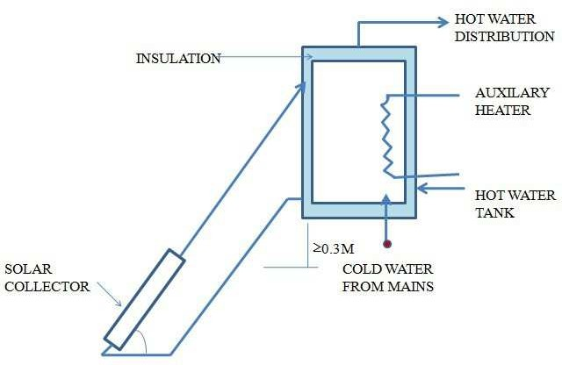

*Fig 3.1. Natural circulation solar water heater*

˜ The flow continues until the water in the pipes and the tank is at the same temperature. As long as the sunshine the water will quietly circulate, getting hotter.

˜ After sunset, the thermo-syphon system can reverse its flow direction and loss heat to surroundings during the night.

˜ To provide heat during long, cloudy periods an electrical heater is provided in the storage tank.

**Forced circulation solar water heater or Active heating system**

˜ The natural circulation solar water heater is normally used for domestic purpose where less amount of hot water is required.

˜ When a large amount of hot water is required for supplying process heat in an industry or in commercial utilization, a natural circulation solar water heater is not suitable.

˜ Large arrays of flat plate collectors are then used and forced circulation is maintained with a water pump.

˜ As shown in Fig, forced circulation solar water heater in which pump is provided in cold water line. Water from a storage tank is pumped through a collector array

where it is heated and then flow back into the storage tank, colder water takes it place.

˜ The pump for maintaining the forced circulation is operated by an ON-OFF controller which senses the difference between this temperature of the water at exist of collector and suitable location inside the storage tank.

˜ The pump is switched ON whenever this difference exceeds a certain value and OFF when it falls below a certain value.

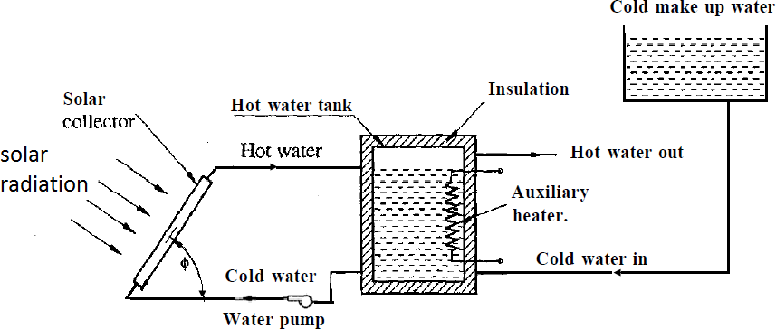

*Fig 3.2. Forced circulation solar water heater*

### COLLECTORS USED IN MODERN DOMESTIC SOLAR WATER HEATER

1. **Unglazed liquid flat-plate collector**

˜ Made of a black polymer.

˜ They do not normally have a selective coating and do not include a frame and insulation at the back

˜ Low cost

˜ Thermal losses to environment – high at windy places

˜ Used for low temperature application

1. **Glazed liquid flat-plate collector**

˜ Absorber with selective coating is fixed in a frame between a single or double layer of glass & insulated at back

˜ Used for moderate temp application

1. **Evacuated tube solar collector**

˜ Absorber with selective coating enclosed in sealed glass vacuum tube.

˜ Thermal losses –low

˜ Used for moderate to high temperature application

### SOLAR HEATING AND COOLING OF BUILDINGS

˜ It can be broadly classified as

1. Passive space heating / cooling systems
2. Active space heating / cooling system

**Comparison**

|  |  |
| --- | --- |
| **Passive space heating I**  **cooling systems** | **Active space heating I**  **cooling system** |
|  |  |
| 1. This system operates without pumps, blowers, or other mechanical devices. | 1. In this system, pumps, blowers, or other mechanical devices are  required to circulate the working fluid for transportation of heat. |
| 2. A special building design is necessary | 2. A special building design is not necessary |
| 3. In this system, the solar radiations are collected by an element of the structure itself. The various elements of the buildings like walls, roof, windows, partitions etc., are so selected and so architecturally integrated that they participate in the collection, storage, transportation and distribution  of thermal energy. | 3. In this heating system, the solar radiations are collected using some kind of separate collectors. Solar energy may be stored in sensible heat storage materials, or in latent heat storage materials and the energy is redistributed in the building space using pumps, blowers, fans etc,. |
| 4. These systems are suitable where there is ample winter sunshine and an unobstructed southern exposure  is possible. | 4. Active system can be employed to almost any location and types of building. |
| 5. It is less expensive than active system to construct and operate | 5. It is more expensive than passive system to construct and operate |

**Solar heating of buildings**

1. **Passive solar space heating systems**

˜ The passive solar heating are classified as

* 1. Direct gain,
  2. Thermal storage wall (indirect gain),
  3. Thermal storage roof (indirect gain),
  4. Attached sun space and
  5. Convective loop.

1. **Direct gain:**

˜ This is the simplest passive solar heating method for heating the building during the winter.

˜ A double glazed windows facing south as shown in the Fig. or the entire south facing wall is double glazed through which direct radiation in winter enters and strikes floor, walls or other objects in the room; is absorbed and stored as heat. The heat loss from the room is reduced by using double glazes window.

˜ The floor or walls are made massive to increase the thermal mass which helps in storing the heat during day time when sufficient heat is available and releasing the same during night time. An appropriate overhang is provided above the windows or at the roof level for the case where south wall is glazed shaded the window or the wall during summer when the elevation of the sun is high.

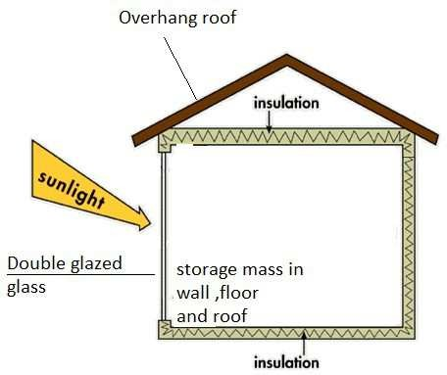˜ Adequate movable insulation may be used to reduce heat losses during night.

*Fig 3.3. Direct gain*

1. **Thermal storage wall:**

˜ In this method, the thermal storage wall is provided between the double glazed facing south and room living space as shown in Fig.3.4.

˜ Thus this thermal storage wall collects stores and transfers the heat to the room. This wall also known as Trombe wall.

˜ This is the more effective way of heating the rooms and reducing the large variation in the room air temperature. Also it allows reducing storage mass in floor, roof and walls.

˜ A south facing thermal storage wall made of masonry or concrete with an outer side facing the sun is blacked.

˜ The solar radiation after passing through glazing is absorbed by Trombe wall thereby heating it. Hence, air in the gap between the glazing and thermal wall get heated, rises and enters room through the upper vent while the cooled air from the room enters in the gap through bottom vent. This circulation continues till the wall goes on heating the air.

˜ The dampers are provided at top and bottom vents to control the mass flow rate of air. Room also heated by convection and radiation from thermal wall.

˜ One additional damper also provided on the top of the glazing to remove the excess heat from the air space.

*Fig 3.4. Thermal storage wall*

1. **Thermal storage roof:**

˜ This method of heating is similar to thermal storage wall except that the interposed thermal storage mass is on building roof instead of a wall as shown in the Fig.

˜ The building is provided with metal roof which conducts heat more effectively. Water bags made of transparent or black plastic sheet and filled with water or any other massive material are put over the metal roof.

˜ In the winters, during daytime when sun is shining, the water in the bags gets heated, stores the heat and heats the room below during day time as well as night time when sun is not shining.

˜ Movable insulating shutter are used over the water bags. During off sunshine hours or during the night, the insulating shutter are slid over the bags, reducing heat loss from the water bags to the outside.

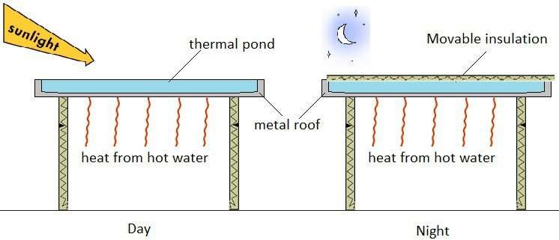

*Fig 3.5. Thermal storage roof*

1. **Attached sun space (green house):**

˜ This method of heating combines features of direct gain and indirect gain (thermal storage).

˜ A sunspace is an enclosed space on extreme south facing side of the house covered with single or double layers of glass or plastic sheets which function like green house Andean be used either for grooving vegetables or flowers or as sunny space for living.

˜ The system also consists of thermal storage wall facing south in between the room and sun space. The thermal storage wall gets heated by direct absorption of solar radiation coming through the green house transparent cover.

˜ The living space is heated through convection and radiation heat transfer from the thermal wall. Vents near the top and bottom of the wall permit the circulation of living room air in the heated sun space.

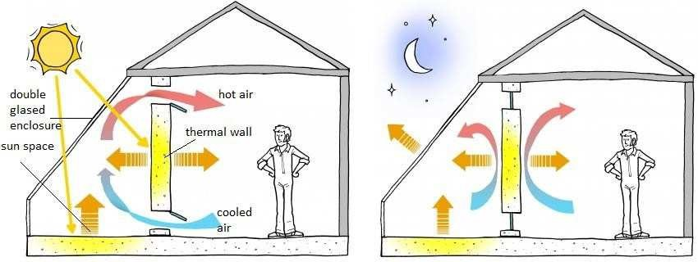

*Fig 3.6. Sun space passive solar heating system*

1. **Convective loop:**

˜ In this heating system the heated air is circulated by means of natural convection (thermo-syphon principle).

˜ The system consists of

˜ solar air heater collector,

˜ thermal storage

˜ pipes for air circulation

˜ The bed of rock is located beneath of sunspace, provides thermal storage.

˜ Air after getting heated in the solar air heater goes either directly into the living room to be heated or through the rock bed thermal storage unit.

˜ The cool air from the room or from bottom of storage unit enters through the bottom of solar air heater automatically by natural convection and again gets heated, rises and enters the room.

˜ If more solar heat is available than is required for space heating , the floor vents may be closed.

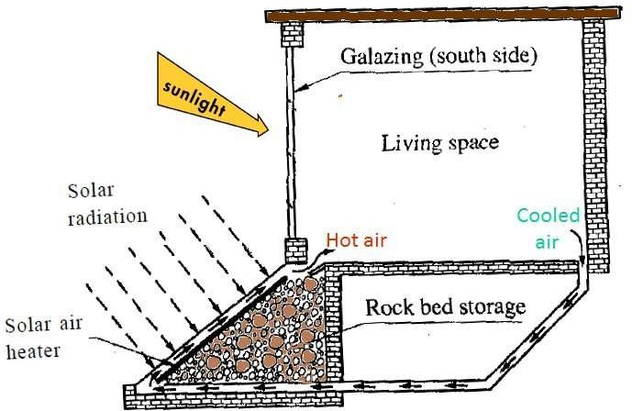

*Fig 3.7. Convective loop passive solar heating system*

1. **Active solar space heating system**

˜ In the active system of solar heating, separate solar collectors are used to heat the fluid; storage devices to store heat for use at night and during off sunshine hours; auxiliary heating system to supply heat when required and distribution system along with controls to supply heat to required space.

˜ If active system is installed in the existing buildings, such a system is called retrofit system.

˜ However if the buildings are designed which receives more solar energy in winter and less energy in summer, such buildings are called solar house.

˜ Main components:

˜ Solar water collector

˜ Heat storage device

˜ Pumping device or distribution system

˜ Auxiliary heating system

˜ Control system

˜ Generally hot water and air as working fluid are used for active space heating system. An active space heating system using water as working fluid is shown schematically in fig.

˜ In this system, water is heated in solar flat plate collectors and stored in the storage tank.

˜ Heat is transferred to the air circulating in the space to be heated by mean of the water to air heat exchanger.

˜ An auxiliary heater is provided in the hot water line which heats water when water temperature falls below the predefined temperature.

˜ During the normal operation, the three way valves are set to permit solar heated water to flow from the storage tank and auxiliary heater to the distribution system and back to the tank.

˜ During the long of sunshine hours, the three way valves will adjust automatically to bypass the storage tank and auxiliary heater directly heat exchanger, otherwise large amount to heat is wasted to heat water in the tank.

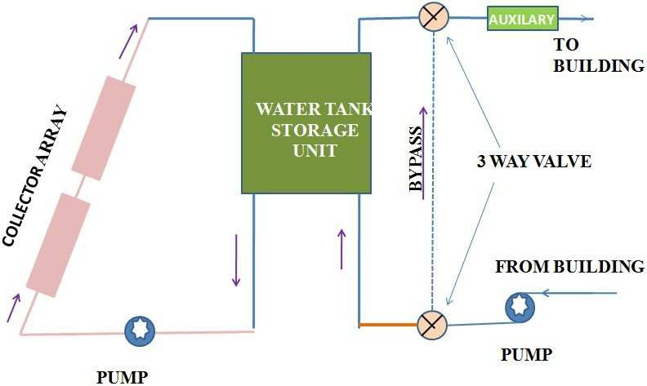

*Fig 3.8. Active solar space heating system*

**Solar cooling of buildings**

**Solar passive cooling through ventilation**

˜ Ventilation is the process of moving air into and out of an interior space by natural or mechanical means.

˜ In this method flow of air takes place using chimney effect and is effective where outside temperature is moderate.

˜ The air between the glazing and the interior south wall is heated by solar radiation.

˜ The heated air rises up, is ducted outside and the warm air from the room is drawn into this space due to the natural draught thus produced.

˜ Hence, cooled outside air enters the room from the bottom air vent on the other side of the room.

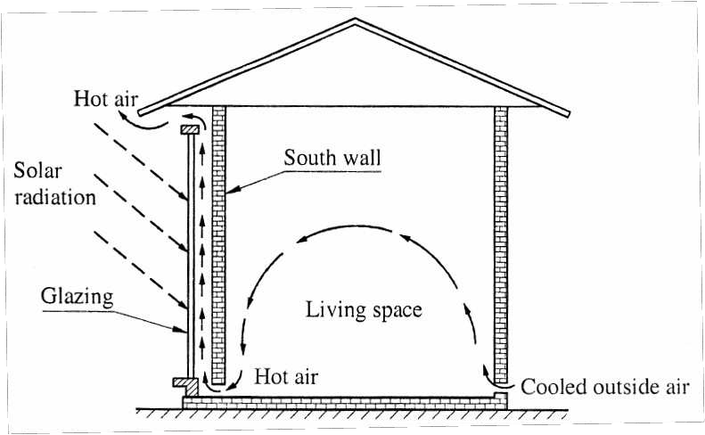

### SOLAR PUMPING

*Fig 3.9. Solar passive cooling through ventilation*

˜ A solar water pump is a socially and environmentally attractive technology to supply water. Especially if the need for water is in remote locations which are beyond the reach of power lines, solar power is often the economically preferred technology.

˜ Solar energy can be used for pumping of water in two ways as:

1. Direct conversion method
2. Thermodynamic conversion method
3. **Direct conversion method:**

˜ In this method, solar energy is directly converted into electricity using Photovoltaic (PV) panels.

˜ This electricity either stored or used directly in D.C. motor or converted into A.C. using inverter and then used in conventional water pump.

˜ A typical solar powered pumping system consists of a solar panel array (solar collectors) that powers an electric motor, which in turn powers a bore or surface pump as shown in Fig.

˜ The water is often pumped from the ground or stream into a storage tank that provides a gravity feed, so energy storage is not needed for these systems.

˜ The basic system consist of:

* 1. Solar panel
  2. Electronic pump enhancer
  3. Pump
  4. Water tank
  5. Supporting pole

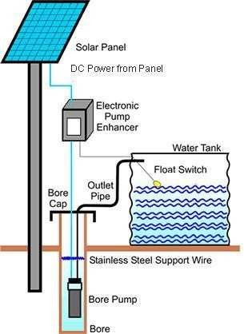

*Fig 3.10 Photovoltaic water pumping system*

1. **Thermodynamic conversion method**

˜ In this method, solar energy is first converted mechanical energy and then mechanical energy is used for pumping water.

˜ In this system some kind of solar energy collectors like flat plate or concentrating type are used for heating a of a working fluid which is then used for operating a Rankine, Brayton or Stirling engine producing mechanical power.

˜ Rankine cycle is preferred in solar energy conversion over the other two cycles because of its superiority in terms of overall efficiency, components size and high work ratio.

˜ The system consist of:

* 1. Solar collector

˜ Flat plate collectors

˜ Stationary concentrator

˜ Sun tracking concentrators

* 1. The heat transport system
  2. Heat exchanger/ boiler
  3. Rankine engine
  4. Condenser
  5. Pump

˜ Reciprocating pump

˜ Centrifugal pump

˜ Diaphragm pump

˜ Rotary pump

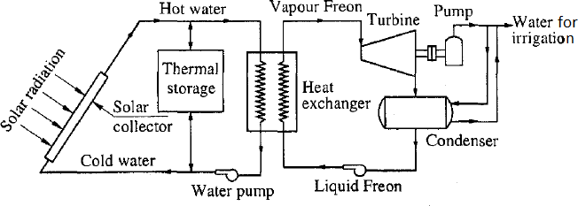

*Fig 3.11 Solar thermal water pumping system*

˜ Water is used as a heat transport fluid and conveys its heat to a low boiling point organic Rankine cycle working fluid (Freon R12 or R113 or isobutene) in a heat exchanger.

˜ The solar collector receives solar energy which is absorbed by water. The hot water gives up heat to Rankine cycle working fluid in the heat exchanger. The high pressure vapours of working fluid produced in heat exchanger is expand in turbine; condense in the condenser and liquid fluid return in heat exchanger. Surplus heat is stored in the thermal storage to be used later when the solar energy is not available.

**Advantages of solar pumping:**

˜ Simple and reliable, Unattended operation, Low maintenance, no fuel costs or spills, Easy to install, System can be made to be mobile.

**Disadvantages of solar pumping:**

˜ Potentially high initial costs, Lower output in cloudy weather, Must have good sun exposure between 9 AM and 3 PM.

### SOLAR COOKER

˜ A solar cooker, or solar oven is a device which uses the energy of sunlight to heat food /drink to cook it or sterilize (to make free from micro-organisms) it.

˜ Thermal energy requirement for cooking purpose forms a major share of total energy consumed, especially in rural area. Using solar energy for cooking purposes is an attractive and relevant option.

˜ Basically there are three design of solar cooker: 1 Flat plate box type

˜ With reflector

˜ Without reflector 2 Multi reflector box type

1. Parabolic disc concentrator type solar cooker Simple solar cooker uses the following basic principles

**Concentrating sunlight:**

˜ Increasing its heating power

**Converting light to heat**

˜ Light absorption converts the sun's visible light into heat, substantially improving the effectiveness of the cooker.

**Trapping heat**

˜ The convection heat transfer from inside the cooker to atmosphere can be reduced by isolating the air inside the cooker from the air outside the cooker. A plastic bag or tightly sealed glass cover will trap the hot air inside.

˜ This makes it possible to reach similar temperatures on cold and windy days as on hot days.

**Greenhouse effect**

˜ Glass transmits visible light but blocks infrared thermal radiation from escaping. This amplifies the heat trapping effect.

**Box type solar cooker**

˜ A box cooker consists of

1. Rectangular enclosure made up of inner and outer metal or wooden box with double glass sheet on it and insulated on bottom and sides,
2. Top transparent glass covers of each 3 mm thick plain glass,
3. Reflector mirror,
4. Cooking pots made from aluminum with blackened coating on outer surface,
5. Mechanism for adjusting reflector mirror, and
6. Handle to carry the cooker

˜ The extern dimensions of a typical model are 60cm x 60cm x 20cm height.

˜ The temperature inside the solar cooker is maintained from 70°to 110°c.

˜ This temperature is sufficient to cook food slowly steadily and surely with delicious taste and preservation of nutrients.

˜ Maximum temperature obtained is

1. 140°C in winter
2. 160°C in summer

˜ Solar direct radiation and also reflected radiation (from a reflector mirror) enters through the top transparent glass cover and absorbed by aluminum blackened tray kept inside the solar box. The solar radiation entering the cooker is short wavelength.

˜ The glass cover reduces re-radiation losses from absorber surface to outside solar cooker. The solar re-radiation (solar energy leaving from absorber surface) has higher wavelength which is not able to pass through the top glass cover. The blackened surface starts absorbing sun rays and temperature inside the box starts rising.

˜ The cooking pots gets heat energy and food will be cooked in a certain period of time depending upon actual temperature attained inside. The temperature attained depends upon the intensity of solar radiation.

˜ Depending on the latitude and weather, time of cooking with this cooker ranges from 1 hr to 4 hrs.

*Fig 3.12Box type solar cooker*

**Box type solar oven - Multi reflector type**

˜ A box type solar oven was designed by Central Arid Zone Research Institute Jodhpur.

˜ The solar box type solar oven typically reaches a temperature of 250°C in winter and 350°C in summer.

˜ In this oven, practically all types of food preparation like cooking, roasting, baking and boiling can be done within 25 to 75 minutes under clear sky conditions.

˜ This solar oven is ideal for baking purposes.

˜ A box type solar oven consists of a well-insulated semi-cylindrical box made of sheet aluminum and wood as shown in Fig.

˜

´

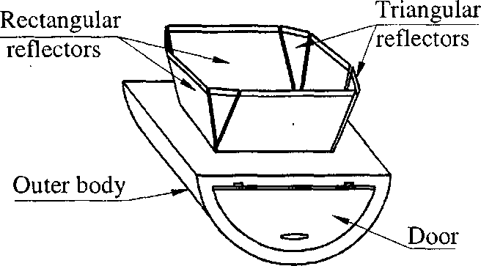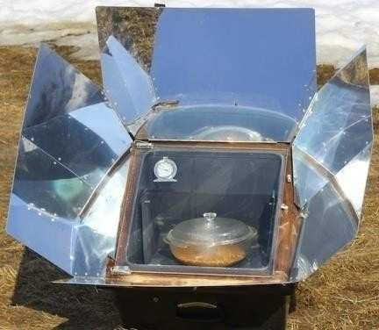

*Fig 3.13Multi reflector type*

˜ Two shells are made and the space between them, 7.5cm, is filled with fiber glass insulation. The interior sheet is painted black. A door of a same insulating material is also made for keeping and taking out food.

˜ The window of the oven consists of two transparent glass sheets. Eight reflectors are provided on the oven, four of square shape and four of triangular shape. The reflectors are made from silver glass mirrors. The oven can be manually tilted and oriented toward sun.

˜ A cradle like cooking platform is made in the oven which helps in keeping the vessel containing food horizontally irrespective of the sun.

˜ The main advantage of this solar cooker is that its efficiency is high because its performance is not affected by wind and there are no chances of dust falling in the cooking spots which is problem in the arid zone of India.

Moreover, the food remains warm if kept inside the oven for hours together even after sunset.

**Parabolic disc concentrator type solar cooker**

˜ Parabolic disc concentrator type solar cooker consists of paraboloid reflecting surface as shown in Fig, through which the radiation is concentrated.

˜ In this cooker cooking pot is placed at focus of paraboloid mirror and is thus directly heated.

˜ Maximum temperature obtained 450°C

˜ It can be used for cooking food items requiring roasting, frying or boiling. It can save on fuel for up to 10 LPG cylinders per year for family having 10-15 persons.

˜ Cooking time 20-30 minutes

˜ Approximate cost is about Rs.10, 000.

˜ They generate high temperatures and cook quickly, but require frequent adjustment and supervision for safe operation. Also it requires manual tracking every 15 or 20 minutes. Used for large scale institutional cooking.

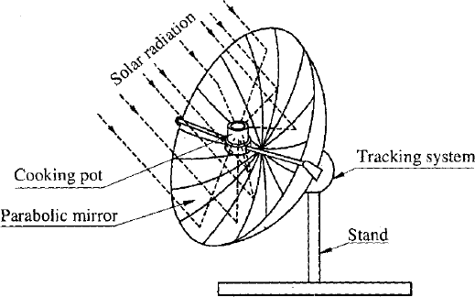

*Fig 3.14Parabolic disc concentrator type solar cooker*

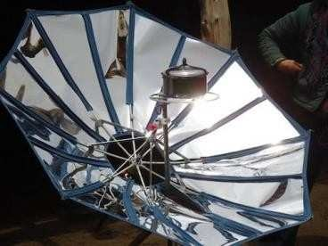

### SOLAR STILL

˜ One of the major problems in many parts of world is the scarcity of fresh water (water with less than 500 ppm salt content). Due to climate changes and less rainfall in many parts of the world, fresh water which was available in abundance from rivers, lakes and ponds, is becoming scarce. Also the available resources are getting polluted due to discharge of industrial effluents and sewage in large quantities.

˜ In this area solar energy is plentiful and can be used for converting saline water into distilled water with help of distillation process.

˜ Solar distillation process is considered to be one of the simplest and widely adopted techniques for converting sea water into fresh water.

˜ A solar still is a simple device which converts saline water into fresh water using heat of the sun. Several types of solar stills have evolved. However, only the Basin type solar still has been tried commercially on the large scale.

˜ The basic principles of solar water distillation are simple yet effective, as distillation replicates the way nature makes rain. The sun's energy heats water to the point of evaporation. As the water evaporates, water vapour rises, condensing on the glass surface for collection. This process removes impurities such as salts and heavy metals as well as eliminates microbiological organisms. The end result is water cleaner than the purest rainwater.

˜ A simple basin type solar still consists of a shallow blackened basin filled

-saline or brackish water to be distilled.

˜ The depth of water is kept about 5-10cm. It is enclosed with a transparent airtight cover.

˜ The cover, which usually glass may be plastic, is sloped toward a collection trough(a liquid conveying channel). The transparent roof material transmits nearly all radiation falling on it and absorbs very little, hence it remains cool.

˜ Solar radiation passed through the cover and is absorbed by bottom blackened surface and converted into heat. Saline water is heated in basin and vapour produce, which is then condensed on the inner surface of glass cover.

˜ The transparent cover is cool enough to condense water vapour. The condensed water flows down the sloping roof and is collected in troughs at the bottom.

˜ On a good sunny day, 3 litters/m2 with efficiency of 30-35 % can be obtained in well designed solar still.

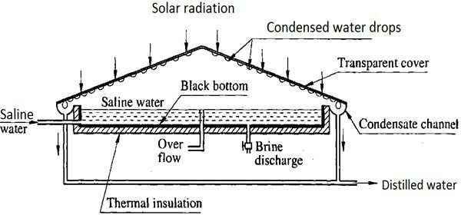

*Fig 3.15 Solar Still*

### SOLAR

**DRYERS**

˜ Drying involves the removal of moisture; this is achieved through the application of heat to the product.

˜ Due to that water vapour form and it is transferred to surrounding through evaporation.

˜ Drying process can be possible by two methods:

1. Sun drying

˜ Product directly placed under sunlight

1. Solar drying

˜ Product is placed in solar dryer device & then under sunlight

˜ Hence it gives faster drying rates.

**Types of solar dryers**

There are mainly three types of solar dryers:

* 1. Direct type solar dryer

˜ with

* + 1. natural convection type
    2. forced convection type
  1. Indirect type with forced circulation type solar dryer
  2. Mixed mode type solar dryer

**Direct type with natural convection type solar dryer**

˜ Direct drying uses incident radiation only or incident radiation plus reflected radiation.

˜ Most solar drying techniques that use only direct solar energy also use some means to reflect additional radiation onto the product to further increase its temperature.

˜ An example of direct absorption dryer is the Cabinet dryer.

˜ The aim of this type of a dryer is mainly to improve product quality by reducing contamination by dust, insect infestation, and animal or human interference.

˜ It consists of an enclosure with a transparent top and blackened interior surfaces. Ventilation holes in the base and upper parts of side walls maintained a natural air circulation. The material to be dried is placed on perforated trays.

˜ Solar radiation entering the enclosure is absorbed in the product itself and the surrounding blackened interior surfaces of enclosure. Therefore, moisture is removed from the product and air inside is heated

˜ Temperatures ranging from 50 °C to 80 °C are normally attained by this type of solar dryer and the drying time ranges from 2 to 4 days.

˜ It can be used for drying such as grapes, dates, apricots, chilies etc.

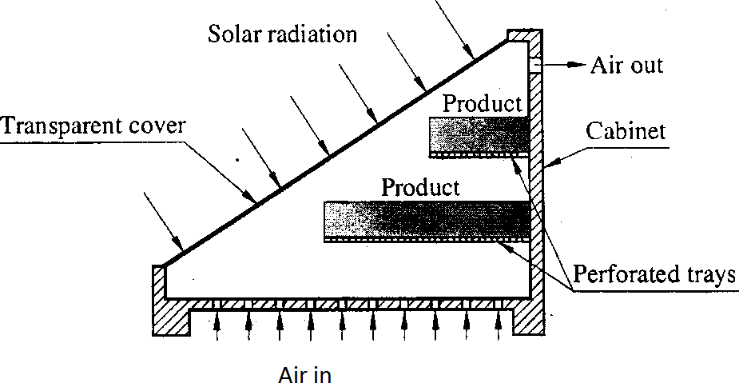

*Fig 3.16 Direct type with natural convection type solar dryer*

**Direct type with forced convection type solar dryer**

˜ In this type of dryer, some kind of blower is used for the circulation of air which is either operated electrically or mechanically.

˜ Such dryers are more efficient, faster, and can be used for drying large quantities of agricultural products.

˜ The forced circulation type dryer may be direct or indirect types. The direct mode type forced circulation drier is similar to direct type natural circulation except that here natural circulation of air is replaced by forced circulation.

˜ Used for drying timber.

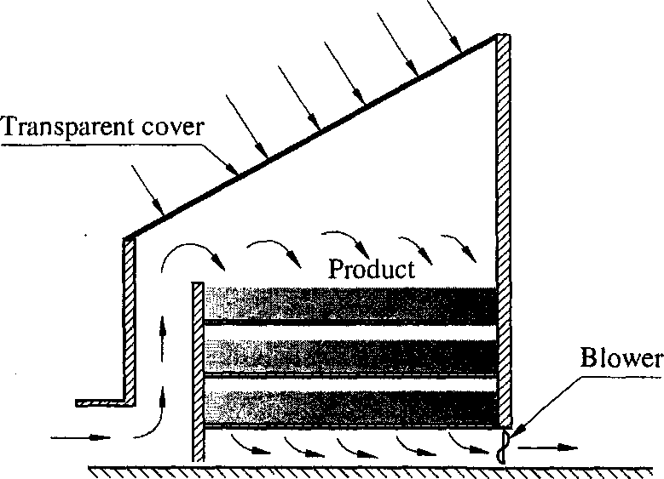

*Fig 3.17 Direct type with forced convection type solar dryer*

**Indirect type with forced convection type solar dryer**

˜ Indirect mode type forced circulation dryers are very efficient, can be used at low as well as high temperatures, and for large quantities of agricultural products.

˜ Normally, the indirect mode type forced circulation dryers are used when the solar radiation falling directly is not adequate and temperature of product need to be controlled.

˜ The main idea behind this type of a dryer is to obtain a low cost multi- product system. Also, it leads to choose a drying chamber able to accommodate different kinds of trays.

˜ Indirect mode with force convection type drier consists of chamber in which the product to be dried is stored and a separate solar air heater which receives solar radiation and convey the heated air to the chamber.

˜ This type of dryer is suitable for food grains, tea, spices etc. and for the products like leather and ceramics.

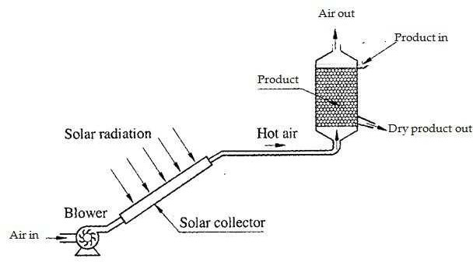

*Fig 3.18 Indirect type with forced convection type solar dryer*

**Mixed mode type solar dryer**

˜ This utilizes both direct and indirect solar radiation.

˜ In these types of systems, radiant energy from the sun falls directly onto the product being dried; however, in addition, a preheater also is used to raise the air temperature, which in turn, accelerates the drying rate.

˜ Acceleration of drying rate can occur in two ways: hot air can transfer some of its heat to the product being dried, thus raising its vapour pressure causing a faster moisture loss; or as temperature of air mass increases, the water-holding capacity also increases.

### SOLAR REFRIGERATION AND AIR CONDITIONING

˜ There is major environmental concern regarding conventional refrigeration technologies including contribution to ozone layer depletion and global warming.

˜ The use of solar energy to power refrigeration strives to minimize the negative impacts refrigerators have on the environment.

**Types of Solar refrigeration system**

1. Photovoltaic operated refrigeration system
2. refrigeration system with thermal collectors

˜ Vapour compression refrigeration system

˜ Vapour absorption refrigeration system

**Photovoltaic operated refrigeration system**

˜ Photovoltaic involve the direct conversion of solar radiation to D.C. using semi conducting materials.

˜ Solar photovoltaic panel produce D.C. electrical power that can be used to operate motor, which is coupled to the compressor of a vapour

compression refrigeration system.

˜ The system consist of

* 1. Compression
  2. condenser
  3. Expansion valve
  4. Evaporator

˜ The power is supplied not by the domestic electrical supply system, but from the solar PV panel.

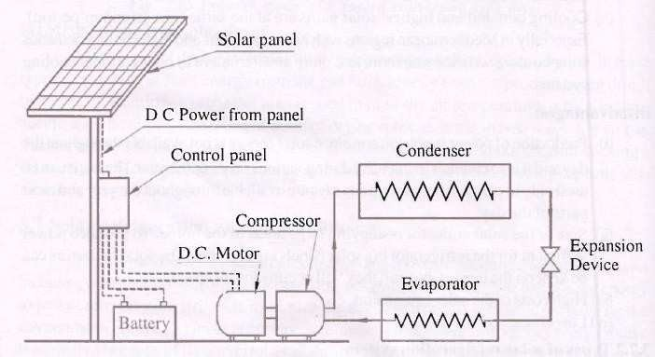

*Fig 3.19 Photovoltaic operated refrigeration system*

˜ The solar system of the solar refrigerator consists of the solar panel as shown in Fig. that collects the solar energy. The solar panels are fitted with photovoltaic cells that convert the solar energy into electrical energy and store it in the battery.

˜ During the normal running of the solar refrigerator the power is supplied directly by the solar panel, but when the output power of solar panels is less, the additional power is supplied by the battery. The battery is recharged when excess amount of power is produced by the solar panels.

**Refrigeration system with thermal collectors**

1. **Vapour compression refrigeration systemIsolar mechanical refrigeration**

˜ Solar mechanical refrigeration uses a conventional vapour compression system driven by mechanical power that is produced with a solar-driven heat power cycle.

˜ The heat power cycle usually considered for this application is a Rankine cycle.

˜ The overall efficiency of solar mechanical refrigeration, defined as the ratio of mechanical energy produced to the incident solar radiation, is the product of the efficiencies of the solar collector and the power cycle.

˜ Solar mechanical systems are competitive only at higher temperatures for which tracking solar collectors are required.

˜ Because of its economy-of-scale, this option would only be applicable for large refrigeration systems e.g., 1,000 tons

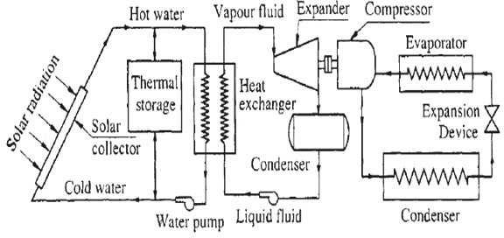

*Fig 3.20 Vapour compression refrigeration system/solar mechanical refrigeration*

1. **Vapour absorption refrigeration system**

˜ Absorption refrigeration is the least intuitive of the solar refrigeration alternatives. Unlike the PV and solar mechanical refrigeration options, the absorption refrigeration system is considered a "heat driven" system that requires minimal mechanical power for the compression process. It replaces the energy-intensive compression in a vapor compression system with a heat activated "thermal compression system."

˜ A single-stage absorption system using ammonia as the refrigerant and ammonia- water as the absorbent is shown in Fig.

˜ Absorption cooling systems that use lithium bromide-water absorption- refrigerant working fluid cannot be used at temperatures below 0°C. The condenser, throttle and evaporator operate in the exactly the same manner as for the vapor compression system.

˜ In place of the compressor, however, the absorption system uses a series of three heat exchangers :

* 1. absorber
  2. regenerating intermediate heat exchanger and
  3. a generator
  4. Small solution pump.

˜ Ammonia vapor exiting the evaporator is absorbed in a liquid solution of water ammonia in the absorber. The absorption of ammonia vapor into the water- ammonia solution is analogous to a condensation process. The process is exothermic

and so cooling water is required to carry away the heat of absorption. The principle governing this phase of the operation is that a vapor is more readily absorbed into a liquid solution as the temperature of the liquid solution is reduced. The ammonia- rich liquid solution leaving the absorber is pumped to a higher pressure, passed through a heat exchanger and delivered to the generator.

˜ In this system the power requirement for the pump is much smaller than that for the compressor in case of vapour compression system.

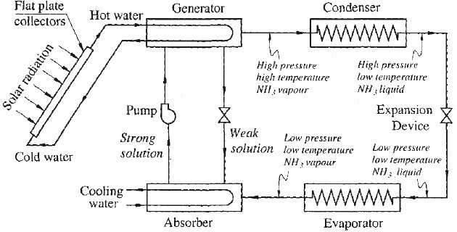

*Fig 3.21 Vapour absorption refrigeration system*

˜ In the generator, the liquid solution is heated, which promotes desorption of the refrigerant (ammonia) from the solution. Unfortunately, some water also is desorbed with the ammonia, and it must be separated from the ammonia using the rectifier. Without the use of a rectifier, water exits with the ammonia and travels to the evaporator, where it increases the temperature at which refrigeration can be provided. This solution temperature needed to drive the desorption process with ammonia-water is in the range between 120°C to 130°C.

˜ Temperatures in this range can be obtained using low cost non-tracking solar collectors. At these temperatures, evacuated tubular collectors may be more suitable than flat plate collectors as their efficiency is less sensitive to operating temperature.

˜ The advantage of solar refrigeration systems is that they displace some or all of the conventional fuel use.

˜ The operating costs of a solar refrigeration system should be lower than that of conventional systems, but at current and projected fuel costs, this operating cost savings would not likely compensate for their additional capital costs, even in a long

term life-cycle analysis. The major advantage of solar refrigeration is that it can be designed to operate independent of a utility grid.

˜ Of the three solar refrigeration concepts presented here, the photovoltaic system is the most appropriate for small capacity portable systems located in areas not near conventional energy sources (electricity or gas).

˜ Absorption and solar mechanical systems are necessarily larger and bulkier and require extensive plumbing as well as electrical connections.

### SOLAR POND

˜ In the continuous or discontinuous energy supply system, the energy storage is required to balance the energy of mismatches between the demand and the supply of energy.

˜ Especially in solar energy system the energy available only particular duration and only day time, hence thermal energy storage is required to improve performance and reducing total cost.

˜ Solar pond is a device to collect and store the solar thermal energy in the form of sensible heat.

˜ It consists of an expanse of water about 2 m deep with a thick durable plastic liner laid at the bottom. Salts like magnesium chloride, sodium chloride or sodium nitrate are dissolved in the water, concentration varying from 20 % to 30 %.

There are 3 distinct layers of water in the pond as:

1. **The top layer - Surface convective zone:**

˜ Normally, it has a small thickness, about 0.3 m to 0.5 m.

˜ It has a low, uniform concentration (low salt content, salinity < 5 %) as well as a fairly uniform temperature close to atmospheric temperature.

1. **An intermediate insulating layer with a salt gradient - Non-convective zone:**

˜ It is much thicker, about 1.0 m to 1.5 m and occupies more than half the depth of the pond.

˜ Both concentration and temperature increases with depth in this zone.

˜ This layer establishes a density gradient that prevents heat exchange by natural convection.

1. **The bottom layer - Lower convective or storage zone:**

˜ Normally, it has a thickness about 0.5 m to 1 m and high salt content (salinity about 20 %).

˜ Both concentration and temperature are nearly constant in this zone.

˜ This zone serves as the main heat collection as well as thermal storage medium.

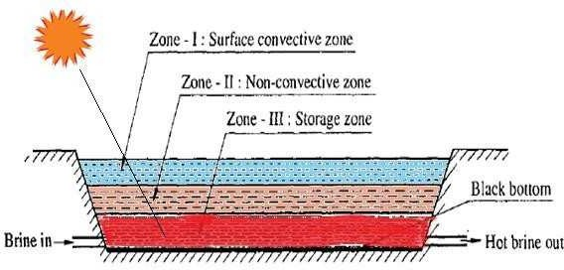

*Fig 3.22 Solar pond*

˜ If the water is relatively translucent, and the pond's bottom has high optical absorption, then nearly all of the incident solar radiation (sunlight) will go into heating the bottom layer. When solar energy is absorbed in the water, its temperature increases which causes thermal expansion and reduced density.

˜ If the water were fresh (without salts) the low-density hot water would float to the surface, causing circulation of water by convection. The temperature gradient alone causes a density gradient that decreases with depth.

˜ The situation is changed if the pond contains salts water at bottom with layer of fresh water above it. In this case, the salinity gradient forms a density gradient that increases with depth and this counteracts the temperature gradient, thus preventing heat in the lower layers from moving upwards by convection and leaving the pond.

˜ Because of its salt content, the solar pond bottom is denser than the cooler fresh water at the top, and hence it does not tend to rise.

˜ A relatively stable layer of heated salt water is thus produced at the bottom of the pond with a lighter layer of cooler fresh water, which acts as a heat insulator, above it.

˜ Normally, the temperature at the bottom of the pond will rise to over 90 °C while the temperature at the top of the pond is usually around 30 °C.

˜ A solar pond can be used for various applications, such as heating and cooling of buildings, industrial process heating, desalination, refrigeration, heating animal housing, drying crops on farms, heat for biomass conversion and solar power generation.

˜ The heat trapped in the salty bottom layer can be used for many different purposes, such as the heating of buildings or industrial hot water or to drive an organic Rankine cycle turbine or Stirling engine for generating electricity.

***Temperature and ConCentration profile for a typiCal solar pond***

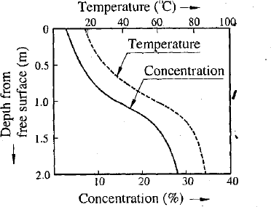

*Fig 3.23 Temperature and concentration profile*

### SOLAR POWER PLANTS

˜ Solar power generation technologies can be broadly classified into two broad categories:

˜ Solar Photovoltaic technologies: Photovoltaic converters are semiconductor devices that convert part of the incident solar radiation directly into electrical energy.

˜ Solar thermal power plants: Solar thermal power plants produce electricity by converting the solar radiation into high temperature heat using mirrors and reflectors.

**Classification solar thermal power plants**

1. **Classification based on temperatures**
   1. Low temperature cycles:

˜ Maximum temperature is limited to 100°C.

˜ For low temperature cycle, the thermodynamic cycle preferred is Rankine cycle.

* 1. Medium temperature cycles:

˜ Maximum temperatures ranging from150°C to 300 °C.

˜ For medium temperature cycle, the thermodynamic cycle also preferred is Rankine cycle.

* 1. High temperature cycles:

˜ Work at temperatures above 300 °C.

˜ For high temperature cycle, the thermodynamic cycle preferred is the Rankine cycle, the Brayton cycle and the Stirling cycle.

1. **Classification based on types of collectors**
   1. Solar pond power plant
   2. Solar distributed collector thermal power plant
   3. Central receiver system or Power tower -Heliostat
   4. Solar chimney power plant

**LOW TEMPERATURE SOLAR THERMAL POWER PLANT**

1. **Low temperature power generation cycle using liquid flat plate collectors:**

˜ Array of flat plate collectors are used to receive the solar radiation.

˜ The booster mirrors are used with collector to get maximum solar energy.

˜ The hot water at temperature close to 100°C is stored in a well insulated thermal storage tank.

˜ Hot water from storage tank is circulated through the heat exchanger (vapour generator), and give up heat to the working fluid (low boiling temperature fluid) of Rankine cycle.

˜ Low boiling temperature fluid evaporates at about 90 °C and pressure of a few atmospheres. Vapour generated in generator is then passes through turbine. After expansion in the turbine, low pressure vapour is condensed in the condenser and then liquid again supply to the vapour generator with help of liquid pump.

˜ Normally, the working fluids used are methyl chloride, toluene or refrigerants like R11, R113, and R114.

˜ This power plant is very simple, but it required large investment cost per kW because of large collector area involved.

˜ Overall efficiency of power plant is very low about 2%.

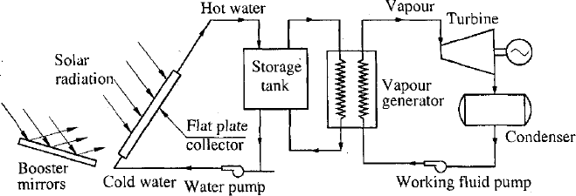

*Fig 3.24 Low temperature power generation cycle using liquid flat plate collectors*

1. **Low temperature power generation cycle using solar pond**

˜ solar pond is used to receive and to store the solar radiation.

˜ The system works on Rankine cycle using low boiling temperature working fluid.

˜ The bottom layers of brine reach 70 to 85 °C while the top remains 25 °C.

˜ The hot brine from bottom is slowly withdrawn in the laminar flow pattern from the pond and used to evaporate low boiling temperature working fluid of Rankine cycle in the vapour generator.

˜ The vapours of working fluid flows under high pressure to the turbine and thereby, expanding through the turbine and electrical generator coupled to it. expansion in the turbine, low pressure vapour is condensed in the condenser and then liqn again supply to the vapour generator with help of liquid pump.

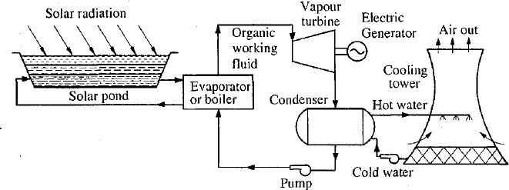

*Fig 3.25 Low temperature power generation cycle using solar pond*

**MEDIUM TEMPERATURE SOLAR THERMAL POWER PLANT**

˜ In this system, an array of parabolic line focusing type concentrating collectors is used to receive the solar energy because of low cost and require sun tracking in one plane only as compared to paraboloidal concentrating collectors.

˜ It is work at maximum temperatures ranging from 150 to 300 °C.

˜ This power plant consists of a parabolic cylindrical reflector to concentrate sunlight on to a collecting pipe within a pyrex or glass envelop, a storage tank, steam generator, steam turbine, condenser, pump and electrical generator.

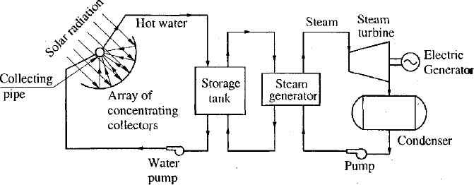

*Fig 3.26 Medium temperature solar power plant*

˜ Incoming solar energy is absorbed by water, and this heat is transferred to storage tank and finally to steam generator where steam is generated. This steam is utilized to run a turbine. After expansion in the turbine, low pressure steam is condensed in the condenser and then water again supply to j steam generator with help of liquid pump.

**HIGH TEMPERATURE SOLAR THERMAL POWER PLANT**

1. **Solar distributed collector thermal power plant**

˜ In this power plant, solar energy is collected by several individual collectors located in solar field. A very large area of few km2 is covered by the field

˜ The Parabolic through collectors with line focus are used

˜ The main components of plant are:

* 1. Parabolic through collectors distributed in the solar field
  2. Piping system for primary heat transport (water) circuit
  3. At transport fluid pump
  4. Storage tank
  5. Steam generator
  6. Secondary fluid (steam)circuit
  7. Steam turbine
  8. Condenser and condensate pump

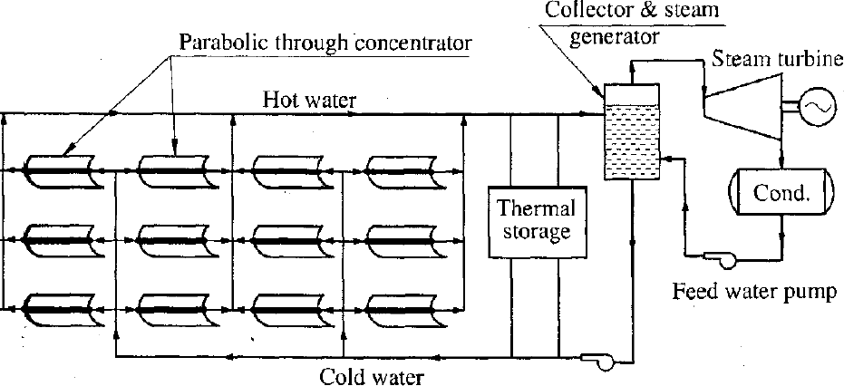

*Fig 3.27 Solar distributed collector thermal power plant*

˜ Incoming solar energy is collected in the collector which absorbed by water, and this heat is transferred to storage tank and then to steam generator where steam is generated. This steam is utilized to run a turbine.

˜ After expansion in the turbine, low pressure steam is condensed in the condenser and then water again supply to the steam generator with help of feed water pump after feed water heating in the feed water heater.

˜ The operating temperature of parabolic through collectors with line focus with sun tracking in one plane is in the range of 200 °C to 300 °C.

˜ In the solar distributed collector thermal power plant, parabolic through collectors with line focus are generally recommended for medium size electrical power plant (typically size 50 MW) used for applications such as standalone power plant for farm or community centre, captive power plant for small industry.

˜ The small solar distributed collector thermal power plant (typically size 2 MW) may be preferred for cogeneration plant (to deliver steam, hot water and electric power) and irrigation water pumping.

1. **Solar Central Receiver or Solar Tower thermal power plant:**

˜ In this solar-thermal power plant, a wide field of heliostats focuses the sun's power onto a single collector to heat a medium such as water or molten salt.

˜ The system consists of

* 1. The field of oriented flat mirrors or array of heliostats
  2. Tower with the central receiver on top of it
  3. heat conversion sub system
  4. Heat storage device

˜ The fields of heliostats comprise many mirrors. The movement of most modern heliostats employs a two-axis motorized system, controlled by computer based on the latitude and longitude and the time and date.

˜ In the central receiver at the top of the tower on which solar radiation reflected from fields of heliostats is concentrated. The central receiver has a heat absorbing surface by which the heat transport fluid is heated.

˜ In most of case water is a heat transport medium and working fluid of Rankine cycle. Another possibility is to use a gas as heat transport medium and also working fluid of Brayton cycle of a gas turbine.

˜ Thermal buffer storage is provided so that the plant can continue to operate for a maximum period of 30 minute in case of cloud cover. Short term storage of heat can be provided by fire bricks, ceramic oxides, rocks, eutectic salts, fused salts, sulphur or lithium metal, sodium metals etc.

˜ Heliostat costs represent 30-50% of the initial capital investment for solar power plant depending on the energy policy and economic framework in the location country.

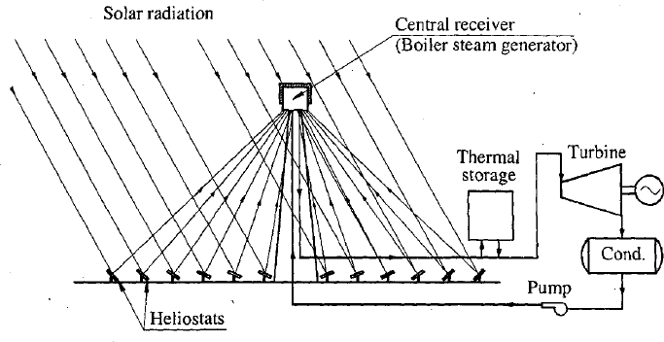

*Fig 3.28 Solar Central Receiver thermal power plant*

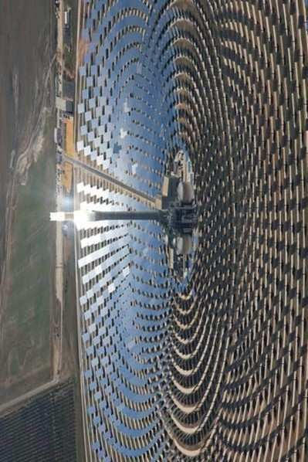

### SOLAR FURNACE

˜ A solar furnace is an optical system used to produce high temperatures by concentrating solar radiation onto specimen.

˜ Solar furnace consists of

1. A concentrator (paraboloidal reflector surface),
2. Small size receiver
3. Heliostats

˜ The large number of heliostats directs solar radiation on to a concentrator (paraboloidal reflector surface). The heliostats are adjusted such that they direct the radiation parallel to the optical axis of the paraboloidal reflector. The paraboloidal reflector then brings the radiation to a focal point where the receiver is fitted.

˜ The temperature at the focal point may reach 3,500 °C and this heat can be used to generate electricity, melt steel, and make hydrogen fuel or nano- materials.

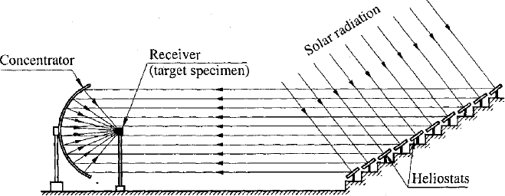

*Fig 3.29 Solar furnace*

**Applications of solar furnace:**

˜ The rays are focused onto an area the size of a cooking pot and can reach 3,500 °C depending on the process installed, for example: (i) about 1,000

°C for metallic receivers producing hot air, (ii) about 1,400 °C to produce hydrogen by cracking methane molecules, (iii) up to 2,500 °C to test materials for extreme environment such as nuclear reactors or space vehicle, (iv) up to 3,500 °C to produce nano- materials by solar induced sublimation and controlled cooling, such as carbon nanotubes or zinc nano- particles.

˜ The solar furnace is an excellent means for studying properties of ceramics at high temperatures above the range ordinarily measured in the laboratory with flames and electric currents.

˜ Physical measurements such as melting points, phase changes, specific heat, thermal expansion, thermal conductance, magnetic susceptibility and thermionic emission.

˜ Solar furnaces can be used in space to provide energy for manufacturing purposes.

˜ The solar furnace can be utilized to produce high temperature for metallurgical and chemical operations.

**Advantages of a solar furnace:**

˜ In the solar furnace, heating is possible without any contamination and easy to control the temperature.

˜ Solar furnace provides high temperature and rapid heating & cooling.

˜ Using solar furnace it is possible to measure various properties on an open specimen and continuous observation is possible.

**Disadvantages of a solar furnace:**

˜ Their use is limited to sunny days and that too for 4-5 hours only.

˜ Very high temperature is obtained only over a very small area.

˜ Initial cost of solar furnace is very high.

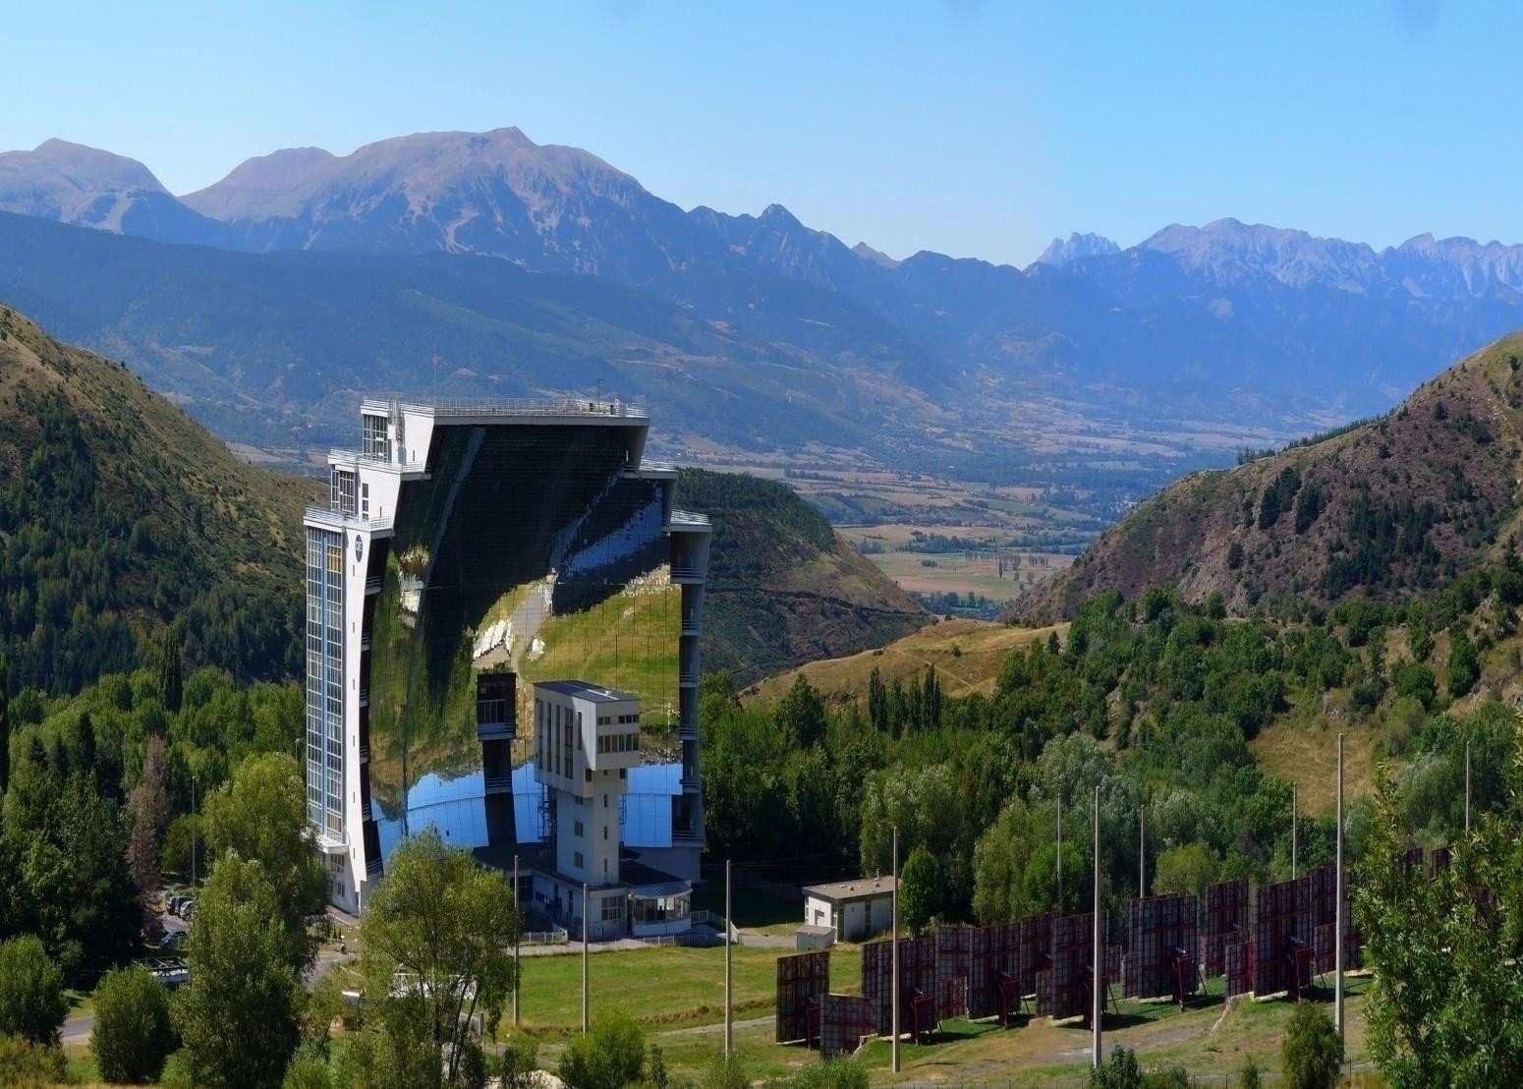

### SOLAR CHIMNEY POWER PLANT

˜ The solar chimney power plant is a renewable-energy power plant for generating electricity from solar power.

˜ Sunshine falling on a greenhouse-like collector structure around the base of a tall chimney heats the air within it.

˜ The resulting convection causes air to rise up the tower by the chimney effect.

˜ This airflow drives wind turbines to produce electricity.

˜ It is also called solar updraft tower power plant.

˜ Sunlight passing through the transparent cover causes the air trapped in the greenhouse to heat up by 10°C to 20°C.

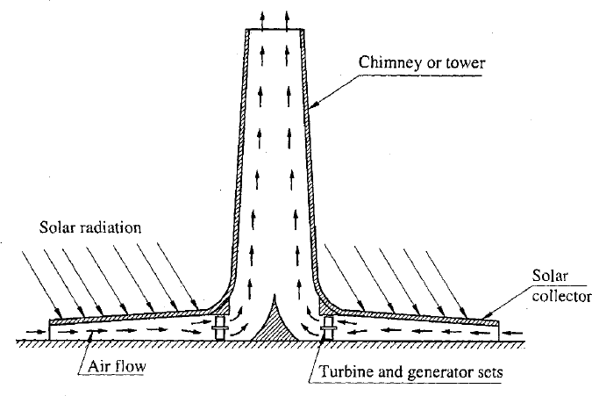

*Fig 3.30 Solar chimney power plant*

˜ A typical 50 kW solar chimney power plant requires chimney height of 195 metres and a diameter of 10 metres with a collection area(greenhouse) of 46000 m2 and a diameter of 244 metres.

˜ Solar thermal collectors or photovoltaics can be arranged inside the collector greenhouse to increase output.

˜ Initial cost –high

˜ Operating cost –low

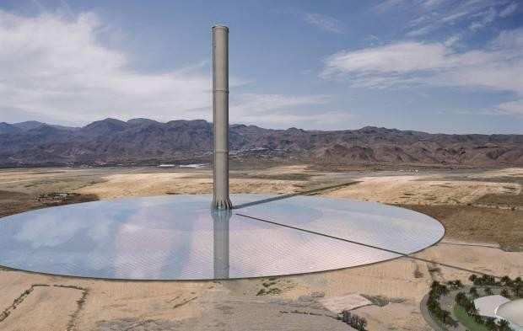

### PHOTOVOLTAIC SYSTEM OR SOLAR CELLS

˜ Solar cells are devices which convert solar energy directly into electricity via the photovoltaic effect.

˜ Solar cell principles:

˜ It is based on the photovoltaic effect.

˜ In general, the photovoltaic effect means the generation of a potential difference at the junction of two different materials in response to visible or other radiation.

The solar cell works in three steps:

1. Photons in sunlight hit the solar panel and are absorbed by semiconducting materials, such as silicon.
2. Electrons (negatively charged) are knocked loose from their atoms, causing an electric potential difference. Current starts flowing through the material to cancel the potential and this electricity is captured. Due to the special composition of solar cells, the electrons are only allowed to move in a single direction.
3. An array of solar cells converts solar energy into a usable amount of direct current (DC) electricity.

˜ Semi-conductors like silicon, cadmium telluride, gallium arsenide etc. are a suitable material for absorbing the energy of photon of sunlight.

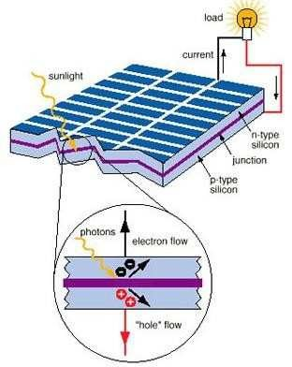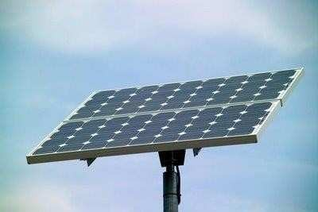

*Fig 3.31 Principle of working of solar cell*

**Photovoltaic cells, modules, panels and arrays**

˜ Photovoltaic array is the device which generates electricity when exposed to light.

˜ A typical single PV cells can produce about 0.5 V and 6 Amp, which gives 3W power.

˜ A number of cells are combined to form a module.

˜ When modules are combined we get a panel.

˜ Panels are combined to get an array.

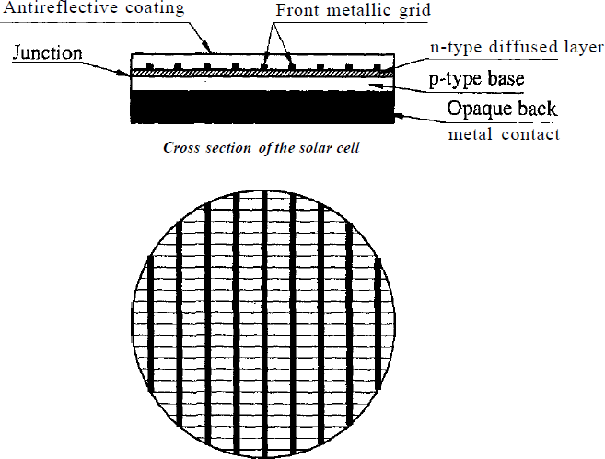

*Fig 3.32 Structure of solar cell*

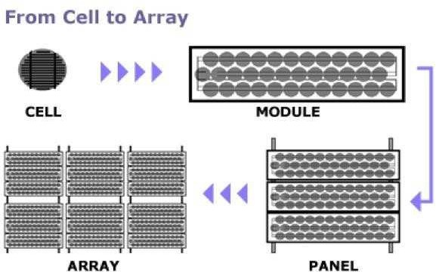

*Fig 3.33 Photovoltaic cell, module, panel and array*

**A basic solar photovoltaic system for power generation**

˜ It consist of :

1. A PV panel array, ranging from two to many hundreds of panels;
2. A control panel, to regulate the power from the panels;
3. A power storage system, generally comprising of a number of specially designed batteries;
4. An inverter, for converting the DC to AC power e.g. 240 V AC.
5. A backup power supplies such as diesel start-up generators (optional)
   * Framework and housing for the system
   * Trackers and sensors (optional)

˜ Arrays of panels are being increasingly used in building construction where they serve the dual purpose of providing a wall or roof as well as providing electric power for the building.

˜ Eventually as the prices of solar cells fall, building integrated solar cells may become a major new source of electric power.

˜ The daily energy output from PV panels will vary depending on the orientation, location, daily weather and season. On average, in summer, a panel will produce about five times its rated power output in watt hours per day and in winter about two times that amount.

˜ For example, in summer a 50 watt panel will produce an average of 250 watt-hours of energy, and in winter about 100 watt-hours.

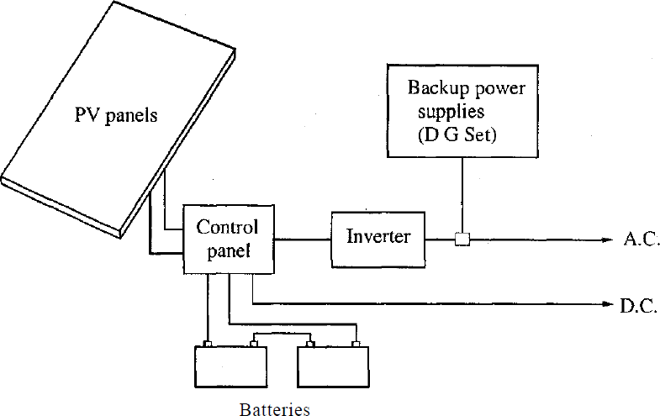

*Fig 3.34 Element of PV system*

˜ Trackers are used to keep PV panels directly facing the sun, thereby increasing the output from the panels.

˜ Energy storage is often necessary when power is required when the sun is not shining - either at night or in cloudy periods - or in quantities greater than can be supplied directly from the array. Specially designed "deep-cycle" lead acid batteries are generally used. Unlike normal batteries, they can discharge about half of their stored energy several thousand times before they deteriorate.

˜ Inverters are necessary if mains-voltage appliances are to be used. In assessing the cost of the total system, it may be more economical to purchase an inverter and mass produced consumer appliances than to use low voltage DC appliances which may be more expensive.

˜ Sometimes wind generators are used in conjunction with PV systems, if the combination of sun and wind is viable. Small petrol or diesel generators are often used as the backup. These systems are relatively cheap to purchase but expensive to run.

˜ The performance of PV modules and arrays are generally rated according to their maximum DC power output (watts) under Standard Test Conditions (STC).

˜ Standard Test Conditions are defined by a module (cell) operating temperature of 25° C, and incident solar irradiance level of 1000 W/m2 and under Air Mass 1.5 spectral distribution.

˜ Today's photovoltaic modules are extremely safe and reliable products, with minimal failure rates and projected service lifetimes of 20 to 30 years.

**Types of solar cell**

˜ Solar cells can be classified in the three ways as followed:

1. **Classification on basis of type of active materials used in its fabrication**
   1. Single crystal silicon solar cell
   2. Multicrystalline silicon solar cell
   3. Amorphous silicon solar cell
   4. Cadmium telluride solar cell
   5. Copper indium gallium diselenide
   6. Gallium arsenide multi-junction
   7. Dye-sensitized solar cell
   8. Quantum dot solar cell
   9. Organic/polymer solar cell
2. **Classification on basis of thickness of active material**
   1. Bulk material solar cell
   2. Thin film solar cell
3. **Classification on basis of junction structure**
   1. p-n homo-junction solar cell
   2. p-n hetro-junction solar cell
   3. p-n metal semiconductor-junction solar cell
   4. p-i-n semiconductor-junction solar cell

**Wafer-based crystalline silicon I Bulk material solar cell**

1. **Mono crystalline silicon solar cells**

˜ A mono crystalline silicon solar cell is made from a wafer of one big silicon mono crystal.

˜ These cells belong to the most efficient class in the photovoltaic technology. For the moment the efficiency factor is about 15 %. The required production process for this type of solar cell is complex and rather expensive. The surface of the cell is smooth and equally colored blue. They are not flexible and must be mounted in a firm frame and protected against an aggressive environment.

1. **Polycrystalline silicon solar cells**

˜ A polycrystalline silicon solar cells wafer is sawed out of a cast “ingot” of molten silicon which is re crystallized. The wafer forms the basic of a polycrystalline solar cell. This solar cell is cheaper because the production process is less complex. The efficiency factor is lower as compared with mono crystalline cells.

˜ For the moment the efficiency factor is about 12 %.

˜ The surface of a poly solar cell looks a little bit smudged with various blue patches. They are not flexible and must be mounted in a firm frame and protected against an aggressive environment.

**Thin film solar cell**

1. **Amorphous silicon solar cells**

˜ An amorphous silicon solar cell consists of a thin homogenous layer of silicon atoms instead of a crystal structure. The light absorption in amorphous silicon is more effective compared to the former silicon types. So the cells can be thinner, hence the name “thin film” cells.

˜ Amorphous cells can be used on various carriers both on solid and flexible materials. Bend or folded surfaces are no problem. The cell surface is dark grey colored.

These cells are cheap but the efficiency factor is a low 6 % for the moment.

˜ A property of amorphous solar cells is the power decrease in the first month after first introduction. After this period the power output remain rather steady. In the specification of the cell the steady power state is mentioned.

1. **Cadmium telluride solar cell**

˜ A cadmium telluride solar cell uses a cadmium telluride (CdTe) thin film, a semiconductor layer to absorb and convert sunlight into electricity. The cadmium present in the cells would be toxic if released. However, release is impossible during normal operation of the cells.

1. **Copper indium gallium diselenide**

˜ Copper indium gallium diselenide (CIGS) is a direct band gap material.

Incorporation of Ga in to the CIGS mixture increases the band gap beyond

1.1 eV. It has the highest

efficiency (~20%) among thin film materials and more stable as compared to a-Si cell in outdoor applications.

˜ However, exposure to elevated temperature results in loss of efficiency, but light soaking restores it to original efficiency level. The main attraction of this solar cell is inexpensive preparation.

**Applications of solar cells**

1. Cathodic protection systems
2. Electric fences
3. Remote lighting systems
4. Telecommunications and remote monitoring systems
5. Solar powered water pumping
6. Rural electrification
7. Water treatment Systems
8. Miscellaneous applications of solar cells

˜ Watches, toys, calculators, emergency power systems, refrigerators for remote areas, portable power supplies for camping and fishing etc.

**Advantages of solar cell**

1. Photovoltaic systems can be designed for a variety of applications and operational requirements.
2. It can be used for either centralized or distributed power generation.
3. Photovoltaic systems have no moving parts, are modular, easily expandable and even transportable in some cases.
4. Energy independence and environmental compatibility
5. The fuel (sunlight) is free, and no noise or pollution is created from operating photovoltaic systems.
6. Minimal maintenance and have long service lifetimes.

**Disadvantages of solar cell**

1. High initial cost.
2. Surface area required is high.
3. Solar energy is intermittent. Hence requires large storage. This increase the cost and make the system bulky.
4. Conversion efficiency - low - about 30%

# UNIT-III

## Wind Energy &Biomass



Wind Energy:

### INTRODUCTION

˜ Wind is essentially air in motion, which carries with it kinetic energy.

˜ The amount of energy contained in the wind at any given instant is proportional to the wind speed at that instant.

˜ Wind results primarily by unequal heating of the earth's surface by the sun.

˜ About 2% of the total solar flux that reaches the earth's surface is transformed into wind energy.

˜ Solar energy meets clouds, uneven surfaces, and mountains while reaching the earth.

˜ This unequal heating causes temperature, density, and pressure differences on the earth's surface that are responsible for local wind formation.

˜ During daytime, the air over the land mass heats up faster than the air over the oceans. Hot air expands and rises while cool air from oceans rushes to fill the space, creating local winds.

˜ At night the process is reversed as the air cool more rapidly over land than water over off-shore land, causing breeze.

˜ On a global scale, the primary force for global winds is developed due to differential heating of the earth at equatorial and Polar Regions.

### POWER IN WIND

˜ Wind possesses energy by virtue of its motion. Any device capable of slowing down the mass of moving air like a sail or propeller can extract part of the energy of the energy and convert it into useful work.

˜ Three factor determine the output from a wind energy converter:

* The wind speed
* The cross-section of wind swept by rotor
* The overall conversion efficiency of the rotor, transmission system and generator or pump.

˜ Wind mill/turbine converts the kinetic energy of the wind into mechanical energy.

˜ The total power of the wind stream is equal to the time rate of kinetic energy.

*K*.*E*. 1 *mV* 2

2

˜ The amount of air passing in unit time through an area A with velocity V

*A*.*V m*3 / *s*

.˙. Mass flow rate of air m =p A ● V Where, p is the density

of air.

*K*.*E*. 1 (*AV*)*V* 2

2

power ,*P*

1 A.*V*3

2



J/s

 Total

*t* 1 A .*V*3 Watts 2

˜ This equation tells us that the maximum wind available the actual amount will be somewhat less because all the available energy is not extractable- is proportional to the cube of the wind speed. It is thus evident that small increase in wind speed can have a marked effect on the power in the wind.

˜ Wind velocities below 5 m/s and above 25 m/s are not suitable for wind turbine.

˜ Wind power is proportional to the intercept area. Thus, wind turbine with a large swept area has higher available power.

˜ Normally, area is circular with diameter D, Thus



*A* *D*2

4 

*P* 1 .



*D*2.*V*3

*t* 2 4

.*D* .*V*

*P*  2 3

*t* 8

˜ It is clear that power is proportional to the square of the diameter of swept area.

˜ The total wind power density is defined as the total wind power per unit area of wind stream.

*Pt*

*A*

**Effects of wind speed and rotor diameter on wind power**

˜ Wind machines intended for generating substantial amount of power should have large rotor and be located in areas of high wind speeds.

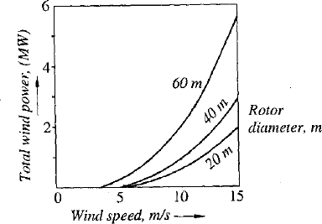

*Fig 4.1 Effects of wind speed and rotor diameter on wind power*

**Power coefficient**

˜ The fraction of the free-flow wind power that can be extracted by a wind turbine rotor is called the power coefficient.

Mathematically,

Power co - efficient



Power of wind turbine Power available in the wind

˜ The maximum theoretical power coefficient is equal to 0.593.

### POWER EXTRACTION FROM WIND

˜ Wind turbines extract energy from wind stream by converting the kinetic energy of the wind to rotational motion required to operate an electric generator.

˜ The velocity of the flowing wind decreases due to conversion of kinetic energy into shaft power.

˜ It is assumed that the mass of air which passes through rotor is only affected and remains separate from the air which does not pass through the rotor.

˜ As the free wind interacts with the turbine rotor, the wind transfer part of its energy into the rotor and the speed of the wind decreases to a minimum leaving a trail of disturbed wind called wake. The variation in velocity is considered to be smooth from far upstream to far downstream.

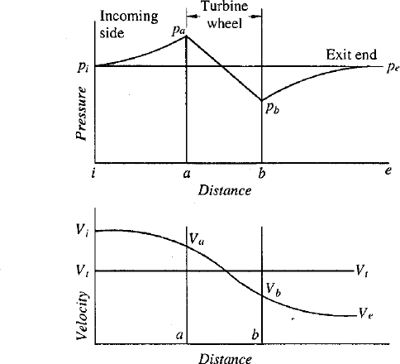˜ Wind flow is considered incompressible and hence the air stream flow diverges as it passes through the turbine. Also the mass flow rate of wind is assumed constant at far upstream, at the rotor and at far downstream.

*Fig 4.2 Pressure and velocity curve of wind*

˜ Most commonly used wind turbine is horizontal axis, propeller type. Consider this wind turbine,

Let,

*a* = Inlet plane,

*b-* Exit plane,

P - Incoming wind

i

pressure, V =Incoming

i

wind velocity, P *-* Wind

e

pressure at exit *e,* V *=*

e

Wind velocity at exit *e, v*

*=* Specific volume = 1/p.

V >V

i e

Applying total energy equation, considering flow energy and kinetic energy of wind

1 *p* .*v* . *Vi* . . *q* *u* . *p v* . *Va* .

2

2

*u*

.

*Z*

*Z*

*a* .

1

2

. *w*

Where,

2

*i* 2*g* 2

Z=potential energy =0

2

*Vi* = kinetic energy 2*g*

u= internal energy =0

*p*.*v*

=flow energy

Δq=net heat added=0 Δw=net work done=0 g=1 m2/s

Therefore,

*p* .*v* . *iV*2

.*v* . *Va*

*p*

*a*

2

*i* 2 2

*p* . *iV**p* . *a* *V*

2

2

*i a*

2*v* 2*v*

. ´*V*2

*p*

.

*i* 

*i* 2

*pa* .

*V* 2

. ´ *a*

2

Similarly, for exit area

*V* 2

*V* 2

. ´ *e* 2

*p*

.



*e*

*pb* .

. ´ *b* 2

The wind velocity decreases from a to b, because kinetic energy is converted to mechanical work.

Therefore,

*a i b e*

*V* *V* , *V*  an

*i a b*

d

*V*

*e*

*p* *p* , *p* *p*

2

 *V* ˜

2  

*V* 2 ˜



*V* 2 

*p* ˜ *p*  *p* .  *i a* ˜

*V*

*p* .  *e b*

*a b*  *i*

2 

 *e* 2 

Assume that at exit end away from the turbine at e, can be assumed to ambient

i.e. P

e

= P and V

i t

= V = V

a b

 2 2 

˜ *p* .*V i* ˜ *V* *e*

*b*

*p*

*a*

 

2 2

*p* ˜ *p*



. *i*2



*e* 2 

*a b*  2 

If 'A' is the projected area of wind turbine perpendicular to the wind stream, the axial force F is given by

*F* *p* ˜ *p*

A  *A* *i*2 ˜ *e*2 

*X a b*

 2 

But, Axial force also equal to the change of momentum

*F* *m*.*V*

*X*

*AV* . *V* ˜ *V* .

*F*

*t*

*i*

*e*

*X*

By equating the equations,

. *V* ˜ *V* .

*A**i*2



 *i e*

*AV*

*e*2

  *t*

 

 2 2

*i e* *V* . *V* ˜ *V* .

*t i e*

 

*V* ˜ *V*

 *V* . *V*  

*i e* *i*

*V*

*V*

*V*

*e*  . ˜ .

  

###### 2

*t i e*

Now consider the total thermodynamic system bounded by i and e.

*V*2 ˜ *V* 2

*w* *KE*

*i*

*e*

˜ *KE*

 *i e*

2

Power 'P' is defined as rate of work done.

*V*2 ˜ *V* 2 *V*2 ˜ *V* 2

*P* *m i e* *AV*  *i e*

*t*

2

*V* . *V*



  2

*V*2 ˜ *V* 2

*i e*  *i e*

*A*

 2

    

2

  

*P* 1 *A*. *V* . *V* . . *V*2 ˜ *V* 2 .



##### 4

For maximum power,

*i e i e*

*dp* 0

*dV*

*e*

*dp* 3*V* 2 . 2*V* .*V* ˜ *V*2 0

*dV e i* *i*

*e*

(3*V* ˜ *V* ) (*V* ˜ *V* ) 0

*e i e* *i*

By Solving,

*V* *V* and *V* 1 *V*

*e i e*

*i*

3

*V* 1

*V* is the only physically acceptable (*V* *V* )

*e* *i*

*e*

*i*

Thus, 3

. *V* . 

1*V*

*e opt* *i*

˜ 3



Optimum exit velocity

This is the condition for maximum power. Maximum power

8 3

 *P*  *AV*

max *i*

Ideal or maximum 2th7eoretical efficiency / power coefficient (CP)

*P* 

max

8 *AV*3

27

max

*P*

*total*

 1  3

*AV*



max

2 *i*

###### 16 0.593



27

The factor 0.593 is known as Bets limit.

**Forces on blades and thrust on turbine**

˜ The circumferential force or torque causing the rotation of the wind turbine shafts depends on the turbine rated power output and rotor angular velocity.

Wher

e,

*T* *P*

 *P*



*DN*

T=torque, Nm

ω=angular velocity of turbine wheel, rad/s

N=rotational speed of shaft, rpm D=diameter of turbine wheel in m

Efficiency is given by

*P*

*P*

*t*

 *P* *P*

1 *D*2*V* 3

*t* *i*

Substituting the v8alues in equation…..

. ´1 *D*. ´

*T* *i* *i*

2*V*3 1 *DV*3

8 *DN* 8 *N*

But, maximum efficiency (η= 16/27)

*T*

max 16



1

*DV*3

. *N*

.

*i*

T

max

27 8



2 *DV*3

*i*

###### 27 . *N*

**Axial force or thrust**

2 2

*F* *A* *i e* 

*x*  2 



 2 2 



*i e*

2

4 *D*  2  

*F*  *D* 2 . *V* 2 ˜ *V* 2 .



 



*x i e*

The con8dition for maximum efficiency is

But ,*V* 1 *V*

. *F* .

3

*D*2

*e*

*i*

2 

2 *Vi* 

*V* ˜    



*x* max  3

8    

. *F* .

*x* max

˜



 2 2

*D V*

*i*

9

From above equation, it is clear that axial forces are proportional to the square of the diameter of the turbine wheel, this limits turbine wheel diameter of large size.

### EXAMPLE

1. **A propeller type, horizontal shaft wind turbine has diameter of 80 m and its operating speed is 40 rpm at maximum efficiency. Wind at 1 bar and 25°C has a velocity of 10 mIs.**
   * Calculate :
2. Total power density in the wind stream.
3. maximum obtainable power density,
4. a reasonable obtainable power density assuming η= 35%,
5. total power produced, and
6. Torque and the axial thrust produced at maximum efficiency.

**Solution:**

Given: D = 80 m, N = 40 rpm, p = 1 bar, T =25°C = 298 K, V =

i

I0m/s, η=35% Density of air is given by

*p*

*R T*

 1105 287

298

1.169 kg/m3

1. Total power density in the wind stream:

Total power ,*P* 1 A .*V* 3

Power density

*t*

Pt

*i*

 p. V  1.169(10)

21 3 1 3

A 2 i 2

584.5W/m2

1. Maximum power density: P 8

MaximumPower density 

max 

p. V 3

A 27 i

8 3

 1.169(10) 27

346.37W/m2

1. A reasonable obtainable power density:

P η

Pt A

A

0.35x584.5= 204.575W/m2

1. Total power produced:

P = Power density x Area

= 204.575 Y (D)2 = 204.575

Y ( 8 0)2

 

4 4

1028.3x l 03 W = 1028.3kW

1. Torque and axial thrust:

*T*  2 *DV* 3

2 1.16980103

max

*i*

27 .

.

*N*  27

40/ 60

.  2

*F* . 

10391.11N.m

2 2 2



*D V*



1.169(80)

(10)

*x* max

9

*i* 9

261157.1 N

1. **The following data refer to a wind mill of a wind farm in Gujarat. Average wind speed = 23.5 kmIhr, Atmospheric pressure = 1.01 bar, Atmospheric temperature**

**=30°C, Power coefficient = 0.41, Total power output capacity of wind farm = 1 MW.**

* + Determine :

1. Available power density of wind,
2. Actual power density of wind mill,
3. Number of wind mills in the farm if the rotor diameter is 25 m.

**Solution:**

Given data:

V = 23.5 km/hr= 6.53 m/s, p= 1.01 bar, T= 30°C = 303 K, C

i p

Total capacity = 1 MW, D = 25 m Density of air is given by

= 0.41,

p p

1.01

1.161kg/m3

R 

T 105

287

303

1. Available power density of wind:

Power density Pt 1 p. V 3 1 1.161(6.53)3

A 2 i 2

161.637W/m2

1. Actual power density of wind mill:

Actualpower density P P

 C  t

A A

1. Number of wind mills:

0.411.161.637= 66.27 W/m2

Power developed by wind mill, P = Actual power density x area

= 66.27

Y Y

 D = 66.27

2

252

4 4

32530.21 W

Total capacity of wind farm No. of windmills P=ower developed by one windmill

1x106

30.74

32530.21 

31

### BASIC COMPONENTS OF A WIND ENERGY CONVERSION SYSTEM (WECS)

˜ The main components of a wind energy conversion system (WECS) in the form of block diagram.

˜ A wind energy conversion system converts wind energy into some form of electrical energy. In particular, medium and large scale WECS are designed to operate in parallel with a utility AC grid. This is known as a grid-connected system. A small system, isolated from the id, feeding only to a local load is known as autonomous or isolated power system.

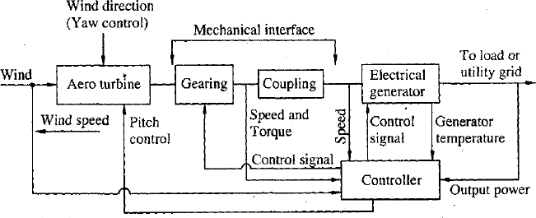

*Fig 4.3 wind energy conversion system*

**Types of wind mills**

1. **According to orientation of the axis of rotor**
   * Horizontal axis: When the axis of rotation is parallel to the air stream (i.e. horizontal), the turbine is said to be a Horizontal Axis Wind Turbine (HAWT).
   * Vertical axis: When the axis of rotation is perpendicular to the air stream (i.e. vertical), the turbine is said to be a Vertical Axis Wind Turbine (VAWT)
2. **According to useful electrical power output**
   * Small output: up to 2 kW
   * Medium output: 2 to 100 kW output
   * Large output: More than 100 kW output
3. **According to type of rotor**
   * Propeller type: It is horizontal axis high speed rotor.
   * Multiple blade type: It is horizontal axis low speed rotor.
   * Savonius type: It is vertical axis rotor.
   * Darrieus type: It is vertical axis rotor.

**Horizontal Axis Wind Turbine (HAWT)**

˜ Horizontal axis machines have emerged as the most successful type of turbines. These are being used for commercial energy generation in many parts of the world.

˜ They have low cut-in wind speed, easy furling and, in general, show high power coefficient.

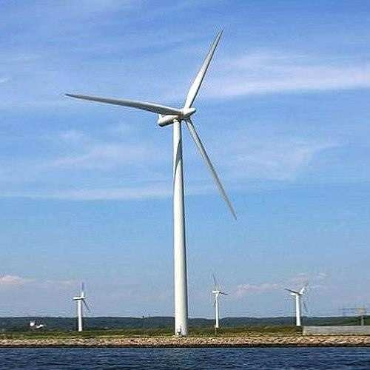˜ However, their design is more complex and expensive as the generator and gear box are to be placed at the top of the tower. Also, a tail or yaw drive is to be installed to orient them in the wind direction.

˜ Main components:

1. Turbine blades
2. Hub
3. Nacelle
4. Power transmission system
5. Generator
6. Yaw control
7. Brakes
8. Tower
9. Turbine blades

˜ Wind turbine blades need to be light weight and possess adequate strength and hence require to be fabricated with aircraft industry techniques.

˜ The blades are made of glass fibre reinforced plastic (F.R.P.). They have an aerofoil type of cross section to create lift as the air flows over them.

˜ The blades are slightly twisted from the outer tip to the root to reduce the tendency to stall.

˜ In addition to centrifugal force and fatigue due to continuous vibration, there are many extraneous forces arising from wind turbulence, gust, gravitational forces and directional changes in the wind. All these factors have to be considered at the designing stage.

˜ The diameter of a typical, MW range, modern rotor may be of the order of 100m.

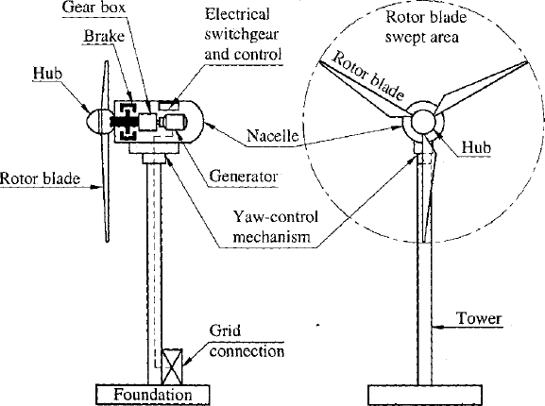

*Fig 4.4 Horizontal Axis Wind Turbine*

˜ Modern wind turbines have two or three blades.

˜ Two or three blade rotor HAWT are also known as propeller type wind turbine. Three blades are more common in Europe and other developing countries including India. The American practice, however, is in favour of two blades.

1. Hub

˜ A hub is the central solid portion of the rotor wheel. All blades are attached to the hub. The pitch angle control mechanism is also provided inside the hub.

1. Nacelle

˜ It houses the generator, the gear box, brakes, hydraulic system, and the yawing mechanism. Nacelle is placed at the top of the tower and is linked with the rotor.

1. Power transmission system

˜ Mechanical power generated by rotor blades is transmitted to the generator through a gear box. From the gear box, the transmission shaft rotates the generator with a built-in friction clutch. The gear box is provided to increase the speed to suit the generator.

˜ The generated electrical power is conducted to ground terminals through a cable.

1. Generator

˜ Generally, the grid connected large wind turbines have induction generators. They use reactive power from grids and feed the generated power to boost the grid supply.

˜ Medium capacity wind turbines use synchronous generators installed to electrify villages and remote places.

˜ Small capacity wind turbines use permanent magnet DC generators which supply power to microwave stations and illuminating light houses.

1. Yaw control

˜ Yaw control continuously tracks and keeps the rotor axis in the wind direction. Yawing is done by two yawing motors, which mesh with a big-toothed wheel mounted on top of the tower. Wind direction sensor is used to maintain the orientation.

˜ During high speed wind, i .e. more than the cut-out speed, the machine is stopped by turning the rotor axis at right angles to the wind direction. In small wind turbines, a tail vane is used for passive yaw control.

1. Brakes

˜ Brakes are used to stop the rotor when power generation is not desired. An emergency stop activates the hydraulic disc brakes fitted to the high speed shaft of the gear box.

1. Tower

˜ The tower supports the nacelle and rotor. Modern wind turbine generators are instal led on tubular towers.

˜ Both steel and concrete towers are being used.

**Types of rotors**

˜ The rotors for HAWT have been developed in various types of shapes and sizes depending on wind speed and nature of application.

˜ Propeller type, high speed wind turbine rotors is shown in Fig. They are suitable for applications such as electrical power generation. The rotational speeds of propeller type are in the range of 300-400 rpm. Large HAWTs have been manufactured with two and three blades as discussed earlier.

˜ A single blade rotor, with a balancing counterweight is economical, has simple controls but it is noisier and produces unbalanced forces. It is used for low- power applications.

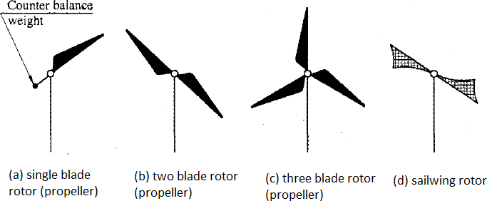

*Fig 4.5 Rotor blade*

˜ Sailwing rotor blade surfaces are made from cloth, nylon or plastics arranged as mast and pole. There is also variation in the number of sails used.

˜ Low speed wind turbine rotors are shown in Fig. They are most suited for water lifting applications which require a high starting torque. They can capture power even from very slow winds.

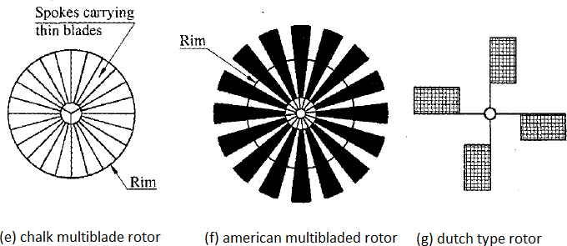

*Fig 4.6 Multiblade rotor*

˜ Multiblade rotor consists of number of curved sheet metal blades with increasing chord length away from the centre. Numbers of blades used are 12 to 20 which having their inner and outer ends fixed on to the respective rims. The speeds of multiblade type wind turbine rotors are 60 to 80 rpm.

˜ They have good power coefficient, high starting torque and added advantage of simplicity and low cost.

˜ Dutch type rotor is one of the oldest designs. The blade surfaces are made from an ray of wooden slats which feather at high wind speeds.

**Pitch control system**

˜ The pitch of a blade is controlled by rotating it from its root, where it is connected to the hub.

˜ The pitch control mechanism is provided through the hub of the rotor using hydraulic jack in the nacelle.

˜ The controller continuously adjusts the pitch to obtain the optimum performance.

˜ Thereby the power and speed of the wind turbine shaft is adjusted to match with the generator speed and its electrical output.

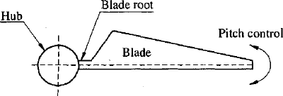

*Fig 4.7 Pitch control*

**Vertical Axis Wind Turbine (VAWT)**

˜ Vertical axis wind turbine (VAWT) is also known as cross-wind axis machines.

˜ In these machines, the axis of rotation is perpendicular to the direction of the wind.

˜ The main advantages of a VAWT compared to HAWT are:

1. The vertical axis wind turbine receives wind from any direction, and hence the yawing system is not required.
2. The generator, gearbox, etc. can be installed at the bottom of the tower, hence their tower design and installation is simple.
3. The inspection and maintenance is easier.
4. They are lighter in weight and cheaper in cost.

˜ VAWTs are generally not self starting and have low power coefficient, these are the major disadvantages. They require a mechanism to start from the stationary position. Additionally, there is a possibility of running the blades at very high speed and causing damage to the system.

˜ Main components:

1. Rotor shaft or Tower
2. Blades
3. Support structure

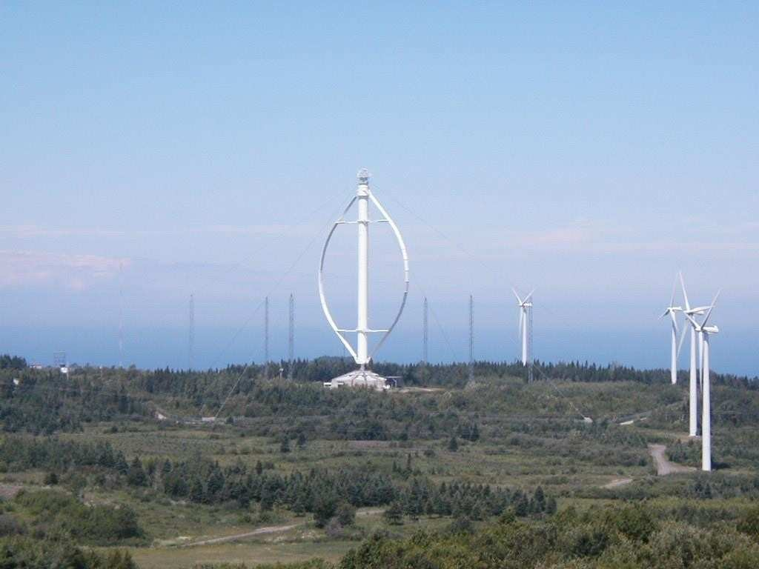

1. Rotor shaft or Tower

˜ The tower is a hollow vertical rotor shaft, which rotates freely about the vertical axis between the top and bottom bearings. It is installed above a support structure. In the absence of any load at the top, a very strong tower is not required, which greatly simplifies its design.

˜ The upper part of the tower is supported by buy ropes. The height of the tower of a large turbine is around 100 m.

1. Blades

˜ It has two or three thin and curved blades. The blades are shaped like an eggbeater in a profile. The blades have an airofoil cross section with constant chord length. The pitch of the blades cannot be changed. The diameter of the rotor is slightly less than the tower height.

1. Support structure

˜ The support structure is provided at the ground to support the weight of the rotor.

˜ Generator, gear box, brakes, controls, and electrical switchgear are housed within this structure.

˜ Guy ropes are attached to the top for support.

**Types of rotors**

˜ The vertical axis rotors can be either drag or lift based.

˜ The drag based devices have relatively high starting torques compared to lift devices, but have relatively low tip to wind speed ratio and lower power outputs for a given rotor size. The important vertical axis rotors are described below.

1. **Savonious rotor**

˜ This type was invented by S.J. Savonius in the year 1920.

˜ This rotor consists of two half cylindrical or elliptical blades arranged in an 'S' shape .

˜ It is also known as S-rotor.

˜ The rotor works on drag force produced by the blades

˜ It has high starting torque, low speed and low efficiency

˜ It can extract power even from very slow wind, making it working most of the time.

˜ These are used for low power applications.

˜ Suitable for pumping application due to high starting torque.

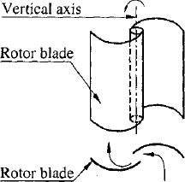

*Fig 4.8 Savonius rotor*

1. **Darrieus rotor**

˜ The Darrieus rotor was invented by Georges Jeans Darrieus.

˜ This rotor works due to the lift force produced by a set of airofoils.

˜ The blades are shaped like a troposkein profile (turning rope), which minimizes the bending stress caused by centrifugal forces.

˜ The Darrieus rotor is used for large scale power generation.

˜ Its power coefficient is considerably better than that of an S-rotor.

˜ This machine is not self starting, it can be started by using electrical generator as motor.

˜ At high wind speed it becomes difficult to control the output because the pitch of the blade cannot be changed.

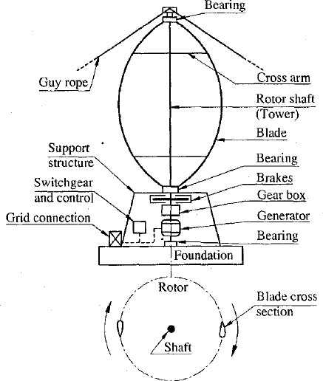

*Fig 4.9 Darrieus type rotor*

**Comparis on**

|  |  |
| --- | --- |
| **Horizontal axis turbine** | **Vertical axis turbine** |
|  |  |
| 1. Axis of rotation is parallel to the air stream | 1. Axis of rotation is perpendicular to the air stream. |
| 2. Yaw control mechanism is required to adjust the rotor around vertical axis to keep it facing the  wind. | 2. No orientation of rotor is required; these turbines can generate power with the wind coming from any  direction. |
| 3. The heavy nacelle containing the gearbox, generator, etc. is mounted at the top of the tower, thus the design and installation is  complex. | 3. The nacelle is not required because the gearbox, generator, etc., are located at the ground, thus the design and installation is  simple. |
| 4. The power coefficient and tip speed ratio are high. | 4. The power coefficient and tip speed ratio are considerably low. |

|  |  |
| --- | --- |
| 5. The rotor is mounted at the top of high tower, it experience higher velocity wind. This  yields more energy output | 5. The rotor is generally mounted near ground proximity, it experience lower velocity wind.  This yields less energy output. |
| 6. Suitable for large scale power generation. | 6. Suitable for small scale power generation and  pumping  applications. |
| 7. Initial and maintenance cost are high. | 7. Initial and maintenance cost are low. |

### DESIGN CONSIDERATION

˜ The fundamental design goal is to keep the cost of power lower than that from the turbine of the available design.

Parameters: Power coefficient (C ) , Tip speed ratio (λ), Solidity(σ)

˜

p

˜ The wind turbine may be exposed to severe and unpredictable environmental conditions due to which its rotor design becomes complicated. The general procedure starts with identification of various rotor parameters and the choice of an airofoil. Then an initial blade shape is found using an optimum blade shape and assuming wake rotation. The final blade shape and performance are obtained iteratively based on drag, tip losses and ease of manufacture.

The power P needed at a particular wind speed V is to be decided first. Also,

˜

i

the value of C

p

and overall efficiency η for various components are to be

predicted. The value of C

p

for a well designed system is in the range of 0.4 to

0.45 and r^ may be taken as 0.9 for the combined drive train and generator.

˜ Power P obtained is given by,

*P* *C* *P*

*P t*

 *P* *C*

 

*D*2*V*3 

*P*  



8 *i*

m Diameter of rotor

 *D* 

Maximum torque T on a turbine rotor

D

But,

*T* max  ma

F

x

 *F*

###### 2

*R*

max

*F* 1 A.*V*2

max *i*

2

*T* 1 A.*V* 2 *R*

max *i*

2

For a wind turbine producing a shaft torque T, the torque coefficient C is

T

defined by C

T

or

= T/T

max

T = C

T

.T

max

˜ The tip speed ratio (λ) is defined as the ratio of the blade's outer tip speed Vt to the upstream (free) wind speed Vi.

Mathematically,

*Vt* *R*



*V*

*i* *V*

*i*

A.*V*2 . *V*.



3

1

*T*



max

*i* *i*

2

´ A.*V*

2 *i*  



*T *  

max  

*t*  

˜ The shaft power (P)

*P* *T*.*C T* 

*T* max

˜ But Power,

*P t*

*C P*

*P* *C*

*T* 

*P*

*P*

*t*

 ma   

 

*T* x *CT* 

*C*

*t*

*C*  

*P*

*C*

*T*

˜ From the Betz criterion the maximum value of Cp is 0.593

. *C* max

0.593

*T*  



*C*

*P* 

˜ The tip speed ratio (λ) is chosen according to the type of application. E.g.

* Water pumping wind turbine 1 < λ < 3 is used.
* Wind-electric generators have λ in the range 4 < λ < 10.

˜ The number of blades can be chosen from the Fig., which represents number of blades for different values of λ. Curved blades can be used as airofoil if λ < 3 and more aerodynamic shape is required for λ > 3.

˜ The tip speed ratio at optimum power extraction is given by

4П



Number of blade

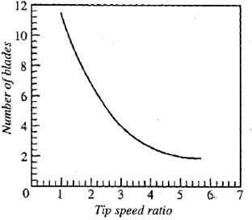

*Fig 4.10 Number of blades versus tip speed ratio*

Solidity (σ)

˜ Solidity is defined as the ratio of the blade area to the swept frontal area of the wind turbine.

˜ Solidity determines the quantity of blade material required to intercept a certain wind area.

Mathematically,

. ´Blade area σ Swept frontal area of



turbine

σ Bb

BRb

ПR2



Where, ПR

B = Number of blades, b = Blade width,

R = Blade radius.

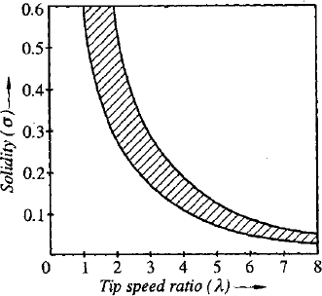

*Fig 4.11 Variation of solidity with tip speed ratio*

˜ A high solidity rotor rotates slowly and uses the drag force while a low solidity rotor uses lift forces.

˜ The solidity of the Savonious rotor is unity, and that of the American multiblade rotor is typically 0.7.

**Blade design**

˜ Wind turbine blades have an airofoil type cross section and a variable pitch.

They are slightly twisted from the outer tip to the root.

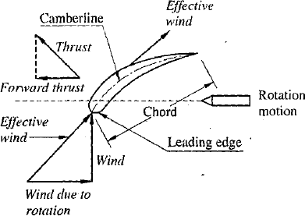˜ As shown in Fig., the force that propels the blades of a wind turbine comes from the chord of the airofoil, being tilted away from the direction of motion. The motion causing the 'wind due to motion' is the rotation of the blades.

*Fig 4.12 Wind turbine blade as an airofoil*

**Tower**

**:**

˜ Winds are much stronger as the elevation above ground increases, and they are also less turbulent. Therefore, the tower should be as high as practical. Choice of tower height is based on an economic trade-off of increased energy capture versus increased cost.

˜ The minimum height of the tower for HAWT is that the blade tip should not touch the ground during rotation.

˜ The principle options in towers are tubular, pipe-type structures or trusses.

**The overall conversion efficiency (η**

**0**

**) of the system is given by**

Where,

0 Useful power output







Wind power input .

*G*

*A*

η = Efficiency of the

A

. .

*Gen*



*C*

turbine=C , η

p G

the gearing,

= Efficiency of

η = Efficiency of the mechanical

C

coupling, η generator.

Gen

= Efficiency of the

**Variation of power coefficient with tip speed ratio**

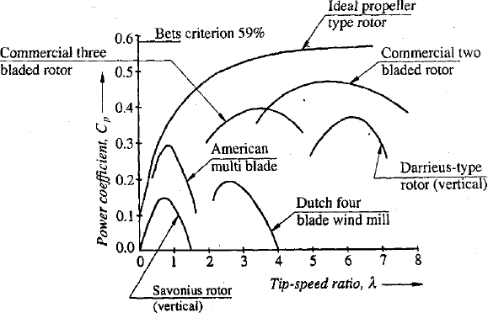

*Fig 4.13 Variation of power coefficient with tip speed ratio*

**Variation of torque coefficient with tip speed ratio**

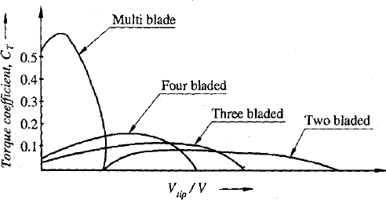

*Fig 4.14 Variation of torque coefficient with tip speed ratio*

### SITE SELECTION CONSIDERATIONS

1. **Average annual wind speed**

˜ The power available in wind increases rapidly with wind speed. Therefore, the main consideration for locating a wind-power generation plant is the availability of adequate and uniform average wind velocity throughout the year.

˜ The total wind power from free wind stream increases as the cube of the wind speed. Therefore, wind velocities available should be in the range of 5 m/s to 25 m/s throughout the year.

1. **Area**

˜ As the building, forests offers the resistance to the air movement, the wind farms are located away from cities and forests. Flat open area should be selected, as the wind velocities are high in flat open area.

1. **Altitude of the site**

˜ Altitude of the proposed site should be considered. Higher altitude ground experience strong winds than lower altitude ground. Thus, altitude affects the electric power output of wind energy conversion system.

˜ Wind velocities must be measured by anemometer at several heights from the ground The velocity of wind increases with height given by the relation:

*V* *H* 1/ 7

˜ This relation is applicable for the heights between 50 m to 250 m.

1. **Wind structure**

˜ At the proposed site, wind should blow, smooth and steady all the time, i.e. the wind velocity curve should be flat. Wind specially near the ground is turbulent and gusty, and changes rapidly in direction and in velocity.

1. **Local ecology**

˜ If small trees, grass or vegetations are present, all of which destructure the wind, then the height of the tower will increase, which increases the cost of the system.

1. **Nature of land and its cost**

˜ The site selected should have high load bearing capacity. It would reduce the cost of foundation. The cost of the land should be low to reduce the initial cost.

1. **Transport facilities**

˜ There should be transport facilities for transportation of heavy machinery, structures, materials, blades, etc to chosen site for installation.

1. **Nearness of site to load centre**

˜ The site should be located near the load to which the power is supplied. The location of site near load centre reduces the cost of transmission lines and the losses occurring in it.

1. **Away from localities**

˜ The selected site should be away from localities so that the sound pollution caused by wind turbine does not affect the habitants in near areas.

**Four types of sites are considered as suitable:**

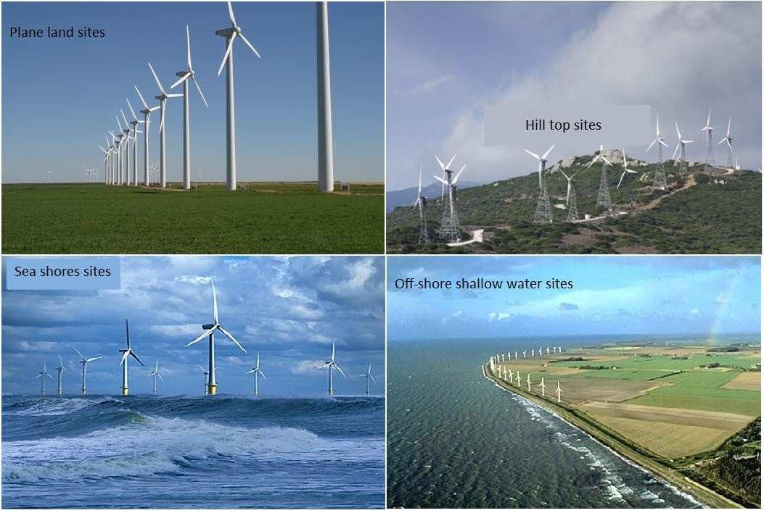

**Advantages**

* 1. It is renewable and not depleted with the use like fossil fuels.
  2. Wind energy generation is ecofriendly and does not pollute the atmosphere, unlike in the case of generation from coal, oil, etc.
  3. The cost of installation of wind power plant is competitive compared to conventional power plant/Since, there is no fuel cost and low maintenance cost, the cost of energy produced in long run is almost free.
  4. Wind energy system does not require fuel and its transportation.
  5. In large portion of the world, wind blows for 320 days in a year and this gives them an advantage over sunlight in direct conversion programme.

**Disadvantages**

1. Wind energy is available in dilute and fluctuating in nature.
2. It is necessary to store wind energy in some other forms during periods of high winds for use later on during calm.
3. Favourable winds are available only in few geographical locations.
4. There is fluctuation in electric power depending on fluctuating wind speed.
5. The capital cost is high. At present it is about Rs. 3.5 crores/MW.
6. It causes negative impacts like noise, bird hits, land erosion, impact on wild life, etc.

### WIND ENERGY DEVELOPMENT IN INDIA

˜ The wind power programme in India was initiated towards the end of the Sixth Plan, in 1983-84.

˜ In India, the wind energy programme is managed and implemented by the Ministry of New and Renewable Energy sources, Government of India. The wind power potential in India is 49,130 MW as per the official estimates in the Indian Wind Atlas (2010) by the Centre for Wind energy Technology.

˜ The potential is calculated with respect to 2% land availability at windy locations and pertains to a 50 meter hub height level of the wind turbines.

˜ A total capacity of 17365.03 MW has been established up to March 31,2012 in the country. India is now the fifth largest wind power producer in the world, after USA, Germany, Spain and China.

˜ The break-up of projects implemented in prominent wind potential states is as given in Table

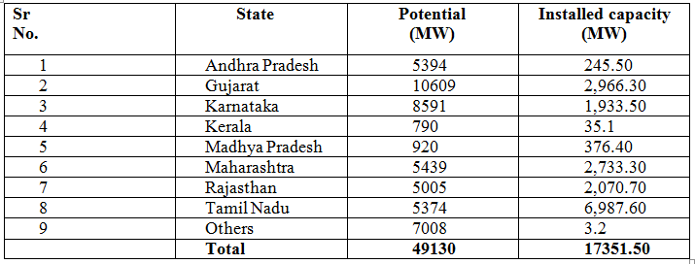Table 4.1

## Bio Energy:



### INTRODUCTION

In the past few years, there have been significant improvements in renewable energy technologies along with declines in cost. The growing concern for the environment and sustainable development, have led to worldwide interest in renewable energies and bioenergy in particular. Biomass can be converted into modern energy forms such as liquid and gaseous fuels, electricity, and process heat to provide energy services needed by rural and urban populations and also by industry. This paper explains the different ways of extracting energy from biomass and a comparison is made among them. This paper also explains about the potentiality of biomass energy in India, analyses current situation compares bio- energy and other options for promoting development, brings out the advantages over the other renewables putting forth the drawbacks to be overcome to make it still more successful. This paper analyses current situation compares bio-energy and other options for promoting development, explore the potential for bio-energy.

In past 10 years or so, considerable practical experience has accumulated in India as well as in other developing and industrialized countries, on biomass energy production and conversion. India is pioneer among developing countries, with significant indigenous efforts in promoting renewable energy technologies. The importance of bioenergy as a modern fuel has been recognized. India has about 70,000 villages yet to be connected to the electricity grid. The supply of grid power to rural areas is characterized by

1. Low loads
2. Power shortages
3. Low reliability
4. Low and fluctuating voltages
5. High transmission and distribution costs and power losses

Decentralized power generation based on renewables is an attractive option to meet the energy needs. The availability of biomass such as wood, cow- dung, leaf litter in rural areas is more. Hence a choice of biomass energy especially in rural areas is more reasonable but at the same time the technology is being developed to meet the large- scale requirements using biomass.

Biomass energy has played a key role in the time of Second World War when there was a fuel deficiency. Many vehicles, tractors and trucks used wood gasifies, which generate producer's gas, running an internal combustion Engine. One of the major advantages of biomass energy is that it can be used in different forms. For e.g., Gas generated from the biomass can be directly used for cooking or it can be used for running an internal combustion Engine for developing stationary shaft power or otherwise coupled to generator for generating electric power.

The subsequent sections explain about the different ways of extracting energy from biomass, explaining about technological and economic aspects followed by a case study. The issue of land availability for biomass (wood) production is also discussed.

#### Different Ways of extracting energy from biomass

The different methods of biomass extraction can be broadly be classified as:

* 1. Anaerobic Digestion
  2. Gasification
  3. Liquefaction

**Solid fuel combustion**

The simplest and most common way of extracting energy from biomass is by direct combustion of solid matter. Majority of the developing countries especially in rural areas obtain the majority of their energy needs from the burning of wood, animal dung and other biomass. But burning can be inefficient. An open fireplace may let large amounts of heat escape, while a significant proportion of the fuel may not even get burnt.

**Gasification**

˜ Gasification is a process that exposes a solid fuel to high temperatures and limited oxygen, to produce a gaseous fuel. This is a mix of gases such as carbon monoxide, carbon dioxide, nitrogen, hydrogen and methane.

˜ Gasification has several advantages over burning solid fuel. One is convenience - one of the resultant gases, methane, can be treated in a similar way as natural gas, and used for the same purposes.

˜ Another advantage of gasification is that it produces a fuel that has had many impurities removed and will therefore cause fewer pollution problems when burnt. And, under suitable circumstances, it can produce synthesis gas, a mixture of carbon monoxide and hydrogen. This can be used to make almost any hydrocarbon (e.g., methane and methanol), which can then be substituted for fossil fuels. But hydrogen itself is a potential fuel of the future.

**Paralysis**

˜ Paralysis is an old technology with a new lease of life. In its simplest form it involves heating the biomass to drive off the volatile matter, leaving behind the black residue we know as charcoal. This has double the energy density of the original material. This means that charcoal, which is half the weight of the original biomass, contains the same amount of energy - making the fuel more transportable. The charcoal also burns at a much higher temperature than the original biomass, making it more useful for manufacturing processes. More sophisticated Paralysis techniques have been developed recently to collect the volatiles that are otherwise lost to the system. The collected volatiles produce a gas rich in hydrogen (a potential fuel) and carbon monoxide. These compounds, if desired, can be synthesized into methane, methanol and other hydrocarbons. 'Flash' Paralysis can be used to produce bio-crude

- a combustible fuel.

**Digestion**

˜ Biomass digestion works by the action of anaerobic bacteria. These microorganisms usually live at the bottom of swamps or in other places where there is no air, consuming dead organic matter to produce, among other things, methane and hydrogen.

˜ We can put these bacteria to work for us. By feeding organic matter such as animal dung or human sewage into tanks - called digesters - and adding bacteria, we can

collect the emitted gas to use as an energy source. This can be a very efficient means of extracting usable energy from such biomass - up to two- thirds of the fuel energy of the animal dung is recovered.

˜ Another, related, technique is to collect gas from landfill sites. A large proportion of household biomass waste, such as kitchen scraps, lawn clippings and pruning, ends up at the local tip. Over a period of several decades, anaerobic bacteria are at work at the bottom of such tips, steadily decomposing the organic matter and emitting methane. The gas can be extracted and used by 'capping' a landfill site with an impervious layer of clay and then inserting perforated pipes that collect the gas and bring it to the surface.

**Fermentation**

˜ Like many of the other processes described here, fermentation isn't a new idea. For centuries, people have used yeasts and other microorganisms to ferment the sugar of various plants into ethanol. Producing fuel from biomass by fermentation is just an extension of this old process, although a wider range of plant material can now be used, from sugar cane to wood fiber. For instance, the waste from a wheat mill in New South Wales has been used to produce ethanol through fermentation. This is then mixed with diesel to produce 'dishelm', a product used by some trucks and buses in Sydney and Canberra.

˜ An elaborated discussion on Digestion and Gasification, which are the major ways employed in India, are explained in subsequent sections.

#### Anaerobic Digestion

˜ Anaerobic Digestion is a biochemical degradation process that converts complex organic material, such as animal manure, into methane and other byproducts.

**What is Anaerobic Digester?**

Anaerobic digester (commonly referred to as an AD) is a device that promotes the decomposition of manure or “digestion” of the organics in manure to simple organics and gaseous biogas products. Biogas is formed by the activity of anaerobic bacteria. Microbial growth and biogas production are very slow at ambient temperatures. These bacteria occur naturally in organic environments where oxygen is limited. *Biogas is comprised of about 60% methane, 40% carbon dioxide, and 0.2 to 0.4% of hydrogen sulfide.* Manure is regularly put into the digester after which the microbes break down the manure into biogas and a digested solid. The digested manure is then deposited into a storage structure. The biogas can be used in an engine generator or burned in a hot water heater. AD systems are simple biological systems and must be kept at an operating temperature of 100 degrees F in order to function properly. The first methane digester plant was built at a leper colony in Bombay, India. Biogas is very corrosive to equipment and requires frequent oil changes in an engine generator set to prevent mechanical failure. The heating value of biogas is about 60% of natural gas and about 1/4 of propane. Because of the low energy content and its corrosive nature of biogas, storage of biogas is not practical.

There are two major types of biogas designs promoted in India

1. Floating Drum
2. Fixed Dome

The floating drum is an old design with a mild-steel, Ferro-cement or fiberglass drum, which floats along a central guide frame and acts as a storage reservoir for the biogas produced. The fixed dome design is of Chinese origin and has dome structure made of cement and bricks. It is a low- cost alternative to the floating drum, but requires high masonry skills and is prone to cracks and gas leakages. Family biogas plants come in different size depending on the availability of dung and the quantity of biogas required for cooking. The average size of the family is 5-6 persons, and thus biogas plant of capacity 2-4 m3 is adequate. The biomass requirement is estimated to be 1200 liters for a family.

**Comparison between two designs:**

|  |  |
| --- | --- |
| **Fixed dome**  Digester and gas holder, masonry or  concrete structure | **Floating Drum**  Digester, masonry, Gas holder, mild steel or  fiberglass |
| Requires high masonry skills | Low masonry or fabricating skills |
| Low reliability due to high construction failure  Variable gas pressure | High reliability, gas holder prefabricated |
| Constant gas pressure |
| Digester could be inside the ground | Requires space above ground for three  tanks; inlet, digester, outlet |
| Low Cost (2 m3 = Rs.5000) | Low Cost (2 m3 = Rs.8000) |

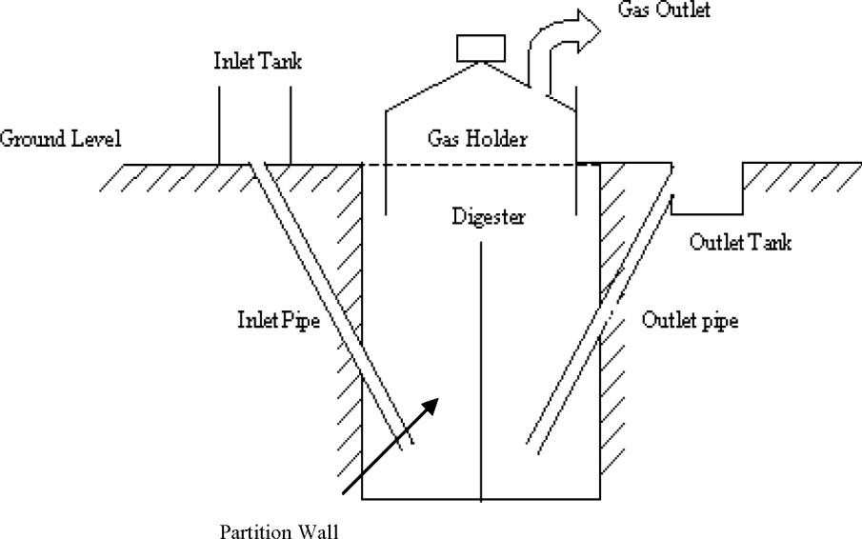

Floating Gasholder drum design (a conventional Indian desig

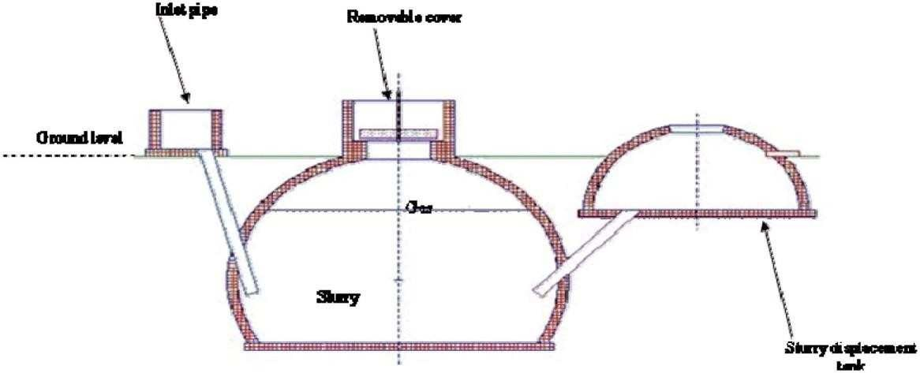

**Uses of Biogas**

Spherical shaped fixed - dome plant

Biogas can be directly used for cooking by supplying the gas though pipes to households from the plant. Biogas has been effectively used as a fuel in industrial high compression spark ignition engines. To generate electricity an induction generator can be used and is the simplest to interface to the electrical grid. Induction generators derive their voltage, phase, and frequency from the utility and cannot be used for stand-by power. If a power outage occurs generator will cease to operate. Synchronous generator can also be used to connect to the grid. However, they require expensive and sophisticated equipment to match the phase, frequency and voltage of the utility grid. Biogas can also be used as fuel in a hot water heater if hydrogen sulfide is removed from the gas supply.

**Case Study of Community Biogas programmes in India**

Biogas Electricity in Pure Village

In India, Biogas option is considered largely as a cooking fuel. The need for considering decentralized electricity options and the potential of biogas is analyzed. A field- demonstration programme was implemented in pure village in South India to use cattle dung in a community biogas plant to generated electricity for services such as pumping drinking water and home lighting.

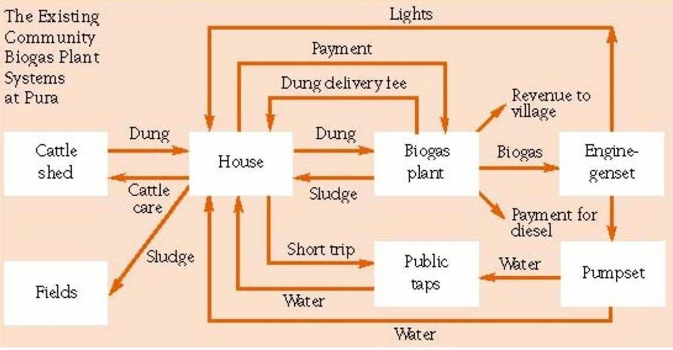

Community Biogas Plant in Pura Village

**Technology**

The Indian floating-drum design shown in fig.1 with modified dimensions for cost reductions was used. The Pure biogas plants have a capacity to digest up to 1.2 t cattle dung/day and produce 42.5-m3 biogas/day. Sand bed filters were installed to remove excess water and convert the sludge to dung-like consistency for subsequent use as a fertilizer. The filtrate, which contains the required anaerobic microorganisms, is mixed with the input dung. A 5 kW diesel engine is connected to a 5kVA, 440 V three-phase generator of electricity generation.

**Lighting**

Out of 87 households in the village 39 already had grid electricity, there are

103 fluorescent tube lights of 20 W capacity connected biogas generated electricity. Forty-seven houses opted for one tube light and 25 houses have two tube lights. Lighting is provided in the evening for 2.5 hours/day. Even homes connected to the grid had lighting connections from the biogas system.

**Water supply**

A submersible pump is connected to a tube well and water is pumped to storage tanks for 1 hour and 40 minutes/day. The majority of the households have opted for private taps at their doorsteps.

**Biomass Gasifies:**

Biomass, or more particularly wood, can be converted to a high-energy combustible gas for use in internal combustion engines for mechanical or electrical applications. This process is known as gasification and the technology has been known for decades, but its application to power generation is of recent origin. A biomass gasified consists of a reactor where, under controlled temperature and air supply, solid biomass is combusted to obtain a combustible gas called *Producers gas*

(consisting of H and CH ). This gas passes through a cooling and cleaning

2 4

system before it is fed into a compression ignition engine for generation of mechanical or electricity (by coupling to a generator). An assessment of its potential concluded that India presents a unique opportunity for large-scale commercial exploitation of biomass gasification technology to meet a variety of energy needs, particularly in the agricultural and rural sectors. The large potential of biomass gasification for water pumping and power generation for rural electrification was recognized.

***Feed StoCks for produCer-gas systems:***

A range of crop residues and woody biomass from trees could be used as feedstocks for producer-gas systems. Currently, wood-based systems are available, and designs using other low-density biomass are under development and should soon be available in India. Crop residues with fuel potential are limited, since nearly all cereal and most pulse residues are used as fodder or manure and thus are not available as

fuel. It is important to note that currently crop residues are used and have an opportunity cost. Rice husks are used in the cement industry, in rice mills and in the manufacture of bricks. Coconut leaves are used as thatch and the husk as fiber and sugarcane biogases is used in sugar mills. In Punjab, for rice- husk-based power generation systems, the price of residues such as rice husk could increase once new uses and demands are developed. Crop residues may continue to be used as fuel in domestic sector assuming that cooking-energy requirements are going to be met from bio-energy options.

Constant supply of crop residues as feedstock cannot be assured over a long period on continuous basis and the transportation of low-density residues is not feasible.

Woody biomass would be the dominant source of feedstock for gasification. The availability of woody biomass and production potentials are discussed in the following section.

**Biomass availability issues:**

Before assessing the country's bioenergy production potential, it is important to:

1. Estimate the land availability for biomass production,
2. Identify and evaluate the biomass production options—yield/ha and financial viability,
3. Estimate sustainable biomass production potential for energy,
4. Estimate the energy potential of biomass production,
5. Assess the investment required and barriers to producing biomass sustainably for energy.

Different options for wood supply

1. Conservation potential of wood used in cooking.
2. Producing wood on community, government, or degraded forest land.
3. Producing wood on degraded private or farm land.
4. Sustainable harvest from existing forest.
5. Logging waste.

Consideration of options 2 and 3 involves a range of related issues, such as land availability, land quality, competitive uses of land, and sustainability of wood production.

Some proportion of wood currently burnt, as cooking fuel would become available for the producer-gas electricity option. Tree plantations, farm trees, homestead gardens, and degraded lands are the various sources of fuel wood used for cooking. Among these sources, only wood from tree plantations could be considered as easily available as feedstock for power generation.

Woody biomass would be the dominant source of feedstock for gasification. The availability of woody biomass and production potentials are discussed in the following section.

Estimates of degraded land availability in India (Mha):

|  |  |  |
| --- | --- | --- |
| SPWD; degraded (waste) land quoted in PC | Degraded forest, Degraded non- forest, Total | Total degraded land 130 Mha |
|  | degraded land |  |
| Chambers; land available for tree planting | Cultivated lands, Strips and boundaries,  Uncultivated degraded land, Degraded forest land, Land for tree  planting | Total Land for tree planting  84 Mha |
| Kapoor; land available  plantation | Agricultural land,  Pasture land, Fallow, Urban | Total land for tree  106 Mha |
|  | Forest land with < |  |
| Ministry of Agriculture | 10% tree crown cover, Grazing land, gTreoeves, Culturable  waste, Old fallow, | Total degraded  land 66 Mha |

# UNIT-IV

## Geothermal energy:

1. **Geo thermal energy**

˜ Geo thermal energy itself on earth's surface in the form of geyster, hot spring, furnarhole& boingMud

˜ By drilling hole 3 km deep in the field the steam and water comes out from surface at temperature Up to 500°c

˜ It can be used for power generating.

**Geothermal power plant:**

**Geothermal electricity** is electricity generated from geothermal energy. Technologies in use include dry steam power plants, flash steam power plants and binary cycle power

plants. Geothermal electricity generation is currently used in 24 countries while geothermal heating is in use in 70 countries.

Estimates of the electricity generating potential of geothermal energy vary from 35 to 2000 GW. Current worldwide installed capacity is 10,715 megawatts (MW), with the largest capacity in the United States (3,086 MW), Philippines, and Indonesia.

**Geothermal Power (Hot Dry Rocks)**

Geothermal heat of over 200 °C can be delivered from up to 5000 m deep holes to operate organic Rankine cycles or Kalina cycle power machines. Unit sizes are about 1 MW today and limited to about 100 MW maximum in the future. Geothermal energy is often used for the co-generation of heat and power. Geothermal power plants are used all over the world where surface near geothermal hot water or steam sources are available, like in USA, Italy and the Philippines. In the MED-CSP study region those conventional geothermal potentials are significant in Island, Italy, Turkey, Yemen and Iran. Those potentials are small in comparison to the HDR potentials and are not quantified separately in the study. The Hot Dry Rock technology aims to make geothermal potentials available everywhere, drilling deep holes into the ground to inject cold water and receive hot water from cooling down the hot rocks in the depth /IGA 2004/. However, this is a very new though promising approach and technical feasibility must still be proven. Geothermal power plants provide power on demand using the ideal storage of the earth's hot interior as reservoir. They can provide peak load, intermediate load or base load electricity. Therefore, the capacity factor of geothermal plants is defined by the load and their operation mode. Assuming a plant availability of 90 %, their capacity credit would have that same value.

|  |  |  |
| --- | --- | --- |
| 16  14  12  10  8  6  4  2  0  0 100 400  200  300  **Rock Temp eratu re [°C]** | | |
|  | Efficiency [%] Recovery Factor [%] |  |

Figure 2-6: Efficiency () and recovery factor (R) of geothermal power schemes as function of temperature adapted from

/TAB 2003/.

The available heat in place Eth is calculated as a function of the volume of rocks that will be affected by the cooling process /TAB 2003/. From that, the extracTable 2-geothermal electricity per year Egeo can be calculated as a function of the power cycle efficiency, the recovery factor and the total time of extraction. The recovery factor takes into account that

only a small part of the affected rock volume is cooled down, and that the lower cycle temperature is higher than the surface temperature.

E = c

th G

··V·(T

G

–T

5000

)

surface

E = E

geo th

·R·/t

extract

Eth Heat in place [J]

Eel ExtracTable 2-electricity [J/y]

cG Spezific heat of the rocks [J/kg K]

G Density of the rocks [kg/m3] V Volume of rock affected [m3]

T5000 Temperature of the rocks at 5000 m depth [°C] Tsurface Surface Temperature [°C] R Recovery Factor

 System Efficiency textract

Extraction time

[y]

For the study we have made the following assumptions:

cG = 840 [J/kg**·**K], G = 2600 kg/m3, TS = 10°C, V = 1 km³, textract = 1000 years

**Ocean thermal energy conversion(OTEC):**

˜ Ocean serves a big store house of solar energy

˜ At water surface 23°c-source ,while temperature at depth of 100m is 5°c-sink

˜ Temperature differential can be used to run heat engine & power can be produce using working fluids NH3,R-12, propane gas .



**Ocean thermal energy conversion** (*OTEC* )uses the difference between cooler deep and warmer shallow or surface ocean waters to run a heat engine and produce useful work, usually in the form of electricity.

A heat engine gives greater efficiency and power when run with a large temperature difference. In the oceans the temperature difference between surface and deep water is greatest in the tropics, although still a modest 20oC to 25oC. It is therefore in the tropics that OTEC offers the greatest possibilities. OTEC has the potential to offer global amounts of energy that are 10 to 100 times greater than other ocean energy options such as wave power. OTEC plants can operate continuously providing a base load supply for an electrical power generation system.

The main technical challenge of OTEC is to generate significant amounts of power efficiently from small temperature differences. It is still considered an emerging technology. Early OTEC systems were of 1 to 3% thermal efficiency, well below the theoretical maximum for this temperature difference of between 6 and 7%.[2] Current designs are expected to be

closer to the maximum. The first operational system was built in Cuba in 1930 and generated 22 kW. Modern designs allow performance approaching the theoretical maximum Carnot efficiency and the largest built in 1999 by the USA generated 250 kW .

The most commonly used heat cycle for OTEC is the Rankine cycle using a low- pressure turbine. Systems may be either closed-cycle or open-cycle. Closed-cycle

engines use working fluids that are typically thought of as refrigerants such as ammonia or R-134a. Open-cycle engines use vapour from the seawater itself as the working fluid.

OTEC can also supply quantities of cold water as a by-product . This can be used for air conditioning and refrigeration and the fertile deep ocean water can feed biological technologies. Another by-product is fresh water distilled from the sea.

Cold seawater is an integral part of each of the three types of OTEC systems: closed- cycle, open-cycle, and hybrid. To operate, the cold seawater must be brought to the surface. The primary approaches are active pumping and desalination. Desalinating seawater near the sea floor lowers its density, which causes it to rise to the surface.

The alternative to costly pipes to bring condensing cold water to the surface is to pump vaporized low boiling point fluid into the depths to be condensed, thus reducing pumping volumes and reducing technical and environmental problems and lowering costs.

Diagram of a closed cycle OTEC plant

Closed-cycle systems use fluid with a low boiling point, such as ammonia, to power a turbine to generate electricity. Warm surface seawater is pumped through a heat exchanger to vaporize the fluid. The expanding vapor turns the turbo-generator. Cold water, pumped through a second heat exchanger, condenses the vapor into a liquid, which is then recycled through the system.

In 1979, the Natural Energy Laboratory and several private-sector partners developed the "mini OTEC" experiment, which achieved the first successful at-sea production of net electrical power from closed-cycle OTEC.[12] The mini OTEC vessel was moored

1.5 miles (2 km) off the Hawaiian coast and produced enough net electricity to illuminate the ship's light bulbs and run its computers and television.

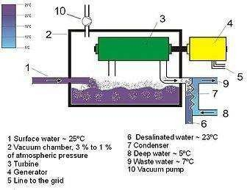

Diagram of an open cycle OTEC plant

Open-cycle OTEC uses warm surface water directly to make electricity. Placing warm seawater in a low-pressure container causes it to boil. The expanding steam drives a low-pressure turbine attached to an electrical generator. The steam, which has left its

salt and other contaminants in the low-pressure container, is pure fresh water. It is condensed into a liquid by exposure to cold temperatures from deep- ocean water. This method produces desalinized fresh water, suitable for drinking water or irrigation.

In 1984, the *Solar Energy Research Institute* (now the National Renewable Energy Laboratory) developed a vertical-spout evaporator to convert warm seawater into low- pressure steam for open-cycle plants. Conversion efficiencies were as high as 97% for seawater-to-steam conversion (overall efficiency using a vertical-spout evaporator would still only be a few per cent). In May 1993, an open-cycle OTEC plant at Keahole Point, Hawaii, produced 50,000 watts of electricity during a net power-producing experiment. This broke the record of 40 kW set by a Japanese system in 1982.

## Tidal energy:

˜ Tides are generated due to gravitational pull between the earth and the moon and sun.

˜ The difference between high tide & low tide could be utilized to operate hydraulic turbine.



**Tidal power**, also called **tidal energy**, is a form of hydropower that converts the energy of tides into electricity or other useful forms of power. The first large-scale tidal power plant (the Rance Tidal Power Station) started operation in 1966.

Although not yet widely used, tidal power has potential for future electricity generation. Tides are more predictable than wind energy and solar power. Among sources of renewable energy, tidal power has traditionally suffered from relatively high cost and limited availability of sites with sufficiently high tidal ranges or flow velocities, thus constricting its total availability. However, many recent technological developments and improvements, both in design (e.g. dynamic tidal power, tidal lagoons) and turbine technology (e.g. new axial turbines, crossflow turbines), indicate that the total availability of tidal power may be much higher than previously assumed, and that economic and environmental costs may be brought down to competitive levels.

Historically, tide mills have been used, both in Europe and on the Atlantic coast of North America. The earliest occurrences date from the Middle Ages, or even from Roman times.

Tidal power is extracted from the Earth's oceanic tides; tidal forces are periodic variations in gravitational attraction exerted by celestial bodies. These forces create corresponding motions or currents in the world's oceans. The magnitude and character of this motion reflects the changing positions of the Moon and Sun relative to the Earth, the effects of Earth's rotation, and local geography of the sea floor and coastlines.

Tidal power is the only technology that draws on energy inherent in the orbital characteristics of the Earth–Moon system, and to a lesser extent in the Earth– Sun system. Other natural energies exploited by human technology originate directly or indirectly with the Sun, including fossil fuel, conventional hydroelectric, wind, biofuel, wave and solar energy. Nuclear energy makes use of Earth's mineral deposits of fissionable elements, while geothermal power taps the Earth's internal heat, which comes from a combination of residual heat from planetary accretion (about 20%) and heat produced through radioactive decay (80%).

A tidal generator converts the energy of tidal flows into electricity. Greater tidal variation and higher tidal current velocities can dramatically increase the potential of a site for tidal electricity generation.

Because the Earth's tides are ultimately due to gravitational interaction with the Moon and Sun and the Earth's rotation, tidal power is practically inexhaustible and classified as a renewable energy resource. Movement of tides causes a loss of mechanical energy in the Earth–Moon system: this is a result of pumping of water through natural restrictions around coastlines and consequent viscous dissipation at the seabed and in turbulence. This loss of energy has caused the rotation of the Earth to slow in the

4.5 billion years since its formation. During the last 620 million years the period of rotation of the earth (length of a day) has increased from 21.9 hours to 24 hours;[4] in this period the Earth has lost 17% of its rotational energy. While tidal power may take additional energy from the system, the effect is negligible and would only be noticed over millions of years.

The world's first commercial-scale and grid-connected tidal stream generator – SeaGen – in Strangford Lough. The strong wake shows the power in the tidal current.

Top-down view of a DTP dam. Blue and dark red colors indicate low and high tides, respectively.

Tidal power can be classified into three generating methods:

Tidal stream generators (or TSGs) make use of the kinetic energy of moving water to power turbines, in a similar way to wind turbines that use moving air.

Tidal barrages make use of the potential energy in the difference in height (or *head*) between high and low tides. Barrages are essentially dams across the full width of a tidal estuary.

**Wave energy:**

˜ The wave energy is developed due to wind interacting with the surface of the ocean

.wind get 1 to 5% of sun energy and part of this is transfer to wave this can be used for power generating.



**UNIT-V**

**Direct energy conversion:**

### UNIT-V

#### Direct energy conversion:

**Carnot Cycle :**

A Carnot gas cycle operating in a given temperature range is shown in the T-s diagram in Fig. 4.1(a). One way to carry out the processes of this cycle is through the use of steady-state, steady-flow devices as shown in Fig. 4.1(b). The isentropic expansion process 2-3 and the isentropic compression process 4-1 can be simulated quite well by a well-designed turbine and compressor respectively, but the isothermal expansion process 1-2 and the isothermal compression process 3-4 are most difficult to achieve.

**Process 1 2: isothermal**

**Process 2 3: isentropic**

**p** **1**

**Process 3 4: isothermal**

**Process 4 1: isentropic**

#### 2

**4**

**3**

**(a)**

**Piston displacement**

**(b)**

**Fig.4.2. Reciprocating Carnot engine**

**3**

**4**

**2**

**1**

**Volume**

**T =T 3** **4**

**3 4**

# T =T

2

1

**2 1**

## Entropy

**Fig.4.3. Carnot cycle on p-v and T-s diagrams**

**Perfect insulator cum Perfet conductor**

**Fig.4.4. Working of Carnot engine**

Since the working fluid is an ideal gas with constant specific heats, we have, for the isentropic process,



T V ˜ 1

˜ 1

T 1

4 

V  ;

T2 V3 

T = V 

4  1  3  3 

Now, T1 = T2 and T4 = T3, therefore

v4 = =v r = compression or expansion ratio

3

v v

2

1

Carnot cycle efficiency may be written as,

= 1 - 1

 - 1

r

th

From the above equation, it can be observed that the Carnot cycle efficiency increases as ‘r' increases. This implies that the high thermal efficiency of a Carnot cycle is

obtained at the expense of large piston displacement. Also, for isentropic processes we have,

T1 =

 and

p ˜

1 1



 ˜ 1

T p 

=

2

2

´

T   T  

4 4  3 3 

Since, T1 = T2 and T4 = T3, we have

p

= rp = pressure ratio

1 = p2

p p

4

3

**Thermoelectric generator:**

**Thermoelectric generator**. A **thermoelectric generator** (TEG), also called a

Seebeck **generator**, is a solid state device that converts heat flux (temperature differences) directly into electrical energy through a phenomenon called the Seebeck effect (a form of**thermoelectric** effect).

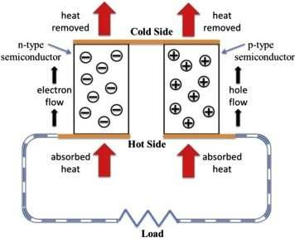

**Seebeck effect:**

The **Seebeck effect** is a phenomenon in which a temperature difference between two dissimilar electrical conductors or semiconductors produces a voltage difference between the two substances.

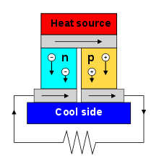

**Peltier effect:**

The **thermoelectric effect** is the direct conversion of temperature differences to electric voltage and vice versa via a thermocouple. A **thermoelectric** device creates voltage when there is a different temperature on each side The

Thomson**effect** is an extension of the **Peltier**–Seebeck model and is credited to Lord Kelvin.

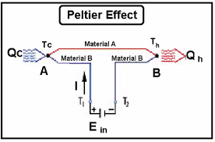

**Joule**–**Thomson effect** :

In thermodynamics, the **Joule**–**Thomson effect** (also known as the **Joule**–Kelvin **effect**, Kelvin–**Joule effect**, or **Joule**– **Thomson** expansion) describes the temperature change of a real gas or liquid (as differentiated from an ideal gas) when it is forced through a valve or porous plug while kept insulated so that no heat is ...

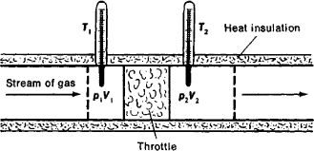

**generator** (**MHD generator**):

A magnetohydrodynamic **generator** (**MHD generator**) is a magnetohydrodynamic device that transforms thermal energy and kinetic energy into electricity. **MHD generators** are different from traditional electric**generators** in that they operate at high temperatures without moving parts.

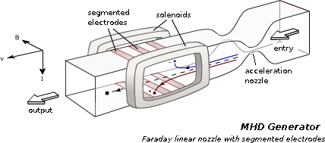

##### Magnetohydrodynamic power generation principle:

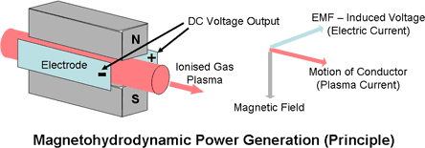

A **magnetohydrodynamic generator** (**MHD generator**) is a [magnetohydrodynamic](https://en.wikipedia.org/wiki/Magnetohydrodynamic) device that transforms [thermal energy](https://en.wikipedia.org/wiki/Thermal_energy) and [kinetic](https://en.wikipedia.org/wiki/Kinetic_energy)  [energy](https://en.wikipedia.org/wiki/Kinetic_energy) into [electricity](https://en.wikipedia.org/wiki/Electricity). MHD generators are different from traditional [electric generators](https://en.wikipedia.org/wiki/Electric_generator) in that they operate at high temperatures

without [moving parts](https://en.wikipedia.org/wiki/Moving_parts). MHD was developed because the hot exhaust gas of an MHD generator can heat the boilers of a [steam](https://en.wikipedia.org/wiki/Rankine_cycle) [power plant](https://en.wikipedia.org/wiki/Power_plant), increasing overall efficiency. MHD was developed as a [topping cycle](https://en.wikipedia.org/wiki/Topping_cycle) to increase the efficiency of [electric generation](https://en.wikipedia.org/wiki/Electric_generation), especially when burning [coal](https://en.wikipedia.org/wiki/Coal) or [natural gas](https://en.wikipedia.org/wiki/Natural_gas). MHD dynamos are the complement of [MHD propulsors](https://en.wikipedia.org/wiki/Magnetohydrodynamic_drive), which have been applied to pump liquid metals and in several experimental ship engines.

##### Fuel cell:

A ***fuel Cell*** is an electrochemical cell that converts the chemical energy from a fuel into electricity through an electrochemical reaction of hydrogen fuel with oxygen or another oxidizing agent. ***Fuel Cells***are different from batteries in requiring a continuous source of fuel and oxygen (usually from air) to sustain the chemical ...

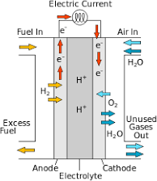

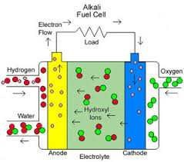

**Faraday˙s law** :

**Faraday˙s law** of induction is a basic **law** of electromagnetism predicting how a magnetic field will interact with an electric circuit to produce an electromotive force (EMF)—a phenomenon called electromagnetic induction.

